***Interactive Dashboard for COVID-19 Deaths Analysis***

Submitted by:

Sneha Mondal

Registration No.12308247

Section: K23EVA,59 Course Code : INT217

Under the Guidance of

Mrinalini Rana UID: 22138

Discipline of CSE/IT

Lovely School of Computer Science and Engineering Lovely Professional University, Phagwara

CERTIFICATE

This is to certify that Sneha Mondal bearing Registration no. 12308247 has completed INT217 project titled, **“ *Interactive Dashboard for COVID-19 Deaths Analysis*”** under my guidance and supervision. To the best of my knowledge, the present work is the result of his/her original development, effort and study.

Dr. Mrinalini Rana Professor

School of Computer Science and Engineering

Lovely Professional University Phagwara, Punjab.

Date: 12-04-2025

DECLARATION

I am Sneha Mondal, student of BTech under CSE/IT Discipline at, Lovely Professional University, Punjab, hereby declare that all the information furnished in this project report is based on my own intensive work and is genuine.

Date: 12-04-2025

Registration No.: 12308247 Name of the student: Sneha Mondal

ACKNOWLEDGEMENT

I would like to express my sincere gratitude to my faculty and department for their guidance and support throughout the completion of this minor project titled "Interactive Dashboard for COVID-19 Deaths Analysis."

I also thank Lovely Professional University for providing the necessary resources and environment to carry out this work successfully.

Sneha Mondal B.Tech CSE

Table of Contents

1. Introduction 7

2. Source of Dataset 8

3. Sample Dataset 9

4. Dataset Preprocessing 10

6. Analysis on dataset 13

Objective 1: **Analysis of Deaths by Age Group**

i. General Description: 13.

ii. Specific Requirements: 13.

iii. Analysis Results: 13.

iv. Visualization: 13.

Objective 2: **Analysis of Deaths by Gender**

i. General Description: 15.

ii. Specific Requirements: 15.

iii. Analysis Results: 15.

iv. Visualization: 15.

Objective 3: **State-wise Death Analysis**

i. General Description:

ii. Specific Requirements: 17.

iii. Analysis Results: 17.

iv. Visualization: 17.

Objective 4: **Total Death Trends**

i. General Description: 19.

ii. Specific Requirements: 19.

iii. Analysis Results: 19.

iv. Visualization: 19.

Objective 5: **Combined Years and Months Analysis**

i. General Description: 21.

ii. Specific Requirements: 21.

iii. Analysis Results: 21.

iv. Visualization: 21.

Objective 6: **Complete Dashboard**

i. General Description: 23.

ii. Specific Requirements: 23.

iii. Analysis Results: 23.

iv. Visualization: 23.

5. Conclusion 25

6. Future Scope 26

7.Linkedin…………………………………………………………………………………27

8.Github: ………………………………………………………………………………….28

9.Reference: ………………………………………………………………………………29

**1.INTRODUCTION:**

The **COVID-19 pandemic**, caused by the **SARS-CoV-2 virus**, has undeniably altered the course of modern history since its outbreak in late 2019. The pandemic has affected millions of lives worldwide, leading to widespread illness, death, and economic disruption. Among the hardest-hit nations, the **United States** stands out, with one of the highest numbers of confirmed COVID-19 cases and related fatalities globally. As the virus rapidly spread across the country, it became increasingly important for public health authorities to **monitor, analyze**, and **understand** the patterns of **mortality** in order to develop effective healthcare strategies, allocate resources, and create policies that could mitigate the pandemic’s impact.

In response to the challenges posed by the pandemic, this project focuses on **analyzing COVID-19 death statistics** within the United States using a comprehensive dataset provided by the **Centers for Disease Control and Prevention (CDC)**. The dataset offers a detailed breakdown of COVID-19 fatalities, segmented by **age group**, **gender**, and **state**, which forms the basis for exploring how different demographic groups and geographical regions have been affected by the virus. By leveraging this rich source of information, we aim to draw actionable insights that can aid public health professionals, policymakers, and the general public in understanding the full scope of the pandemic's mortality trends.

The **primary objective** of this project is to analyze the COVID-19 death data across various dimensions such as **age group**, **gender**, and **geographical location**. Using **Excel dashboard tools**, we aim to transform the raw, unprocessed data into a set of **meaningful visualizations** that clearly highlight the key trends and patterns. These visualizations can help identify the **most vulnerable populations** and **regions** that were disproportionately impacted by the virus, thus allowing stakeholders to take targeted actions. Whether through public health interventions, resource allocation, or the implementation of focused policies, these insights have the potential to **drive better decision-making** and **improve crisis response** efforts in the future.

Moreover, the dashboard is designed to be **interactive**, enabling users to slice and filter the data across multiple dimensions. This interactive feature allows users to delve deeper into the **COVID-19 mortality trends**, providing a more nuanced understanding of how different factors have influenced the course of the pandemic. By enabling real-time exploration of the data, the dashboard empowers users to analyze and interpret trends from various perspectives, making it a valuable tool for both retrospective analysis and future preparedness.

Through this project, we not only provide a **historical analysis** of the pandemic’s toll on U.S. society, but we also lay the groundwork for the **use of data-driven insights** in managing future public health crises. This effort highlights the critical role that **statistical tools** and **data visualization** play in **health informatics** and **crisis management**, and serves as a framework for addressing similar challenges in the years to come. The findings of this report not only offer important lessons learned but also underscore the value of data as a key asset in shaping global health responses in the face of ongoing or future pandemics.

**2. SOURCE OF DATASET:**

The dataset utilized for this project is officially published by the **Centers for Disease Control and Prevention (CDC)** and provides **provisional counts of COVID-19 deaths** in the United States. These counts are categorized by **sex**, **age group**, and **state**, offering a comprehensive view of the pandemic's impact across different demographic groups and geographical regions. As the pandemic evolved, the dataset was regularly updated to ensure the most accurate and up-to-date statistics are available, reflecting changes in death counts and the reporting process. This ensures that the data remains a **reliable and timely source** for ongoing research and analysis.

* **Dataset Title:** Provisional COVID-19 Deaths by Sex and Age
* **Provided by:** [Data.gov](https://data.gov/)
* **Data Format:** Excel Spreadsheet (.xlsx)
* **Link:** [Provisional COVID-19 Death Counts by Sex, Age, and State](https://catalog.data.gov/dataset/provisional-covid-19-death-counts-by-sex-age-and-state)

This dataset is **publicly available** and has been widely trusted by **researchers, health professionals, and government agencies** for its accuracy and comprehensiveness. The data provides detailed records, allowing for in-depth analysis, such as breaking down death counts by **age group**, **sex**, and **state-level data**. This feature is particularly valuable for conducting **targeted analysis** and **visualization efforts**, as it enables users to explore how different demographic and regional factors contributed to the overall COVID-19 death toll in the U.S.

The dataset was initially downloaded in its raw form, which contained unprocessed information in a straightforward tabular format. In order to prepare the data for effective visualization and dashboard creation, it required a series of **preprocessing steps**. These steps included cleaning, categorizing, and restructuring the data, ensuring its accuracy and usability for the project's analysis. Among the various columns present in the dataset, key attributes include **age groups**, **sex categories**, **state identifiers**, and the **death counts** reported during the pandemic.

Overall, the dataset serves as an essential foundation for this analytical project, enabling a clear, data-driven understanding of the impact of COVID-19 across different segments of the U.S. population. It remains a critical resource for public health analysis, offering insights that can drive informed decision-making and policy formulation.

**3. Sample DATASET:**

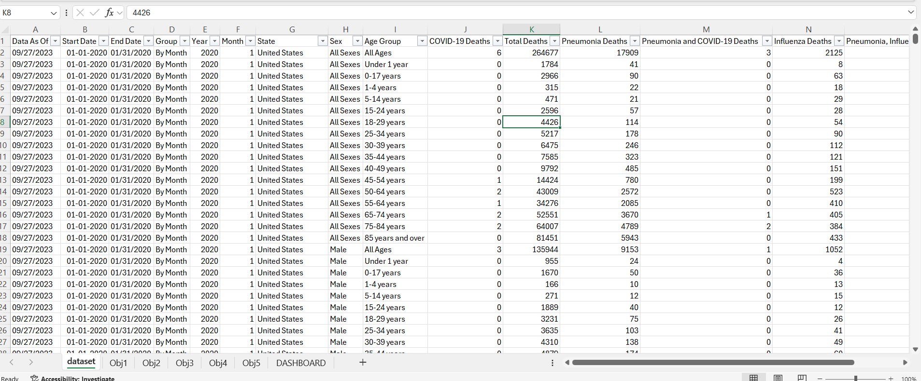

**4. DATASET PREPROCESSING:**

Before initiating any analytical procedures, it was essential to ensure that the raw dataset was clean, consistent, and properly structured to support insightful visualizations and reliable decision-making. Data preprocessing is a foundational stage in any data analytics workflow, especially when building dynamic dashboards in Excel. It transforms unrefined data into a usable format and lays the groundwork for meaningful exploration and interpretation. The preprocessing of the COVID-19 death dataset involved multiple critical steps, each contributing significantly to the overall quality and usability of the dashboard.

**1.Data Cleaning**

The first step in preprocessing was thorough data cleaning. The raw dataset often contained extraneous elements, such as unnecessary columns that did not contribute to the analysis or were completely empty. These were removed to streamline the dataset and improve its clarity. In addition, all records were inspected for missing, null, or incomplete values. This included checking for blanks in key columns like age, gender, state, and number of deaths. In cases where data was missing but still usable, appropriate handling techniques were employed—such as replacing missing text with standardized placeholders (e.g., "Unknown") or imputing zeroes where logically appropriate. Ensuring data consistency was also vital—values that were recorded differently (e.g., "M" vs. "Male") were standardized to maintain uniformity.

**2. Data Categorization**

Once the data was cleaned, categorical standardization was undertaken to enhance interpretability. The age values were grouped into meaningful buckets, such as "0–17", "18–44", "45–64", "65–74", "75–84", and "85+." These groupings allowed for easier demographic analysis and enabled comparative visualization across age ranges. Gender values were also standardized to a consistent naming convention: "Male", "Female", and "Unknown", ensuring that any analytical dimensions involving gender would be coherent and not fragmented due to inconsistent naming.

**3. Normalization of Data**

Normalization ensured uniform formatting across all entries. Text data was formatted consistently with proper case usage, while numerical values were validated to ensure they followed a consistent number format (e.g., no unexpected symbols, thousands separators, or irregular decimal places). This step was crucial in preventing errors when using Excel functions or creating visualizations, as inconsistently formatted data can cause Excel charts and slicers to malfunction or misrepresent the actual information.

**4. Creation of Derived Fields**

To enhance the analytical value of the dataset, additional fields were derived based on existing columns. These derived fields included calculated metrics such as total deaths per state, death counts by demographic segment (age or gender), and percentage contributions of each group to the overall death toll. These fields were crucial in generating more insightful and interpretive dashboards. For example, percentage contributions allowed users to compare the relative impact of COVID-19 across age or gender groups rather than just viewing raw numbers.

**5. Pivot Table Integration**

A key structural transformation during preprocessing was the use of pivot tables. Pivot tables allowed for dynamic restructuring of the dataset, enabling users to analyze the data from multiple dimensions simultaneously—such as filtering by age group while comparing gender across states. Pivot tables provided the flexibility to summarize, sort, and group data dynamically, which was essential for the interactivity expected in the dashboard. This step significantly improved the responsiveness of visual components like slicers and drop-down filters.

**6. Dashboard Structuring and Data Layout Optimization**

Finally, the processed data was reorganized and structured in a layout suitable for dashboard creation. Specific attention was given to placing raw data, pivot tables, and derived metrics in separate, well-labeled sheets. This not only helped maintain data clarity but also ensured that charts, slicers, and filters could be built on reliable data sources without interference. The structured format was conducive to the development of interactive elements such as geographic maps, bar charts, pie charts, and line graphs—all of which contributed to a compelling visual narrative of the COVID-19 death trends in the U.S.

By executing this comprehensive preprocessing strategy, the dataset was transformed from a raw, unrefined collection of records into a clean, structured, and analysis-ready foundation. This enabled the development of an intuitive and visually engaging Excel dashboard that effectively communicated key insights into the COVID-19 death toll across various demographic and geographic dimensions. The preprocessing stage not only ensured data integrity but also played a pivotal role in enhancing the usability and interactivity of the final dashboard product.

**5. ANALYSIS ON DATASET:**

The data analysis is structured around multiple objectives, each designed to uncover specific trends within the dataset. Below, each objective is detailed with its description, specific requirements, analysis results, and visualization approach.

* **Objective 1: Analysis of Deaths by Age Group**
  + **General Description**: **General Description:**  
    This objective focuses on analysing the impact of COVID-19 across various age groups to understand which segments of the population were most vulnerable. By segmenting the data into predefined age brackets, the analysis aims to highlight patterns and disparities in mortality rates among different age demographics. This information is crucial for assessing risk and guiding public health policies.
  + **Specific Requirements:**  
    To fulfill this objective, the dataset was grouped according to standardized age categories (e.g., 0–17, 18–44, 45–64, 65–74, 75–84, and 85+). The total number of deaths within each age group was calculated, and comparisons were made to identify trends and determine which age groups bore the brunt of the pandemic’s mortality impact.
  + **Analysis Results:**  
    The analysis revealed that individuals aged **65 years and above** experienced the highest number of fatalities. Within this age segment, the subgroups **75–84** and **85+** accounted for a significant portion of the total deaths. This trend reflects the heightened vulnerability of older adults to severe complications from COVID-19, likely due to underlying health conditions and weaker immune responses. In contrast, younger age groups, particularly those aged 0–17 and 18–44, recorded relatively fewer deaths, indicating a lower mortality risk.
  + **Visualization:**  
    A **pie chart** was used to visualize the distribution of deaths by age group, providing a clear and immediate view of which age brackets were most affected. The use of this chart type helps convey the proportion of deaths in each group relative to the whole, making it easier for users to grasp the disparities across demographics at a glance. This visualization is interactive in the dashboard, allowing further filtering by state or gender for deeper insights.

* **Objective 2: Analysis of Deaths by Gender**
  + **General Description:**  
    This objective aims to determine whether gender had a noticeable impact on COVID-19 mortality rates. Understanding gender-related patterns in fatalities

can offer valuable insights into how biological, behavioral, or societal factors may have contributed to different outcomes for males and females. Analyzing gender as a dimension of mortality helps in identifying disparities and tailoring health responses more effectively for future health crises.

* + **Specific Requirements:**  
    The dataset was categorized into three gender groups: **Male**, **Female**, and **Unknown**. Death counts were grouped accordingly, and comparisons were made to evaluate whether a particular gender experienced a higher rate of fatalities. This required cleaning and standardizing the gender labels in the data to ensure consistency, followed by grouping the death data based on these categories.
  + **Analysis Results:**  
    The analysis revealed that **males experienced slightly higher fatalities** compared to females. This pattern was consistent across several states and age brackets, suggesting a potential link between gender and COVID-19 mortality risk. While the difference was not overwhelmingly large, it was still significant enough to note. Various studies have suggested that biological factors (such as differences in immune response), as well as lifestyle and exposure-related behaviors, might contribute to this disparity. The “Unknown” category represented a very small portion of the data and had minimal influence on the overall trends.
  + **Visualization:**  
    The gender-wise distribution of deaths was visualized using a **Bar chart**, allowing for an easy side-by-side comparison between the male, female, and unknown categories. This chart clearly illustrated the slight predominance of male deaths and made it easier for users to interpret gender-based trends. In the dashboard, this visualization was made interactive, enabling further filtering by age group or state to uncover deeper patterns within the gender dimension of COVID-19 fatalities.

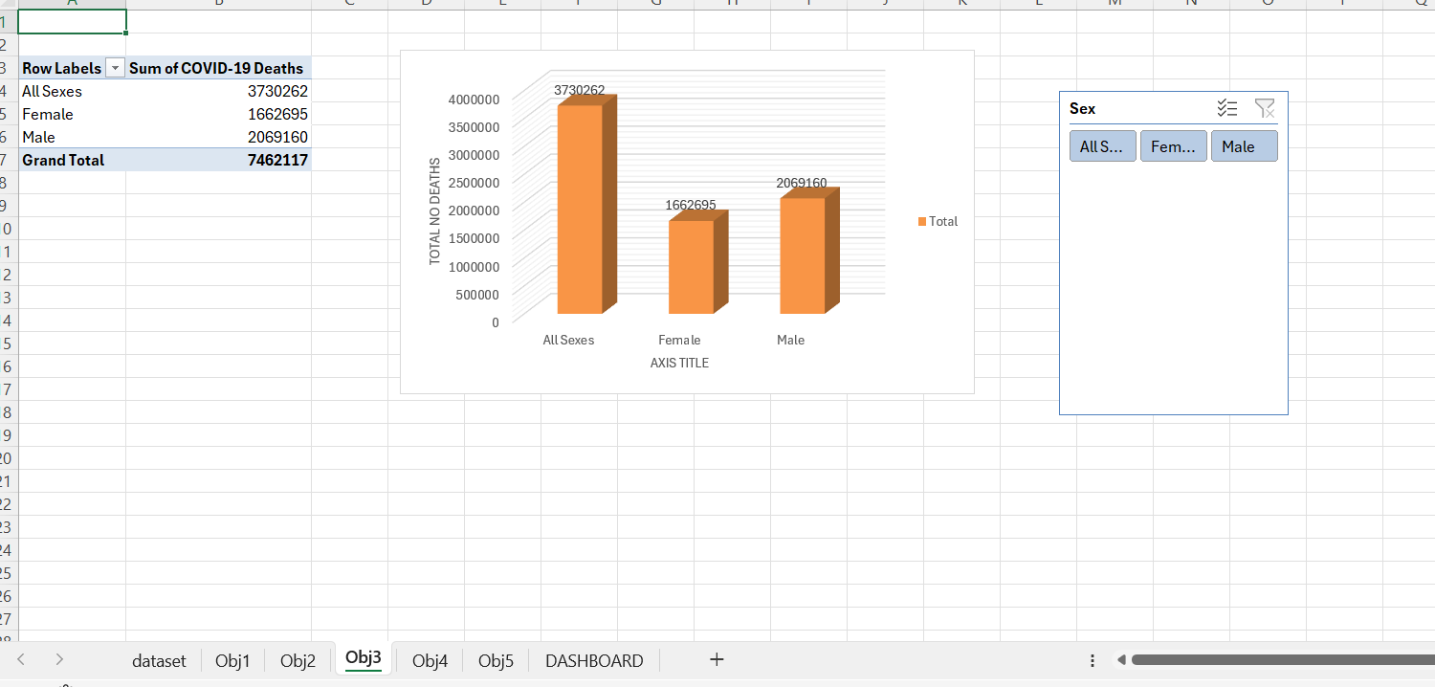

* **Objective 3: State-wise Death Analysis**
  + **General Description**:

This objective explores the geographical distribution of COVID-19 fatalities across different U.S. states. Understanding how mortality rates varied from one state to another provides critical insights into regional trends, healthcare infrastructure challenges, population density effects, and public health policy effectiveness. A state-wise breakdown of deaths helps to identify which areas were most impacted and supports localized decision-making for future health emergencies.

* + **Specific Requirements:**  
    To carry out this analysis, the total number of COVID-19-related deaths was aggregated for each state. The dataset was cleaned to ensure uniform naming conventions for states, and any discrepancies or incomplete entries were addressed during preprocessing. The summed values for each state were then compared to highlight variations and identify states with particularly high or low death tolls.
  + **Analysis Results:**  
    The results of the analysis indicated that states such as **New York, California, and Texas** experienced the highest number of COVID-19 deaths during the observed period. These states are among the most populous in the U.S., which partially explains the higher death counts. However, factors such as early outbreak severity, healthcare capacity, public health responses, and population density also played significant roles in influencing outcomes. States with smaller populations or more effective containment strategies tended to report comparatively lower fatality numbers.
  + **Visualization:**  
    A **bar chart** was used to display the total number of deaths for each state, enabling a clear visual comparison across the country. This visualization allowed users to quickly identify which states were most affected and provided a straightforward way to rank them by death count. The chart was designed to be interactive within the dashboard, with filtering capabilities that allowed users to cross-analyze death counts by other variables such as age group or gender for a more granular view of the data.

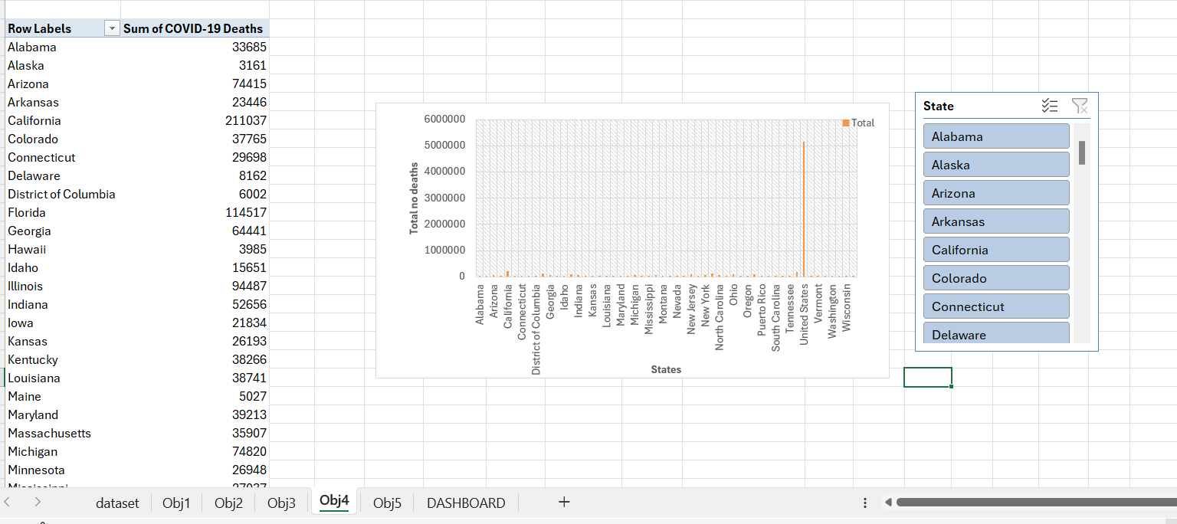

* **Objective 4: Total Death Trends**
  + **General Description**:

This objective focuses on analyzing how COVID-19-related deaths evolved over time, aiming to uncover patterns, identify peak periods, and observe the pandemic's progression across different phases. Temporal analysis allows for a deeper understanding of when the virus had the most impact and how public health responses, seasonal factors, and variant outbreaks influenced mortality. Recognizing these trends is essential for evaluating crisis response and preparing for future health emergencies.

* + **Specific Requirements:**  
    The dataset was organized with a clear time dimension, aggregating death counts on a **weekly or monthly basis**. Each time interval was assigned a standardized label to ensure accurate grouping. This required preprocessing date fields, converting them into uniform formats, and grouping corresponding death counts to allow comparison across time periods. The data was then categorized by time-based segments to highlight fluctuations in fatalities over the span of the pandemic.
  + **Analysis Results:**  
    The analysis revealed clear **spikes in death counts** during specific timeframes that align with major **COVID-19 waves**. Notably high death rates were recorded during early 2020, the winter surge of 2020–2021, and the mid-2021 Delta wave, followed by the Omicron wave in early 2022. Between these surges, death counts tended to decline, reflecting periods of improved control, increased immunity, and vaccine distribution. These trends showcased the cyclical nature of the pandemic and illustrated how various factors, such as seasonality, public gatherings, and variant emergence, contributed to changes in mortality rates.
  + **Visualization:**  
    A **series of pie charts** was used to represent the proportional distribution of deaths across different months or waves. Each chart allowed for a visual comparison of how much each time period contributed to the overall death toll. Additionally, an **interactive map visualization** was included to display how death trends varied geographically over time, offering a layered view that combined both spatial and temporal insights. The map made it easy to observe which states were most impacted during specific phases of the pandemic, giving a comprehensive perspective on the evolving nature of COVID-19 fatalities across the U.S.

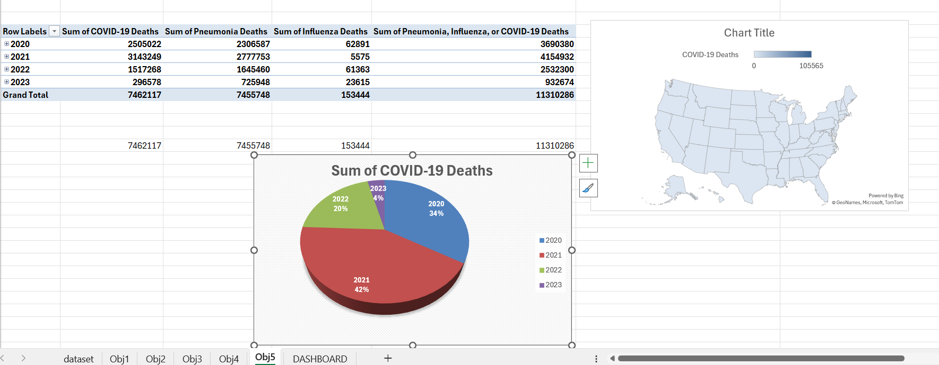

* **Objective 5: Combined Years and Months Analysis**
  + **General Description:**  
    This objective aims to investigate the **relationship between age and gender** in COVID-19-related deaths, highlighting how these two demographic variables interact to influence mortality outcomes. While earlier objectives examined age and gender separately, this deeper analysis focuses on their intersection—providing a more comprehensive understanding of vulnerable populations. Identifying how gender-related risk varies across different age groups can support targeted interventions, healthcare resource planning, and public health education campaigns tailored to specific at-risk communities.
  + **Specific Requirements:**  
    The dataset was first preprocessed to include well-defined **age group categories** and **gender identifiers** (Male, Female, Unknown). Data was then **cross-tabulated** by age and gender, calculating death counts for each combination. This allowed the creation of a detailed matrix, showing how mortality numbers varied not only by age or gender independently, but also by their **combined effect**. Standardization of category names was performed to avoid duplication or misclassification during grouping. The data structure also ensured compatibility with interactive elements such as slicers in the Excel dashboard.
  + **Analysis Results:**  
    The analysis revealed a **concentrated pattern of higher deaths among older males**, particularly in the 65–74 and 75–84 age groups. As age increased, the gap between male and female deaths widened, with males showing disproportionately higher numbers. This pattern was consistent across most states and time frames. While female fatalities were also significant in higher age groups, the upward trend for males was noticeably steeper. In younger age brackets, such as 25–44, the gender gap was narrower but still observable. The results suggest a **compounding effect** where age amplifies gender-based vulnerability.
  + **Visualization:**  
    A **scatter chart** was used to visualize the relationship between age and gender in COVID-19 deaths. Each point on the chart represents a data combination of age group and gender, with the **x-axis** showing age groups and the **y-axis** indicating death counts. Different colors or markers were used to distinguish gender categories, making it easy to spot disparities.  
    To enhance user interaction and allow dynamic exploration, a **slicer** was integrated into the dashboard. This slicer enables filtering by other variables such as **state** or **time period**, providing users with the flexibility to examine specific subsets of data. For instance, a user could view how gender-based mortality trends changed over time or varied from one state to another. This interactive feature transforms the scatter chart from a static visual into a powerful tool for multidimensional analysis.

* **Objective 6: Complete Dashboard**
  + **General Description:**

This objective offers a **holistic overview** of the entire dashboard, ensuring that users can access a comprehensive, user-friendly tool for analyzing COVID-19 mortality trends across multiple demographic and temporal dimensions. The goal is to provide clear insights into how age, gender, state, and time interact in shaping the COVID-19 death toll. By aggregating and visualizing the complete dataset, the dashboard presents an interactive experience where users can explore different aspects of the data, uncover patterns, and make informed conclusions. This overarching view ensures that the dashboard is not just a static report but a dynamic tool that fosters deeper data exploration and understanding.

* + **Specific Requirements:**  
    The dashboard needed to integrate a **wide array of data dimensions**—age, gender, state, and time—into a cohesive layout. It required **aggregating** data from all sources and transforming it into meaningful visual representations. This entailed grouping data by multiple dimensions, such as **state-wise comparisons of deaths across different age groups** or **gender-based trends over time**. Additionally, the dashboard was designed to allow for easy dynamic filtering, enabling users to **slice the data** by various categories such as state, time period, or age group. Such aggregation allows users to see both macro and micro-level trends, supporting a flexible approach to data exploration.
  + **Analysis Results:**  
    The integrated dashboard provided a **dynamic and intuitive interface** for understanding the broad and complex patterns of COVID-19 mortality. Users could explore how different age groups and genders were impacted by the virus in specific states, or how death trends evolved across time. The data clearly illustrated that older age groups, particularly males, were most vulnerable to severe outcomes. The dashboard's design allowed users to identify **regional variations** and **temporal spikes** in the death toll, reflecting different waves of the pandemic. Moreover, it highlighted **percentage contributions** from each group, enabling users to interpret the relative impact of each demographic category on overall mortality. The interactive features empowered users to generate targeted insights without needing advanced technical skills, ensuring that the tool could serve both **analysts** and **general audiences**.
  + **Visualization:**  
    A **combination of visualizations** was used to enhance the dashboard’s ability to communicate key insights effectively:
  + **Donut charts** were used to present the **proportional contributions** of different demographic categories (age groups, gender, etc.) to the overall death toll, offering a clear view of the distribution.
  + **Percentage-labeled bar charts** provided a precise and intuitive way to compare death counts across different age groups, genders, and states, making it easy to identify trends and differences at a glance.
  + **Interactive slicers** allowed users to filter the data by time periods (e.g., monthly or yearly), states, or demographic categories, providing a more tailored exploration of the dataset. This interactivity was crucial for enabling users to drill down into specific subsets of the data and uncover finer details.
  + **Summary visuals** were included to offer quick insights into the overall death toll, top-ranking states, and other critical trends, acting as a high-level overview for users who might not want to dig deeply into the granular details. These summary visuals helped in guiding users to the most important findings in the dataset, making the dashboard both accessible and informative.

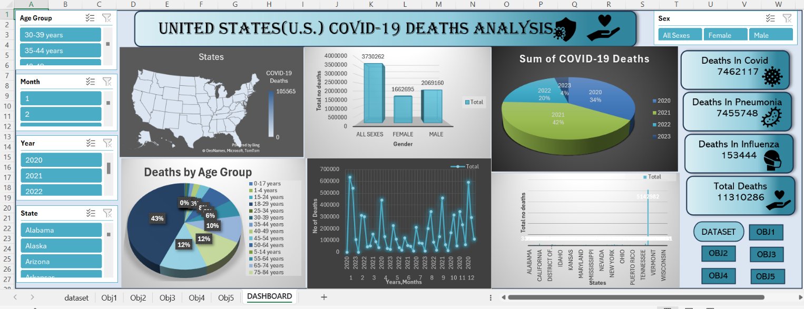

**6. CONCLUSION:**

This analytical project on **COVID-19 deaths in the United States** provides a **deep and insightful exploration** of pandemic-related mortality, offering a granular perspective through the lens of **demographic segmentation** and **regional differences**. By examining the

data across multiple dimensions—such as **age, gender, state, and time**—the project paints a clearer picture of how the virus disproportionately affected certain populations and regions. Through this analysis, we gain a better understanding of the **vulnerabilities** within different demographic groups, particularly the elderly and males, and how their mortality rates fluctuated across time and geographical locations.

The **interactive dashboard** created as part of this project has proven to be an effective medium for communicating **critical, data-driven insights**. By visualizing mortality trends, the dashboard not only makes complex data more accessible but also empowers users to explore patterns in a dynamic, engaging way. It highlights significant findings such as the higher mortality rates among individuals aged 65 and above and the elevated risks for males, particularly in older age groups. The **regional disparities** in death tolls, notably the higher fatalities recorded in states like New York, California, and Texas, further emphasize the importance of localized response strategies during pandemics.

The project also underscores the importance of **data preprocessing and cleaning**. The steps taken to clean, categorize, and structure the raw dataset were essential in transforming raw figures into meaningful, usable data. This meticulous preprocessing, combined with thoughtful **dashboard design** that incorporated various visualization techniques (e.g., pie charts, bar charts, scatter plots), made the data not only more understandable but also more actionable. The **use of slicers** and **interactive filters** allowed for greater exploration and customization, enabling users to focus on specific subsets of the data for targeted analysis.

This project has not only contributed to a **retrospective understanding** of the impact of COVID-19 but also offers valuable insights that can inform future public health strategies. The approach demonstrated here has great potential for use in the fields of **epidemiology**, **policy-making**, and **crisis response**, where timely, data-driven decisions are crucial. By showcasing the power of clear data visualization and interactive dashboards, this project provides a **strong foundation** for the development of similar analytical tools in future health crises.

Moreover, this work can serve as a model for future **pandemic data analysis**, aiding health professionals, researchers, and policy-makers in better understanding and responding to such challenges. By embracing the intersection of **data science**, **public health**, and **visual analytics**, we can enhance our preparedness for future outbreaks and improve decision-making in the face of evolving global health threats.

**7. FUTURE SCOPE:**

The current **COVID-19 mortality dashboard project** serves as a robust foundation for data analysis and visualization. However, there are numerous avenues for **enhancing and expanding** the dashboard's scope to provide deeper insights and broaden its applicability. By incorporating additional data points and advanced analytics, the dashboard can evolve into a more comprehensive tool for public health decision-making, research, and policy development. Below are several potential areas for expansion:

* **Include Vaccination Data:**  
  One significant enhancement would be to **integrate vaccination data** alongside mortality statistics. Tracking vaccination rates across different demographic groups and regions, and comparing these rates with death rates, would provide a clearer picture of the **effectiveness of vaccination efforts** in mitigating the impact of the pandemic. This could include information on **vaccine coverage**, **breakthrough cases**, and the relationship between vaccination status and COVID-19 mortality. Such insights would be invaluable for understanding the success of vaccination campaigns and for future public health strategies aimed at controlling infectious diseases.
* **Add Hospitalization Trends:**  
  Another important addition would be the integration of **hospitalization and ICU data**. Hospitalization trends are a crucial aspect of pandemic response, as they reflect the strain on healthcare systems and the severity of the disease. Including data on hospital admissions, ICU occupancy, and ventilator usage would allow for a more holistic analysis of the healthcare burden. This could also help policymakers and healthcare providers better allocate resources and plan for potential surges in cases, providing a more dynamic picture of healthcare system capacity.
* **Use Predictive Analytics:**  
  To further enhance the dashboard’s usefulness, **predictive analytics** could be incorporated. By leveraging **machine learning models** and other forecasting techniques, future trends in COVID-19 cases and mortality could be predicted. This would allow for proactive planning and better preparedness for future outbreaks or waves. Forecasting models could be based on various factors, such as current case trends, vaccination rates, and even seasonal patterns. By incorporating predictive models, stakeholders could anticipate potential surges in cases and allocate resources more effectively to mitigate the impact.
* **Create Web-Based Dashboards:**  
  Migrating the dashboard to **online platforms** like **Power BI** or **Tableau** would enable the creation of **real-time interactive dashboards** accessible to a global audience. Web-based dashboards provide the benefit of being more easily updated with the latest data and can offer greater accessibility for users, whether they are researchers, healthcare providers, or the general public. Additionally, the ability to embed the dashboard in websites or share it across social media platforms would enhance its visibility and usability, making it a powerful tool for widespread information dissemination.
* **Compare with Global Trends:**  
  Expanding the dashboard to include **global COVID-19 data** would allow for **international comparisons** and benchmarking. Analyzing U.S. data in the context of global mortality trends could provide valuable insights into how different countries have responded to the pandemic. This could also highlight differences in healthcare systems, vaccination strategies, and public health policies. By examining global trends, the dashboard could offer comparative insights, allowing stakeholders to identify best practices and areas for improvement on a global scale.

These proposed enhancements would make the dashboard an even more comprehensive and versatile tool, valuable not only for U.S.-focused analysis but also for **global public health efforts**, **government planning**, and **academic research**. As the dashboard evolves, it can continue to serve as an indispensable resource for public health professionals, policymakers, and researchers striving to understand and respond to the ongoing challenges of the COVID-19 pandemic and similar public health crises in the future.

**8. LinkedIn:**

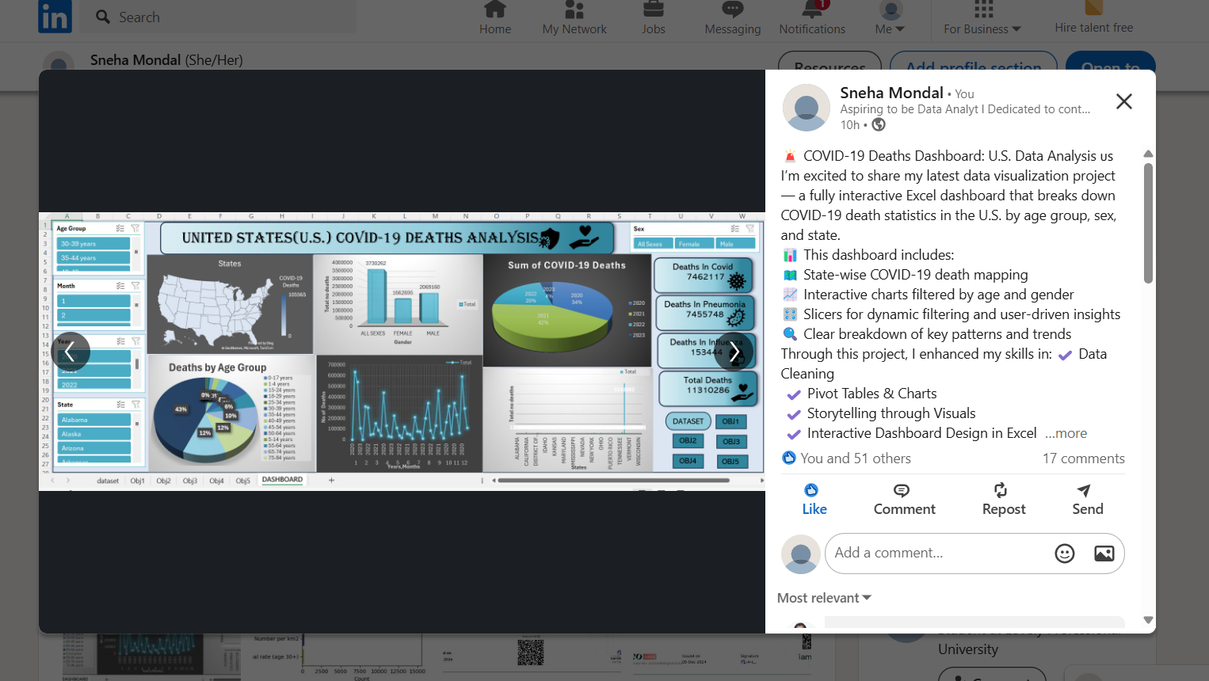

**LINK: https://www.linkedin.com/feed/update/urn:li:activity:7316721358401351680/?commentUrn=urn%3Ali%3Acomment%3A(ugcPost%3A7316721357419884544%2C7316874403974189057)&dashCommentUrn=urn%3Ali%3Afsd_comment%3A(7316874403974189057%2Curn%3Ali%3AugcPost%3A7316721357419884544)**

**9. GitHub:**

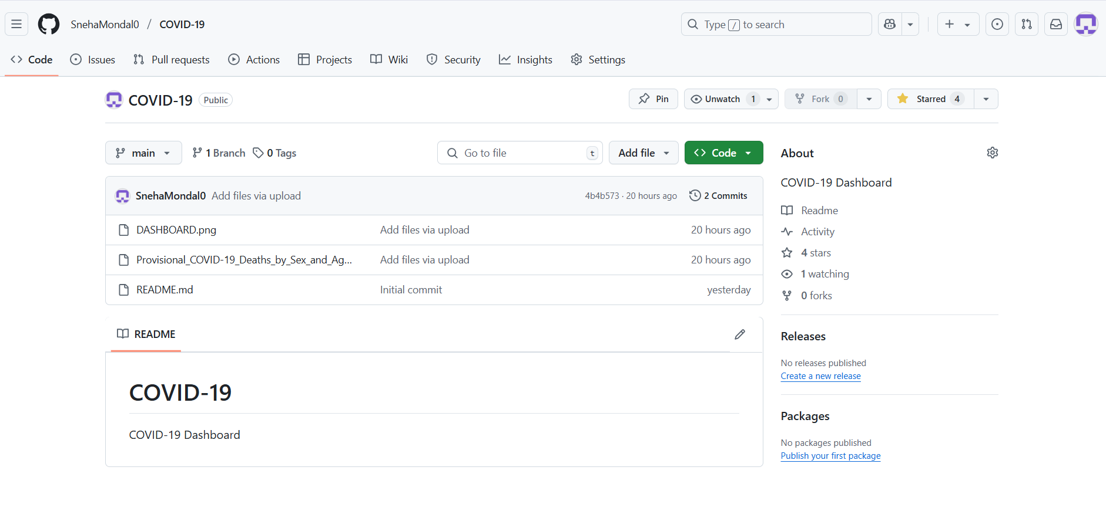

**LINK: https://github.com/SnehaMondal0/COVID-1**

**8. REFERENCES**

[1] **Centers for Disease Control and Prevention (CDC)**, “**Provisional COVID-19 Death Counts by Sex, Age, and State**,” Centers for Disease Control and Prevention, 2024. [Online]. Available: <https://data.cdc.gov>.  
This dataset, provided by the CDC, offers **provisional counts of COVID-19 deaths** in the U.S., categorized by sex, age group, and state. The data is regularly updated to reflect the most accurate and current statistics, making it a vital resource for public health research and analysis.

[2] **World Health Organization (WHO)**, “**Coronavirus Disease (COVID-19) Pandemic**,” World Health Organization, 2024. [Online]. Available: <https://www.who.int>.  
The WHO provides a global perspective on the **COVID-19 pandemic**, offering up-to-date information on the virus’s spread, impact, and response strategies. This resource is essential for understanding the global context in which national and regional trends, like those in the U.S., have unfolded.

[3] **Microsoft Excel** Official Documentation, 2024. [Online]. Available: <https://support.microsoft.com/excel>.  
Microsoft Excel's official documentation provides comprehensive guidance on using Excel's various **data analysis and visualization** tools. The resources available on this site helped in the effective creation of the interactive dashboard used in this project, offering step-by-step instructions on utilizing Excel’s powerful features, such as **pivot tables**, **charts**, and **data cleaning** techniques.

[4] **Tableau Software**, “**Interactive Dashboards**,” Tableau Software, 2024. [Online]. Available: <https://www.tableau.com>.  
Tableau Software offers a wide range of tools for **creating interactive dashboards**, which can be used to visualize and analyze complex datasets. While not directly used in this project, Tableau's resources on dashboard creation provided valuable insights into **best practices for interactive data visualization**, influencing the design of the Excel dashboard used in this analysis.