**OVERVIEW**

**PROJECT: JEERA**

**CLIENT: In-House**

**Domain: Software Testing Tool**

**File name: JeeraTechnicalSpecificationsDocument**

**Author(s): Jeera Team**

**File Location:**

**read only (Jeera Team)**

**Link:**

**Contents**

**1. Introduction**

**1.1 Users Roles and their Responsibilities (Organisation perspective)**

**1.2 Users and their Activity (Application perspective)**

**1.3Glossary of Items**

**2. Project Architecture**

**3. Front-End**

**3.1 Login**

**3.2 Logout**

**3.3 Home Page**

**3.3.1 Home**

**3.3.2 Create project**

**3.3.3 Create issues**

**3.3.4 Search**

**3.3.5 Profile Settings**

**3.3.5(a) User Management**

**3.4 Jeera Board**

**3.4.1 Backlog**

**3.4.1 a Create and Edit Sprint**

**3.4.2 Board**

**3.4.3 Project Setting**

4. Webservices/ Java Components

5. Data Schema

6. Data Base Objects

**1. Introduction:**

Jeera is Project management tool which helps teams to plan, assign, track, report, and manage work and brings teams together for everything from agile software development and customer support to start-ups and enterprises. Deliver amazing service experiences across all teams from IT, Dev, Ops, and more with Jeera Service Management. With templates and solutions crafted for every team and Jeera as your common language - work moves fluently and transparently across your organization.

Jira Software can be configured to fit any type of project. Teams can start with a project template or create their own custom workflow. Jira issues, also known as tasks, track each piece of work that needs to pass through the workflow steps to completion. Customizable permissions enable admins to determine who can see and perform which actions. With all project information in place, reports can be generated to track progress, productivity, and ensure nothing slips.

* 1. **Roles and their Responsibilities (Organisation perspective)**
* **Admins:** Admin is the prior person to access the software and act upon it. A Jira administrator **installs, configures, and manages your organization's instance of Jira**. It's the admin's job to ensure that each person has the right user role and privileges assigned in Jira.
* **Project managers:** He will be monitoring all the going on projects within the company.
* Plan and Develop the Project Idea. Every project starts as an idea. ...
* Create and Lead Your Dream Team. ...
* Monitor Project Progress and Set Deadlines. ...
* Solve Issues That Arise. ...
* Manage the Money. ...
* Ensure Stakeholder Satisfaction. ...
* Evaluate Project Performance.
* **Product owners**:
* Managing and prioritizing the product backlog. ...
* Translating product managers' strategies to tasks for development. ...
* Learning the market and customers' needs. ...
* Staying accessible to development to answer questions.
* **Scrum masters:**
* Implement Project Management/Best Practices. ...
* Keep all Parties on Track and Informed. ...
* Introduce Agile Engineering Practices. ...
* Coach Team Members. ...
* Host Daily Stand-up Meetings. ...
* Assist the Product Owner with the Product Backlog. ...
* Teach Scrum Practices and Principles.
* **Developers**
* Work with developers to design algorithms and flowcharts
* Produce clean, efficient code based on specifications
* Integrate software components and third-party programs
* Verify and deploy programs and systems
* Troubleshoot, debug and upgrade existing software
* Gather and evaluate user feedback
* Recommend and execute improvements
* Create technical documentation for reference and reporting
* **Quality Analysts**
  1. **Users Activity and their Authentication (Application perspective):**
* Admin: Admin is the prior person to access the software and act upon it. A Jira admin **installs, configures, and manages your organization's instance of Jira**. It's the admin's job to create the projects and ensure that each person has the right user role and privileges assigned in Jira.

Authentication: He can access the entire application without any restrictions

* **Product Manager**
* **Product Owner:** PO will create and prioritize the product backlog and then he will the manage the backlogs and reviews it once the tasks are finished.

**Authentication:** PO can access the application at the project level. Apart from project creation and allocation, he is responsible for initialization to completion of the project.

* **Scrum Master:** Scrum Master will assist the Product owner in create and assigning the product backlog. He keeps the update the work flow and he facilitate the ceremonies to raise any requests, clarifications, updating and impediments.

Authentication: Scrum Master can only view the activities on the applications but he cannot manipulate it. Scrum Master as the same access like product owner.

* **Team lead:** Extension to Product owner, will assign the story points and handles the scrum board with the reference to the sprint backlogs.

**Authentication:** Lead will be limited to the scrum board he can only make changes and update the sprint board and give updates to the product owner.

* **Developer/QA:**

Authentication: They can only view the projects assigned to them and update their issues by tagging the concern persons related to the project/s.

## **1.3 Features:**

* **Scrum board**: Scrum Boards enable teams to manage their sprints and backlog.
* **Backlogs**: A backlog contains outstanding issues for a team to work on.
* **Epics, User Stories, Issues:** An epic represents a large body of work, which may require several sprints to complete. Multiple user stories comprise an epic. A Jira issue represents a single piece of work in a project.
* **Roadmaps:** Roadmaps create a visual representation of all the epics a team is working on, so teams can plan large pieces of work in advance.
* **Permissions**: Utilize permissions to grant team members different levels of access and to lock down sensitive information.
* **Advanced search**: Advanced search uses Jira Query Language (JQL) to search for specific criteria in issues that can’t be done in quick or basic searches.

1. **Project Architecture: Admin**

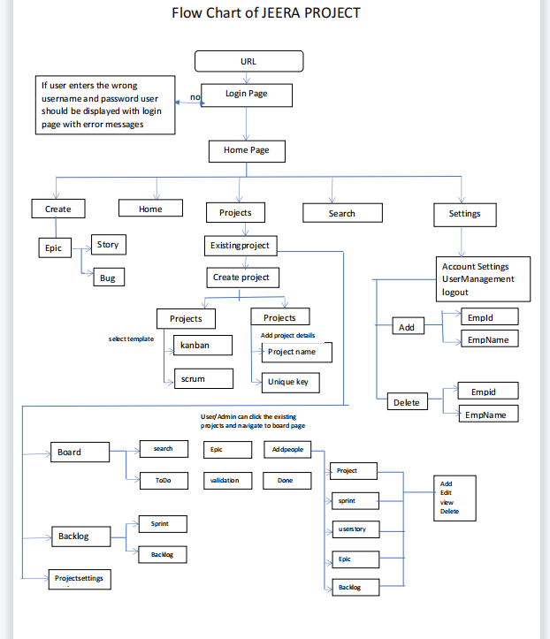

**EMPLOYEE**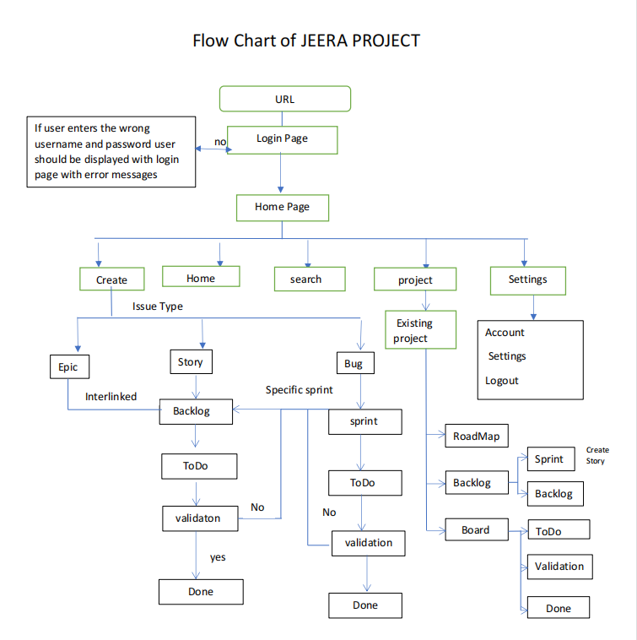

**3.Front-End**

**3.1 Login:**

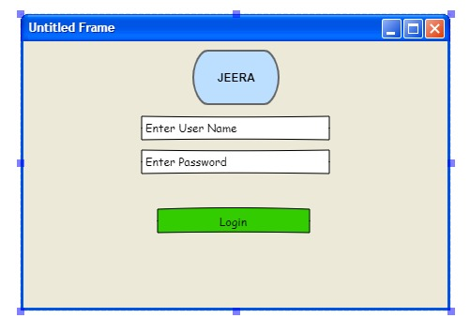

LOGIN PAGE is same for all users where user can login with valid credentials “USERNAME” and “PASSWORD”.

**3.2 Log Out**

Log Out should allow a user who has already logged in with the classified site to log out successfully with the logout successful message and the admin information needed to save successfully.

**3.3 Home Page:**

**3.3.1 Home**

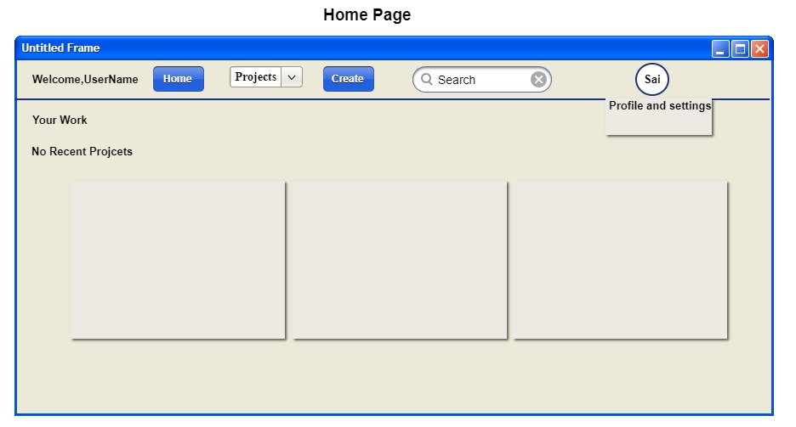

Once User is logged in successfully, user should be navigated to the "HOME PAGE". Page will display with Welcome, User Name along with Project drop-down, Create button, search option and ‘Profile Setting.

**3.3.2 Create project**:

After employee logged in, he should be navigated to the "HOME PAGE". Page will display with Welcome, User Name along with Project drop-down, create button, search option and ‘Profile Setting. In Profile Settings employee will only display Account Settings and Logout.

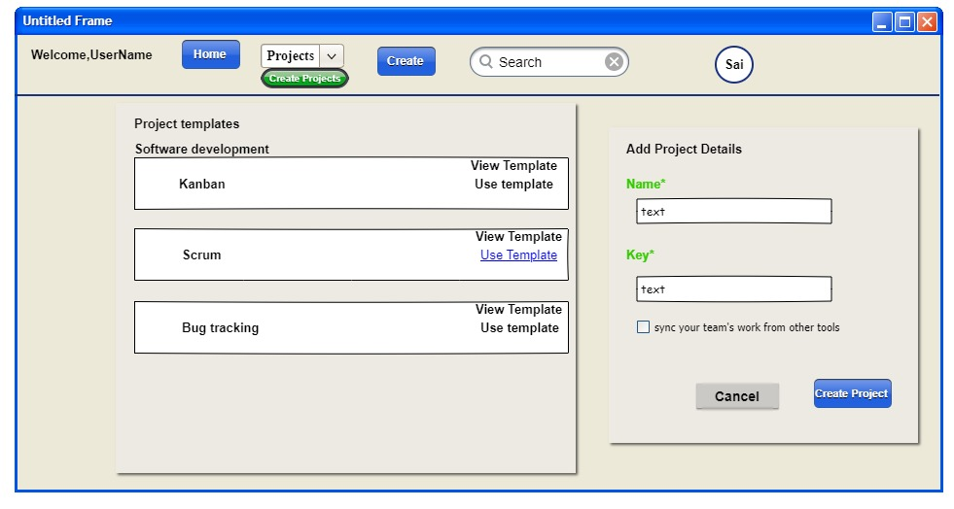

When User (Admin) clicks the project drop-down, user can select create project option, which navigates to project template, then by selecting the template user will navigate to add project details page where user can name the project, and then clicking on create project button then the project gets created. Above attached screen short for references.

**3.3.3 Create issues**

If user want to create a Bug he will click on ‘CREATE’ Button he will display create Issue Pop up.

He can select the project name below to that we have Issue Type in that we have story drop down which has BUG And EPIC. In the same we have Status in that we have Board options Like to Do, In Progress and Done we need to select the status of the Story. Below to that status we have Summary and Description we need to enter valid some data about the story.

In Assignee we need to assign the particular bug to the particular developer which will be in Automatic. Below to that we have labels, sprint, story point estimate, Reporter, Attachment, Linked issues and Flagged drop down. In every stage we need to select the concern query and he can use create button or cancel button to create and delete.

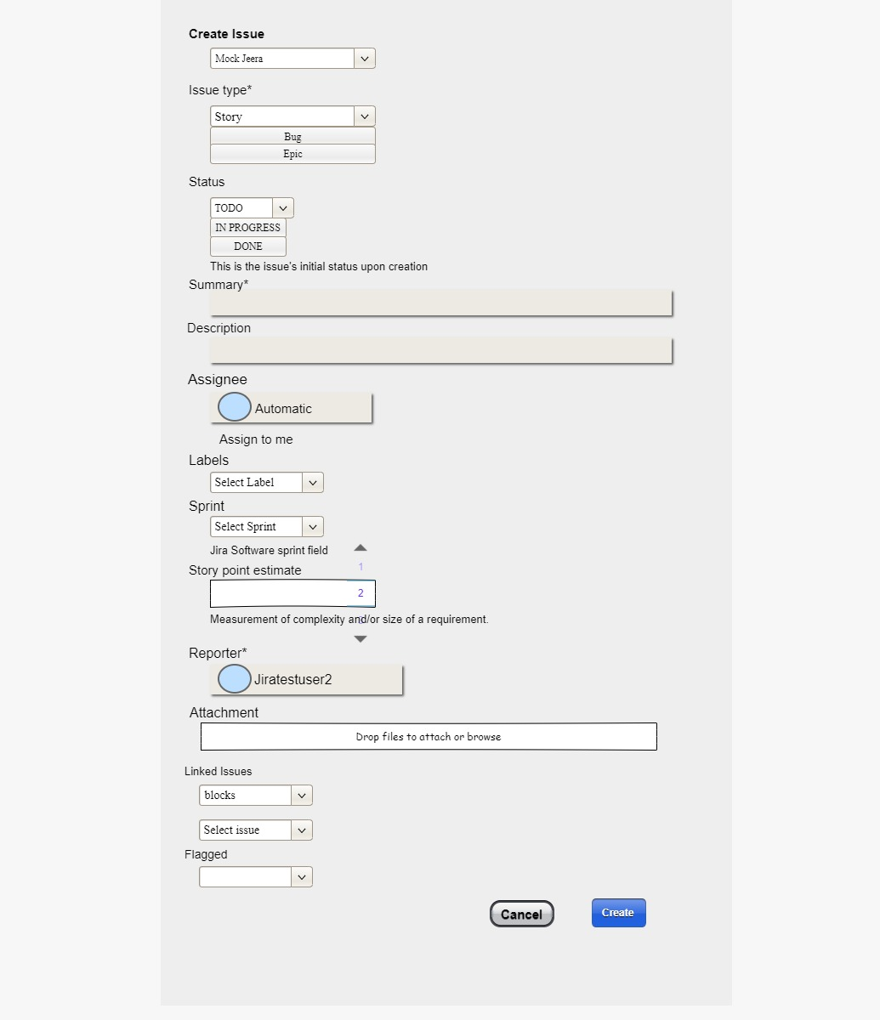

If user select EPIC:

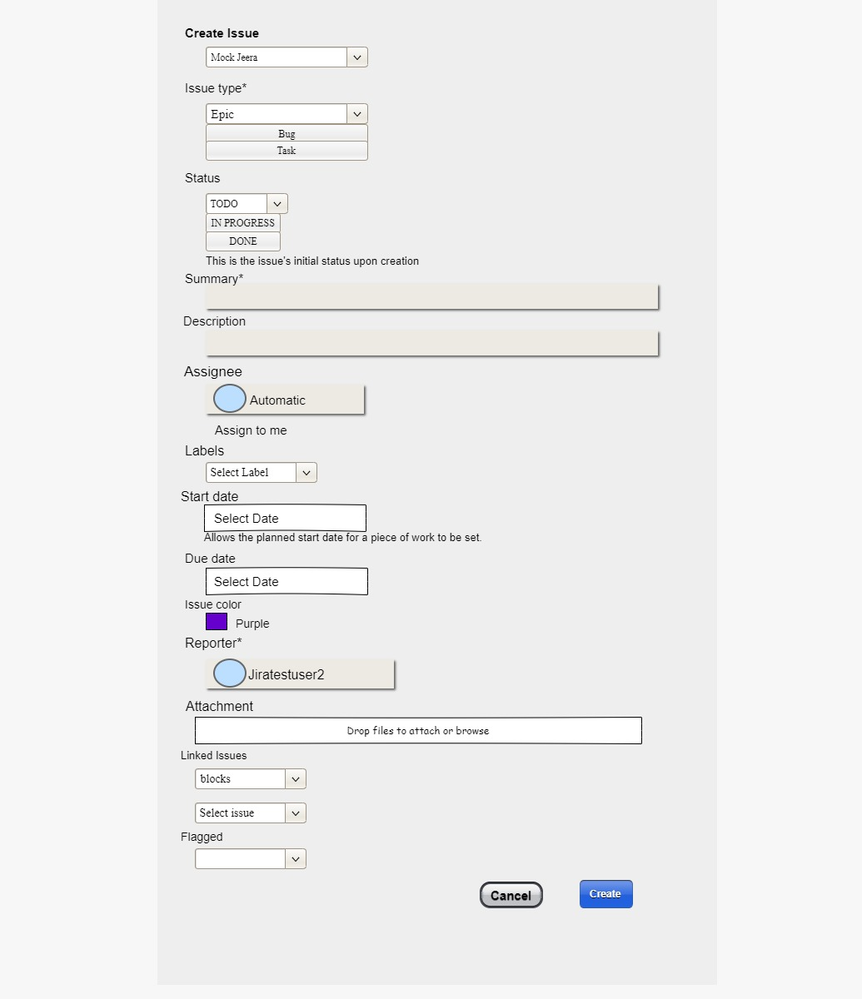

If user selects an EPIC in the Issue Type, user will display Status drop down, Summary, Description, Assign and Labels. Below to that we have Start and End Date for that Epic, followed by Issue colour, Reporter, Attachment, linked Issues and Flagged.

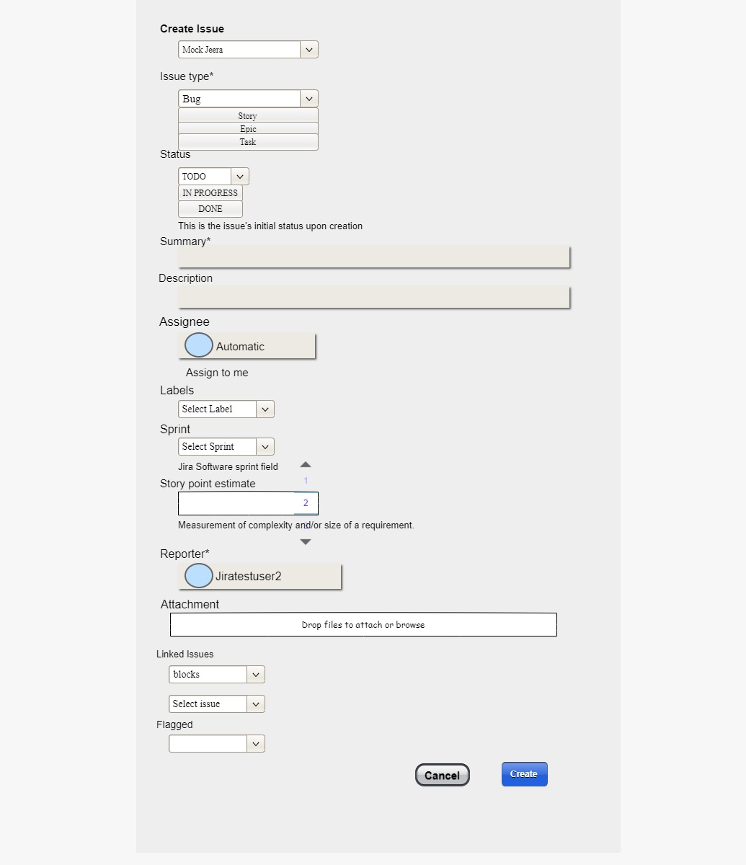

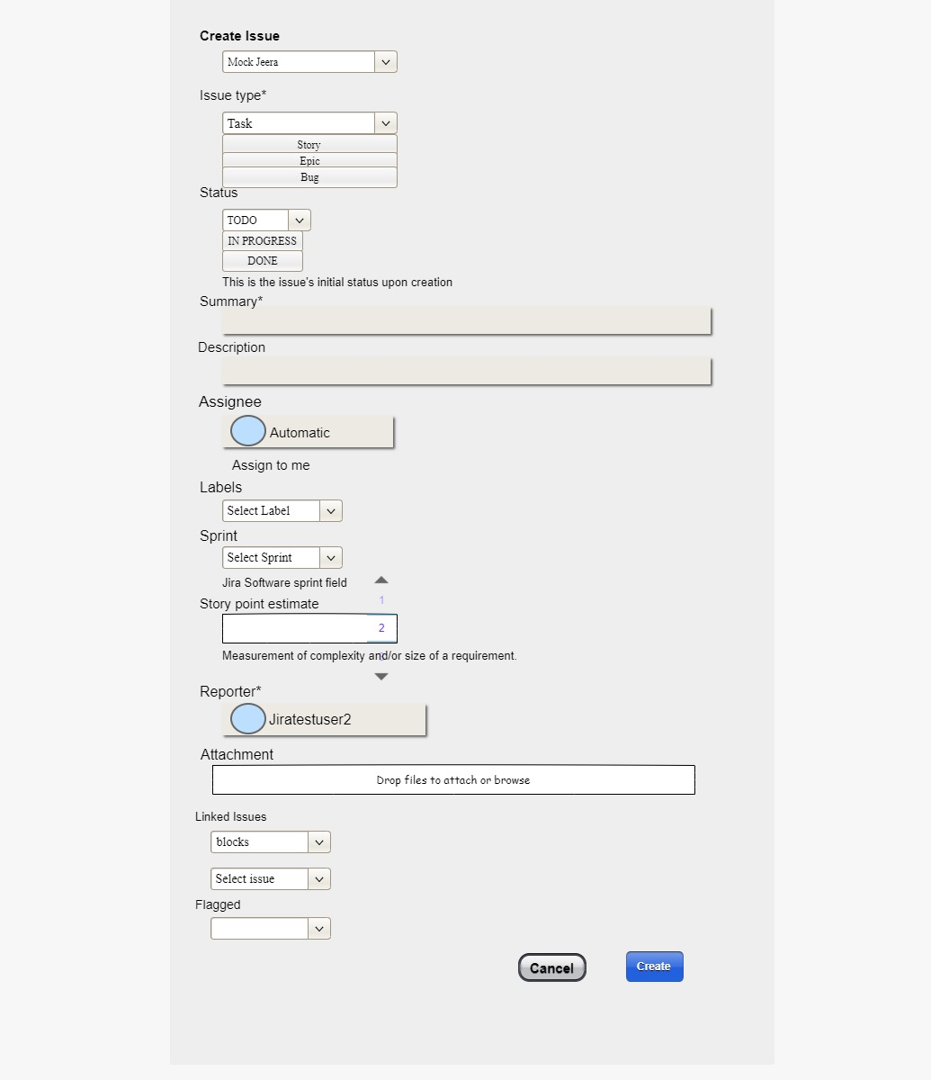

**3.3.4 Search**

Admin can search for existing projects by using ‘search bar’.

**3.3.5 Profile Settings:**

**3.3.5(a) User Management**

In ‘Profile Settings’ if user is an ADMIN he will have “User Management”, and “Logout” options. If ‘ADMIN’ clicks on ‘User Management’ he will get pop -up like ‘Add Employee’ and ‘Delete Employee’.

If user click on ‘Add Employee’ he will display ‘Emp ID’, ‘Emp Name’ and ‘submit button’, admin can add required details to give access for the ‘jeera application’.

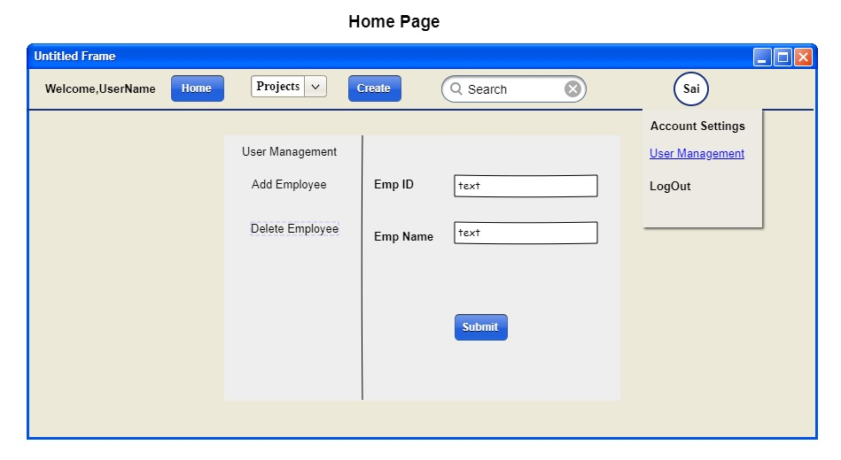

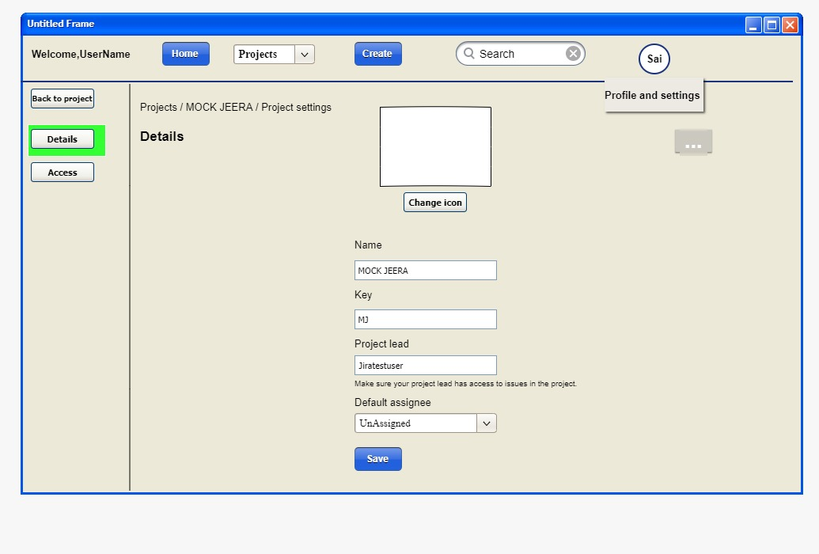

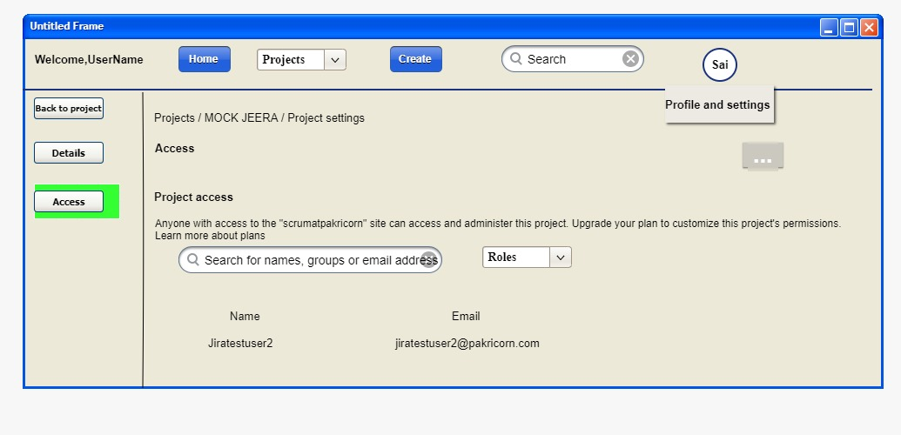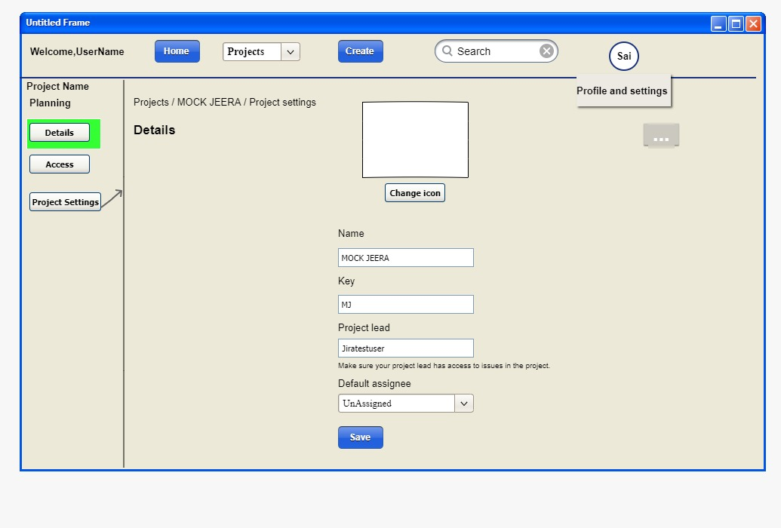

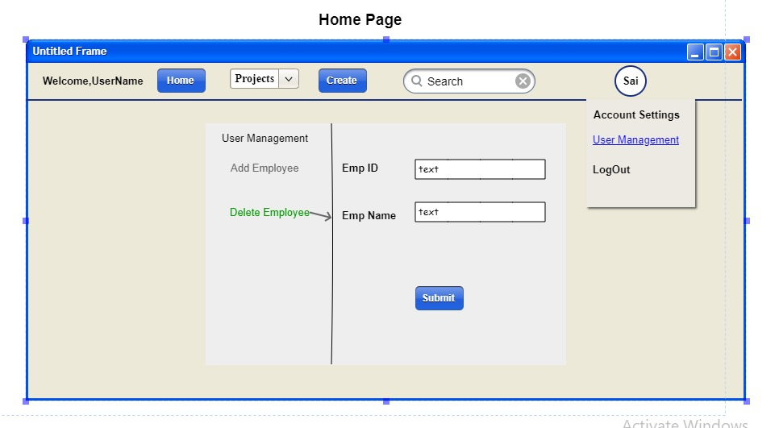

If Admin click on ‘Delete Employee’ he will display ‘Emp ID’, ‘Emp Name’ and ‘submit button’, admin can add required details to delete access form ‘jeera application’.

**3.4 Jeera Board**

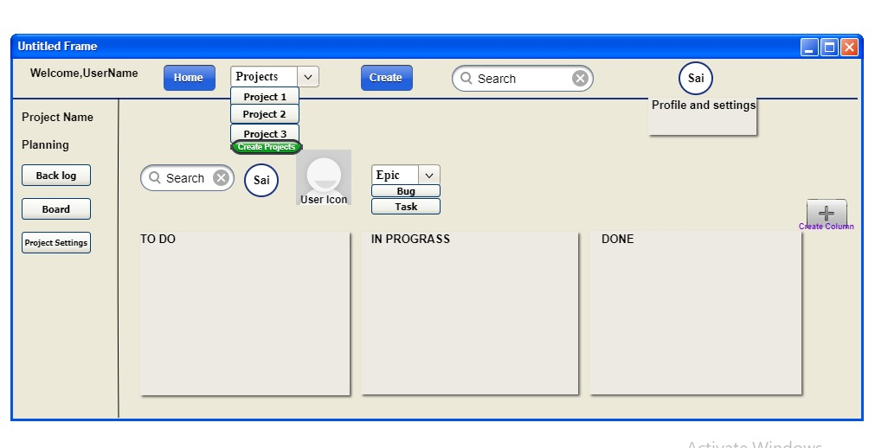

If Admin selects the particular project, it should display "Planning Phase " where user can able to view "Backlog”, "Board" and “Project Settings “on the left side of the bar. user icon, Epic, To Do, In Progress and Done will be display on right side of the bar. If user select particular project user will also display the same page.

**3.4.1 Providing Access to User:**

Admin will select particular project to give access for particular employee. In the board section we find user icon button. After logging in by valid credentials

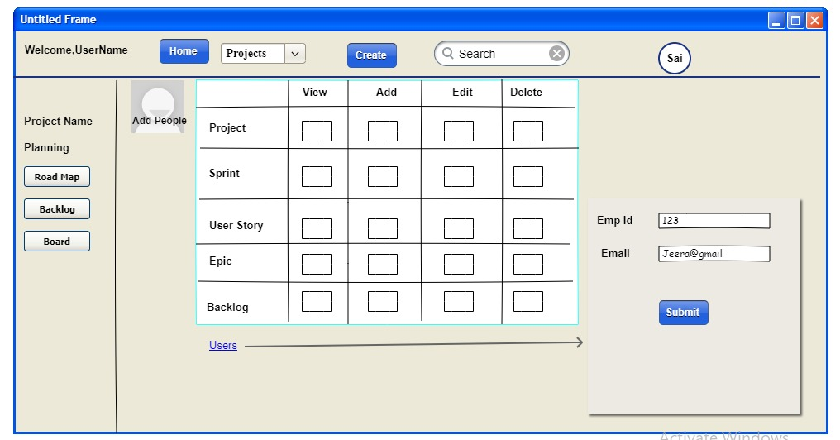

By clicking on user icon button, we are going to display the above screen. Where admin can provide access to that participants to create, view, edit or delete the projectt. After entering their respective id and email user gets assigned to the project where user can perform the tasks for which user got accessed to do. (From admin)

**3.4.1 Backlog**

**3.4.1 a Create and Edit Sprint**

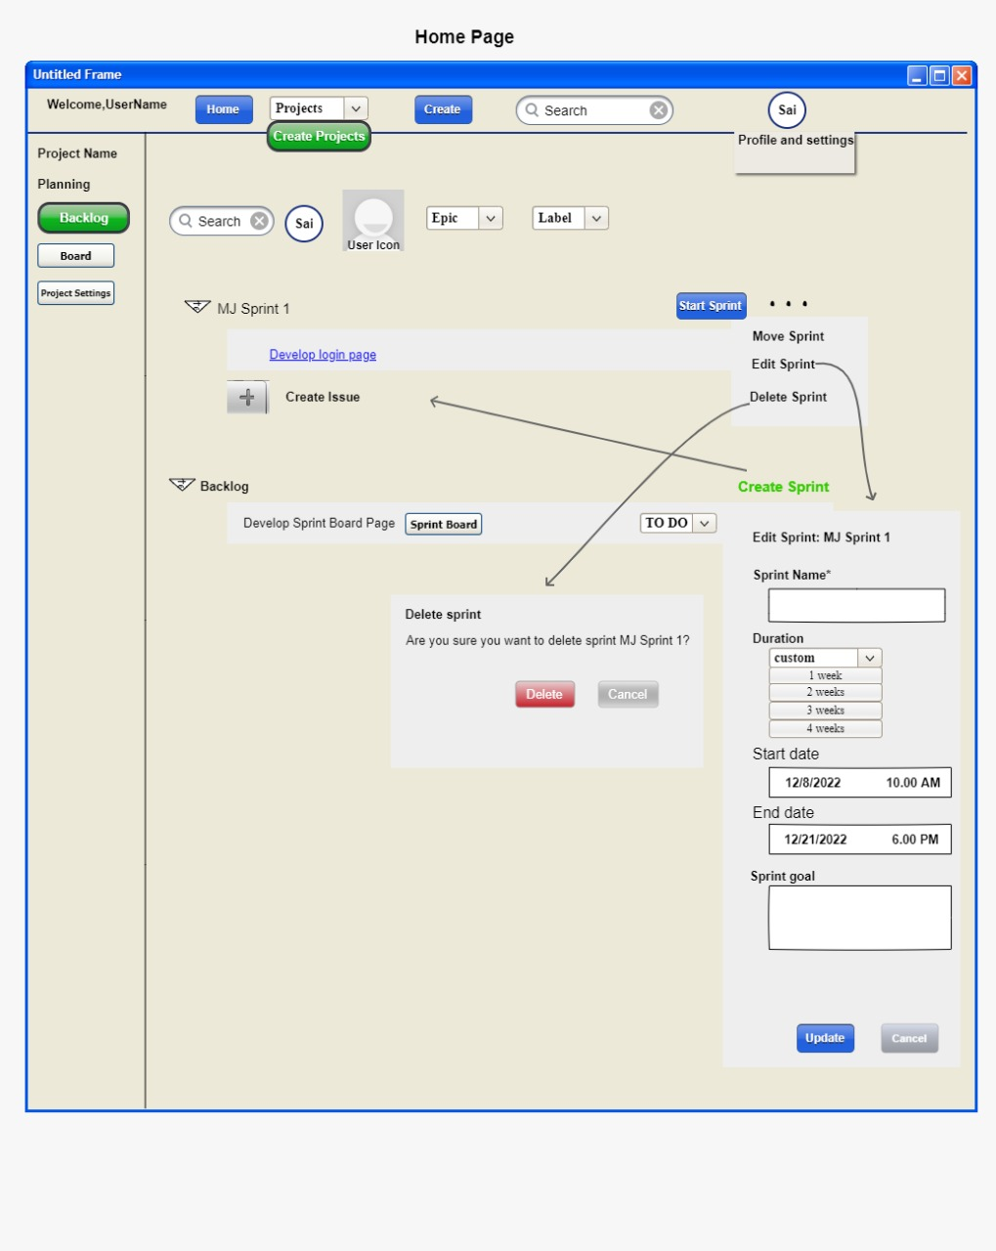

If Admin clicks on Backlog button he will create sprint, if he clicks on create sprint, he will get Backlog and create issue. User can start creating the user story and he can drop and drag the user stories sprint Board to backlog. On the right side of the screen user will display start sprint and beside to that he will have Meatball menu. If user select start sprint the sprint will be started. If user click on Meatball menu, he will get move sprint, edit and delete sprint. If user click on edit sprint, he will get a pop up for editing the sprint which contains project name, sprint name, duration, start and end date, sprint goal and below we see update and cancel button. In sprint name we need to select the sprint name, in duration we need to click on custom drop down there we need to select the duration. Which auto generate the dates of given duration in sprint goal we need to add valid points and click on update button. If user click on delete sprint where user can delete the sprint.

User Story:

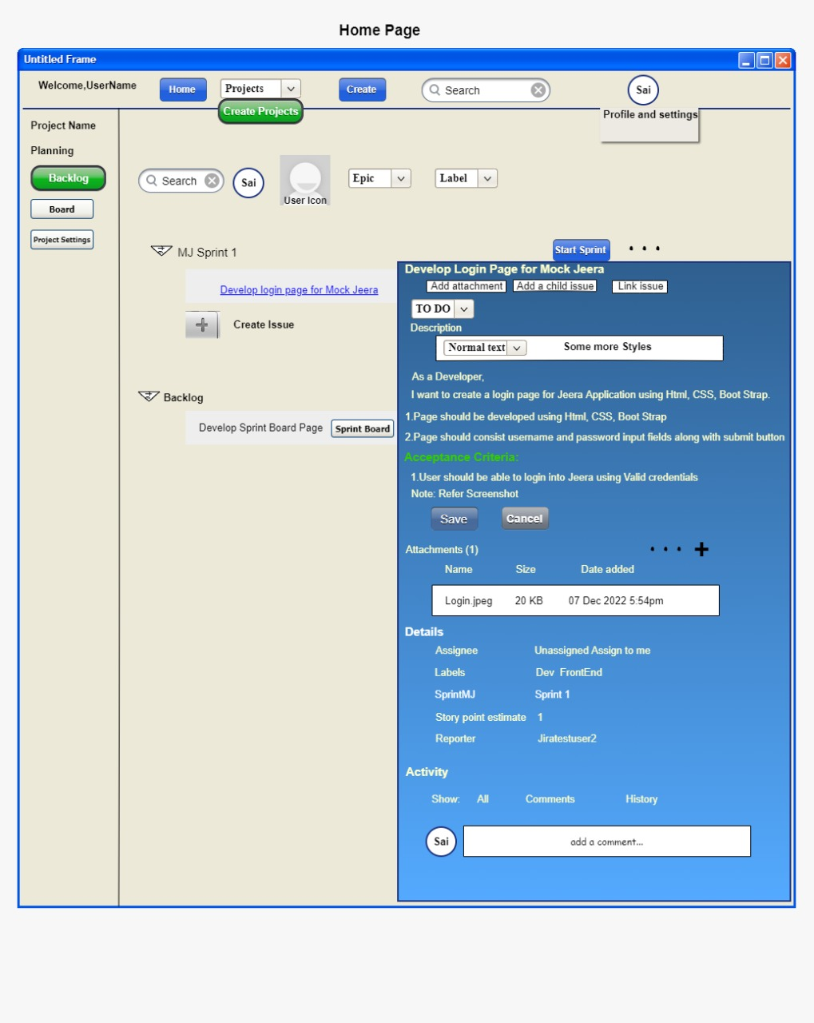

If Employee click on particular user story, he will get a pop up which displays the Description, Acceptance criteria above to that we have To Do drop drown. In below we have Attachments, details of that current sprint which display ‘labels’, ‘sprint name’, ‘story points estimated’ and ‘report’. and we have activity which display ‘All’, ‘Comments’ and ‘History’.

**3.4.2 Board**



**3.4.3 Project Setting:**

**We can manipulate the project settings by viewing, deleting and assigning the project to the concern person.**



