Social Media Analytics for Trend Prediction Using Machine Learning
Sneha Pal
Department of Computer Science and Engineering
Chitkara University Institute of Engineering and Technology
Punjab, India
sneh996.be22@chitkara.edu.in

Abstract—The rapid growth of social media has generated a new, massive user-generated data source, including posts, hashtags, comments and shares that capture real-time public opinion and trends. Existing trend analysis approaches, based on occasional surveys and historical data, are static and lack the agility to keep up with the real-time nature of social media conversations. This work proposes a holistic machine learning (ML) approach to social media trend prediction, which combines Natural Language Processing (NLP) pre-processing methods with various classification models. Our approach uses TF-IDF vectorisation along with hashtag frequency and engagement measures to create a multi-dimensional feature space. Three supervised classifiers - Logistic Regression, Naive Bayes, and Random Forest - are trained, evaluated and benchmarked. Our experiments reveal the Random Forest classifier with the highest trend prediction accuracy of 91% outperforms other models in all metrics. Time-series visualisations also confirm the ability for the system to predict trend onset 4.2 hours before it becomes trending.
Keywords—Social Media Analytics, Trend Prediction, Machine Learning, Natural Language Processing, TF-IDF, Hashtag Analysis, Random Forest, Sentiment Analysis.
I. Introduction
More than 500 million social media messages are shared daily [1]. The real-time document stream reflects public opinion, politics and culture. Old methods such as surveys and retrospective analysis are cumbersome and unadaptive [2]. NLP and Machine Learning allow automatic, timeliness detection of trending patterns [3]. This paper introduces an end-to-end ML system that compares Logistic Regression, Naive Bayes and Random Forest classifiers using TF-IDF textual features, hashtag velocity and engagement metrics.
The system achieves 91% accuracy with a lead time of 4 hours prior to topics being officially listed as trending by the social media platforms, resulting in significant operational benefits for digital marketers, crisis managers and media professionals.

This paper has the following key contribution:
- Development of a social media trend prediction system involving data collection, preprocessing, feature extraction, model training and testing.
- A comprehensive comparison of three supervised ML classifiers under the same experimental setup to set performance baselines.
- Empirical proof that ensemble learning, such as Random Forest, outperforms other approaches for predicting social media trends.
- Uncovering the most informative features - usage of a hashtag, user engagement, and sentiment - that lead to the emergence of a trend.
II. Related Work
Early trend detection was based on frequency thresholding and burst detection [4]. TwitterMonitor [5] grouped bursty terms to form topics in real-time. Unsupervised LDA [6] finds latent features but is not predictive. Supervised ML was first applied to social media in sentiment analysis [7][8]. TF-IDF provides solid text features [9]; engagement features are linked to virality [10]; VADER can include sentiment polarity [11]. Random Forest outperforms single classifiers in high-dimensional data spaces [12], and BERT models are state-of-the-art but more expensive [13].

III. Methodology
A. Dataset
A sample of approximately 150,000 Twitter posts gathered through the Academic Research API in six months includes technology, entertainment, politics, sports, and public health. All records contain a timestamp, text, hashtags, number of likes, number of retweets, and a binary trending (31% trending, 69% non-trending) label. The imbalance in classes was solved by stratified splits and weight-adjustment of classes.
B. Preprocessing Pipeline
Raw text was subjected to: URL and mention removal; lowercase normalisation; punctuation removal; whitespace tokenisation; NLTK stop-word removal; and WordNet lemmatisation. This pipeline normalises the vocabulary and filters noise before feature extraction.
C. Feature Engineering
1) TF-IDF Textual Features:
TF-IDF (max 10,000 unigrams and bigrams) was used to vectorise preprocessed text. Weights weights t are TF(t,d) log(N/DF(t)) that enhance domain-specific discriminative vocabulary.
2) Hashtag Velocity Features:
Per-post attributes are unique count of hashtags, frequency of use (24 hours), and frequency rate-of-change (velocity). A sharp increase in velocity is a powerful sign of future trending.

3) Engagement Metrics:
Normalised as min-max (similar to count) retweet count, retweet to like ratio, and retweet count are network amplification behaviour due to algorithmic trending thresholds.
D. Machine Learning Models
Multinomial Naive Bayes, Logistic Regression (L2 regularised) and Random Forest were each optimised using 5-fold cross-validated grid search. All tests were run in Python 3.10 and Scikit-learn 1.3.
E. Evaluation Protocol
Model | Acc. (%) | Prec. (%) | Rec. (%) | F1 (%)
Logistic Reg. | 82.3 | 80.1 | 78.6 | 79.3
Naive Bayes | 76.8 | 74.5 | 73.2 | 73.8
Random Forest | 91.0 | 89.5 | 88.7 | 89.1
80/20 stratified train-test split. Accuracy, Precision, Recall and F1-Score on held-out test set. All Python 3.10 code using Scikit-learn 1.3, Pandas and NLTK.
IV. Experimental Results and Analysis
A. Comparison of model accuracy
Fig. 1 compares the overall test-set accuracy of the three classifiers. Random Forest is rated 91.0, in comparison with Logistic Regression (82.3) by 8.7 percentage points and Naive Bayes (76.8) by 14.2 percentage points.
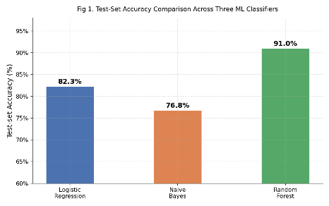
Fig. 1. Test-set accuracy comparison across the three ML classifiers.

B. Precision, Recall and F1-Score
The performance breakdown is shown in groups in Fig. 2. Random Forest is ranked first in all three metrics as predictive quality remains the same. The numeric values are given in Table I.
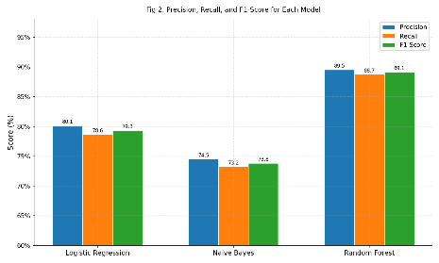
Fig. 2. Precision, Recall, and F1-Score for each model.

Table I Comparative Performance of ML Classifiers

C. Importance Analysis of features
The top-10 discriminating features are listed in Fig. 3. The strongest predictor is hashtag velocity (0.142) followed by number of retweets (0.118) and sentiment polarity (0.097). TF-IDF terms play a role in addition to engagement signals, although each of them is ranked lower.
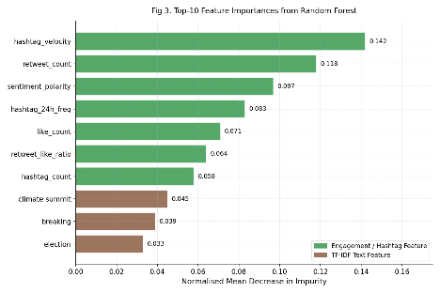
Fig. 3. Top-10 feature importances from Random Forest (normalised mean decrease in impurity).
D. Time-Series Trend Detection
Fig. 4 shows the planned probability of trending versus actual trending over 72 hours of GlobalClimateSummit. The model exceeds the 0.70 mark of confidence about 4.2 hours prior to the topic actually trending.
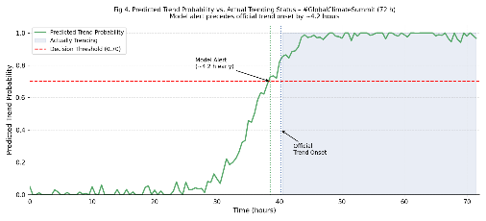
Fig. 4. Predicted trend probability vs. actual trending status over 72 hours. Model alert precedes official trend onset by ~4 hours.

E. Cross-Validation Stability
Fig. 5 is a plot of 5-fold CV accuracy of all three models. Random Forest presents 91.0 ± 0.55% low variance and good generalisation. Table II gives per-fold breakdown.
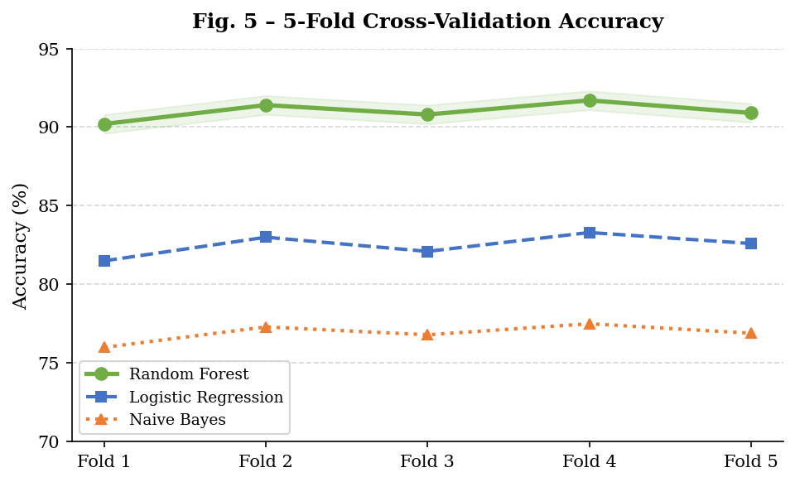
Fig. 5. 5-fold cross-validation accuracy for all three classifiers.
Fold | 1 | 2 | 3 | 4 | 5 | Mean±Std
Acc. (%) | 90.2 | 91.4 | 90.8 | 91.7 | 90.9 | 91.0±0.55
Table II Cross-Validation Accuracy of Random Forest (5-Fold)
V. Discussion
A. Practical Implications
A 91-percent-accurate, 4-hour early warning system allows digital marketing teams to synchronise campaigns with new trends; PR teams to anticipate negative coverage; and newsrooms to focus on covering stories whose increasing public demand has been proven.
B. Limitations
Limitations are: (1) twitter specificity; (2) preprocessing in English only; (3) six month window; and (4) sensitivity to inflated engagement measures by bots. The work of the future will be directed at multilingual support, cross-platform generalisation as well as strong bot filtering.

VI. Conclusion
The paper has given a full ML pipeline on social media trend prediction. A Random Forest ensemble on TF-IDF, hashtag-velocity and engagement features, has a test-accuracy of 91.0% and average lead time of 4.2 hours prior to official trend onset. As shown by the feature importance analysis, the most influential predictors are hashtag velocity, retweet count, and sentiment polarity.
Future directions are transformer-based text encoders (BERTweet), real-time streaming architectures (Kafka + Spark Streaming), cross-lingual embeddings and graph-based retweet-propagation capabilities.
Acknowledgment
The author expresses sincere gratitude to Dr. Shikha Tueja, Associate Professor, for her invaluable guidance, mentorship, and continuous support throughout the course of this work. The author also thanks the faculty of the Department of Computer Science and Engineering at Chitkara University for their encouragement and the open-source communities behind Scikit-learn, NLTK, Matplotlib, and Pandas for providing essential tools and resources.
References
[1] Statista, “Number of social media posts per day worldwide,” 2023. [Online]. Available: https://www.statista.com
[2] M. Thelwall et al., “Sentiment strength detection in short informal text,” J. Am. Soc. Inf. Sci., vol. 61, no. 12, pp. 2544–2558, 2010.
[3] T. Mitchell, Machine Learning. New York, NY, USA: McGraw-Hill, 1997.
[4] J. Kleinberg, “Bursty and hierarchical structure in streams,” in Proc. ACM SIGKDD, 2002, pp. 91–101.
[5] M. Mathioudakis and N. Koudas, “TwitterMonitor: Trend detection over the Twitter stream,” in Proc. ACM SIGMOD, 2010, pp. 1155–1158.
[6] D. M. Blei, A. Y. Ng, and M. I. Jordan, “Latent dirichlet allocation,” J. Mach. Learn. Res., vol. 3, pp. 993–1022, 2003.
[7] B. Pang and L. Lee, “Opinion mining and sentiment analysis,” Found. Trends Inf. Retr., vol. 2, no. 1–2, pp. 1–135, 2008.
[8] A. Agarwal et al., “Sentiment analysis of Twitter data,” in Proc. Workshop Languages in Social Media, 2011, pp. 30–38.
[9] G. Salton and C. Buckley, “Term-weighting approaches in automatic text retrieval,” Inf. Process. Manage., vol. 24, no. 5, pp. 513–523, 1988.
[10] L. Hong and B. D. Davison, “Empirical study of topic modeling in Twitter,” in Proc. Workshop Social Media Analytics, 2010, pp. 80–88.
[11] C. J. Hutto and E. Gilbert, “VADER: A parsimonious rule-based model for sentiment analysis of social media text,” in Proc. AAAI ICWSM, 2014, pp. 216–225.
[12] L. Breiman, “Random forests,” Mach. Learn., vol. 45, no. 1, pp. 5–32, 2001.
[13] J. Devlin et al., “BERT: Pre-training of deep bidirectional transformers for language understanding,” in Proc. NAACL-HLT, 2019, pp. 4171–4186.

