Game Design Document

Fill up the Following document

1. Write the title of your project.

HELICOBTER

1. What is the goal of the game?

To escape form the obstacles and monster it is a type of infinite game .

1. Write a brief story of your game?

In the helicopter there is gold which pilot is taking to its destination but some people behind him to take the gold and there are many obstacles that the people are making for him he just need to clear all the stages and reach the destination.

1. Which are the playing characters of this game?

* Playing characters are the ones which respond to the user based on the input from the user
* Cars, monkeys, dinos, wizards etc, are the playing characters in the game.

|  |  |  |
| --- | --- | --- |
| Number | Character Name | What can this character do? |
| 1 | helicopter | It can move ,can collect powers, mystery boxes |
| 2 |  |  |
| 3 |  |  |
| 4 |  |  |
| 5 |  |  |
| 6 |  |  |
| 7 |  |  |
| 8 |  |  |

1. Which are the Non Playing Characters of this game?

* Non Playing characters are the ones which don't have an action or a behaviour when the user interacts with the game.
* Hurdles, stones, bananas, coins, etc are non playing characters in the game.

|  |  |  |
| --- | --- | --- |
| Number | Character Name | What can this character do? |
| 1 | monsters | If he touches the helicopter its speed will get high so that the player will not able to control |
| 2 | obstacles | If helicopter touches it the game will end |
| 3 | Mystery box | It has coins which will help the player to get more score |
| 4 | power | If the helicopter will get the power so if he touches any obstacle or monster the game will not end the came will continue this power will last only for 5 or 10 sec |
| 5 |  |  |
| 6 |  |  |
| 7 |  |  |
| 8 |  |  |

Draw your imagination of this game. What does this game look like?

* Draw the game either on your computer or on paper,
* Add images of scenes of the game to show each of the playing and non-playing characters at least once.



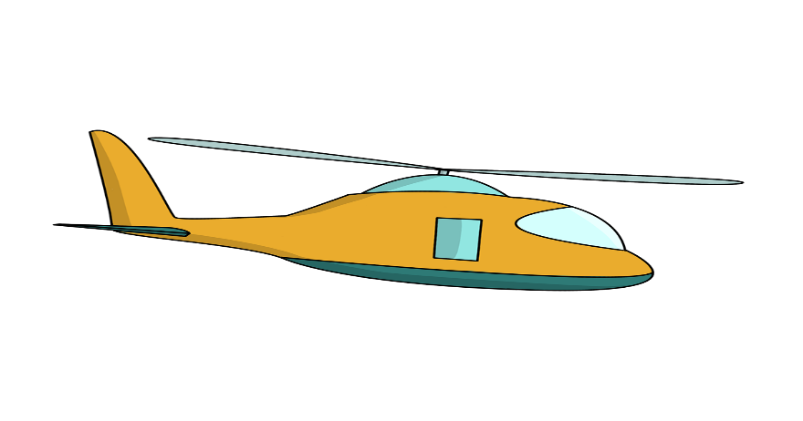

How do you plan to make your game engaging?

By adding powers and monsters and animation and making the helicopter speed high