Resume

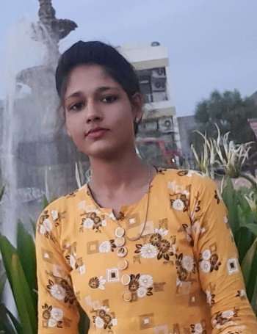
Sneha Raghuwanshi
Department of CSE
1st year student
MITS Gwalior (M.P.)
Mobile No. :- 9302970173
Email Id:23cs10sn134@mitsgwl.ac.in
Objective

Oooooo

objective

- To make our a good personality .
- To learn something new and interesting.
- To explore ourselves.
- To learn to represent ourselves in this world with full confidence

Academic Qualifications
- I am passed 10 th examination with great percentage of 94.
- I am scored 90% in 12 th examination.
- I am qualified Jee examination with 93 percentile .
- I am also qualified cuet and NSUT examination.

Area of Interest
- I like to play badminton,caroom.
- I am enjoyed the gardening.
- I am also interested in painting.

Interesting subjects and computer skills
- Computer Analysis .
- Design of Algorithm.
- Computer networks.
- Data structure.

Personal information
- Father’s Name: Ajay singh Raghuwanshi.
- Date of Birth:28.10.2004.
- Language :English,Hindi.
- Gender:Female.
- Nationality:Indian.
- Religion:Hindu.
- Category:General.

