MCA SEMESTER I
MINI PROJECT REPORT
Console Employee Record-Management Application
Python Programming & Relational Database
Assignment 1
Submitted by: Sneha Sujeesh
Roll No.: 12
Academic Year: 2026–2027

1. Introduction
The Console Employee Record-Management Application is a menu-driven Python application developed to manage employee records. The application allows the user to add, view, search, update, and delete employee records. The data is stored persistently in a JSON file so that records remain available even after the program is closed.
The project demonstrates the major Python programming concepts required for the assignment: data types and variables, conditional statements and loops, functions, exception handling, File I/O, and menu-driven console application design.

2. Objectives
- To develop a simple employee record-management application using Python.
- To implement a menu-driven console interface.
- To use functions for modular and reusable program design.
- To validate user input and handle invalid entries safely.
- To store and retrieve records using JSON file handling.
- To implement CRUD operations: Create, Read, Update, and Delete.

3. Technologies and Modules Used
Technology / Module | Purpose
Python | Programming language used to develop the application.
Json | Stores and retrieves employee records in JSON format.
Os | Checks file existence and creates the correct file path.
Re | Validates email and phone-number formats.
JSON file | Provides persistent storage for employee records.

4. Data Types and Variables
Variables are used to store and manipulate information during program execution. The project uses strings for name, department, email, and phone; integers for ID and age; lists to hold multiple employee records; and dictionaries to represent individual employee records. The dictionary contains key-value pairs such as id, name, age, department, email, and phone.
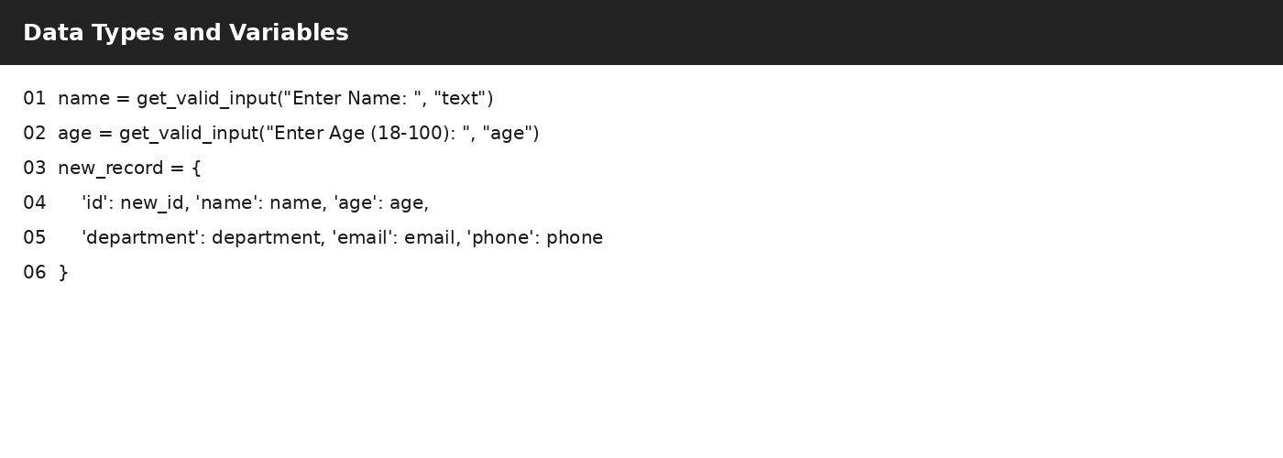
The screenshot shows variables being collected and a dictionary being created for one employee record.

5. Conditional Statements and Loops
Conditional statements control which part of the program is executed based on a condition. The application uses if, elif, and else statements for menu choices and input validation. Loops are used to repeatedly display the menu, validate input until it is correct, and search through records. The while True loop keeps the application running until the user selects Exit.
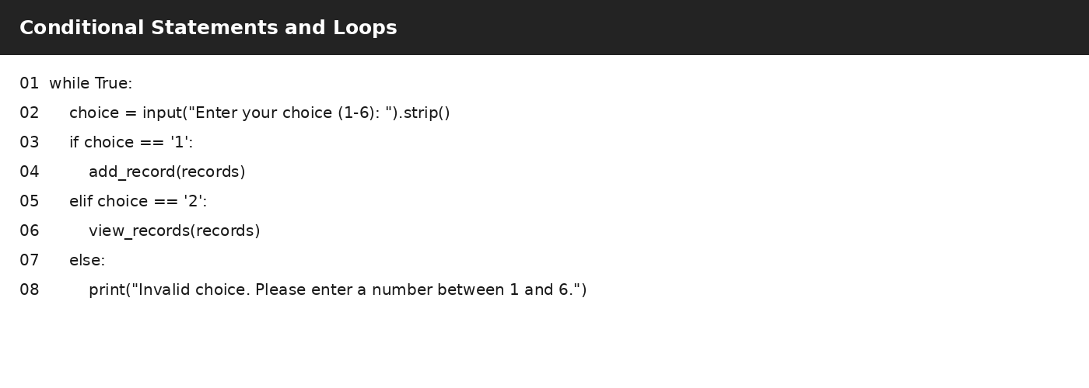
The screenshot demonstrates the while loop and if/elif/else decision structure used in the main menu.

6. Functions
Functions divide the application into smaller, organized units. Each function performs a specific task. Examples include load_data() for reading records, save_data() for saving records, add_record() for creating records, search_record() for searching, update_record() for editing, delete_record() for deletion, and display_menu() for showing the menu. This makes the program easier to understand, test, and maintain.
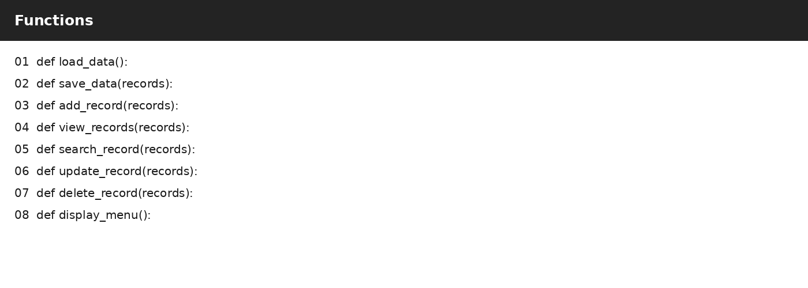
The screenshot lists the main functions used to make the application modular.

7. Exception Handling
Exception handling prevents the application from crashing when unexpected or invalid input is entered. The project uses try and except blocks. For example, when an age is converted from text to an integer, ValueError is handled if the user enters non-numeric data. File operations and JSON loading also use exception handling to deal with errors safely.
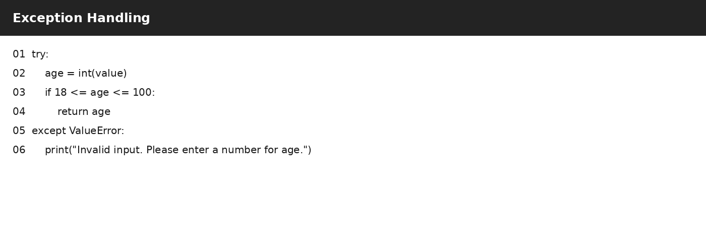
The screenshot shows a try/except block used to handle invalid age input.

8. File I/O
File Input/Output is used to make the records persistent. The application reads records from records.json when it starts and writes updated records to the same file after add, update, or delete operations. json.load() converts JSON data into Python objects, while json.dump() writes Python data into JSON format. The open() function is used with read ('r') and write ('w') modes.
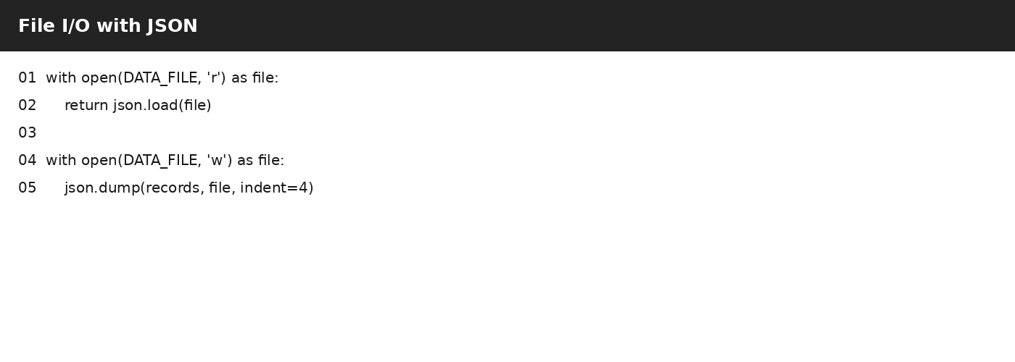
The screenshot shows JSON file reading and writing using open(), json.load(), and json.dump().

9. Menu-driven Console Application Design
The application uses a numbered console menu so that the user can select an operation. The six options are Add Record, View All Records, Search Record, Update Record, Delete Record, and Exit. The main() function repeatedly displays this menu and calls the corresponding function based on the user's choice. This provides a simple and user-friendly way to interact with the application.
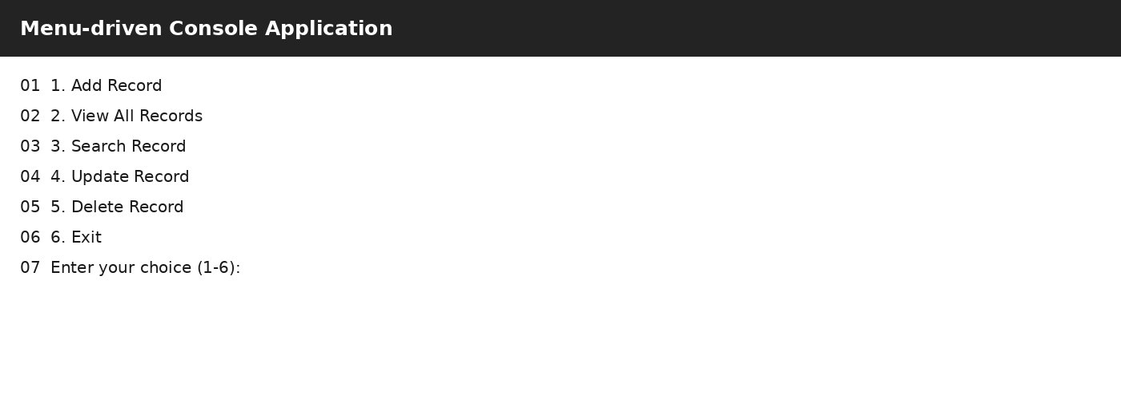
The screenshot represents the application's six-option employee record management menu.

10. CRUD Operations
Operation | Function | Purpose
Create | add_record() | Adds a new employee record.
Read | view_records() | Displays all stored records.
Search | search_record() | Finds records using ID or name.
Update | update_record() | Modifies an existing record.
Delete | delete_record() | Removes a record after confirmation.

11. Conclusion
The Console Employee Record-Management Application successfully demonstrates fundamental Python programming concepts in a single working project. It combines variables and data types, conditional statements, loops, functions, exception handling, File I/O, validation, and a menu-driven interface. The use of JSON storage also allows employee records to remain available between program executions. This project provides practical experience in developing a structured console-based application.

12. Future Enhancements
- Add a relational database such as MySQL or SQLite.
- Add login and user authentication.
- Add sorting and filtering options.
- Generate reports from employee records.
- Create a graphical user interface (GUI).

