# FriendLink

Video Chat Website Report

Sneha Ramesh Sumbe

[sumbesneha@gmail.com](mailto:sumbesneha@gmail.com)

**Abstract**

FrienLlink is an innovative video chat website designed to facilitate seamless group or one-to-one video conversations among friends. The platform aims to enhance social interactions by providing a user-friendly interface and a range of interactive features. Users can create personalised virtual rooms, where they can engage in real-time video discussions with their friends, acquaintances, or colleagues.

Key Features:

1. Group and One-to-One Video Chat: Friendlink offers the flexibility to host group video chats or engage in private one-to-one conversations, catering to various social dynamics and preferences.

2. Screen Sharing: Enhancing communication capabilities, the platform includes a screen sharing feature that allows participants to share their screens during video calls. This facilitates collaboration, presentations, and seamless content sharing.

3. Chatting Bot: To elevate the interactive aspect of the platform, Friendlink incorporates a sophisticated chatting bot. This bot is designed to initiate and engage in conversations with users, creating a dynamic and lively environment for participants.

4. Customizable Room Creation: Users can easily create virtual rooms by entering their preferred room name. In case the user does not specify a room name, the platform automatically generates a unique room name with random numbers, ensuring simplicity and convenience.

5. Room Invitation: The core functionality of Friendlink lies in its room sharing feature. Users can invite their friends to join a specific room by sharing the room name, allowing seamless entry into the conversation.

FriendLink aims to foster meaningful social connections in a fun and interactive manner. With its array of features, the platform provides a versatile solution for friends, colleagues, and various social groups to connect and engage in vibrant video interactions. As the world continues to embrace virtual communication, Friendlink stands as a valuable tool in the pursuit of fostering and maintaining genuine relationships online.

# Table of Contents

1. Introduction
2. Existing Method
3. Proposed method
4. Methodology
5. Implementation
6. Conclusion

# Introduction

FriendLink is a virtual communication platform providing a dynamic platform for interactive video chats among friends and social groups. In an era where connectivity knows no boundaries, Friendlink prioritises user engagement with an array of features, including group and one-to-one video chat options. Emphasising convenience and spontaneity, users can easily create personalised virtual rooms by entering their preferred names, while the platform generates random room names for quick connections. To enhance collaboration, participants can utilise the screen sharing feature, promoting seamless content sharing and joint activities. Additionally, the incorporation of a chatting bot adds a playful touch, initiating lively conversations to keep interactions vibrant and engaging. With its commitment to fostering genuine connections and enriching social interactions, Friendlink redefines the way we connect with friends, creating an enjoyable and accessible video chat experience for individuals from all walks of life.

# Existing Method

There were several existing systems and platforms that provided video chat services. Some of the well-known ones included:

1. Zoom: Zoom gained immense popularity during the COVID-19 pandemic as it became a primary choice for virtual meetings, webinars, and online gatherings. It offered video conferencing, screen sharing, chat functionality, and the ability to create and join virtual meeting rooms.
2. Skype: Skype has been one of the pioneers in video chat and online communication. It allowed users to make free video and voice calls, send instant messages, and share files. Skype was widely used for both personal and business communication.
3. Google Meet: Google Meet, part of Google Workspace (formerly G Suite), offered video conferencing capabilities for businesses and educational institutions. It integrated seamlessly with other Google services and allowed for easy scheduling and joining of virtual meetings.
4. Microsoft Teams: Microsoft Teams is a collaborative platform that includes video conferencing as one of its core features. It allowed users to create teams, schedule meetings, and collaborate on documents, making it popular among businesses and remote teams.
5. FaceTime: FaceTime is an exclusive video chat service for Apple devices. It allowed Apple users to make video and audio calls to other Apple devices over Wi-Fi or cellular data.
6. Facebook Messenger: Facebook Messenger offered video calling capabilities within its messaging app, allowing users to have face-to-face conversations with their Facebook friends.
7. WhatsApp: WhatsApp, a widely used messaging app, also supported video calls. It enabled users to make free video calls to their contacts, making it a popular choice for personal communication.

# Proposed Method

Unlike conventional video chat systems that typically require authentication or registration, FriendLink offers a refreshingly user-friendly approach. Dispensing with the need for complex sign-ups, users can effortlessly join video chats by simply entering their name and the designated room name. This streamlined process enables quick and seamless connections, setting FriendLink apart from platforms like Zoom and Google Meet. Despite its user-friendly interface, FriendLink doesn't compromise on functionality. Users can engage in video and voice chats, making it ideal for both one-on-one conversations and group interactions. Moreover, the platform enriches communication through features like screen sharing and an interactive chatting bot, enhancing collaboration and fostering a dynamic environment for users to enjoy. With FriendLink, the emphasis is on easy accessibility without sacrificing the versatility of a robust video chat platform.

# Methodology

1. Requirement analysis
2. UI/UX Design
3. Development and Implementation of WebRTC
4. Adding functionalities
5. Screen-sharing
6. Chat bot
7. Additional improvements
8. Continuous improvement depending upon feedback

* Tech Stacks used-

1. HTML
2. CSS
3. Javascript

# Implementation

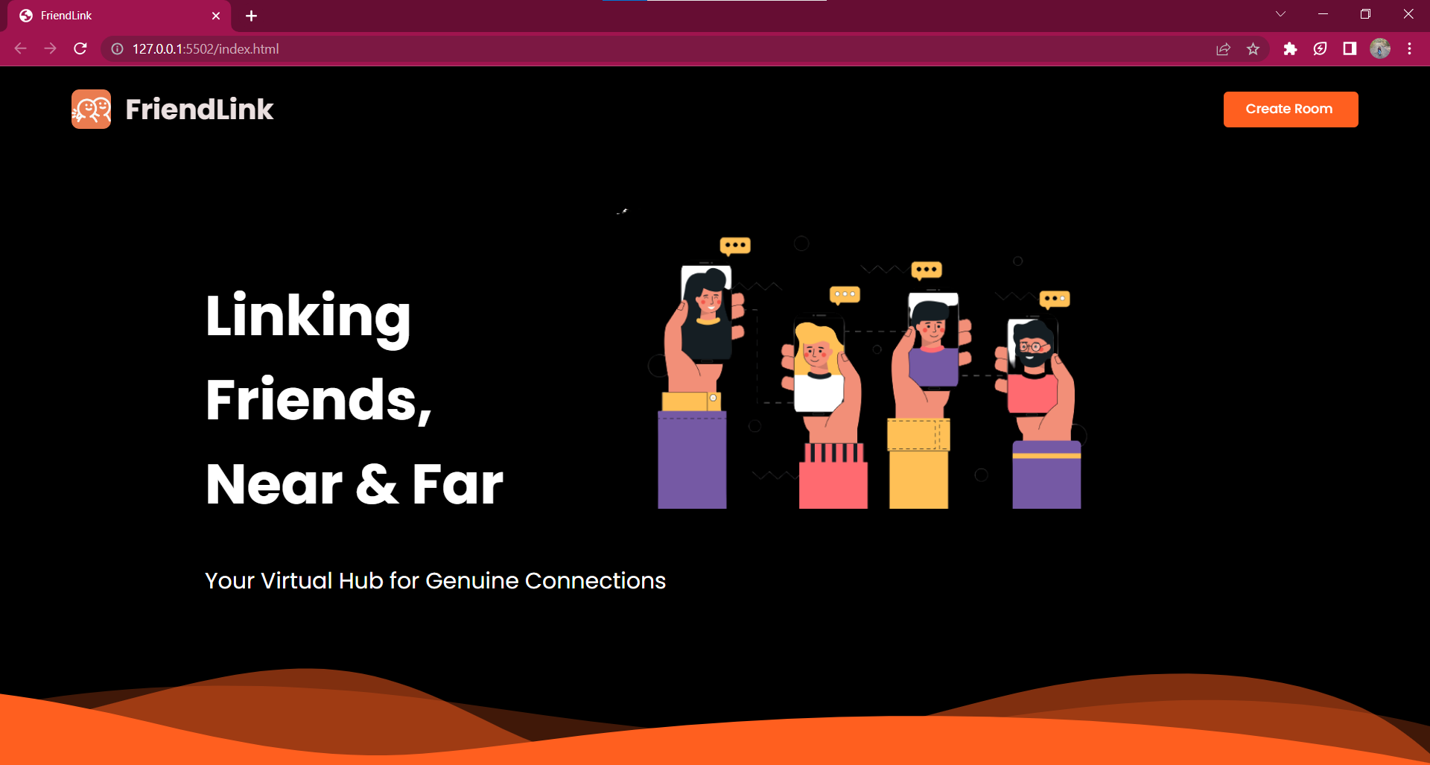

Fig.5.1: Home Page

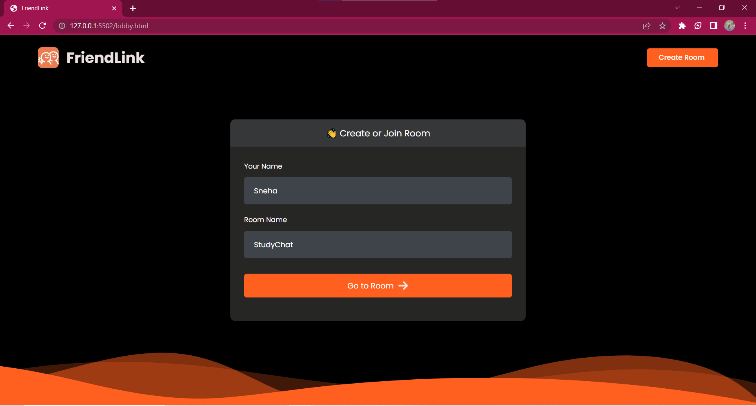

Fig.5.2: Create or Join Room Page

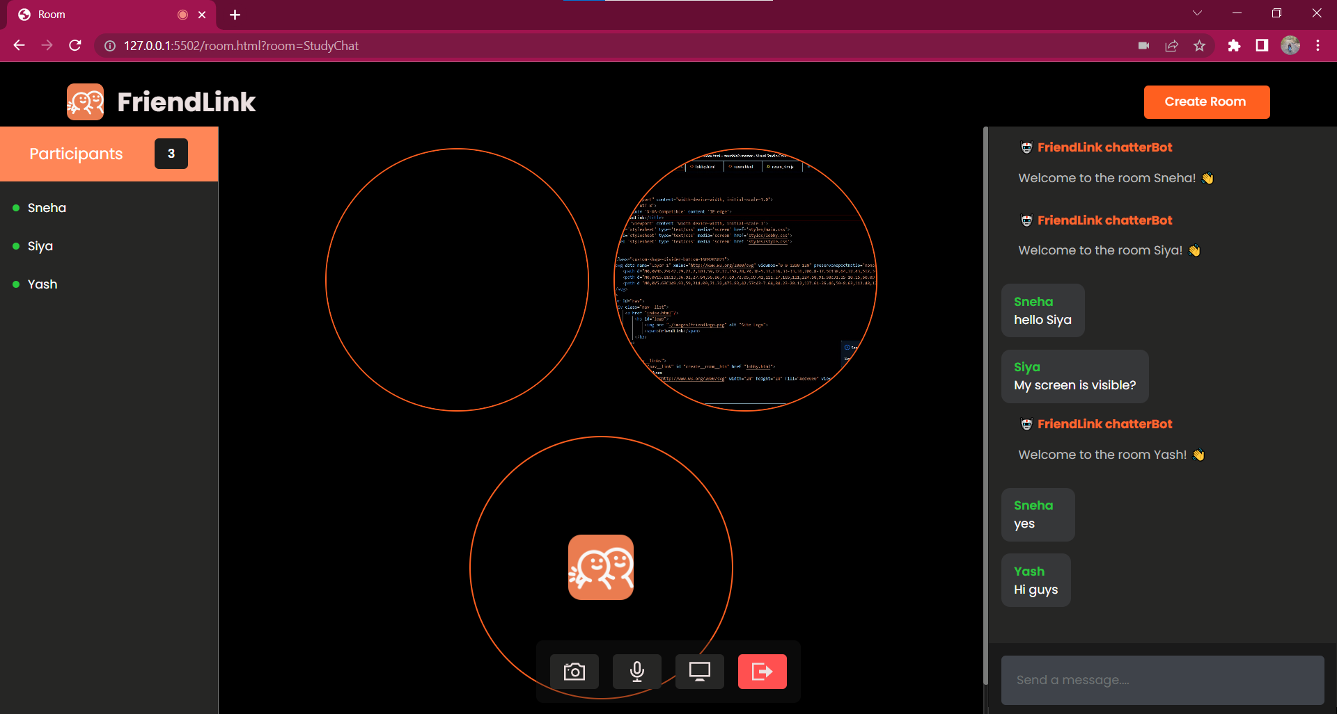

Fig.5.3: Room Interface

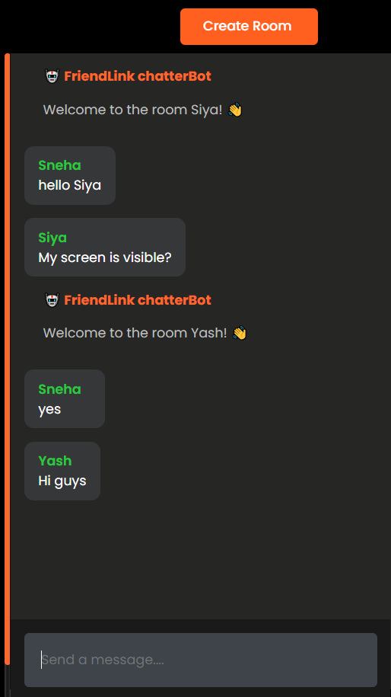

Fig.5.4: Chatting Bot Fig.5.5: Participant’s name

# Conclusion

The development of FriendLink is a user-friendly video chat platform, throughout the development process, special attention was given to the platform's interface and design, ensuring that it remains accessible and enjoyable across different devices. The integration of cutting-edge technologies, such as WebRTC, allowed for high-quality video and voice communication, promoting fluid interactions among users during one-on-one or group chats. Additionally, the implementation of screen sharing and an interactive chatting bot enriched the communication experience, enhancing collaboration.