**Front-End UI/UX Development**    
   
   
**Front-End UI/UX Development Mini Project**    
   
   
**UI/UX DESIGN FUNDAMENTALS**

**Submitted by:**

|  |  |  |  |  |
| --- | --- | --- | --- | --- |
| **SR.NO** | **NAME** | **REGISTER**  **NUMBER** | **COLLEGE EMAIL ID** | **CLASS** |
| 1. | SNEHA | 2462365 | sneha.t@btech.christuniversity.in | 3BTCS DS |
| 2. | VIKASINI CHANDRAKUMAR | 2462373 | vikasini.chandrakumar@btech.christuniversity.in | 3BTCS DS |
| 3. | RAKSHWANTH.K | 2462352 | Rakshwanth.k@btech.christuniversity.in | 3BTCS DS |

**Instructor Name**: Miss. Nagaveena

**Institution Name:** Christ (Deemed to be University),Bangalore.

**Date of Submission:**13/08/2025

**PERSONAL DIARY UI**

**(Notebook Theme)**

**1.Abstract**

This project is a personal diary web application designed with a notebook-themed user interface using only HTML and CSS. It allows users to log in and write daily entries with date and month selection, mimicking the appearance of a real physical diary. The design uses a cursive font, paper-like textured background, and a spiral binding effect to create an authentic journal feel. The project focuses on creativity in layout design and visual aesthetics while maintaining a clean, user-friendly interface. This application provides a simple yet engaging way to document daily thoughts and events without requiring any backend or database integration.

**2.Objectives**

* To design a diary-style journal interface using only HTML and CSS.
* To create an aesthetically pleasing, notebook-like layout with page textures and spiral binding effects.
* To allow users to input and save daily entries with date and month selection (static storage).
* To enhance creativity in font usage, background textures, and overall UI styling.
* To ensure the design is simple, readable, and user-friendly.

**3.Scope of The Project**

* **Included**:
  + Login page with username and password fields.
  + Diary entry page with date and month dropdowns and a text area for writing.
  + Spiral notebook visual effect and paper-like background texture.
  + Visual confirmation message upon saving an entry (static).
* **Not Included**:
  + Real-time data storage or database integration.
  + Multi-user authentication system.
  + Dynamic navigation between months or years.

**5. Tools & Technologies Used**

|  |  |
| --- | --- |
| Tool/Technology | Purpose |
| HTML5 | Markup and content structure |
| CSS3 | Styling and layout management |
| VS Code | Code editor |
| Chrome DevTools | Testing and debugging |
| Google Fonts (Handlee) | Decorative cursive font for handwritten feel |

**6. HTML Structure Overview**

* **login.html**
  + <head>: Title, meta tags, font imports, linked CSS.
  + <body>: .container holding logo, heading, form inputs (username, password), and submit button.
* **diary.html**
  + <head>: Title, meta tags, cursive font import, linked CSS, inline style for saved message.
  + <body>: .container with diary title, logout link, day/month dropdowns, textarea for entry, save button, saved message text, and simple JavaScript to show confirmation.

## ****7. CSS Styling Strategy****

* External CSS files (login.css, diary.css) for separation of structure and style.
* Google Fonts for handwritten aesthetic.
* Background textures (fpg.jpg) for page-like effect.
* CSS pseudo-elements to create spiral binding effect.
* Rounded corners, box shadows, and spacing for clean UI.
* Hover effects for buttons to improve interactivity

**8. Key Features**

|  |  |
| --- | --- |
| Feature | Description |
| Spiral Binding Effect | CSS pseudo-element simulates notebook spiral holes |
| Paper-like Background | Repeating image for realistic texture |
| Static Login Page | Basic username/password inputs |
| Date & Month Selectors | Dropdowns for easy date logging |
| Save Confirmation Message | Displays a message after clicking "Save Entry" |

**9. Challenges Faced & Solutions**

|  |  |
| --- | --- |
| Challenge | Solution |
| Creating spiral effect in CSS | Used ::before pseudo-element with repeating-radial-gradient |
| Making texture cover container | Applied background-size: cover and repeat settings |
| Centering container vertically | Used flexbox on body for alignment |

## ****10. Outcome****

The project successfully delivers a functional, visually appealing personal diary with a realistic notebook aesthetic. Users can log in, select a date, and write entries. The spiral binding and paper texture enhance the immersive design, while HTML and CSS provide a lightweight, static implementation.

## ****11. Future Enhancements****

* Implement backend for storing entries permanently.
* Add search/filter for past entries.
* Make the layout fully responsive for all screen sizes.
* Include themes (light/dark, color variations).

**12. Sample Code**

login.html:

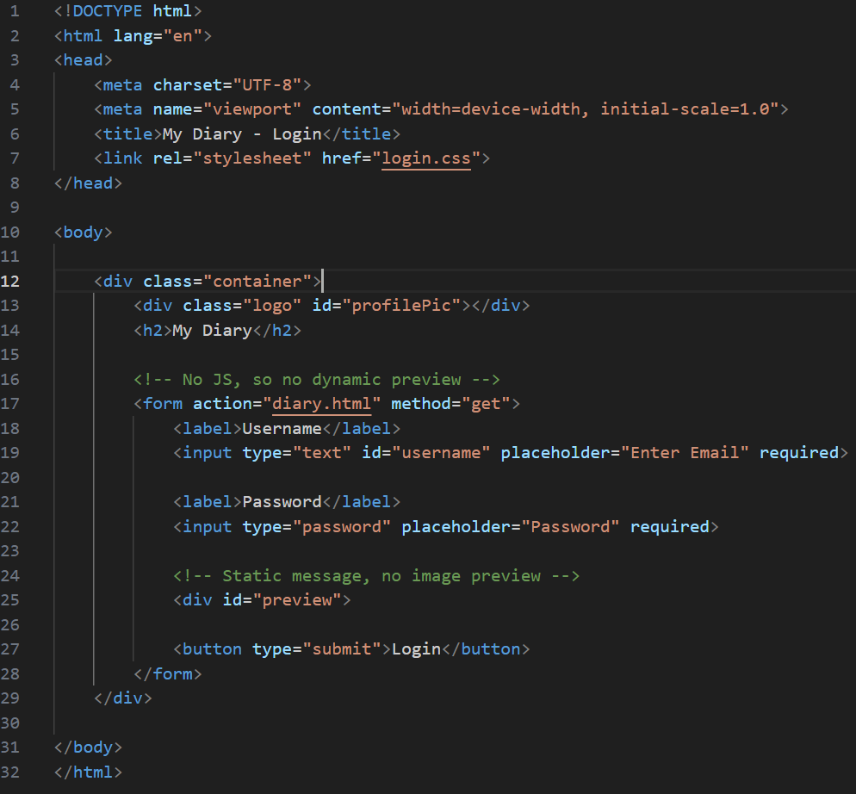 login.css: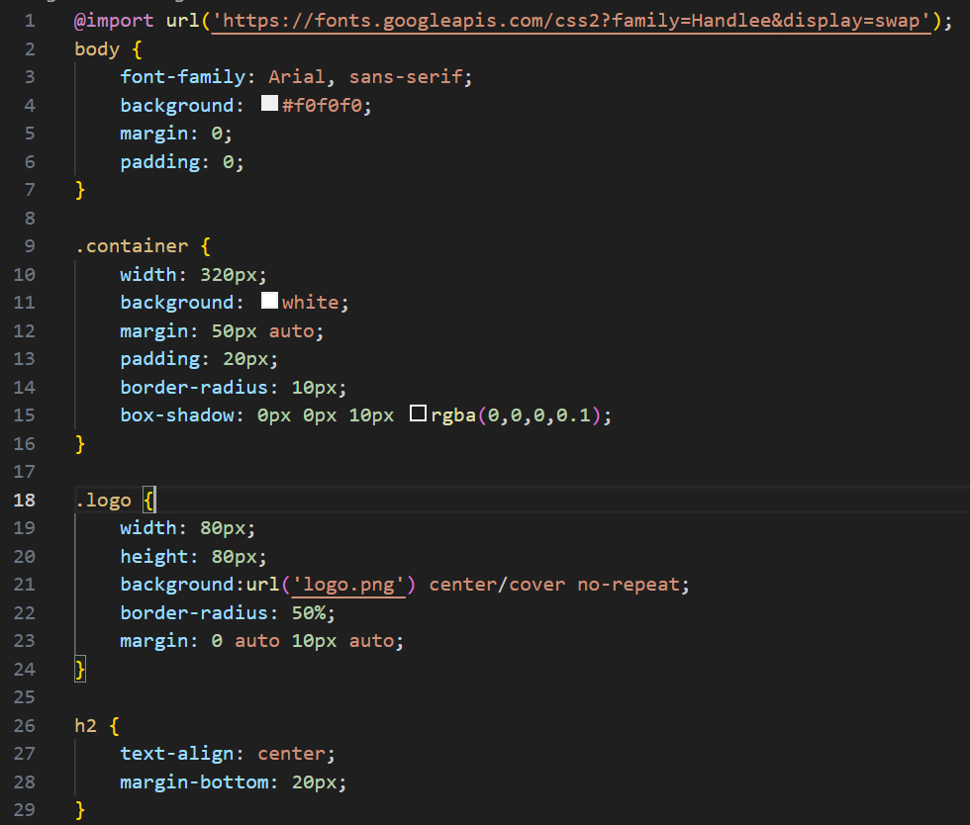

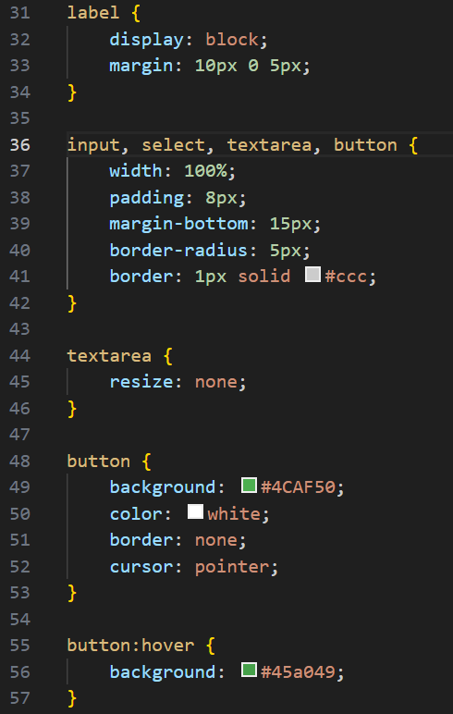

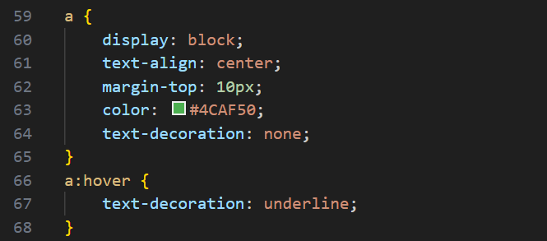

diary.html:

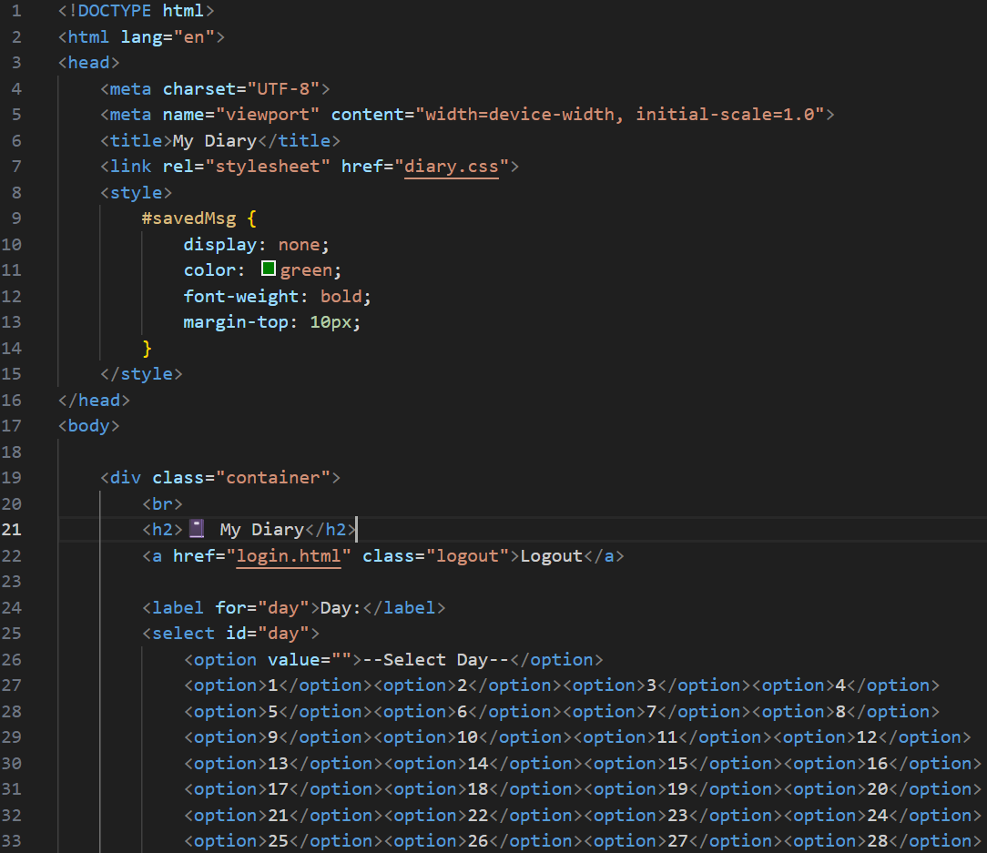

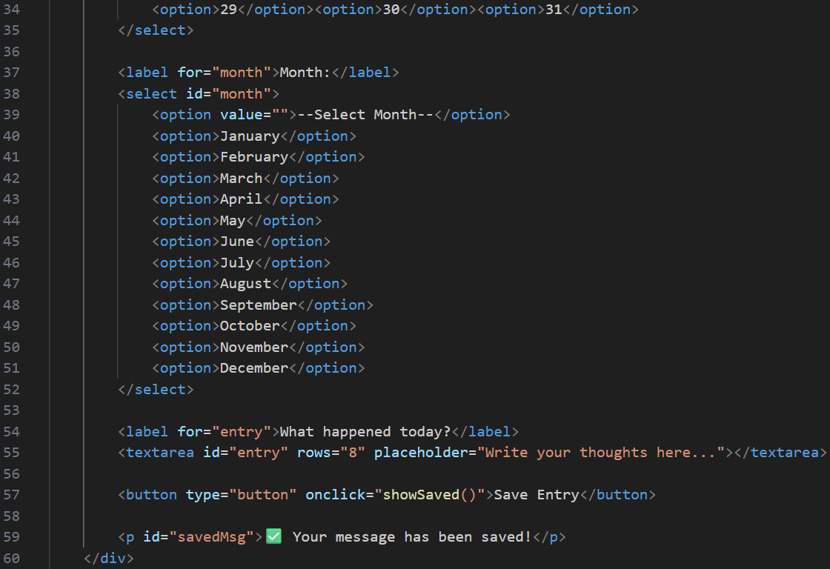

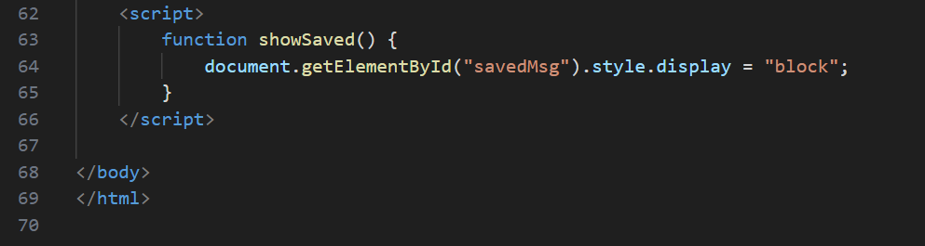

diary.css:

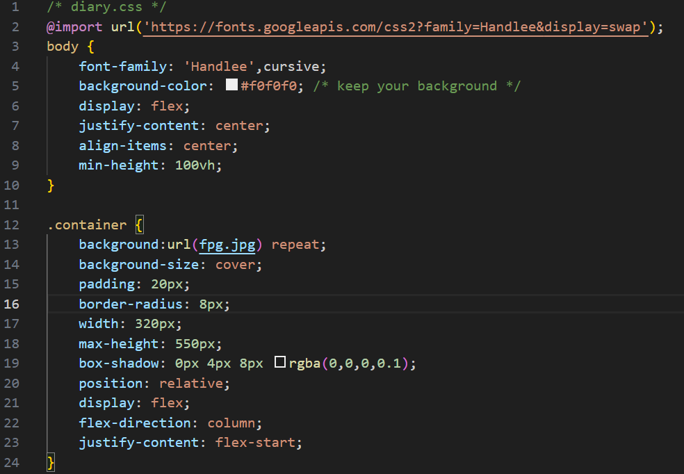

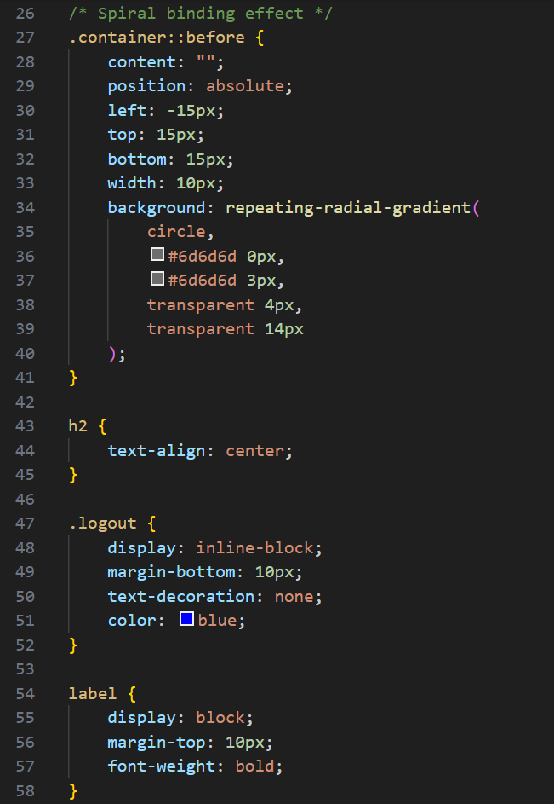

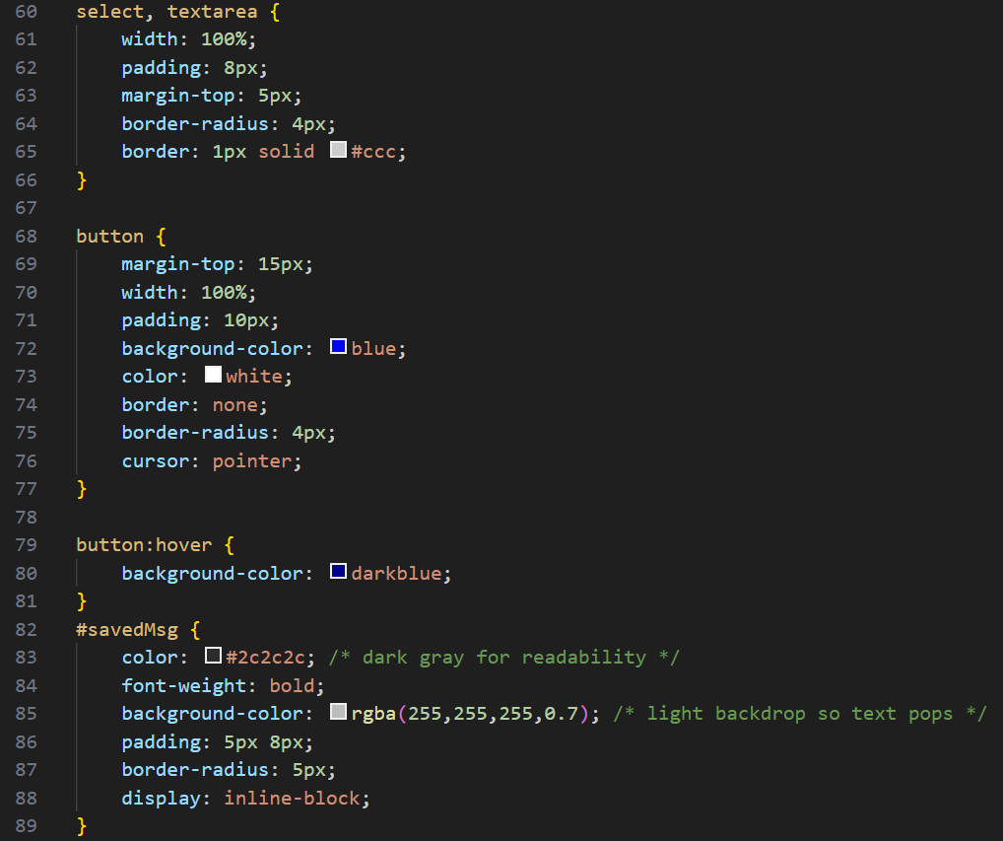

**13. Screenshots of Final Output:**

Login Page:

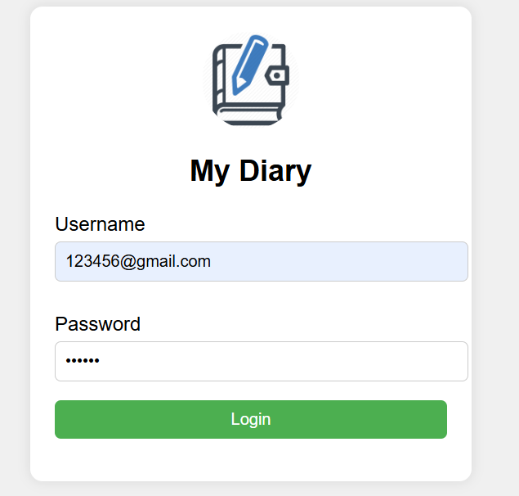

Diary page:

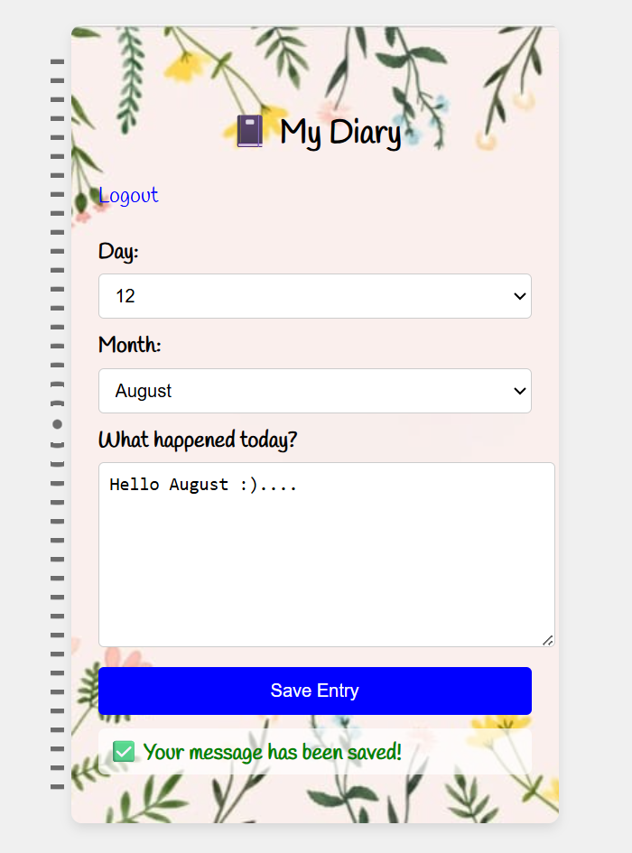

## ****14. Conclusion****

This personal diary project demonstrated how creative design can be achieved using only HTML and CSS. By combining textures, fonts, and decorative effects, the interface replicates the charm of a real notebook. The hands-on process strengthened understanding of CSS styling, layout structuring, and UI creativity without relying on JavaScript or backend technologies.