**Bootstrap**

Bootstrap is a css framework which is responsive (automatically screen will be adjusted) in different rendering to according of devices.

Popular frameworks in css community

1. bootstrap
2. Foundation
3. Polymer
4. Material

To install bootstrap,can do itin multiple ways…

* We can use by bower
* CDN(content Delivery N/w)
* Locally downloaded files

To install through Bower

Bower install bootstrap –save

(it will install and also create instance in json file)

Visual studio code

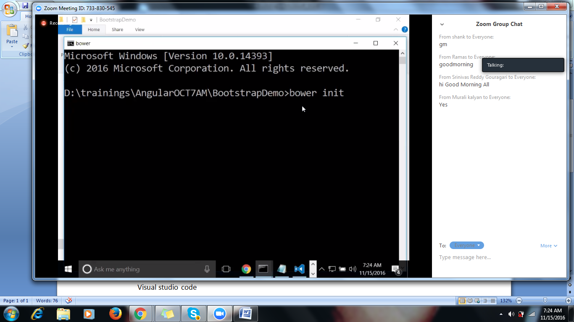

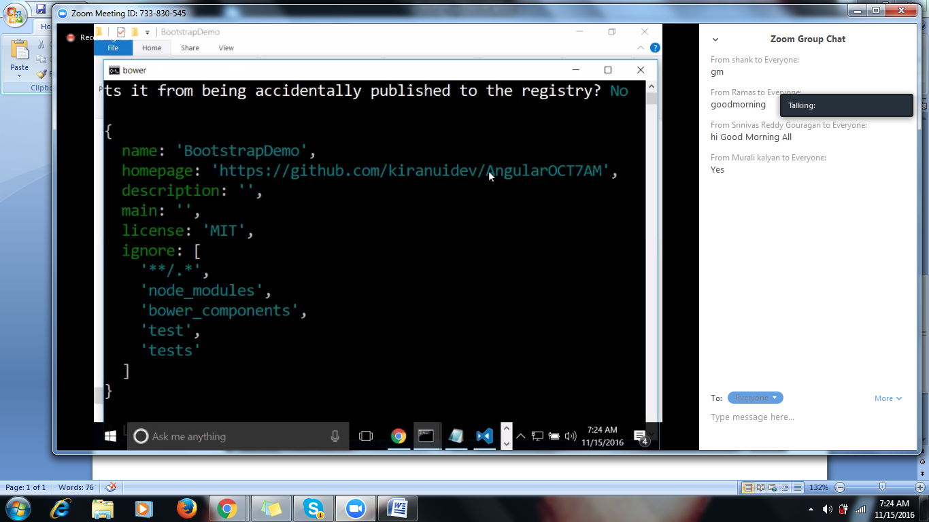

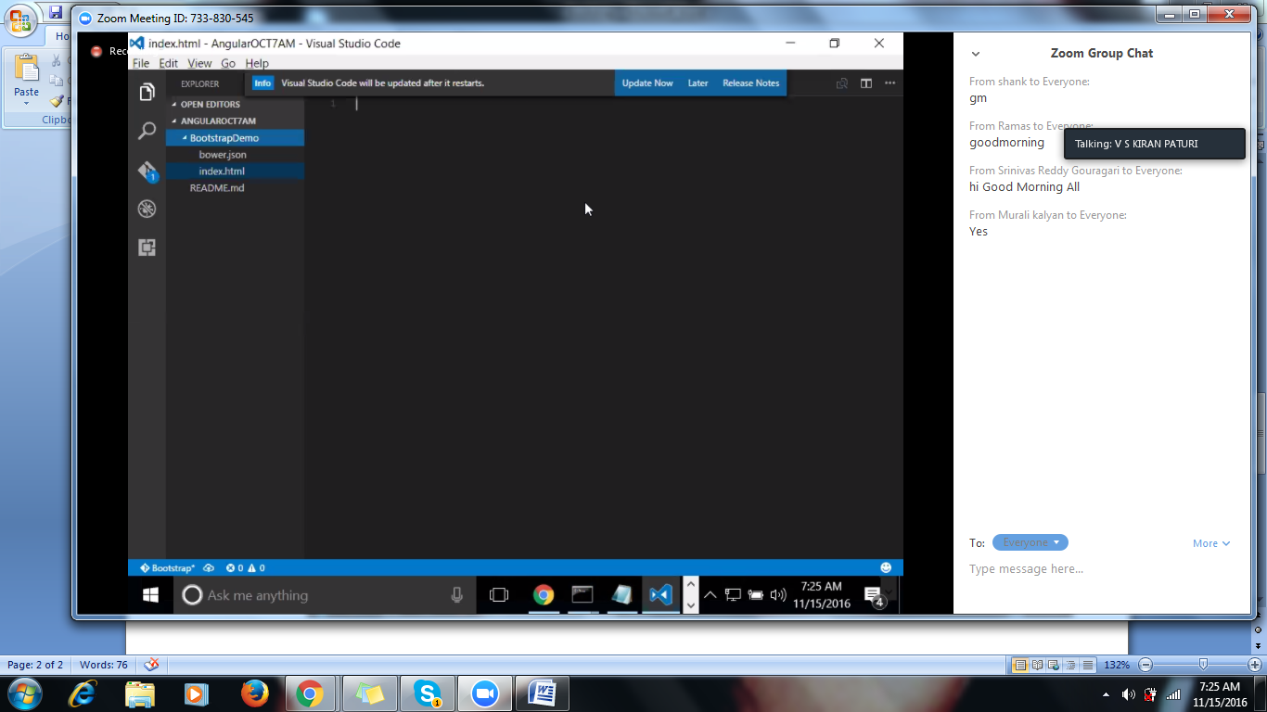

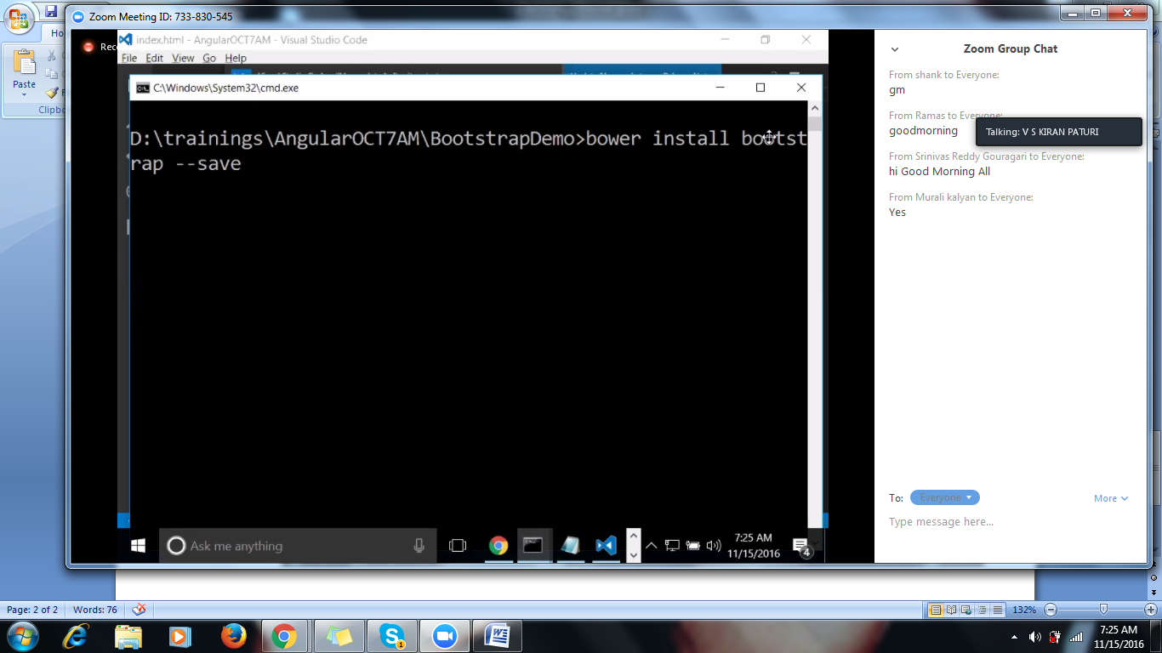

To include bootstrap we need to include 4 files

* Bootstrap.css
* Bootstrap themes.css

Above are the library files

* Bootstrap jquery
* Bootstrap js

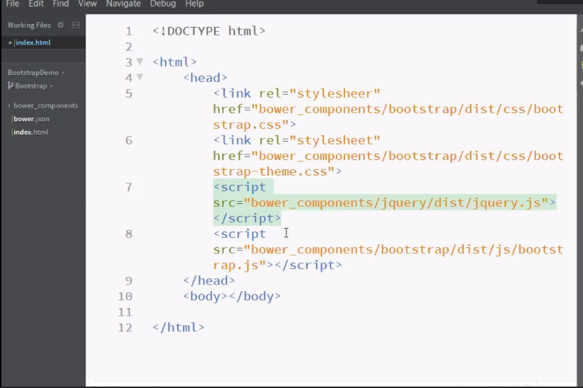

Grid System

Bootstrap follows Grid system

That means In a bootstrap grid system, Entire screen is divided to 12 equal parts.

(i.e.,

Assume screen is 100% width, each column will be 100/12=8.33

Suppose if u want to combine 2 columns i.e.,

* col- *- 2=8.33 *2=16.66%
* col- *- 3=8.33 *3=25%

Bootstrap will start with a class called **container** to wrap the functionality( It is not mandatory)

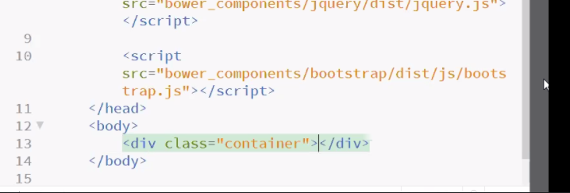

And also **container Fluid** is another class

*Tutorialrepublic.com*

For extra small devices will use col-xs (<768 px mobiles)

For small devices we will use col-sm

For medium devices we will use col-md

For Large devices we will use col-lg

Google for Less and SAAS

<div class =”rw”>

Row is a css class of bootstrap which will occupy entire screen width

In a row , there can be 12 columns can exist, If anything going beyond 12 columns ,row class will automatically align up to the next row

In bootstrap, We will use different coloring schemes,

Success will be in green color

* Danger will be in red
* Primary will in blue
* Default will be light silver

**Components:**

**Glyphicons** :Glyphicons are small icons,

**Buttons** <button class=”btn btn-primary”></button>