Views:

Named views

Nested views

Install UI router

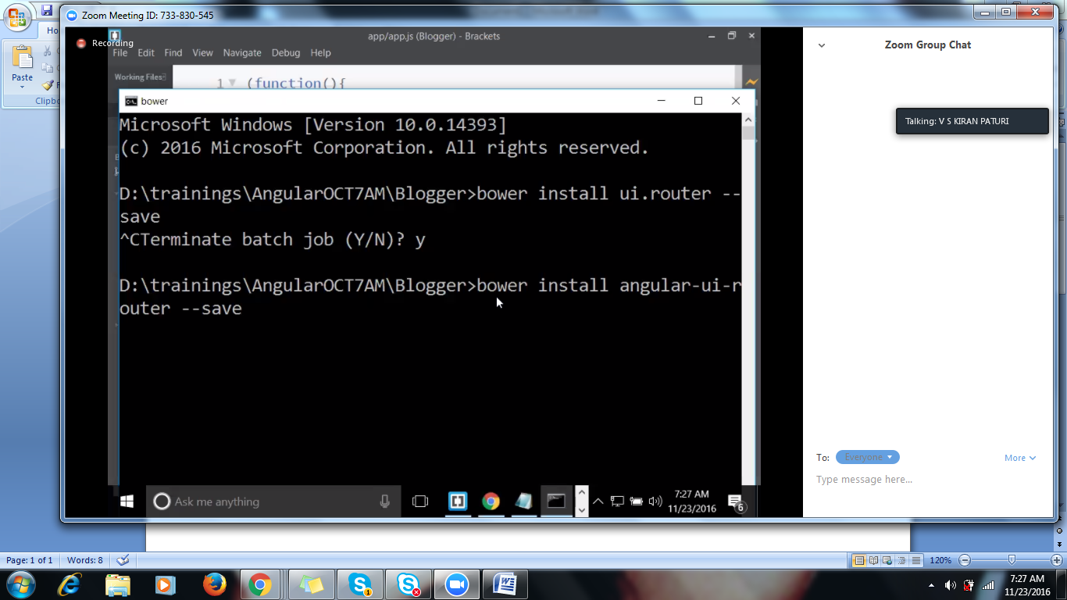

Router is 3rd party..,

Integrate UI router in application include in the application

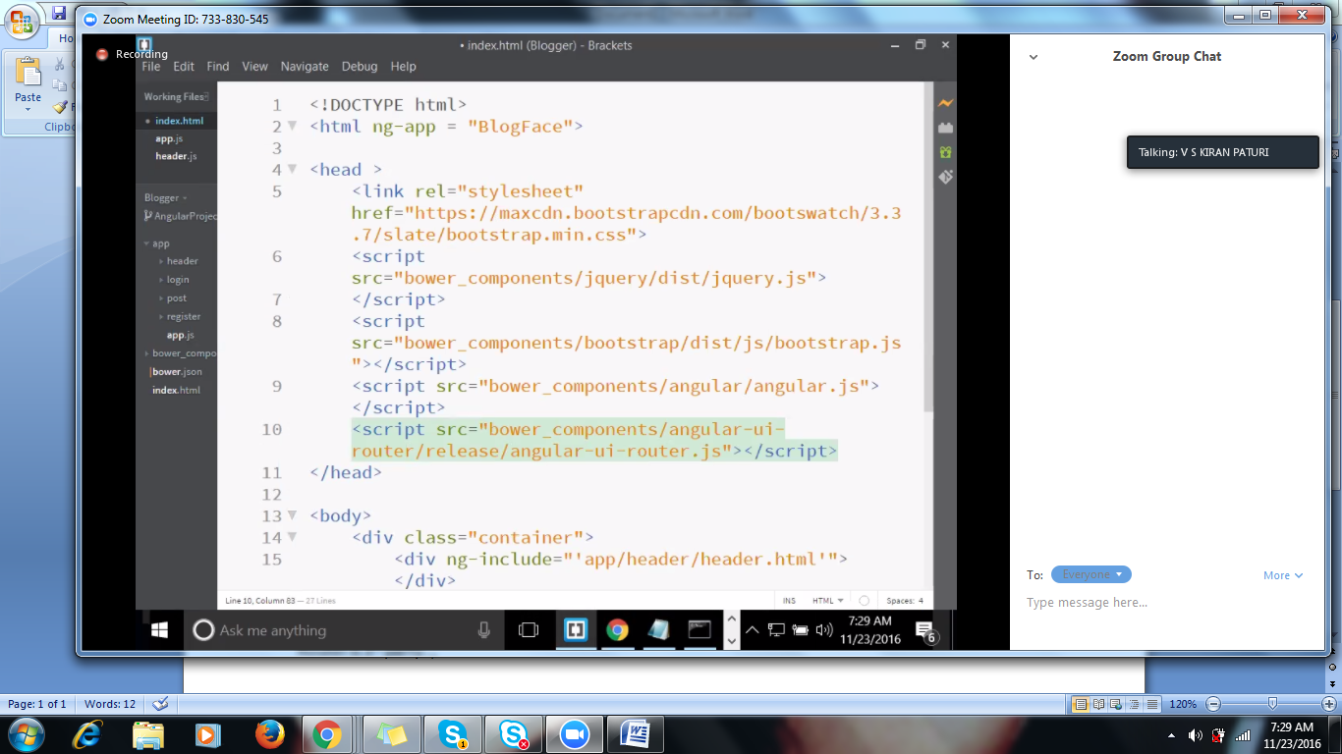

UI Router Integration

UI router comes with a module called UI.router to the main module.