**Roll no. :- 1958**

**PL305 Database Management System Lab Project Documentation**

**Topic : - Pharmacy Management System**

**Introduction**

This project is insight into the design and implementation of a Pharmacy Management System. This project consists of admin and staff side. All the management is done from the admin side like adding other staffs or deleting the records. Firstly you have to sign up in order to perform operations. When you sign up then you can view the admin dashboard. From there you can manage your all the necessary activities.

Front End : - HTML and CSS

Back End : - PHP and MYSQL

**Requirement**

* Staff members should able to login to the system.
* Admin should able to see all the data of the members.
* Admin will manage data of the staff members.

**Objective**

This project allows the shop owner to maintain his business efficiently.

**Design of System**

1. Use Case Diagram

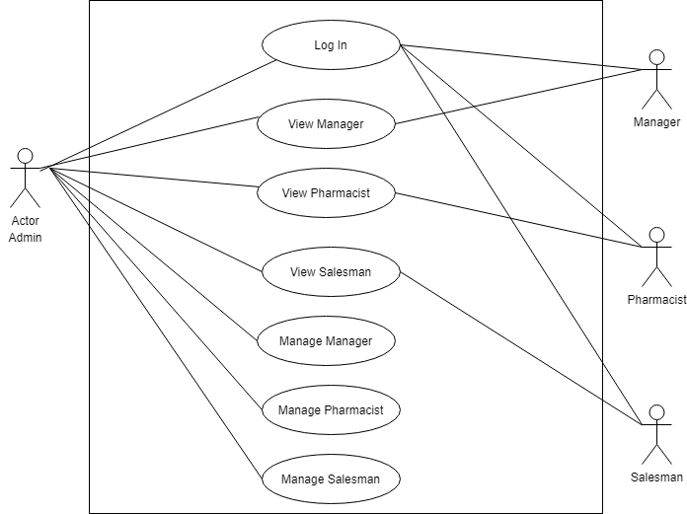

1. **ERD Diagram**

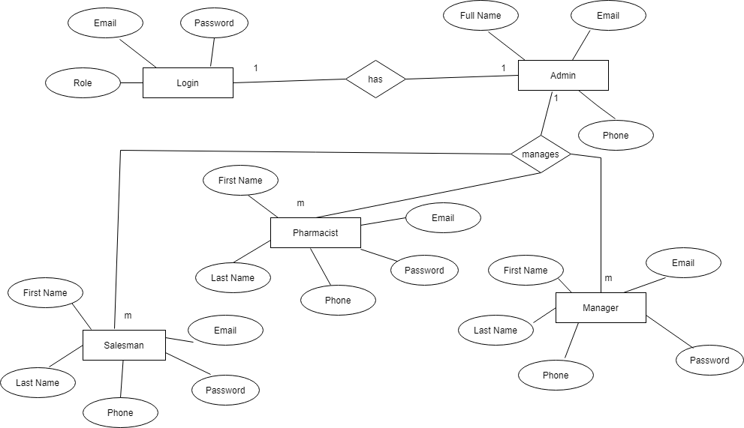

**Implementation**

List of modules

* Login page
* Home page
* Manager
* Pharmacist
* Salesman

**Screenshots**

Before Log in by Admin, Manager, Pharmacist, Salesman

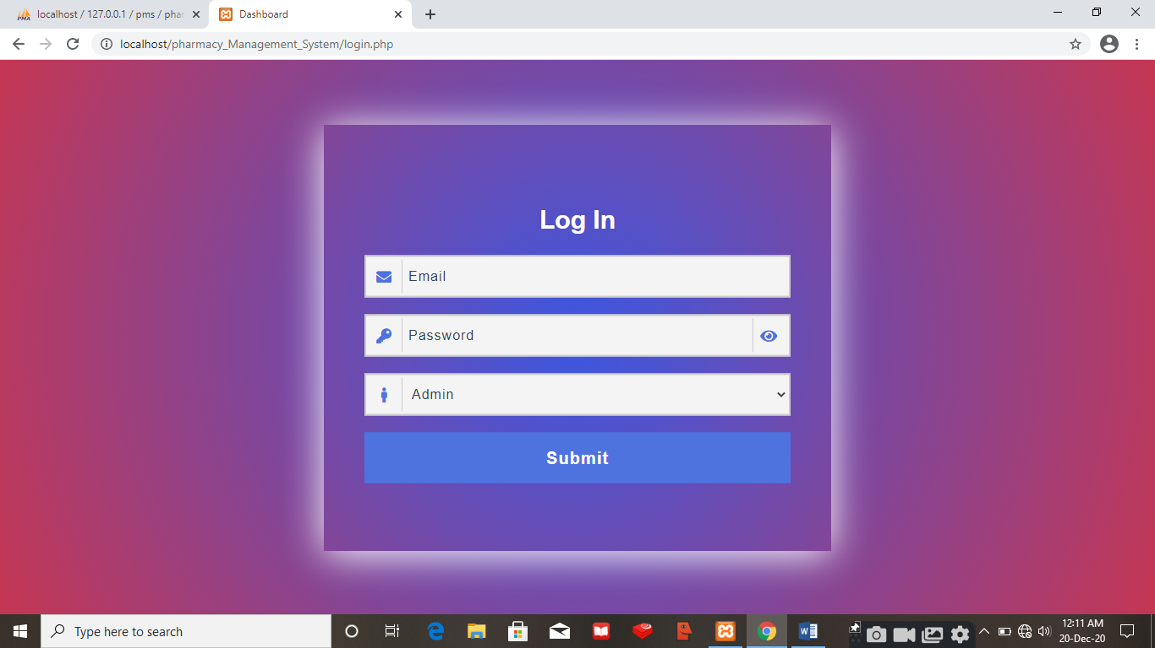

After Log in by Admin

With Email :- [admin@admin.com](mailto:admin@admin.com)

Password :- admin1

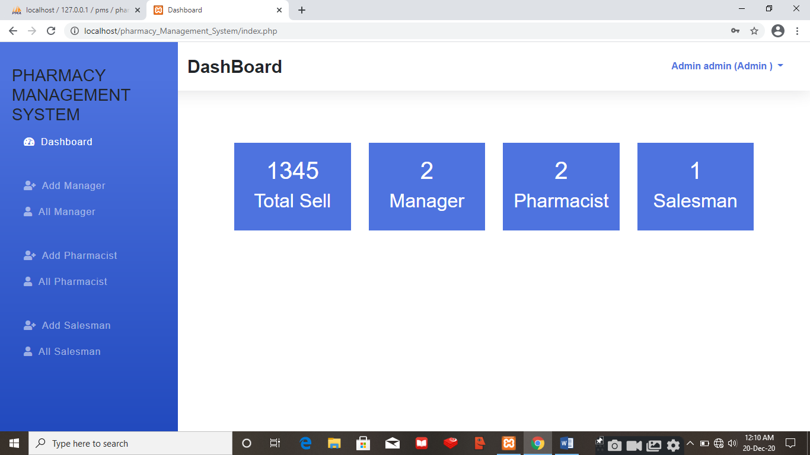

After Log in by Manager

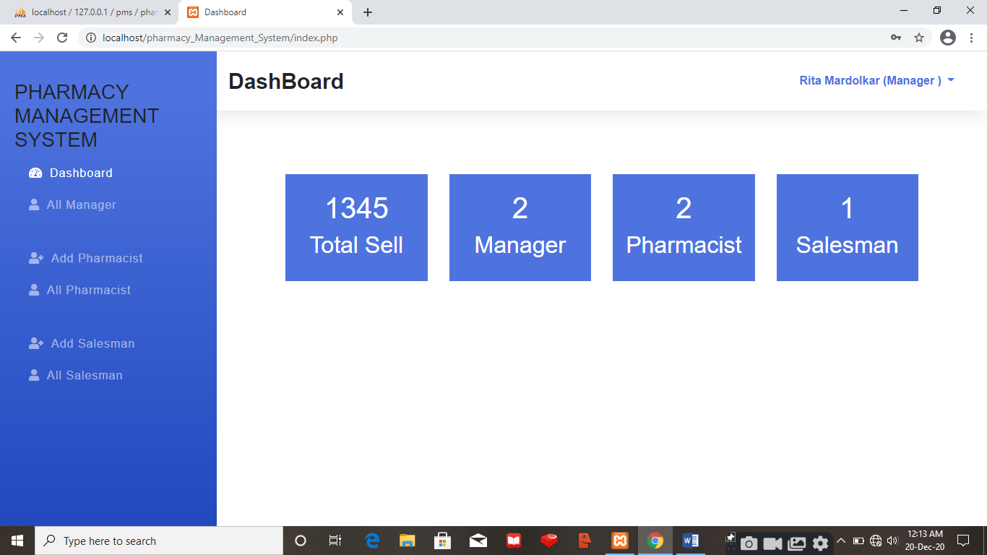

After Log in by Pharmacist

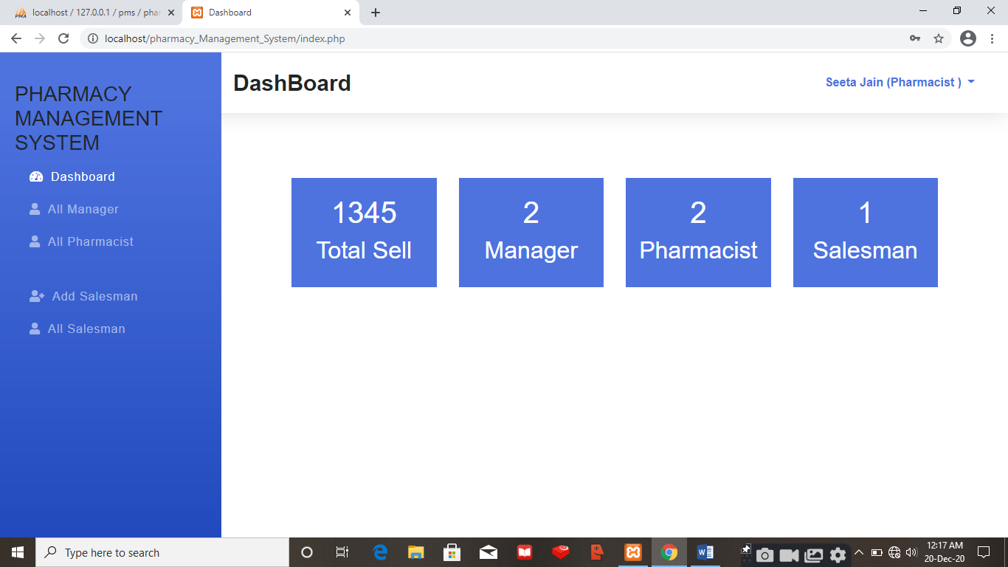

After Log in by Salesman

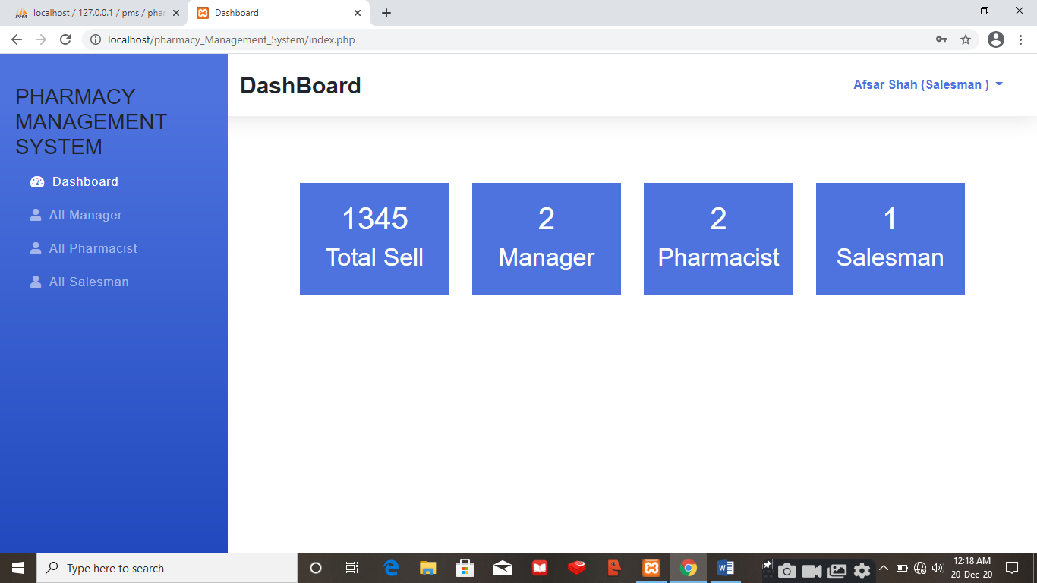

If Log in fails by Admin, Manager, Pharmacist, Salesman

There could be reasons like :-

* If user did not enter the correct Email or
* If user did not enter the correct Password or
* If user did not select the correct Role

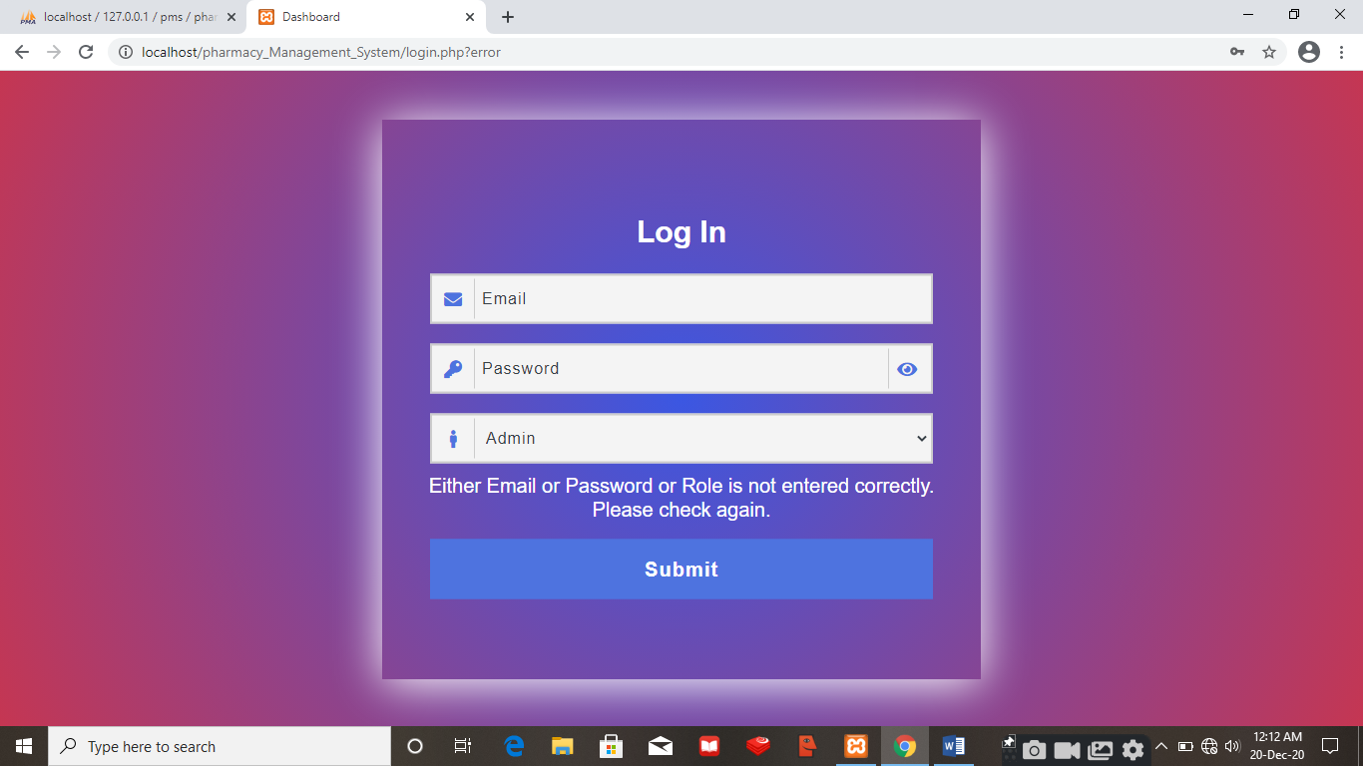

All Managers

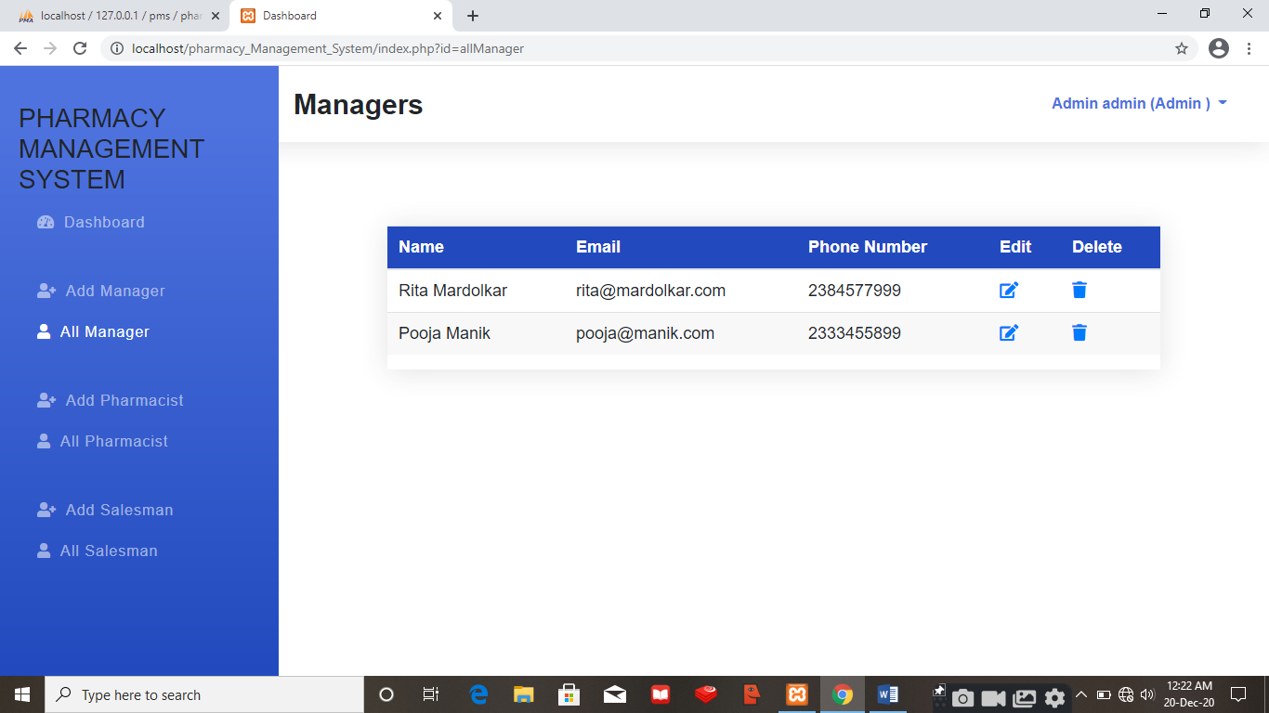

After adding one more Manager as

First name :- Karan

Last name :- Hoble

Email :- karan@hoble.com

Phone :- 2333344550

Password :- karan1

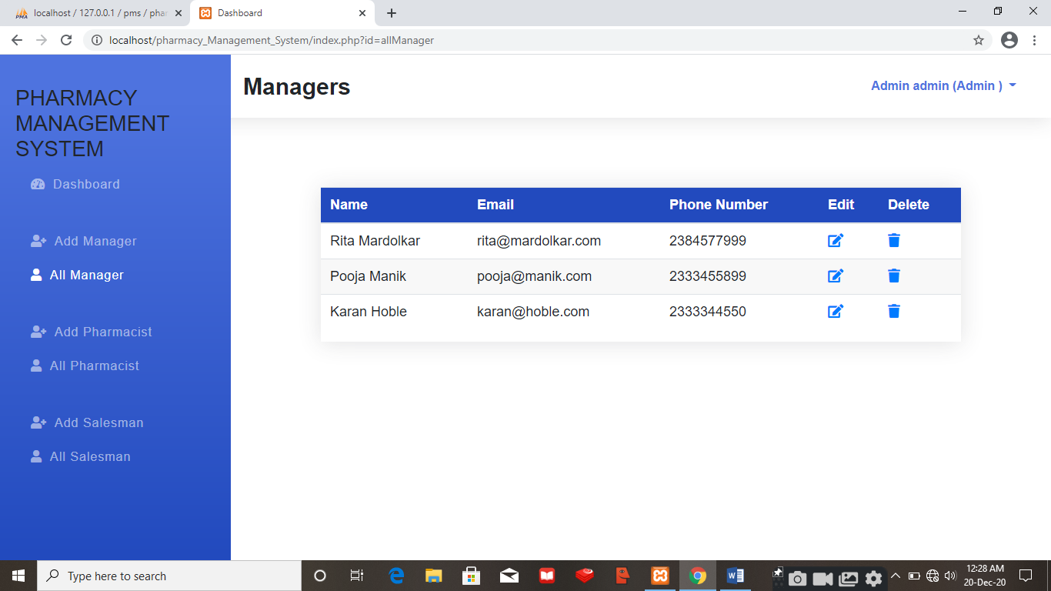

All Pharmacist

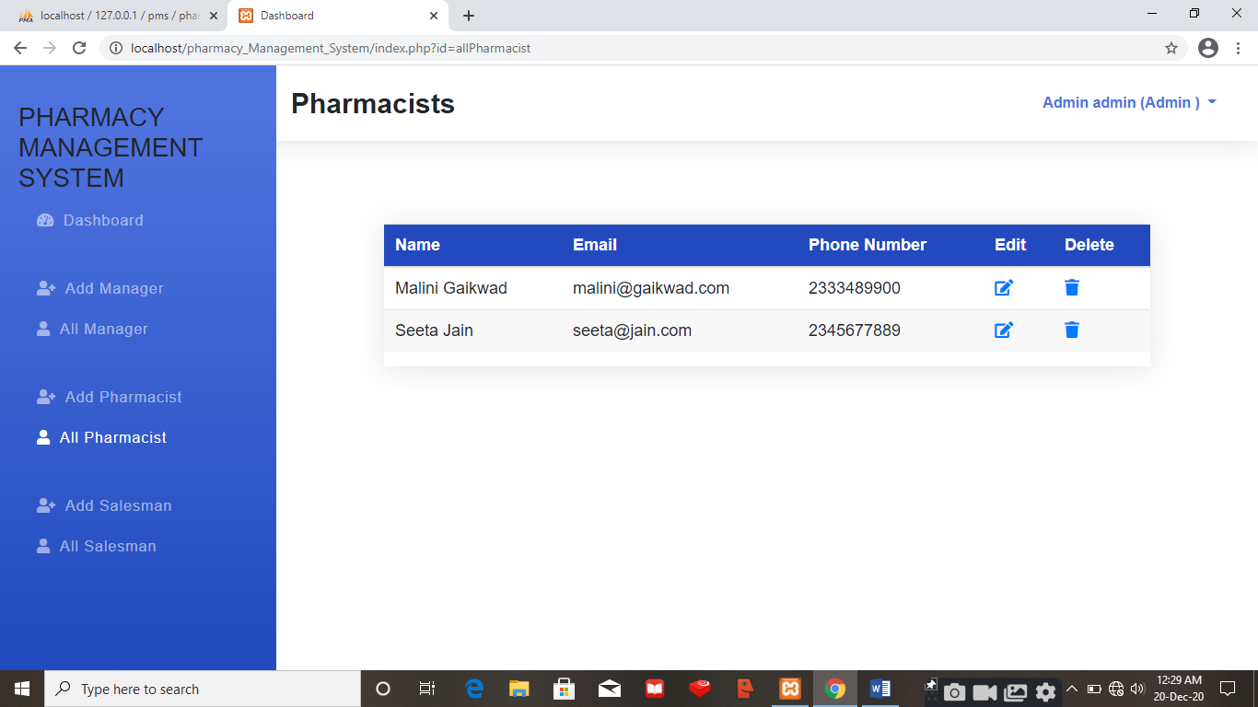

After adding one more Pharmacist as

First name :- Sonia

Last name :- Sirsat

Email :- sonia@sirsat.com

Phone :- 9823459999

Password :- sonia1

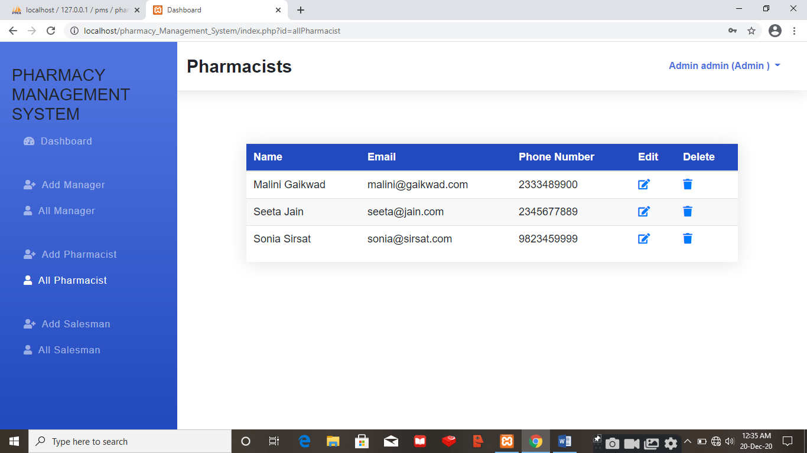

All Salesman

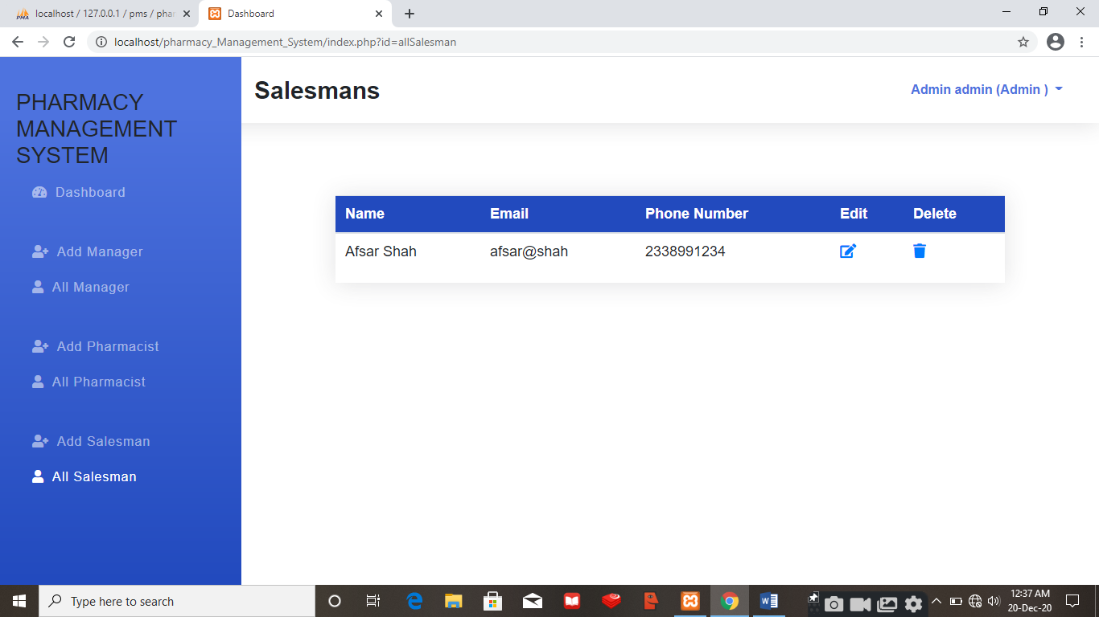

After adding one more Salesman as

First name :- Amar

Last name :- Veli

Email :- amar@veli.com

Phone :- 9823677890

Password :- amar1

