**PL305 Database Management System Lab Project Documentation**

**Topic : - Pharmacy Management System**

**Introduction**

This project is insight into the design and implementation of a Pharmacy Management System. This project consists of admin and staff side. All the management is done from the admin side like adding other staffs or deleting the records. Firstly you have to sign up in order to perform operations. When you sign up then you can view the admin dashboard. From there you can manage your all the necessary activities.

Front End : - HTML and CSS

Back End : - PHP and MYSQL

**Requirement**

* Staff members should able to login to the system.
* Admin should able to see all the data of the members.
* Admin will manage data of the staff members.

**Objective**

This project allows the shop owner to maintain his business efficiently.

**Design of System**

1. Use Case Diagram

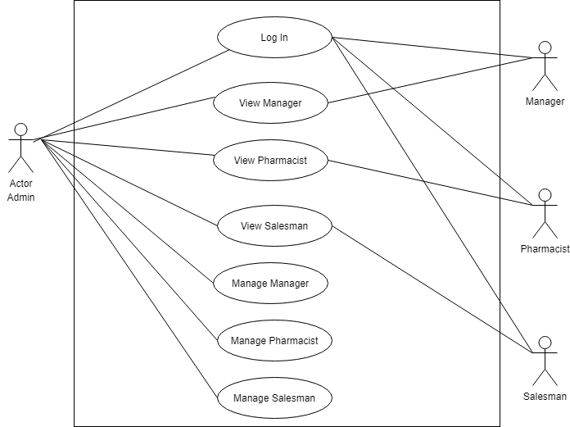

1. **ERD Diagram**

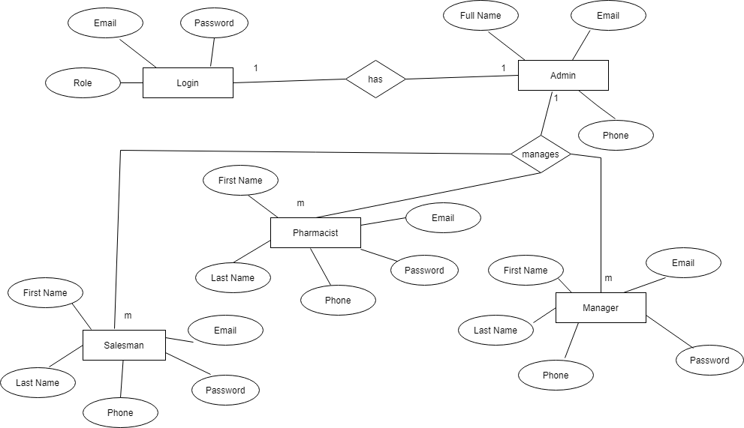

**Implementation**

List of modules

* Login page
* Home page
* Manager
* Pharmacist
* Salesman