Section 9 of 13
Infrastructure
Keysight Technologies . Agentic AI for SalesOps RFP Response . The Hackett Group on ZBrain . Response date 2026-05-11
This section sets out the deployment architecture for the proposed solution under the hybrid build-and-deploy model described in the Executive Summary and Solution Overview. Design and build happen inside ZBrain Solution Builder on the Hackett-operated platform tenancy. The production solution deploys separately onto Keysight's own AWS account (the Keysight cloud standard per Q&A item 55), with ZBrain services running in a VPC behind private subnets, Azure AD for SSO and RBAC (the Keysight enterprise identity standard per Q&A item 55), Azure Open AI bound through a private network path as the currently configured LLM service (model-agnostic; alternatives can be configured), Cloudflare at the edge for any internet-exposed agents (the Keysight standard per Q&A item 55), and Jenkins plus Bitbucket as the build and release toolchain. Production-grade controls (IAM, Secrets Manager, CloudWatch, Inspector, Security Hub) are present from day one.
Material point: prompts, customer data, audit trails, and Knowledge Base content all live inside Keysight's AWS boundary at runtime. The Solution Builder tenancy at Hackett is used for design, build, and release-management only — once a release is cut, the artefacts ship to Keysight's account and the agents execute there. The boundary line is agreed at Functional Design: which signals (anonymised telemetry, error counts) can flow back to the Hackett tenancy for support, and which (customer content, decisions, audit trail) stay inside Keysight's AWS.

9.1 Reference architecture
The diagram below is the ZBrain reference architecture as deployed today. The Keysight deployment follows the same shape, configured to Keysight's account, VPC, and IAM structure. Final region and account boundaries are confirmed at Functional Design.
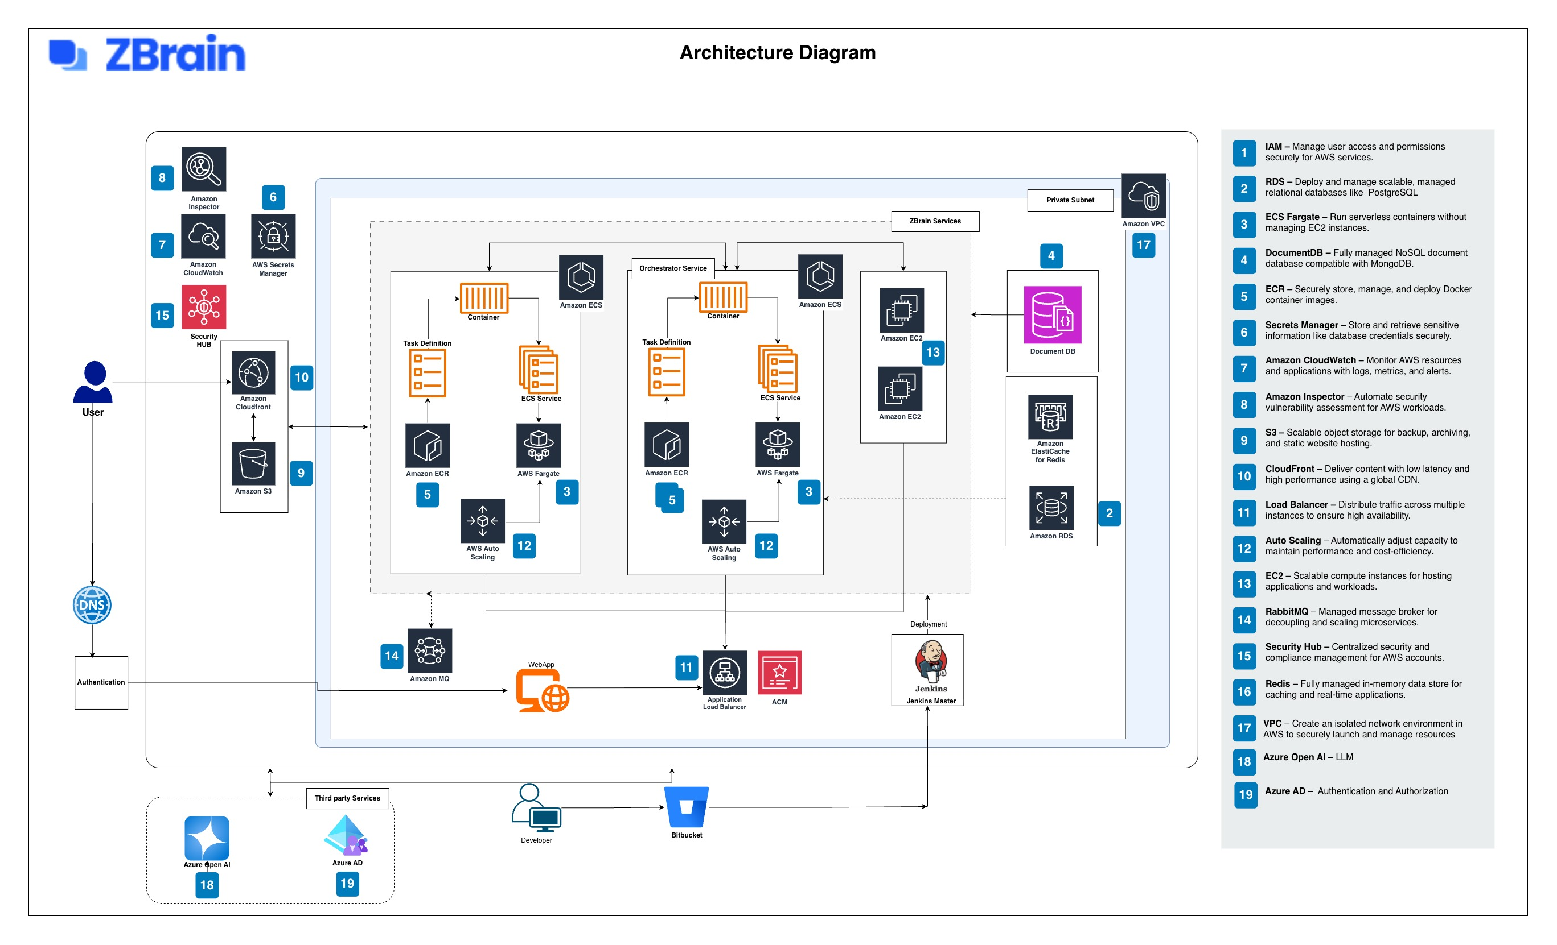
ZBrain reference architecture (AWS-hosted, Azure-side LLM and identity, Jenkins + Bitbucket toolchain).

9.2 Component summary
Layer | Component | Role
Edge | Cloudflare | Per Q&A item 55, the Keysight standard for internet-exposed agents. Edge WAF, DDoS, bot management, and where required mTLS for the HITL portal, the Knowledge Base authoring screens, the Governance and Analytics screen, and any inbound webhook surface.
Edge | CloudFront + S3 | Static-asset delivery and CDN for the operator portal.
Edge | Route 53 (DNS) + ACM (certificates) | Custom domain and TLS termination.
Edge | Application Load Balancer | Distributes traffic across the orchestrator and ZBrain service pools.
ZBrain platform module | Solution Builder | Visual orchestration surface for the end-to-end agents (Intake, Extract, Reconcile, Decide, Execute, Communicate). Configuration runs on the Hackett-operated ZBrain tenancy during design and build; releases ship to Keysight's AWS account.
ZBrain platform module | Knowledge Base | Stores and serves all three RAG retrievers (structured DB grounding, knowledge-graph traversal, unstructured document search) per Q&A item 53. Editable by Keysight rule owners.
ZBrain platform module | Governance | Application-level governance per agent: RBAC, allow-listed tool access, prompt-injection defences, citizenship-based access enforcement, audit forwarding.
ZBrain platform module | Monitor | Real-time observability of every agent: classification mix, confidence distribution, four-gate pass rates, HITL queue depth, drift signals.
Compute | Amazon ECS on Fargate | Serverless containers for the Orchestrator Service and the supporting ZBrain Services. Auto Scaling adjusts capacity to load.
Compute | Amazon EC2 (where Fargate is not used) | Long-running components that need direct EC2 hosting.
State | Amazon RDS (PostgreSQL) | Case state, audit trail, configuration, knowledge-base entries.
State | Amazon DocumentDB | MongoDB-compatible document store for unstructured content and intermediate AI outputs.
State | Amazon ElastiCache for Redis | Low-latency cache and session store.
State | Amazon S3 | Attachment storage, archive, static asset hosting, build artefacts.
Messaging | Amazon MQ (RabbitMQ) | Message broker between the inbound queue and the worker pool. Absorbs burst spikes without back-pressure into the mailbox.
Identity | Microsoft Azure AD | Per Q&A item 55, the Keysight SSO and RBAC standard. Single sign-on for the HITL portal, the Knowledge Base authoring screens, and the Governance and Analytics screen, with conditional-access policies on risky operations.
Identity | AWS IAM | Service-level access controls for the AWS resources behind the ZBrain services.
Secrets | AWS Secrets Manager | Credentials, API keys, integration tokens. No secrets in source code or in container images.
Network | Amazon VPC + private subnets | Network isolation. ZBrain services run inside the VPC; only the Cloudflare-fronted edge and CloudFront are reachable externally.
Monitoring (cloud) | Amazon CloudWatch | Logs, metrics, alarms across the AWS stack.
Monitoring (cloud) | Amazon Inspector | Automated security vulnerability assessment for the AWS workloads.
Monitoring (cloud) | AWS Security Hub | Centralised security and compliance signal for the AWS account.
Container registry | Amazon ECR | Private container image registry feeding the ECS / Fargate services.
LLM provider | Azure Open AI (currently configured) | Model-agnostic platform; alternative providers can be configured. Keysight has no in-house custom LLM per Q&A item 51.
CI/CD | Jenkins (Jenkins Master) + Bitbucket | Source control and the deployment pipeline. Build artefacts published to ECR; deployments rolled out to ECS.

9.3 How the architecture meets Keysight's stated needs
Topic | Approach
Scalability to Keysight's stated volumes | ECS Fargate with AWS Auto Scaling handles the inbound queue and worker pools. Amazon MQ decouples the IMAP poller from the workers so burst spikes (quarter-end and year-end per Q&A item 59) absorb in the queue rather than pushing back into the mailbox layer. Baseline sized at Keysight's stated 2,000 emails per day, ~880K per year (Q&A item 11); stress-test target is 50x baseline sustained for 24 hours, with elastic worker scaling on queue depth. Concurrent operator load (80 to 90 baseline per Q&A item 17) is handled by the HITL portal's separate horizontal scaling.
Resilience and continuity | Multi-AZ deployment within the region. Cross-region disaster recovery position confirmed against Keysight's continuity standards at Functional Design. RDS automated backups and snapshots; S3 versioning for attachments and artefacts.
Network isolation | All ZBrain services run inside a VPC with private subnets. Only the Application Load Balancer (fronted by ACM for TLS) and CloudFront are reachable externally. Outbound calls to Azure Open AI, Salesforce, Jitterbit (Keysight's middleware channel to Oracle EBS and Docunet), and Microsoft Graph for Outlook go through controlled egress paths.
Identity and access | Operator and end-user identity through Azure AD. AWS IAM enforces least-privilege access for the AWS services themselves. AWS Secrets Manager holds every external credential.
Observability | CloudWatch handles logs, metrics, and alarms; Inspector handles vulnerability assessment; Security Hub aggregates security posture. ZBrain Monitor layers application-level telemetry on top. Exports to Keysight's existing SIEM are agreed at Functional Design.
Deployment and release | Multi-stage pipeline orchestrated through Jenkins, with builds promoted from dev to UAT to production using the same container artefact stored in ECR. Quality gates at every promotion; canary or blue-green rollout into production with health-check-driven rollback. Release alignment with Keysight's existing change windows; freezes respected.
Compliance posture | Encryption at rest and in transit by default; AWS KMS managed keys (with customer-managed keys available for sensitive workloads); data residency by region selection; audit trail exportable to Keysight's SIEM; ITAR-ready in a customer-controlled deployment with restricted administrator access and enhanced audit logging.

9.4 Integration channels
Target system | Integration path | Notes
Salesforce | REST and SOQL through Salesforce APIs. | Operator credentials and service-principal credentials managed in AWS Secrets Manager.
Oracle EBS | Through Jitterbit, your existing integration platform. | We do not introduce a parallel middleware. We use Jitterbit the same way your downstream CSR work uses it today.
Docunet (document store) | Reached through Jitterbit, the same middleware Keysight uses for Oracle EBS. The Docunet integration is provided by Keysight on the middleware side. | Files are filed in Docunet with Doc type FCNV, per Keysight's existing convention.
ServiceNow | ServiceNow-side integration is built and owned by Keysight's dev team. | Keysight's existing change-order approval and reminder workflow stays as-is. We coordinate with the Keysight dev team rather than building this integration ourselves.
Microsoft Outlook | IMAP for inbound mail; Microsoft Graph for mailbox metadata and folder operations. | Mailbox-agnostic. Works transparently across the current set of mailboxes during the consolidation transition.
Azure Open AI | Azure Open AI service endpoint via secure outbound from the VPC. | Currently the configured LLM service. ZBrain remains model-agnostic; alternative providers can be configured if Keysight chooses.
Azure AD | OIDC or SAML federation for operator login. | Provides single sign-on; conditional-access policies enforced by Azure AD.

9.5 What stays out of scope at the infrastructure layer
- Changes to the Jitterbit topology Keysight already operates.
- Changes to the Azure AD or Microsoft Graph permission model beyond what is needed to add the application registration.
- Changes to Keysight's existing ServiceNow workflows.
- Changes to the Outlook tenant or mailbox infrastructure.
- Standing up parallel observability or SIEM tooling. We integrate with what Keysight already operates.

