Architecture Document v1.0

Trust Scoring Integration for ZBrain Multi-Agent Microservice

1. Executive Summary
This document defines the production architecture to integrate Agent Governance Toolkit trust scoring into the existing multi-agent microservice.

The selected design is:
1. Synchronous revocation enforcement in runtime before tool execution.
2. Asynchronous trust scoring pipeline via queue + worker.
3. Event-sourced trust ledger for auditability and replay.
4. Current-state trust profile store for fast decisions.
5. Common trust contract shared by both MAF and ADK execution paths.

2. Scope, Goals, and Non-Goals

2.1 Scope
1. Runtime instrumentation in Microsoft Agent Framework and Google ADK.
2. Trust event publication and queue transport.
3. Worker-based score computation using AGT RewardEngine.
4. Trust data persistence and revocation projection.
5. Runtime revocation decision and blocking behavior.
6. Operations, observability, rollout, and testing strategy.

2.2 Goals
1. Prevent revoked agents from executing tools.
2. Track trust as a time-series, not only point-in-time policy checks.
3. Ensure trust decisions are explainable and auditable.
4. Keep request latency minimally impacted.
5. Avoid scoring drift between MAF and ADK.

3. Current-State Baseline (Existing Code)
1. Runtime orchestration exists in app/modules/agent_crew/manager.py.
2. MAF runtime governance hooks exist in app/microsoft_agent_framework/agent.py.
3. Agent factory injection points exist in app/microsoft_agent_framework/agent_factory.py.
4. Session activity persistence exists in app/microsoft_agent_framework/session.py.
5. Worker record persistence exists in app/services/db_service.py.
6. Queue infrastructure already exists via AMQP service.
7. Request model extension point exists in app/models/api_schema.py.

4. Target Architecture (Layered Design)

4.1 Architecture Diagram
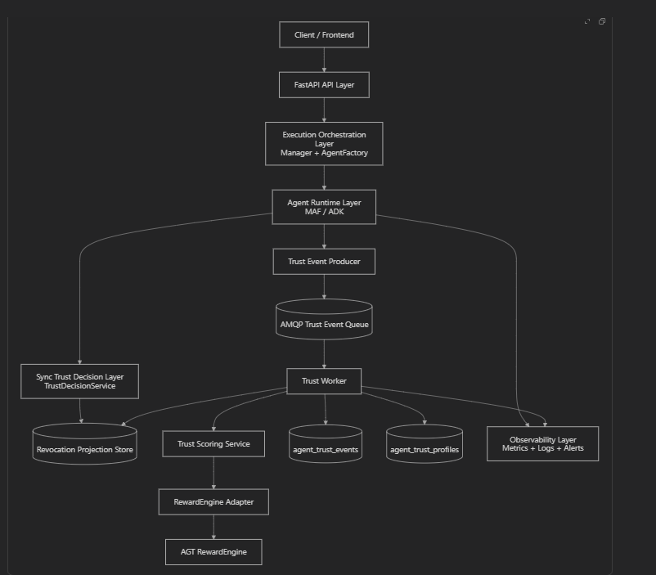

4.2 Layer Catalog
1. L1 API Entry: accept request, route execution, return response.
2. L2 Orchestration: build framework runtime, inject trust dependencies.
3. L3 Runtime Hooks: capture trust-relevant events, call sync revocation check.
4. L4 Identity Mapper: stable did:mesh:* generation and validation.
5. L5 Event Contract: canonical trust event schema and idempotency key.
6. L6 Event Producer: publish trust events to queue.
7. L7 Queue/Broker: durable async transport with retry and DLQ.
8. L8 Trust Worker: consume events, dedupe, score, persist, project revoke state.
9. L9 Scoring Service: event-to-score orchestration.
10. L10 RewardEngine Adapter: wrapper for AGT scoring API.
11. L11 Trust Repositories: event ledger + profile store read/write.
12. L12 Revocation Store: fast read path for runtime is_revoked.
13. L13 Observability: metrics, logs, alerts, runbooks.

5. Detailed Component Responsibilities

5.1 API Entry Layer
Files: app/modules/agent_crew/main.py, app/models/api_schema.py

Responsibilities:
1. Validate payload including optional trust config.
2. Pass tenant/project/session context.
3. Route to framework execution.
4. Return execution output with trust summary fields.
5. Avoid direct trust scoring logic.

5.2 Execution Orchestration Layer
Files: app/modules/agent_crew/manager.py, app/microsoft_agent_framework/agent_factory.py

Responsibilities:
1. Initialize trust dependencies once per request.
2. Inject trust services into runtime classes.
3. Maintain shared trust config across all agents.
4. Ensure resume flows retain same trust identity context.

5.3 Runtime Hook Layer (MAF/ADK)
Files: app/microsoft_agent_framework/agent.py, app/google_adk/agent.py

Responsibilities:
1. Perform synchronous is_revoked check before tool execution.
2. Emit policy_allowed or policy_denied.
3. Emit security events for input/output injection blocks.
4. Emit tool success/failure and resource usage events.
5. Emit feedback quality events from approval/rejection.
6. Emit collaboration events for handoff outcomes.
7. Attach correlation fields to each event.

5.4 Identity Mapper Layer
New file: app/trust/identity_mapper.py

Responsibilities:
1. Deterministic mapping from internal IDs to did:mesh:*.
2. Validate DID format before event publish.
3. Guarantee stable DID across retries and sessions.

5.5 Event Contract Layer
New file: app/trust/contracts.py

Responsibilities:
1. Define strict trust event schema.
2. Generate deterministic idempotency_key.
3. Validate required metadata per event type.
4. Maintain schema version.

5.6 Event Producer Layer
New file: app/trust/event_producer.py
Queue service: app/services/amqp_service.py

Responsibilities:
1. Serialize and publish events reliably.
2. Use routing key by event type/dimension.
3. Add publish metrics and failure logs.
4. Fail gracefully without breaking request completion.

5.7 Queue/Broker Layer
Responsibilities:
1. Durable queueing.
2. At-least-once delivery.
3. Retry transient failures.
4. DLQ for poison events.

5.8 Trust Worker Layer
New file: app/trust/worker.py

Responsibilities:
1. Consume messages from trust queue.
2. Validate event schema.
3. Check idempotency store.
4. Invoke scoring service.
5. Persist event ledger and profile.
6. Update revocation projection.
7. ACK/NACK based on outcome.

5.9 Trust Scoring Service Layer
New file: app/trust/scoring_service.py

Responsibilities:
1. Read score-before snapshot.
2. Map event to adapter scoring method.
3. Apply score update.
4. Read score-after snapshot.
5. Persist transition and explanation.
6. Evaluate revocation threshold crossing.

5.10 RewardEngine Adapter Layer
New file: app/trust/reward_engine_adapter.py
- App code does not directly depend on AGT internals.
- Event-to-score mapping is centralized.
- Future AGT upgrades only require adapter-level changes.
- Runtime frameworks (MAF/ADK) remain consistent.

Responsibilities:
- Initialize RewardEngine with controlled config.
- Register revocation callback from engine.
- Map normalized event types to AGT engine methods.
- Return normalized trust snapshot format to service layer.
- Return score explanation for audit/reporting.
- Translate AGT exceptions to domain-safe errors.

Event Mapping Rules
Canonical mapping should be fixed and versioned.
Event Type | AGT Call
policy_allowed | record_policy_compliance(agent_did, compliant=True, policy_name=...)
policy_denied | record_policy_compliance(agent_did, compliant=False, policy_name=...)
input_injection_blocked | record_security_event(agent_did, within_boundary=False, event_type="input_injection")
output_injection_blocked | record_security_event(agent_did, within_boundary=False, event_type="output_injection")
tool_completed_safe | record_security_event(agent_did, within_boundary=True, event_type="tool_safe")
feedback_approved | record_output_quality(agent_did, accepted=True, consumer="human_feedback")
feedback_rejected | record_output_quality(agent_did, accepted=False, consumer="human_feedback", rejection_reason=...)
resource_usage | record_resource_usage(agent_did, tokens_used, tokens_budget, compute_ms, compute_budget_ms)
handoff_success | record_collaboration(agent_did, handoff_successful=True, peer_did=...)
handoff_failure | record_collaboration(agent_did, handoff_successful=False, peer_did=...)

Snapshot Contract Returned by Adapter
Adapter should return a normalized internal snapshot, not raw AGT objects.
Suggested fields:
- agent_did
- trust_score (0–1000)
- trust_tier
- revoked
- revocation_reason
- updated_at
- dimensions (policy/resource/output/security/collaboration scores)
This prevents AGT model shape changes from leaking into app code.

Revocation Callback Integration
AGT engine supports revocation callback registration.
Adapter should register callback once at initialization.
Callback behavior:
- Receive (agent_did, reason) from engine.
- Store revocation event in in-memory adapter output context.
- Return this info to TrustScoringService.
- TrustScoringService persists and updates projection store.

5.11 Trust Repository Layer
New file: app/trust/repositories.py

Responsibilities:
1. Insert event row with unique idempotency_key.
2. Skip duplicates deterministically.
3. Upsert current profile atomically.
4. Query profile for decisions/reporting.
5. Support replay reads for worker rehydration.

5.12 Revocation Projection + Decision Layer
New files: app/trust/revocation_store.py, app/trust/decision_service.py

Responsibilities:
1. Serve low-latency revoked status lookup.
2. Update projection immediately on worker state change.
3. Fallback to DB if cache miss.
4. Provide simple runtime decision contract.

5.13 Observability Layer
Responsibilities:
1. Track event publish and processing rates.
2. Track queue lag and DLQ size.
3. Track duplicate-drop count.
4. Track revocation and block counts.
5. Correlate request and trust event traces.

6. Database Architecture and Schema

6.1 Data Stores
1. agent_trust_events: immutable event ledger.
2. agent_trust_profiles: latest trust state.
3. Optional cache store for revocation projection.

6.2 Entity Diagram
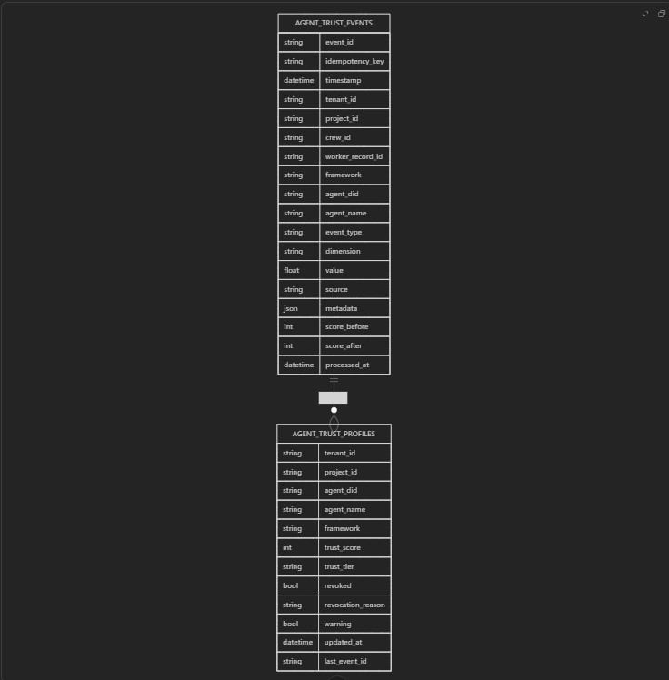

6.3 Collection: agent_trust_events
Sample fields:
1. event_id, idempotency_key, timestamp
2. tenant/project/crew/worker context
3. event_type, dimension, value, source, metadata
4. score_before, score_after, processed_at

Indexes:
1. Unique index on idempotency_key.
2. Index on tenant_id + agent_did + timestamp.
3. Index on event_type + timestamp.

6.4 Collection: agent_trust_profiles
Sample fields:
1. tenant_id, project_id, agent_did
2. trust_score, trust_tier
3. revoked, revocation_reason, warning
4. updated_at, last_event_id

Indexes:
1. Unique index on tenant_id + agent_did.
2. Index on tenant_id + revoked.
3. Index on tenant_id + trust_score.

7. Trust Event Taxonomy and Scoring Mapping
1. policy_allowed -> policy_compliance positive
2. policy_denied -> policy_compliance negative
3. input_injection_blocked -> security_posture negative
4. output_injection_blocked -> security_posture negative
5. tool_completed_safe -> security_posture positive
6. feedback_approved -> output_quality positive
7. feedback_rejected -> output_quality negative
8. resource_usage -> resource_efficiency score from budget ratio
9. handoff_success/failure -> collaboration_health positive/negative

8. End-to-End Flow

8.1 Request and Enforcement Flow
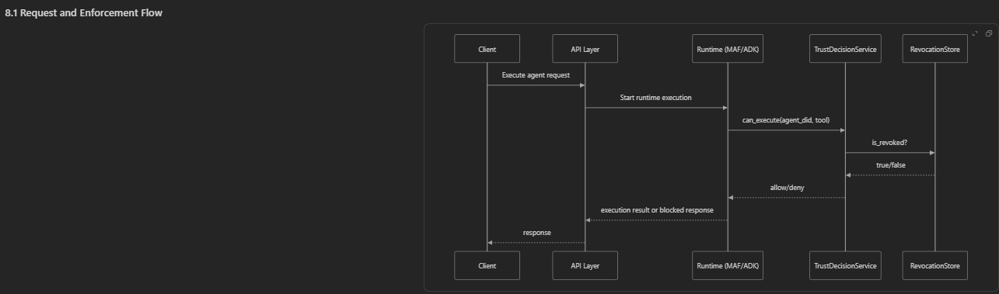

8.2 Async Scoring Flow
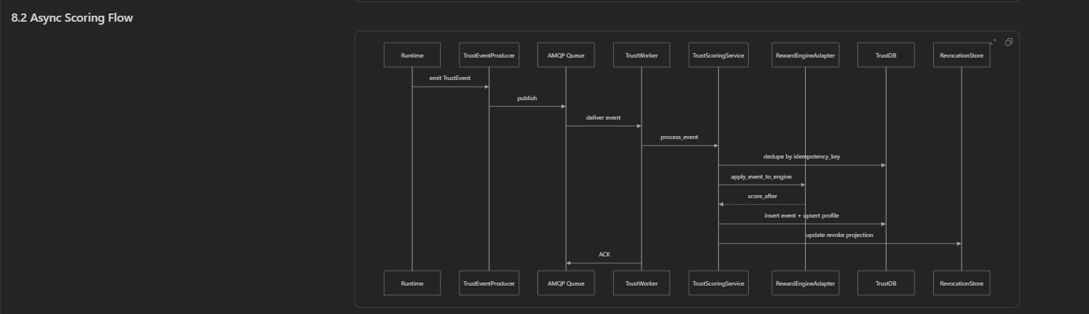

8.3 Revocation Lifecycle
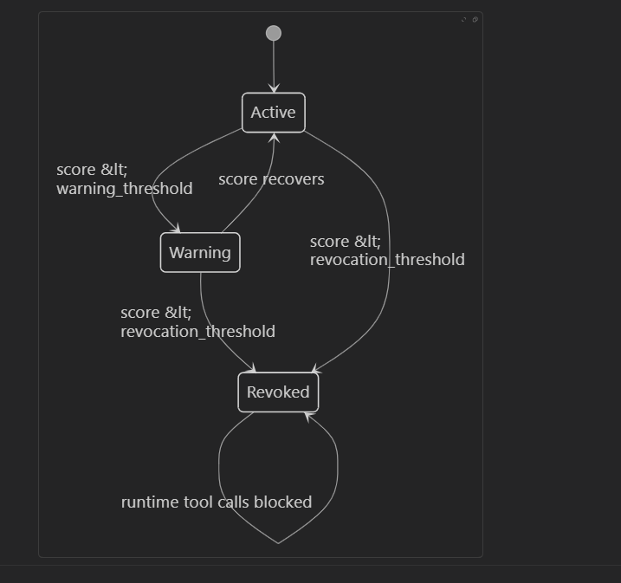

9. Queue Design
1. Exchange: trust.events
2. Queue: trust.events.primary
3. DLQ: trust.events.dlq
4. Routing keys by domain: trust.policy, trust.security, trust.resource, trust.output, trust.collab

Delivery semantics:
1. At-least-once.
2. Idempotent consumer required.
3. ACK after successful persistence and projection update.
4. NACK/retry on transient failure.
5. DLQ on repeated permanent failure.

10. Security, Compliance, and Tenant Isolation
1. Trust records must always include tenant_id.
2. DID mapping must be tenant-scoped.
3. Redact sensitive fields from event metadata.
4. Manual trust overrides must be audited.
5. Strict schema validation at worker ingest.

11. Non-Functional Requirements

11.1 Performance
1. Revocation check adds minimal runtime latency.
2. Scoring throughput scales by worker replicas.
3. Queue absorbs burst loads.

11.2 Reliability
1. Durable queue and DLQ.
2. Idempotency protection for duplicates.
3. Replay from event ledger for recovery.

11.3 Observability
1. Publish rate and consumer lag.
2. Worker success/failure rate.
3. Revocation and block counters.
4. Duplicate event drop count.

12. Implementation Mapping to Codebase

12.1 Existing files to modify
1. app/modules/agent_crew/main.py
2. app/modules/agent_crew/manager.py
3. app/models/api_schema.py
4. app/microsoft_agent_framework/agent_factory.py
5. app/microsoft_agent_framework/agent.py
6. app/google_adk/agent_factory.py
7. app/google_adk/agent.py
8. app/services/amqp_service.py
9. app/common/constants.py
10. app/config/main.py

12.2 New files to create
1. app/trust/contracts.py
2. app/trust/identity_mapper.py
3. app/trust/event_producer.py
4. app/trust/reward_engine_adapter.py
5. app/trust/scoring_service.py
6. app/trust/decision_service.py
7. app/trust/repositories.py
8. app/trust/revocation_store.py
9. app/trust/worker.py
10. app/trust/metrics.py

13. Configuration Blueprint
1. TRUST_SCORING_ENABLED=true
2. TRUST_SCORING_MODE=log_only|enforce
3. TRUST_WARNING_THRESHOLD=400
4. TRUST_REVOCATION_THRESHOLD=300
5. TRUST_EVENT_EXCHANGE=trust.events
6. TRUST_EVENT_QUEUE=trust.events.primary
7. TRUST_EVENT_DLQ=trust.events.dlq
8. TRUST_WORKER_PREFETCH=50
9. TRUST_PROJECTION_CACHE_TTL_SECONDS=30

14. Rollout Plan
1. Phase 1: event emission + log_only.
2. Phase 2: worker scoring + profile updates.
3. Phase 3: sync revocation enforcement.
4. Phase 4: threshold tuning + operational hardening.

15. Risks and Mitigations
1. Dependency mismatch -> lock versions and add CI import checks.
2. Duplicate delivery -> unique idempotency key and insert-if-new.
3. Queue outage -> durable queue and retries.
4. Aggressive thresholds -> start log_only and calibrate.
5. Cross-framework mismatch -> canonical shared event contract.

16. Testing Strategy
1. Unit tests for DID mapping, contract validation, idempotency.
2. Integration tests for MAF and ADK event emission.
3. Worker tests for dedupe and persistence.
4. Revocation enforcement tests.
5. Failure tests for retry and DLQ.
6. Tenant isolation tests.

17. Approval Checklist
1. Components implemented and code-reviewed.
2. Queue, worker, DLQ operational in staging.
3. log_only telemetry stable.
4. Revocation enforcement validated.
5. Security/platform sign-off complete.
6. Rollback plan rehearsed.

18. Glossary
1. Trust Event: normalized record of behavior affecting trust.
2. Idempotency Key: unique key preventing double scoring.
3. Revocation Projection: fast lookup state used at runtime.
4. RewardEngine Adapter: wrapper isolating AGT API.
5. Event Ledger: append-only trust history.

