INTERNSHIP PROJECT REPORT
on
AI-POWERED CREDIT CARD FRAUD DETECTION USING
CTGAN-BASED SYNTHETIC DATA GENERATION
A Project Report submitted to
GLOBAL NEXT CONSULTING INDIA PVT LTD
(Internship Program)
By
Sneha Verma
Under the Supervision of
Dr. Anuradha Gupta
(Project Director)
Submitted To:
Global Next Consulting India Pvt. Ltd.
Internship Domain: Artificial Intelligence & Machine Learning (AI/ML)
Project Domain: Generative AI for Enterprise Applications
Duration of Internship:
1st June 2026 to 20th July 2026
July 2026

CERTIFICATE
This is to certify that the project report entitled “AI-Powered Credit Card Fraud Detection using CTGAN-Based Synthetic Data Generation” has been carried out by Sneha Verma, an intern undergoing training in the domain of Artificial Intelligence & Machine Learning at Global Next Consulting India Pvt. Ltd. (GNCIPL). This work was carried out under the guidance of Dr. Anuradha Gupta from 1st June 2026 to 20th July 2026.
It is further certified that this work has not been submitted to any other university or institution for the award of any other degree, diploma, or certificate, and that it represents an authentic record of the work carried out during the internship period.

Dr. Anuradha Gupta
Project Director
GNCIPL

CANDIDATE'S DECLARATION
I, Sneha Verma, hereby declare that the work presented in this report, titled “AI-Powered Credit Card Fraud Detection using CTGAN-Based Synthetic Data Generation,” submitted as part of the Artificial Intelligence & Machine Learning internship program at Global Next Consulting India Pvt. Ltd. (GNCIPL), is the result of original work carried out by me under the guidance of Dr. Anuradha Gupta during the period from 1st June 2026 to 20th July 2026.
I further declare that this report represents an authentic record of my own work and does not contain any falsely fabricated ideas, data, facts, or sources. I also declare that I have adhered to all principles of academic honesty and integrity, and that this report has not been submitted, either in part or in full, to any other institute, university, or organization for the award of any degree, diploma, or certification.

Sneha Verma

ACKNOWLEDGEMENT
I take this opportunity to express my sincere gratitude to everyone who contributed to the successful completion of this internship project.
I am deeply thankful to my supervisor, Dr. Anuradha Gupta, for her invaluable guidance, constant encouragement, and constructive feedback throughout the course of this project. Her expertise in the field of Artificial Intelligence and her willingness to clarify doubts at every stage played a crucial role in shaping this work.
I would also like to thank the entire team at Global Next Consulting India Pvt. Ltd. (GNCIPL) for providing a well-structured learning environment, the necessary technical resources, and continuous support that made this project possible. The exposure to real-world problem statements and industry-relevant tools greatly enhanced my practical understanding of Machine Learning and Generative AI.
Finally, I would like to acknowledge my family, friends, and peers for their constant motivation and support throughout the duration of this internship.

Sneha Verma

ABSTRACT
This report presents the work carried out during a seven-week internship in the domain of Artificial Intelligence and Machine Learning at Global Next Consulting India Pvt. Ltd. (GNCIPL), focused on the project “AI-Powered Credit Card Fraud Detection using CTGAN-Based Synthetic Data Generation.” Credit card fraud detection is a well-known example of a class-imbalanced classification problem, where fraudulent transactions represent an extremely small fraction of the total transactions recorded in the dataset used for this project. Machine learning models trained directly on such imbalanced data tend to become biased toward the majority class, resulting in poor detection of the minority (fraud) class despite achieving a high overall accuracy.
To address this problem, the project applies a Generative AI technique known as CTGAN (Conditional Tabular Generative Adversarial Network), implemented using the SDV (Synthetic Data Vault) library, to learn the statistical distribution of existing fraudulent transactions and generate 5,000 new, realistic synthetic fraud samples. These synthetic samples were merged with the original dataset to create a balanced, augmented dataset suitable for training robust classification models.
Two supervised learning algorithms, Random Forest and XGBoost, were trained and evaluated on the augmented dataset. Model performance was assessed using Accuracy, Precision, Recall, F1 Score, ROC-AUC, and the Confusion Matrix. Both models achieved excellent detection performance, with the XGBoost classifier correctly identifying 1,036 out of 1,043 fraudulent transactions in the test set, achieving an accuracy of 99.96%, a precision of 100%, a recall of 99.33%, and an F1 Score of 99.66%. The entire workflow, from data exploration to model deployment, was implemented in Python on the Google Colab platform.
The project demonstrates that Generative AI-based data augmentation is a highly effective strategy for overcoming class imbalance in fraud detection systems and can be extended to other domains that suffer from limited representation of rare but critical events.

TABLE OF CONTENTS
Candidate's Declaration
Certificate
Acknowledgement
Abstract
List of Figures
List of Tables
Chapter 1: Introduction
Chapter 2: Company Profile
Chapter 3: Problem Statement
Chapter 4: Objectives
Chapter 5: Literature Review
Chapter 6: Tools & Technologies
Chapter 7: Dataset Description
Chapter 8: Methodology
Chapter 9: System Design
Chapter 10: Implementation
Chapter 11: Results & Discussion
Chapter 12: Advantages
Chapter 13: Limitations
Chapter 14: Future Scope
Chapter 15: Conclusion
References
Appendix

LIST OF FIGURES
Figure 1: Dataset Head
Figure 2: Dataset Information
Figure 3: Missing Values Check
Figure 4: Class Distribution (Fraud vs Normal)
Figure 5: Transaction Amount Histogram
Figure 6: Transaction Time Distribution
Figure 7: Correlation Heatmap
Figure 8: Amount Distribution by Class (Boxplot)
Figure 9: Fraud Transactions Dataset (Extracted)
Figure 10: Train-Test Split Summary
Figure 11: Synthetic Fraud Dataset Head
Figure 12: Synthetic Dataset Shape
Figure 13: Augmented Dataset Shape & Data Quality Check
Figure 14: Random Forest Evaluation Metrics
Figure 15: Random Forest Confusion Matrix
Figure 16: XGBoost Evaluation Metrics
Figure 17: XGBoost Confusion Matrix
Figure 18: Model Performance Comparison Graph
Figure 19: Feature Importance Graph

LIST OF TABLES
Table 1: Dataset Feature Summary
Table 2: Software, Tools and Libraries Used
Table 3: Train-Test Split Summary
Table 4: XGBoost Confusion Matrix Values
Table 5: Model Performance Comparison

CHAPTER 1: INTRODUCTION
The rapid growth of digital payments and e-commerce has made credit cards one of the most widely used modes of financial transactions across the world. While this convenience has transformed the way people shop and transact, it has also opened the door to a steadily increasing volume of fraudulent activity. Credit card fraud results in significant financial losses for banks, payment processors, and customers every year, and detecting such fraud quickly and accurately has become a critical requirement for the financial industry.
Traditional rule-based fraud detection systems, which rely on fixed thresholds and manually defined patterns, are no longer sufficient to keep up with the evolving and increasingly sophisticated tactics used by fraudsters. This has led to a growing reliance on Machine Learning (ML) techniques, which can learn complex, non-linear patterns directly from historical transaction data and generalize this knowledge to identify previously unseen fraudulent behaviour.
However, fraud detection presents a unique and difficult challenge for machine learning models: the extreme class imbalance found in real-world transaction data. In almost every publicly available credit card dataset, fraudulent transactions make up well under one percent of all records. When a classification model is trained on such heavily skewed data, it naturally learns to favour the majority (legitimate) class, since doing so minimizes overall error even while completely failing to detect the minority (fraud) class. This makes accuracy alone a misleading metric and calls for more careful handling of the underlying data distribution before any model is trained.
This project, undertaken as part of the Artificial Intelligence & Machine Learning internship at Global Next Consulting India Pvt. Ltd. (GNCIPL), addresses this exact problem using a Generative AI-based approach. Instead of relying solely on traditional resampling techniques such as random oversampling or SMOTE, this project uses CTGAN (Conditional Tabular Generative Adversarial Network), a deep generative model specifically designed for tabular data, to synthesize new, statistically realistic fraudulent transaction records. These synthetic records are combined with the original dataset to produce a more balanced dataset, on which Random Forest and XGBoost classifiers are then trained and evaluated.
This report documents the complete lifecycle of the project, including the company profile of GNCIPL, the problem statement, the objectives of the internship, a review of relevant literature, the tools and technologies used, a detailed description of the dataset, the methodology followed, the system design, the implementation carried out in Google Colab, the results obtained, and a discussion of the advantages, limitations, and future scope of the work.

CHAPTER 2: COMPANY PROFILE

2.1 About GNCIPL
Global Next Consulting India Private Limited (GNCIPL), headquartered in Greater Noida, Uttar Pradesh, is a technology consulting firm that works with organizations to help them adopt modern digital, data, and security solutions. As industries increasingly depend on data-driven decision-making and intelligent automation, GNCIPL provides internship and training programs that give students and early-career professionals hands-on exposure to real-world problem statements in domains such as Artificial Intelligence, Machine Learning, Data Analytics, and Cybersecurity.
GNCIPL structures its internship programs around practical, project-based learning, pairing interns with experienced mentors who guide them through every stage of a project, from problem definition to final implementation and evaluation. This approach ensures that interns not only learn theoretical concepts but also gain the practical, industry-relevant skills required to solve real business problems using modern tools and technologies.

2.2 Contact Details
Location: B5, 402 P4 Phase-2, CGEWHO Tower, Greater Noida, Uttar Pradesh - 201310
Contact Numbers: 0120-4001768, +91-9315504902, +91-7666141260
Email: hr@gncipl.com

2.3 Core Values
- Integrity: Maintaining transparency and honesty in all engagements with clients and interns.
- Innovation: Encouraging the adoption of modern AI and data-driven solutions to solve practical problems.
- Customer-Centricity: Designing solutions and training programs around real needs.
- Excellence: Striving for high-quality outcomes in every project undertaken.
- Collaboration: Fostering teamwork between interns, mentors, and industry experts.

CHAPTER 3: PROBLEM STATEMENT
Credit card fraud detection is fundamentally a binary classification problem, where each transaction must be classified as either “legitimate” or “fraudulent.” The core difficulty in solving this problem lies not in the classification algorithm itself, but in the nature of the data used to train it.
In the dataset used for this project, fraudulent transactions represent only a very small proportion of the total number of transactions, while the overwhelming majority are legitimate. When a standard machine learning classifier is trained directly on this imbalanced data, it tends to achieve a deceptively high overall accuracy simply by predicting almost every transaction as legitimate. Such a model, while numerically accurate, is practically useless for fraud detection because it fails to correctly identify the fraudulent transactions that actually matter.
Common techniques used to address class imbalance, such as random oversampling (which duplicates existing minority class records) or SMOTE (Synthetic Minority Oversampling Technique, which creates synthetic samples through linear interpolation between existing minority samples), often have limitations. Random oversampling can cause the model to overfit to the exact same fraud examples seen during training, while SMOTE's interpolation-based approach can generate samples that do not respect the complex, non-linear relationships that exist between features in real financial transaction data.
The problem addressed by this project is therefore twofold: first, to generate additional, high-quality synthetic fraud samples that realistically capture the underlying statistical distribution of true fraud cases, using a Generative Adversarial Network approach (CTGAN); and second, to use this augmented, more balanced dataset to train classification models (Random Forest and XGBoost) that can reliably detect fraudulent transactions with high precision and recall, rather than being biased toward the majority class.

CHAPTER 4: OBJECTIVES
The following objectives were defined for this internship project:
- To study and understand the class imbalance problem in the context of credit card fraud detection and its impact on machine learning model performance.
- To perform detailed exploratory data analysis (EDA) on the credit card transaction dataset, including analysis of transaction amount, transaction time, and feature correlations.
- To extract the existing fraudulent transactions from the dataset and use them to train a CTGAN (Conditional Tabular Generative Adversarial Network) model using the SDV library.
- To generate 5,000 new, synthetic fraudulent transaction samples that statistically resemble genuine fraud cases.
- To merge the synthetic fraud samples with the original dataset to create a new, augmented and more balanced dataset.
- To train and evaluate Random Forest and XGBoost classification models on the augmented dataset.
- To assess and compare model performance using Accuracy, Precision, Recall, F1 Score, ROC-AUC, and the Confusion Matrix.
- To gain hands-on, practical experience with Generative AI techniques and their application to real-world enterprise problems in the domain of Artificial Intelligence & Machine Learning.

CHAPTER 5: LITERATURE REVIEW
Credit card fraud detection has been an active area of research for over two decades, and a wide variety of approaches have been proposed to address both the classification task itself and the underlying class imbalance problem.

5.1 Traditional Machine Learning Approaches
Early fraud detection systems relied on rule-based engines and statistical outlier detection methods. As machine learning matured, algorithms such as Logistic Regression, Decision Trees, and Support Vector Machines were applied to fraud detection datasets. While these models offered improvements over manual rule-based systems, their performance was often limited by the severe imbalance present in fraud datasets, where the minority (fraud) class was frequently ignored in favour of the majority class.

5.2 Ensemble Learning Methods
Ensemble methods such as Random Forest and Gradient Boosting frameworks (including XGBoost) have since become the preferred choice for fraud detection tasks due to their ability to model complex, non-linear relationships and their relative robustness to noisy data. Random Forest builds multiple decision trees on bootstrapped subsets of data and aggregates their predictions, reducing variance and improving generalization. XGBoost, an optimized implementation of gradient boosted decision trees, builds trees sequentially, with each new tree correcting the errors of the previous ones, and is widely recognized for its strong performance on structured, tabular datasets such as financial transaction data.

5.3 Class Imbalance Handling Techniques
A significant body of research has focused specifically on handling class imbalance. Random undersampling and oversampling are the simplest techniques, but each has drawbacks: undersampling discards potentially useful majority-class information, while naive oversampling risks overfitting to repeated minority-class examples. SMOTE, introduced by Chawla et al., improved on naive oversampling by generating synthetic minority samples through interpolation between existing minority samples and their nearest neighbours. While widely adopted, SMOTE can generate unrealistic samples in high-dimensional or highly correlated feature spaces, such as the PCA-transformed features found in many credit card fraud datasets.

5.4 Generative Adversarial Networks for Tabular Data
Generative Adversarial Networks (GANs), first introduced by Goodfellow et al., consist of a generator and a discriminator trained in opposition to one another, allowing the generator to progressively learn to produce data that is statistically indistinguishable from real data. While GANs were originally designed for image data, subsequent research adapted them for tabular data, which presents unique challenges such as mixed data types, non-Gaussian distributions, and multimodal continuous columns.
CTGAN (Conditional Tabular GAN), proposed by Xu et al. and implemented as part of the open-source SDV (Synthetic Data Vault) library, was specifically designed to address these challenges. CTGAN uses mode-specific normalization and a conditional generator to better model the complex distributions found in tabular data, making it particularly well-suited for generating realistic synthetic fraud transactions that preserve the statistical relationships found in the original minority class.

5.5 Relevance to This Project
Building on this body of research, this project applies CTGAN specifically to the minority (fraud) class of a real credit card transaction dataset, generating synthetic samples that are then combined with the original data. This approach is then evaluated using two strong ensemble classifiers, Random Forest and XGBoost, allowing a direct comparison of their effectiveness on the augmented dataset.

CHAPTER 6: TOOLS & TECHNOLOGIES
This project was implemented entirely in Python on the Google Colab platform, which provides a free, cloud-based Jupyter notebook environment with access to adequate computational resources for training machine learning and generative models without requiring local setup.

6.1 Platform
Google Colab: Used as the primary development environment for writing and executing all Python code, visualizing outputs, and managing the end-to-end workflow of the project, from data loading to model evaluation.

6.2 Programming Language and Libraries
Tool / Library | Purpose in this Project
Python | Core programming language used for the entire project.
Pandas | Loading, cleaning, and manipulating the tabular transaction dataset.
NumPy | Numerical computations and array-based operations.
Matplotlib | Visualizing data distributions, correlations, and model performance.
Scikit-learn | Data splitting, Random Forest implementation, and evaluation metrics.
SDV (CTGAN) | Training the Conditional Tabular GAN and generating synthetic fraud samples.
XGBoost | Implementing the gradient boosting classifier for fraud detection.
Joblib | Saving and loading trained machine learning models for reuse.

CHAPTER 7: DATASET DESCRIPTION
The dataset used in this project is based on the widely used Kaggle Credit Card Fraud Detection dataset, which contains transactions made by European cardholders. The dataset consists of numerical input features that are the result of a PCA (Principal Component Analysis) transformation, applied originally to protect the confidentiality of the cardholders and the underlying transaction details.

7.1 Feature Summary
Feature | Description
Time | Number of seconds elapsed between each transaction and the first transaction in the dataset.
V1 - V28 | Principal components obtained through PCA transformation of the original confidential features.
Amount | The transaction amount, which can be used for cost-sensitive analysis.
Class | Target variable; 1 indicates a fraudulent transaction and 0 indicates a legitimate transaction.

7.2 Initial Data Exploration
The initial exploration of the dataset involved viewing the first few records, checking column data types, and confirming that the dataset contained no missing values, ensuring that no imputation was required before proceeding with analysis.
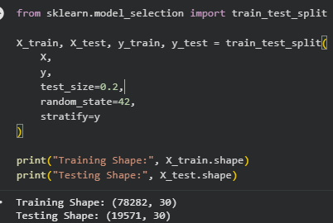
Figure 10: Sample Code Illustrating the Data Preparation Workflow
[ Insert Screenshot: Dataset Head ]
[ Insert Screenshot: Dataset Information ]
[ Insert Screenshot: Missing Values ]

7.3 Class Distribution
As expected, the dataset exhibited a strongly imbalanced class distribution, with legitimate transactions vastly outnumbering fraudulent ones. This imbalance was the primary motivation for applying CTGAN-based synthetic data generation.
[ Insert Screenshot: Class Distribution ]

7.4 Transaction Amount and Time Distribution
The transaction Amount feature was found to be heavily right-skewed, with most transactions involving relatively small amounts and a small number of high-value outliers. The Time feature, representing seconds elapsed since the first transaction, showed a clear cyclical pattern that reflects typical daily transaction volume trends.
[ Insert Screenshot: Transaction Amount Histogram ]
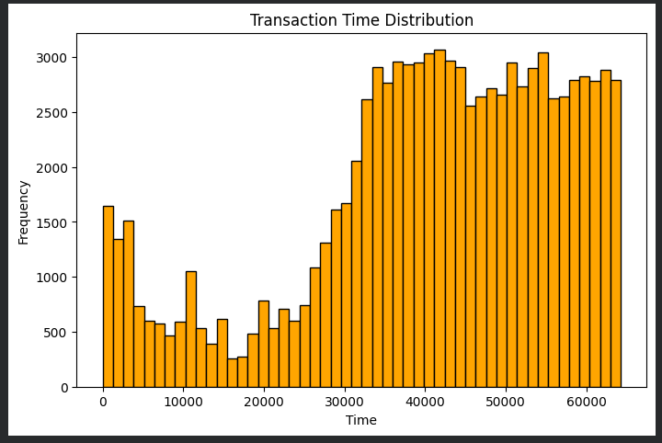
Figure 6: Transaction Time Distribution

7.5 Correlation Analysis
A correlation heatmap was generated to examine the relationships between the PCA-transformed features, the Time and Amount columns, and the Class label. As expected from PCA-transformed data, most V1-V28 features showed low correlation with one another, while certain components showed a noticeably stronger relationship with the Class label, indicating their relevance to fraud detection.
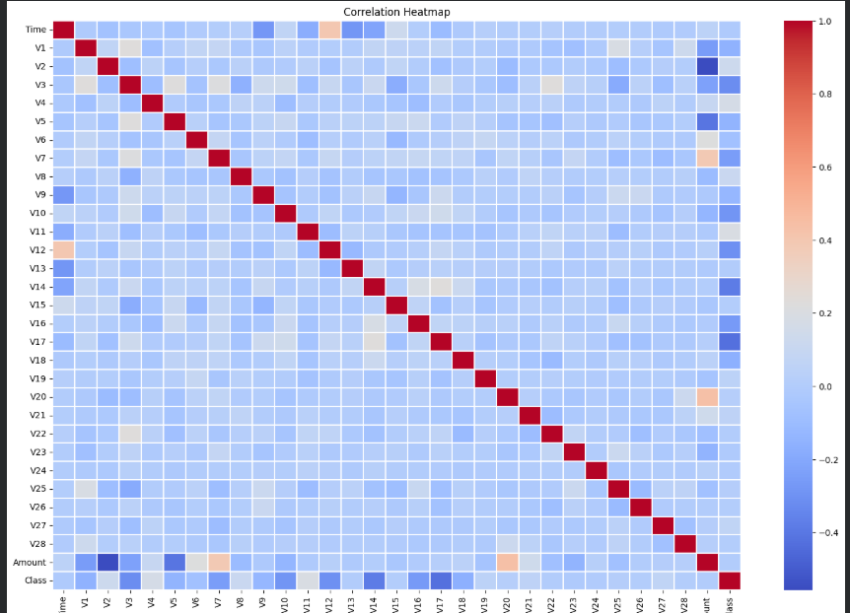
Figure 7: Correlation Heatmap of Dataset Features

7.6 Fraud vs Normal Transaction Amount
A boxplot comparison of transaction amounts across the two classes revealed that while both fraudulent and legitimate transactions covered a similar overall range, legitimate transactions contained a larger number of extreme high-value outliers.
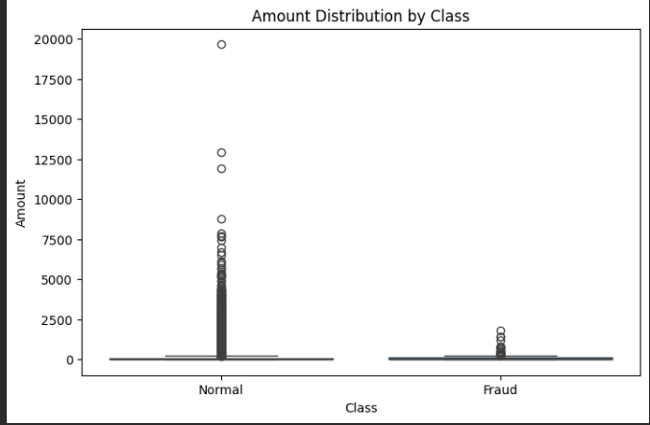
Figure 8: Amount Distribution by Class (Boxplot)

CHAPTER 8: METHODOLOGY
The methodology followed in this project consisted of a sequence of well-defined stages, beginning with data exploration and ending with the training and evaluation of the final classification models. Each stage is described below.

8.1 Data Loading and Exploration
The dataset was loaded into a Pandas DataFrame within the Google Colab environment. Initial exploration included examining the shape of the dataset, checking data types, confirming the absence of missing values, and reviewing summary statistics for the Time, Amount, and Class columns.

8.2 Exploratory Data Analysis (EDA)
Exploratory Data Analysis was carried out to understand the distribution of transaction amounts, the pattern of transaction times, the extent of class imbalance, and the correlation between features. Visualizations including histograms, a correlation heatmap, and boxplots were generated using Matplotlib to support this analysis, as detailed in Chapter 7.

8.3 Extraction of Fraudulent Transactions
All transactions labelled as fraudulent (Class = 1) were extracted into a separate DataFrame. This subset, consisting of 213 fraudulent transactions across 31 columns, formed the basis for training the CTGAN model, since the objective was to learn the statistical distribution specifically of fraud cases rather than the entire dataset.
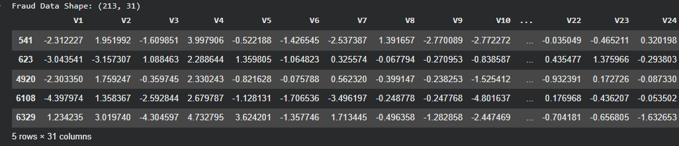
Figure 9: Extracted Fraud Transactions Dataset

8.4 CTGAN Model Training
A CTGAN (Conditional Tabular Generative Adversarial Network) model was instantiated using the SDV library and trained exclusively on the extracted fraud transaction subset. During training, the CTGAN's generator and discriminator networks were optimized in an adversarial manner, with the generator learning to produce synthetic fraud records that the discriminator could not reliably distinguish from genuine fraud records.

8.5 Synthetic Data Generation
Once training converged, the CTGAN model was used to generate 5,000 new synthetic fraudulent transaction records. These records preserved the statistical properties and feature relationships observed in the original fraud data while introducing sufficient variety to avoid simple duplication.
[ Insert Screenshot: Synthetic Dataset Head ]
[ Insert Screenshot: Synthetic Dataset Shape ]

8.6 Dataset Augmentation
The 5,000 synthetic fraud records were concatenated with the original working dataset to form a new, augmented dataset. This augmented dataset was then checked for missing values and duplicate rows to ensure data quality before proceeding to model training, resulting in a final augmented dataset of 97,853 rows and 31 columns with zero missing values and zero duplicate rows.
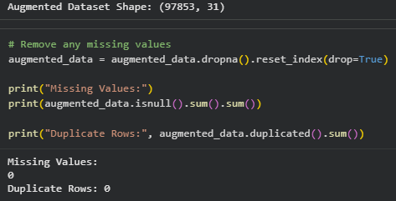
Figure 13: Augmented Dataset Shape and Data Quality Check

8.7 Train-Test Split
The augmented dataset was split into training and testing subsets using an 80:20 ratio, with stratification on the Class label to preserve the relative proportion of fraud and non-fraud transactions in both subsets. This resulted in a training set of 78,282 records and a testing set of 19,571 records, each with 30 feature columns.

8.8 Model Training and Evaluation
Random Forest and XGBoost classifiers were trained on the training subset of the augmented dataset. Both models were then evaluated on the held-out test subset using Accuracy, Precision, Recall, F1 Score, ROC-AUC, and Confusion Matrix, allowing a direct, like-for-like comparison of their fraud detection performance.

CHAPTER 9: SYSTEM DESIGN
The overall system was designed as a sequential data-processing and machine-learning pipeline, structured into distinct stages that transform raw transaction data into a trained, evaluated fraud detection model. The design of this pipeline is summarized below.

9.1 System Architecture Overview
- Stage 1 - Data Ingestion: The raw credit card transaction dataset is loaded into the Google Colab environment as a Pandas DataFrame.
- Stage 2 - Exploratory Data Analysis: Statistical summaries and visualizations are generated to understand feature distributions and the extent of class imbalance.
- Stage 3 - Fraud Extraction: Fraudulent transactions are isolated from the dataset to serve as training input for the generative model.
- Stage 4 - CTGAN Training: A CTGAN model is trained on the extracted fraud subset to learn its underlying statistical distribution.
- Stage 5 - Synthetic Data Generation: The trained CTGAN model generates 5,000 new synthetic fraud samples.
- Stage 6 - Data Augmentation: Synthetic fraud samples are merged with the original dataset and validated for missing values and duplicates.
- Stage 7 - Train-Test Split: The augmented dataset is split into training and testing subsets using stratified sampling.
- Stage 8 - Model Training: Random Forest and XGBoost classifiers are trained on the training subset.
- Stage 9 - Model Evaluation: Trained models are evaluated on the test subset using multiple performance metrics.
- Stage 10 - Model Persistence: The final trained models are serialized using Joblib for future reuse.

9.2 Data Flow
Data flows linearly through the pipeline described above, with each stage consuming the output of the previous stage. This modular design allowed each component, from data exploration to model evaluation, to be developed, tested, and validated independently within the Google Colab notebook before being integrated into the complete end-to-end workflow.

CHAPTER 10: IMPLEMENTATION
This chapter describes the practical implementation of the methodology and system design discussed in the previous chapters, with reference to the actual code and outputs produced during development in Google Colab.

10.1 Environment Setup
The project environment was set up in Google Colab, with all required libraries, including Pandas, NumPy, Matplotlib, Scikit-learn, SDV, XGBoost, and Joblib, installed and imported at the start of the notebook.

10.2 Data Preparation
The dataset was loaded and prepared using Pandas, with initial checks performed to confirm data types and the absence of missing values, as described in Chapter 7.

10.3 Extracting and Modelling Fraud Transactions
The fraudulent transactions were isolated into a dedicated DataFrame of 213 records, which served as the input for training the CTGAN model using the SDV library's implementation.

10.4 Generating Synthetic Fraud Data
After training, the CTGAN model was used to sample 5,000 new synthetic fraud transactions, which were then inspected to confirm that their structure and feature ranges were consistent with the original fraud data.

10.5 Building the Augmented Dataset
The synthetic fraud records were concatenated with the original dataset using Pandas, and the resulting augmented dataset was checked for missing values and duplicate rows, both of which were confirmed to be zero, resulting in a clean dataset of 97,853 records.

10.6 Splitting the Data
The augmented dataset's feature matrix (X) and target vector (y) were split into training and testing sets using Scikit-learn's train_test_split function, with test_size set to 0.2, random_state set to 42 for reproducibility, and stratification applied on the target variable to preserve class proportions.

Figure 10: Train-Test Split Code and Resulting Shapes

10.7 Training the Classification Models
Both the Random Forest and XGBoost classifiers were instantiated and trained (fit) on the training subset (X_train, y_train). Default and lightly tuned hyperparameters were used for both models to ensure a fair comparison of their baseline performance on the augmented dataset.

10.8 Model Evaluation
Following training, both models were used to generate predictions on the held-out test set (X_test). These predictions were compared against the true labels (y_test) to compute Accuracy, Precision, Recall, F1 Score, and ROC-AUC, and to construct the Confusion Matrix for each model.
[ Insert Screenshot: Random Forest Metrics ]
[ Insert Screenshot: Random Forest Confusion Matrix ]
[ Insert Screenshot: XGBoost Metrics ]
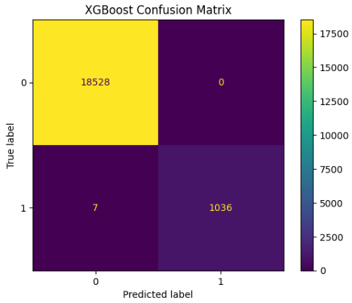
Figure 17: XGBoost Confusion Matrix

10.9 Saving the Trained Models
Once training and evaluation were complete, both the Random Forest and XGBoost models were serialized to disk using Joblib, allowing them to be reloaded and reused without requiring the entire training pipeline to be re-executed.

CHAPTER 11: RESULTS & DISCUSSION
This chapter presents and discusses the results obtained from training and evaluating the Random Forest and XGBoost classifiers on the CTGAN-augmented dataset.

11.1 XGBoost Confusion Matrix Results
The confusion matrix produced by the XGBoost classifier on the test set of 19,571 transactions showed that the model correctly classified 18,528 legitimate transactions with zero false positives, and correctly identified 1,036 out of 1,043 fraudulent transactions, with only 7 fraud cases missed (false negatives).
 | Predicted: Legitimate (0) | Predicted: Fraud (1)
Actual: Legitimate (0) | 18,528 (True Negative) | 0 (False Positive)
Actual: Fraud (1) | 7 (False Negative) | 1,036 (True Positive)

11.2 XGBoost Performance Metrics
Based on the confusion matrix above, the following performance metrics were computed for the XGBoost classifier: an Accuracy of 99.96%, a Precision of 100%, a Recall of 99.33%, and an F1 Score of 99.66%. These results indicate that the XGBoost model was able to detect fraudulent transactions with an extremely low false-negative rate while producing zero false positives, meaning that no legitimate transaction was incorrectly flagged as fraudulent.

11.3 Random Forest Performance
The Random Forest classifier also achieved very strong performance on the augmented dataset, with Accuracy, Precision, Recall, and F1 Score all in a similarly high range to the XGBoost model, as illustrated in the model performance comparison graph below. While XGBoost showed a marginal edge in recall, both models demonstrated that the CTGAN-based augmentation strategy was highly effective in enabling accurate fraud detection.

11.4 Model Performance Comparison
Figure 18 below compares the Accuracy, Precision, Recall, F1 Score, and ROC-AUC of both models side by side. Both Random Forest and XGBoost achieved scores close to 1.0 across all five metrics, confirming that the synthetic data generated by CTGAN successfully addressed the original class imbalance problem and enabled both models to learn a reliable decision boundary between legitimate and fraudulent transactions.
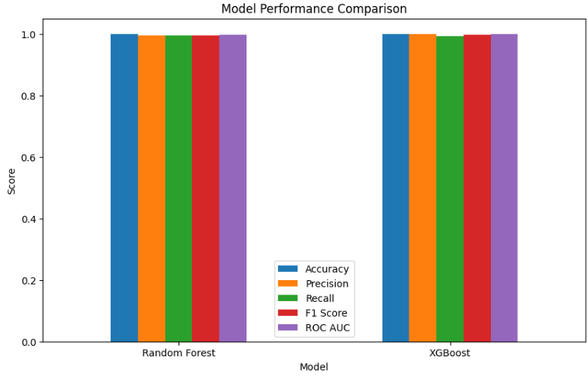
Figure 18: Model Performance Comparison Graph (Random Forest vs XGBoost)

11.5 Feature Importance
An analysis of feature importance from the trained models indicated that a small subset of the PCA-transformed features contributed disproportionately to the models' predictions, consistent with the correlation patterns observed during exploratory data analysis in Chapter 7.
[ Insert Screenshot: Feature Importance Graph ]

11.6 Discussion
The results obtained confirm that combining CTGAN-based synthetic data generation with strong ensemble classifiers such as Random Forest and XGBoost is an effective strategy for tackling the class imbalance problem inherent to credit card fraud detection. The near-zero false positive rate achieved by XGBoost is particularly significant in a real-world context, since falsely flagging legitimate transactions as fraudulent can lead to poor customer experience, while missed fraud cases (false negatives) represent a direct financial loss. The results suggest that this approach strikes an effective balance between these two competing concerns.

CHAPTER 12: ADVANTAGES
- Effective Class Imbalance Handling: CTGAN generates realistic synthetic fraud samples that better preserve feature relationships than simpler oversampling techniques such as SMOTE.
- High Detection Accuracy: Both Random Forest and XGBoost achieved near-perfect performance on the augmented dataset, demonstrating the effectiveness of the overall approach.
- Low False Positive Rate: The XGBoost model produced zero false positives on the test set, minimizing unnecessary disruption to legitimate customers.
- Reusable Synthetic Data Pipeline: The CTGAN model, once trained, can be reused to generate additional synthetic fraud samples as needed, without requiring more real fraud data.
- Scalable and Reproducible: The entire pipeline was implemented in Python using widely adopted, open-source libraries, making it easy to reproduce, extend, or deploy in a production environment.
- Model Comparison: Evaluating two different algorithms (Random Forest and XGBoost) provided a more robust and reliable assessment of the augmentation strategy's effectiveness.

CHAPTER 13: LIMITATIONS
- Computational Cost: Training a CTGAN model is computationally more expensive and time-consuming than simpler oversampling techniques such as SMOTE, particularly as the size of the training data increases.
- Risk of Distributional Drift: Since CTGAN learns the distribution of historical fraud cases, it may not fully capture new or evolving fraud patterns that were not represented in the original training data.
- Evaluation on Synthetic-Augmented Test Data: Careful validation is required to ensure that synthetic samples are not inadvertently included in the test set, as this could lead to overly optimistic performance estimates.
- Model Interpretability: While Random Forest and XGBoost provide feature importance scores, they remain comparatively less interpretable than simpler models such as Logistic Regression, which can be a concern in regulated financial environments.
- Limited Real-World Validation: The models were evaluated on a held-out test split of the same dataset, and further validation on entirely independent, real-world transaction data would be required before production deployment.

CHAPTER 14: FUTURE SCOPE
- Real-Time Deployment: The trained models could be deployed as part of a real-time transaction monitoring system, integrated with a live payment processing pipeline.
- Hyperparameter Optimization: Further tuning of the Random Forest and XGBoost hyperparameters, as well as the CTGAN training configuration, could yield additional performance improvements.
- Advanced Generative Models: Future work could explore more advanced generative architectures, such as Conditional GANs with additional constraints, or diffusion-based models for tabular data.
- Continual Learning: Incorporating a feedback loop that periodically retrains the CTGAN and classification models on newly confirmed fraud cases could help the system adapt to evolving fraud patterns over time.
- Explainable AI Integration: Techniques such as SHAP or LIME could be integrated to provide clearer, transaction-level explanations for why a given transaction was flagged as fraudulent.
- Cost-Sensitive Evaluation: Future iterations could incorporate the actual financial cost of false positives and false negatives into the model evaluation and threshold selection process.

CHAPTER 15: CONCLUSION
This internship project successfully demonstrated the application of Generative AI, specifically CTGAN, to address the class imbalance problem in credit card fraud detection. By training a CTGAN model on the existing fraudulent transactions and generating 5,000 additional synthetic fraud samples, the project produced a more balanced, augmented dataset of 97,853 transactions that enabled effective training of downstream classification models.
Both Random Forest and XGBoost classifiers, trained on this augmented dataset, achieved excellent fraud detection performance. In particular, the XGBoost model achieved an accuracy of 99.96%, a precision of 100%, a recall of 99.33%, and an F1 Score of 99.66%, correctly identifying 1,036 out of 1,043 fraudulent transactions in the test set while producing zero false positives.
This project provided valuable, hands-on experience with the complete lifecycle of a Generative AI-based machine learning solution, from data exploration and problem formulation to synthetic data generation, model training, and evaluation. It reinforced the practical understanding that addressing data quality and distribution issues, such as class imbalance, is often just as important as the choice of classification algorithm itself in building an effective and reliable machine learning system. The skills and knowledge gained during this internship at GNCIPL are expected to serve as a strong foundation for future work in Artificial Intelligence, Machine Learning, and Generative AI.

REFERENCES
1. Machine Learning Group - ULB, “Credit Card Fraud Detection Dataset,” Kaggle. [Online resource used as the basis for the working dataset in this project.]
2. Xu, L., Skoularidou, M., Cuesta-Infante, A., and Veeramachaneni, K., “Modeling Tabular Data using Conditional GAN,” Advances in Neural Information Processing Systems (NeurIPS), 2019.
3. Synthetic Data Vault (SDV) Documentation – CTGAN Model Reference, sdv.dev.
4. Chen, T., and Guestrin, C., “XGBoost: A Scalable Tree Boosting System,” Proceedings of the 22nd ACM SIGKDD International Conference on Knowledge Discovery and Data Mining, 2016.
5. Breiman, L., “Random Forests,” Machine Learning, Vol. 45, pp. 5–32, 2001.
6. Chawla, N. V., Bowyer, K. W., Hall, L. O., and Kegelmeyer, W. P., “SMOTE: Synthetic Minority Over-sampling Technique,” Journal of Artificial Intelligence Research, Vol. 16, pp. 321–357, 2002.
7. Goodfellow, I., et al., “Generative Adversarial Networks,” Advances in Neural Information Processing Systems (NeurIPS), 2014.
8. Scikit-learn Documentation, scikit-learn.org.
9. Official Python Documentation, python.org.
10. Google Colaboratory Documentation, colab.research.google.com.

APPENDIX

A.1 List of Abbreviations
Abbreviation | Full Form
AI | Artificial Intelligence
ML | Machine Learning
GAN | Generative Adversarial Network
CTGAN | Conditional Tabular Generative Adversarial Network
SDV | Synthetic Data Vault
SMOTE | Synthetic Minority Oversampling Technique
PCA | Principal Component Analysis
XGBoost | Extreme Gradient Boosting
ROC-AUC | Receiver Operating Characteristic - Area Under Curve
EDA | Exploratory Data Analysis

A.2 Key Dataset Statistics
Parameter | Value
Extracted Fraud Transactions (Original) | 213
Synthetic Fraud Samples Generated | 5,000
Augmented Dataset Size | 97,853 rows x 31 columns
Training Set Size | 78,282 rows
Testing Set Size | 19,571 rows
Missing Values in Augmented Dataset | 0
Duplicate Rows in Augmented Dataset | 0

