SCREENSHOTS

1. Neural Network

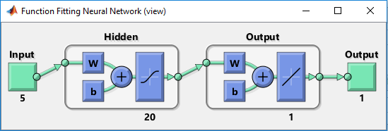

Fig **: shows number of inputs, hidden layers and Output**

1. **After Training the Neural Network**

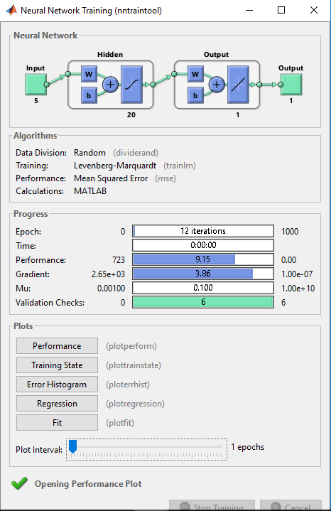

1. **Regression lines**

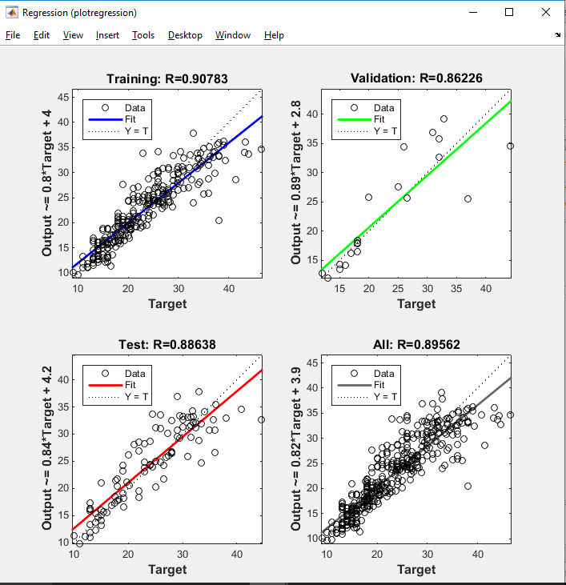

**R = 0.90 for the training data**

**This means the model is trained to have 90% accuracy.**

1. **Curves for Training, testing and validation**

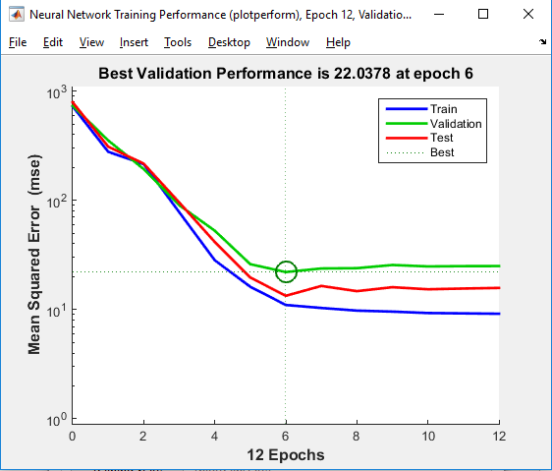

**All three curves are near to the best line.**

**Hence they have very good percentage of training , testing and validation with very less error.**

1. **Test Regression line**

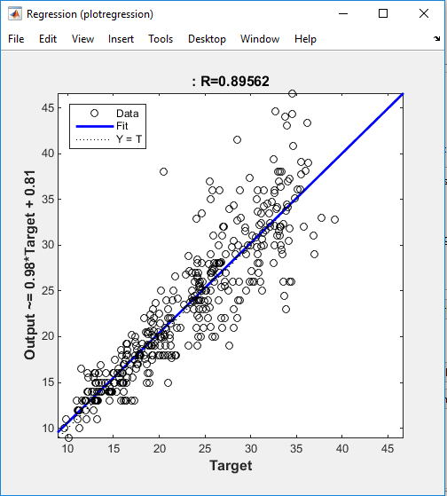

**For the test data, R = 0.89**

**It has 89% of accuracy while calculating the target variable.**

1. **ERROR CALCULATION**

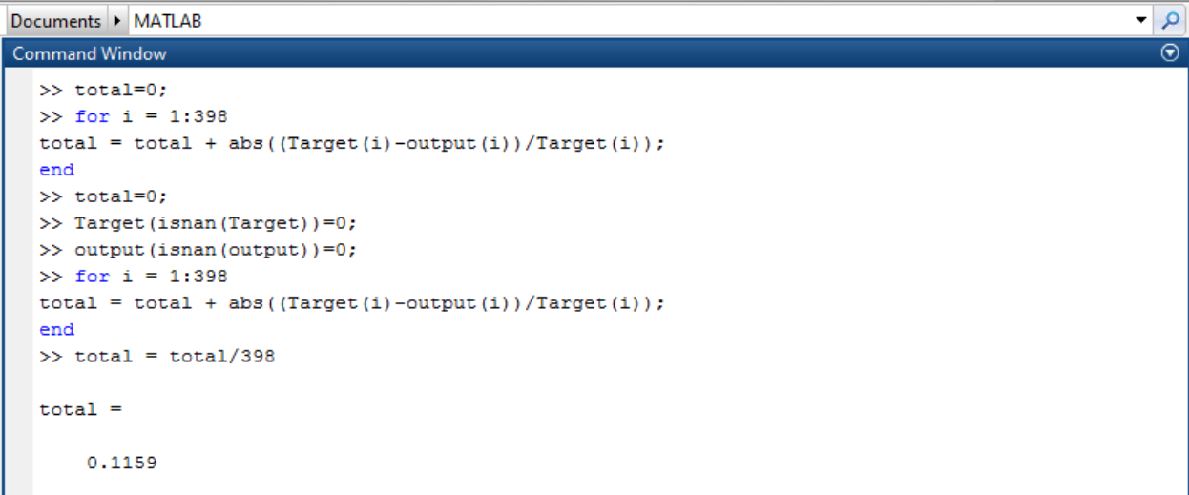

**It says there is 89% accuracy in the model when the model is tested.**

**Error is only 0.1159%**

1. **ERROR HISTOGRAM**

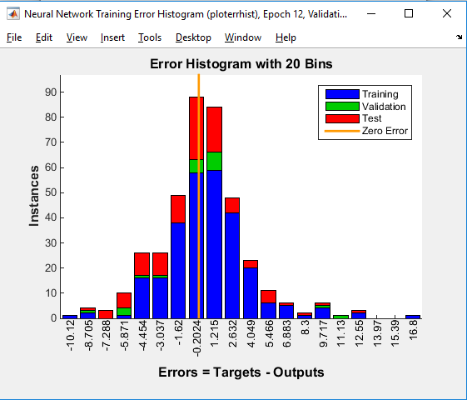

1. **TEST ERROR HISTOGRAM**

