

SER-594

Advanced Software Design

**SNEHA VIDHYASHEKAR | ASSIGNMENT-2 | 03/18/2018**

**ASU ID: 1211274841**

# CONDITIONS

My model has following constraints:

* It consists of 9 rooms. There are 3 rooms in a row, each separated by a wall made of hardwood. Totally, there are three rows (1 row 🡺 3 rooms). All on the same floor of the building.
* Each room is surrounded by four walls. Some walls are common to adjacent rooms. All the walls are made of wood(hardwood) with thickness(t=0.25) and thermal conductivity(k=0.16).
* All the walls are connected to the room with connectors.
* Each wall has the dimension 🡪 length = 4m and width=4m
* Each wall has two connectors. One is the inner flow and one is considered as outer flow. These connectors help to determine the heat flow from environment to wall and from wall to room.
* Each room has one connector. This is used has both inner flow and outer flow.
* Each room is of Volume = 4*4*4. At the beginning I had considered it with Volume=2*2*2 which was taking way too much time for simulation and getting the result.
* Dimension of room and wall are kept constant since they remain same.
* I tried to use SI Units in Modelica. But it was throwing error and not recognizing even after importing the SI Units library/package. Thus, I have used standard way of “Real” types.

## **DIAGRAMS**

**DESIGN**

ROOM MODEL:

Single room surrounded by four walls (hardwood walls)

Room   
Volume= 4*4*4

Wall  
Length*width = 4*4= Area of the wall

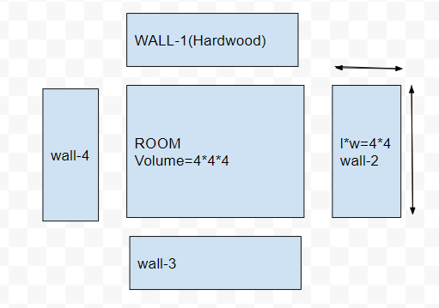

**Figure: Single room surrounded by 4 walls without connectors**

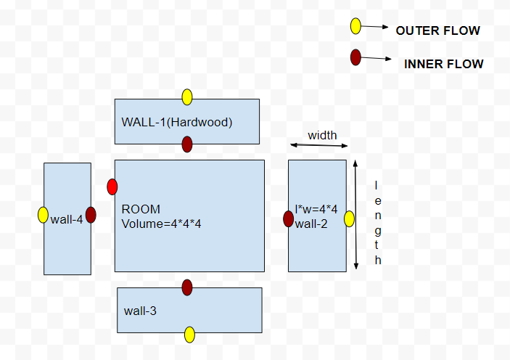

**Figure: Single room surrounded by 4 walls with connectors**

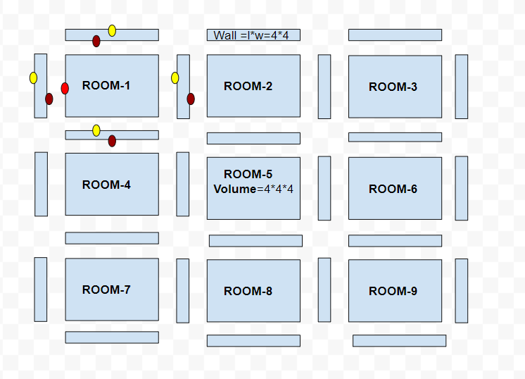

**Figure: Nine Rooms each surrounded by 4 walls and have common walls with adjacent rooms**

* **In the above figure I have shown connector for one room and all other rooms have similar connectors.**
* **Red** 🡪 **inner flow**
* **Yellow** 🡪 **outer flow**
* **I have used 2 connectors for wall – inner flow connector and outer flow connector**
* **I have used single connector for room which acts as both inner and outer flow.**

**Challenge faced with 2 connectors for room: By adding 2 connectors to the room, I had complex issues using connect statement. So, I reduced it to ONE.**

**GRAPHS**

Heat flows from hotter region to cooler region. All my temperature is in degree Celsius and not converted to Kelvin.

Initially,

* Room temperature is 20-degree C
* Environment temperature is zero (0) degree C

So, the heat must flow from room to the environment. Now, temperature inside the room will initially be cooled down to Zero degree Celsius as shown in the graph below.

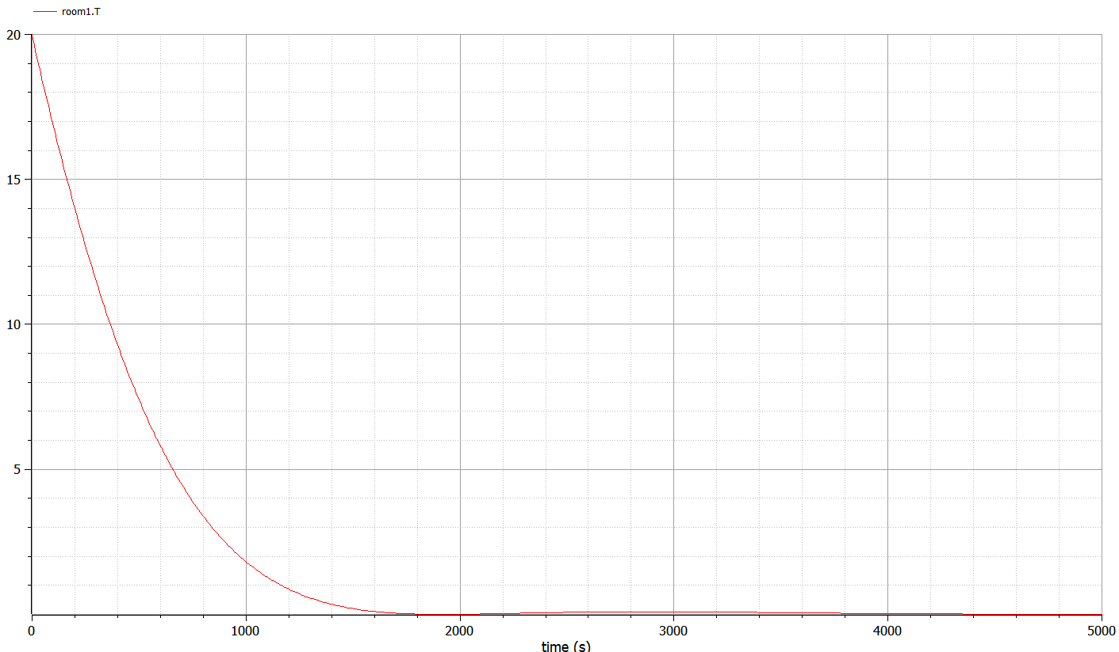

**Graph:1 Temperature falls from 20-degree C to Zero Degree C [Room-1]**

**Graph comparing 2 rooms temperature.**

* One that is closest to the environment and the one far from the environment.
* Room closest to the environment should cool down fast compared to the one that is away from the environment (or surrounded by other rooms)
* Room -1 is close to the environment.
* Room – 5 is the innermost room surrounded by other rooms.
* Room-1 must cool down faster than Room-5. This is shown in the below graph

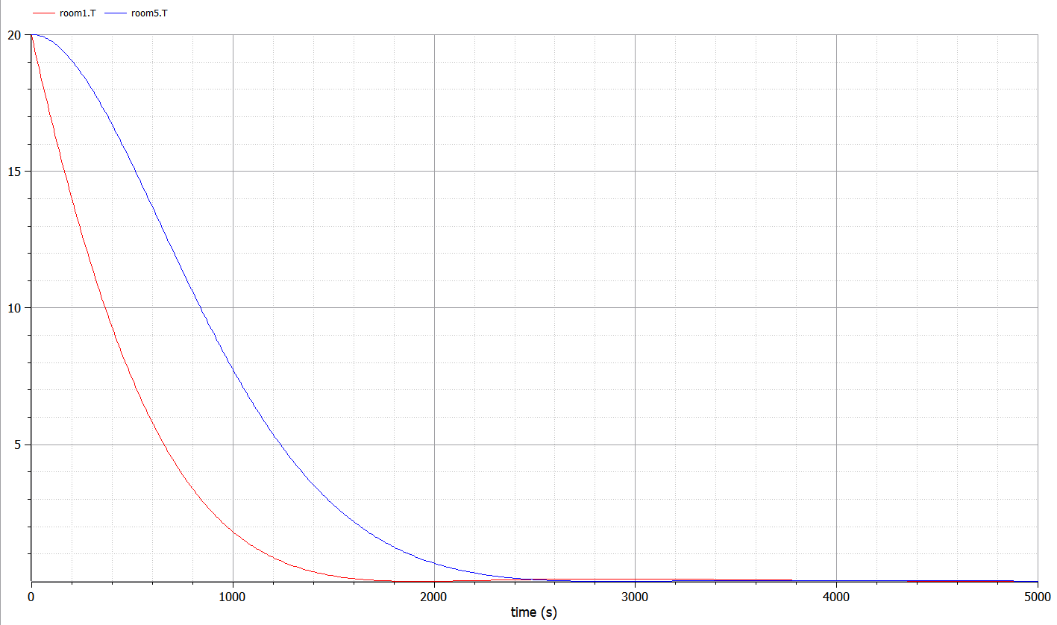

**Graph:2 Room-1 cools down faster than Room-5**

**Comparing 3 different kinds of Rooms – cooling down**

1. Room-1 🡪 closest to the environment
2. Room-5 🡪 inner most room(surrounded by other rooms)
3. Room-4 🡪 surrounded one side by the environment and other 3 sides by rooms

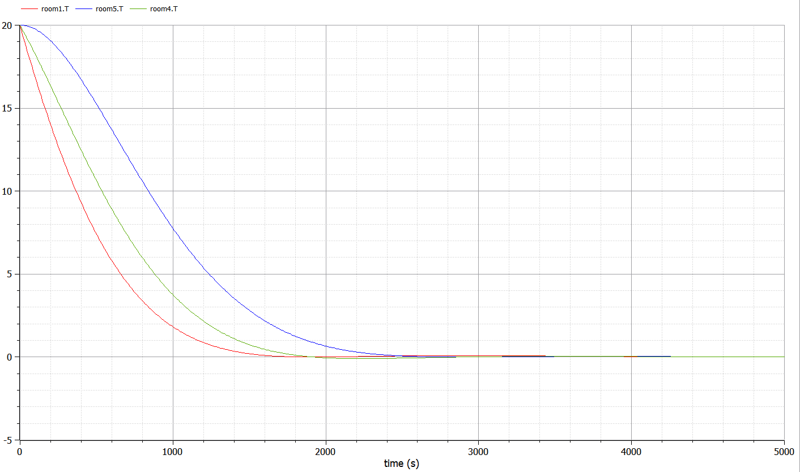

**Graph:3 Room-5 > Room-4 > Room-1**

**Conclusion of Graph-2:**

Room-5cools down at slower rate when compared to Room-4 and Room-4 cools down at slower rate when compared to Room-1

**Rate of cooling down**: Time taken by each room is given by  
**Room-5 > Room-4 > Room-1**

**Simulation set-up for my model**

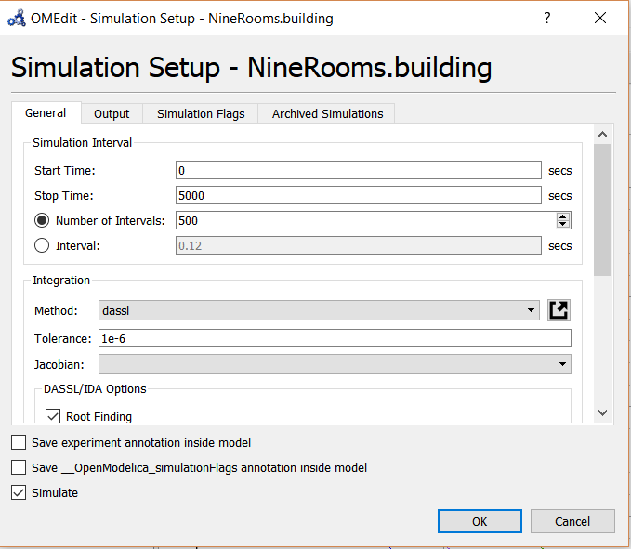

From all the above results, I would like to conclude that my model behaves as expected and hence it is correct.