Mini Project Report

12. Visualization Screenshots
Figure 1: Average Exam Score by Gender
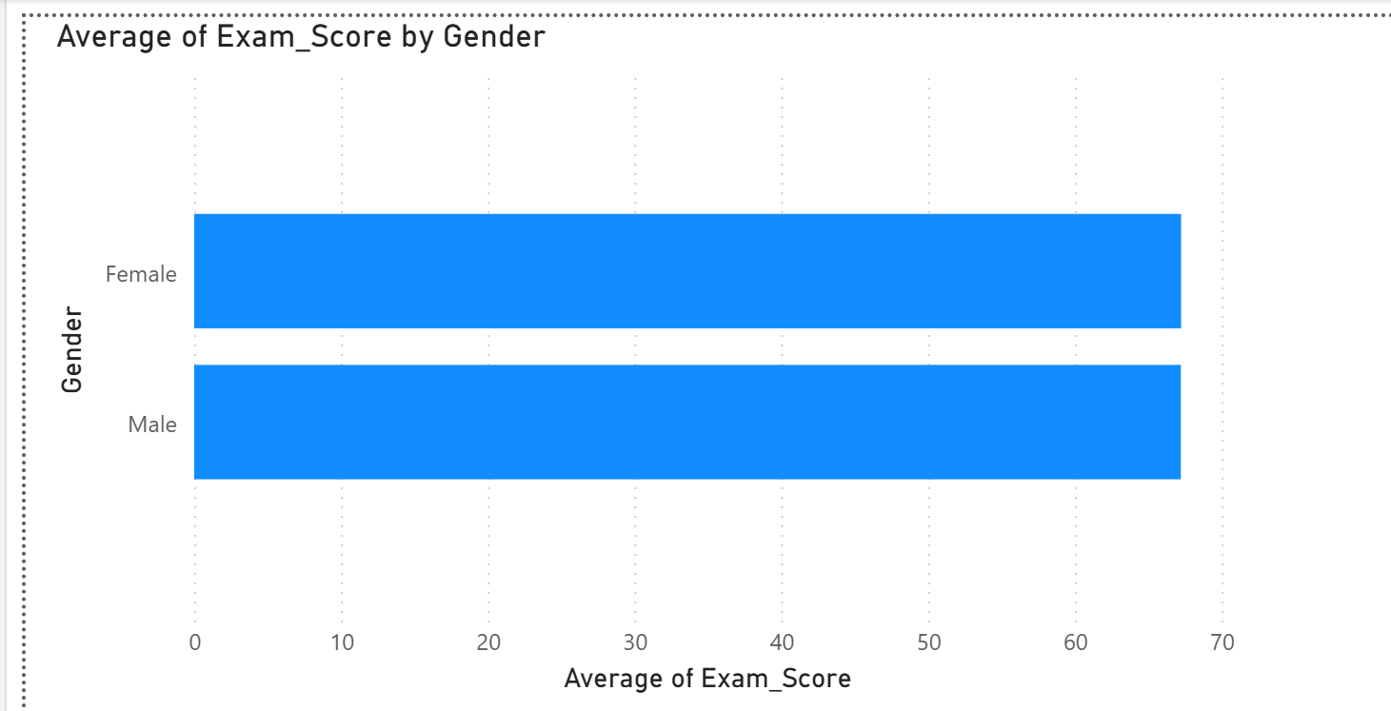
Figure 2: Motivation Level Distribution
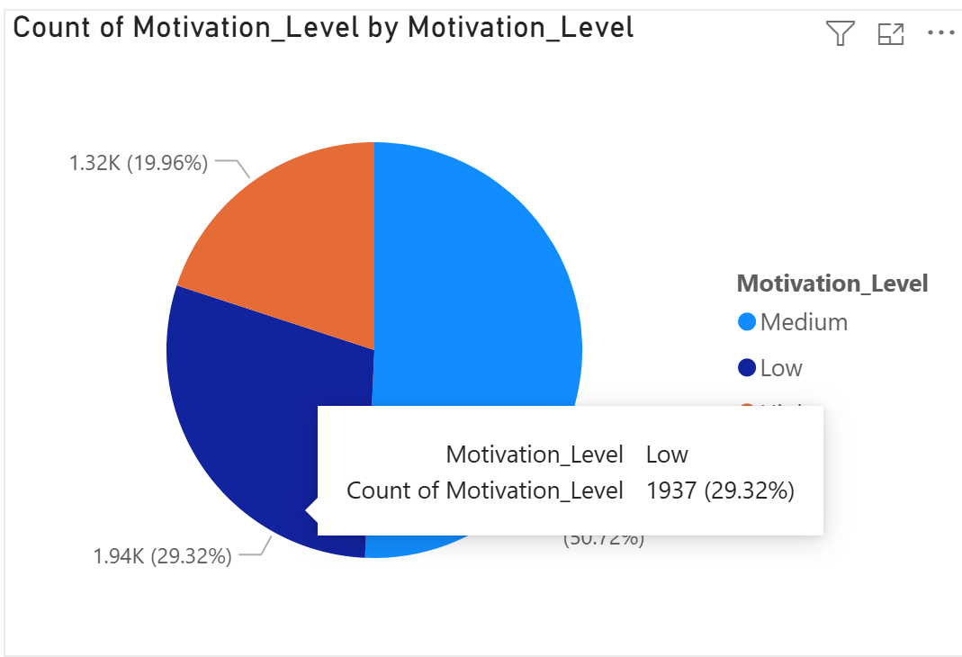

Literature Review
Several studies have explored the use of data mining and machine learning techniques in the field of education to analyze and predict student performance. Researchers have found that factors such as study habits, attendance, socio-economic background, and learning environment significantly influence academic outcomes. Machine learning algorithms like Decision Trees, Logistic Regression, and Random Forest have been widely used for classification and prediction tasks in educational datasets. Visualization tools such as Power BI and Tableau are also commonly used to present insights in an interactive manner. These studies highlight the importance of integrating data preprocessing, statistical analysis, and visualization for effective decision-making in academic institutions.

