WEEK 1 — DATA SCIENCE PROJECT PLANNING
Student Academic Performance Prediction & Early-Warning System
A Python-based hypothetical data science project plan

Project Attribute | Planned Definition
Project type | Supervised machine learning + exploratory data analysis
Primary domain | Education analytics
Primary prediction target | End-of-term academic performance / risk category
Planned implementation | Python-based reproducible workflow
Estimated Week 1 effort | 32 hours
Week 1 deliverable | Project strategy, architecture, timeline and evaluation plan

Prepared as a strategic planning document

1. Executive Summary
This project proposes a hypothetical Student Academic Performance Prediction and Early-Warning System that uses Python and machine learning to identify students who may be at elevated academic risk before the end of an academic term. The purpose is not to replace teachers or make high-stakes decisions automatically, but to transform available educational signals into interpretable insights that can support timely academic intervention.
The planned workflow follows a standard data science lifecycle: problem definition, data-source planning, data collection, data quality assessment, cleaning, exploratory data analysis (EDA), feature engineering, model development, evaluation, interpretation, reporting, and iteration. Because this is a planning exercise, no real dataset is required in Week 1. The document therefore specifies what data would be needed, how it would be processed, which models would be considered, how success would be measured, and what risks would need to be controlled.
- Primary analytical question: Can academic risk be identified early enough to enable useful support?
- Secondary question: Which measurable factors are most strongly associated with academic outcomes?
- Design principle: prioritize interpretability, reproducibility, privacy, fairness, and useful actionability.
- Planned effort: 32 hours, distributed across planning, data strategy, analytics design, modeling strategy, and reporting.

2. Project Background and Motivation
Educational institutions routinely generate information about attendance, assessments, assignments, learning activity, previous performance, and course engagement. In a hypothetical institution, these signals could be combined to understand patterns associated with academic difficulty. The motivation for this project is that support is generally more useful when it is offered before a student reaches a severe academic deficit.
A data science approach can help move from isolated records to evidence-based patterns. Python is particularly suitable because it provides a mature ecosystem for data manipulation, statistical analysis, visualization, machine learning, model interpretation, and reproducible experimentation.

2.1 Problem Statement
Given historical and current academic indicators, design a reproducible Python workflow that estimates the likelihood that a student will fall into an academically at-risk category by the end of a term, while also identifying the factors that contribute to the prediction.

2.2 Why the Problem Matters
- Early identification can support timely tutoring, mentoring, study-planning, or other appropriate academic support.
- Aggregated analysis can reveal recurring patterns in attendance, assessment performance, and engagement.
- Interpretable models can help stakeholders understand why a prediction was made rather than receiving only a score.
- A documented pipeline creates a foundation for future dashboards or institutional analytics systems.

3. Project Objectives and Scope

3.1 SMART-Oriented Objectives
- Define a data model containing relevant academic, engagement, and contextual variables suitable for predictive analysis.
- Design a robust data-cleaning pipeline covering missing values, duplicates, invalid ranges, inconsistent categories, and potential leakage.
- Conduct exploratory analysis to identify distributions, relationships, trends, outliers, and potential sources of bias.
- Develop a baseline model and at least two candidate machine-learning approaches for comparison.
- Evaluate models using metrics appropriate for an early-warning classification problem, emphasizing recall, precision, F1-score, ROC-AUC/PR-AUC, and calibration where appropriate.
- Produce interpretable findings that translate model output into actionable, non-automated academic support insights.
- Document assumptions, risks, limitations, reproducibility requirements, and a path from prototype to future implementation.

3.2 In Scope
- Historical academic and engagement data design.
- Data validation, cleaning, transformation, and exploratory analysis.
- Feature engineering and leakage prevention.
- Binary or multiclass academic-risk prediction.
- Baseline and candidate machine-learning models.
- Model evaluation, error analysis, interpretability, and reporting.
- Documentation of privacy, fairness, governance, and reproducibility considerations.

3.3 Out of Scope
- Automatic disciplinary or admission decisions.
- Automated grading of students.
- Collection of sensitive personal information that is unnecessary for the analytical objective.
- Real-world deployment during Week 1.
- Production cloud infrastructure, mobile applications, or a full institutional dashboard.
- Claims that correlation proves causation.
- Use of predictions as the sole basis for high-impact decisions about individual students.

4. Stakeholders and Success Definition
Stakeholder | Interest | Expected Contribution / Need
Students | Fair and useful support | Transparent, non-stigmatizing interventions
Faculty / mentors | Early academic signals | Interpretable risk indicators and trends
Academic administration | Program-level improvement | Aggregated insights and reporting
Data science team | Reliable analytical pipeline | Clean data, reproducible code, measurable performance
IT / data governance | Security and compliance | Access control, data minimization, auditability

4.1 Success Criteria
- The complete analytical workflow is logically documented and reproducible.
- Data-quality issues and assumptions are explicitly recorded.
- The chosen evaluation metrics align with the cost of false positives and false negatives.
- Model results can be interpreted by non-technical stakeholders.
- The project identifies limitations and mitigation strategies rather than presenting model output as certainty.

5. Methodology and Strategy
The methodology is designed as an iterative lifecycle rather than a one-way sequence. Evaluation findings may require returning to feature engineering, data cleaning, or even problem formulation.
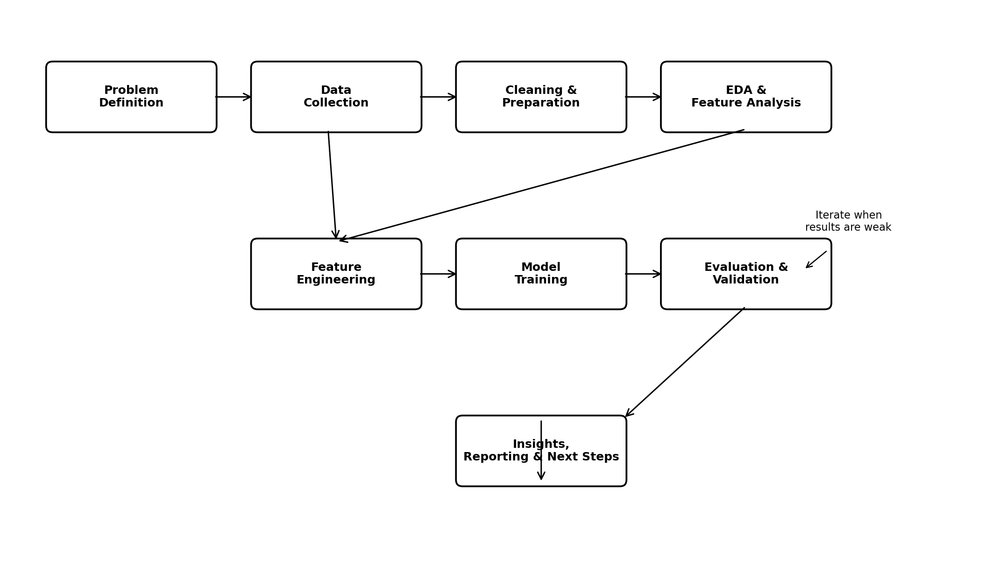
Figure 1. Planned end-to-end data science workflow.

5.1 Phase A — Problem Definition
- Define the prediction unit: one student-course or student-term record.
- Define the prediction horizon: an early point in the term before final outcome is known.
- Define the target carefully, e.g., an academic-risk class derived from a pre-agreed outcome rule.
- Identify the cost of false negatives versus false positives.
- Define what action, if any, would follow from an elevated-risk signal.

5.2 Phase B — Data Collection Strategy
A hypothetical dataset may contain the following categories:
Category | Example Variables | Purpose
Academic history | Prior GPA/marks, previous course outcomes | Capture prior academic trajectory
Current performance | Quiz scores, assignment scores, midterm score | Measure current learning progress
Attendance | Attendance percentage, missed sessions | Represent participation patterns
Engagement | LMS activity, submission timeliness, practice activity | Capture learning engagement
Course context | Course credits, assessment structure | Control for course differences
Support history | Tutoring/mentoring participation | Understand intervention context
Data collection should follow data minimization: only variables with a defensible analytical purpose should be retained. Sensitive attributes should not be included merely because they are available. If protected attributes are needed for fairness auditing, they should be handled under appropriate governance rather than treated as ordinary predictive features.

5.3 Phase C — Data Cleaning and Preparation
- Check schema, data types, duplicate records, impossible values, and inconsistent category labels.
- Quantify missingness by variable and by relevant groups.
- Choose imputation rules based on variable meaning and missingness mechanism; avoid blindly replacing every missing value with a mean.
- Detect outliers using domain-aware rules and robust statistical methods.
- Encode categorical variables appropriately and scale numerical features where required by the chosen algorithm.
- Split data into training, validation, and test sets before fitting transformations that could leak information.
- Document every transformation in code so the same pipeline can be reproduced on future data.

5.4 Phase D — Exploratory Data Analysis
- Univariate analysis: distributions, central tendency, spread, missingness, and unusual values.
- Bivariate analysis: target relationships with attendance, assessment performance, and engagement.
- Multivariate analysis: interaction patterns and correlated predictors.
- Segment analysis: compare performance across courses, cohorts, or other legitimate analytical groups.
- Investigate whether apparent predictors are proxies for the target or are only available after the prediction point.

5.5 Phase E — Feature Engineering
- Aggregate assessment scores into meaningful progress indicators.
- Create trend features such as change in performance across assessments.
- Calculate attendance or engagement ratios over a defined observation window.
- Create missingness indicators when missingness itself may contain useful information.
- Avoid post-outcome variables and any feature that would only become known after the prediction date.

5.6 Phase F — Modeling Strategy
The project will begin with a simple baseline before testing more flexible algorithms.
Model | Role | Advantages | Potential Limitation
Dummy / majority baseline | Reference point | Simple, establishes minimum benchmark | Not predictive
Logistic Regression | Interpretable baseline | Fast, explainable, strong baseline | Linear decision boundary
Decision Tree | Interpretable nonlinear model | Easy to explain, captures interactions | Can overfit
Random Forest | Robust nonlinear candidate | Handles nonlinearities and mixed patterns | Less transparent than a single tree
Gradient Boosting | High-performance candidate | Often strong predictive performance | Requires tuning and careful validation
Model selection will not be based solely on the highest score. The final candidate should balance predictive quality, calibration, interpretability, stability, fairness considerations, and operational usefulness.

5.7 Phase G — Evaluation and Validation
For an early-warning problem, missing a genuinely at-risk student may be more costly than incorrectly flagging a student who is later found to be doing well. Therefore, recall for the at-risk class will receive particular attention, while precision and the overall false-positive burden will also be monitored.
Metric | Why It Matters
Recall / Sensitivity | Measures how many genuinely at-risk cases are identified.
Precision | Measures how often an at-risk prediction is correct.
F1-score | Balances precision and recall.
ROC-AUC | Measures ranking/discrimination across thresholds.
PR-AUC | Especially informative when the at-risk class is relatively uncommon.
Confusion matrix | Shows the practical pattern of correct and incorrect classifications.
Calibration | Checks whether predicted probabilities correspond reasonably to observed frequencies.
Cross-validation will be considered for training-stage model comparison. The final test set should remain untouched until the model-selection process is complete. Threshold selection should reflect the intended intervention capacity and the relative cost of false positives and false negatives.

6. Project Strategy Architecture
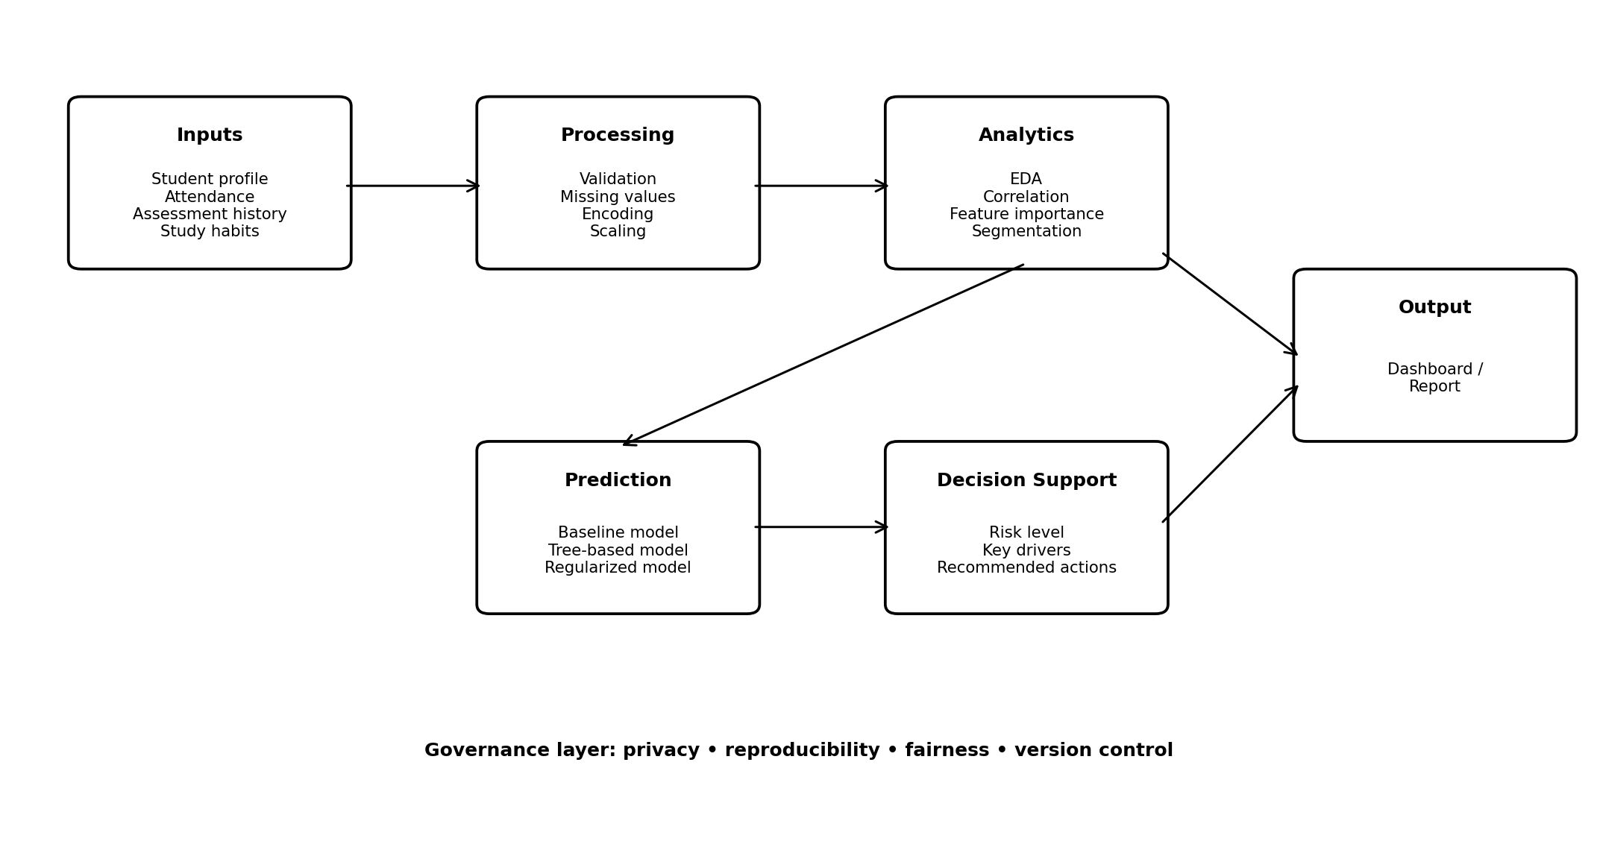
Figure 2. Conceptual data-to-insight architecture.

6.1 Reproducibility Strategy
- Use a consistent project structure separating raw data, processed data, notebooks/scripts, source code, reports, and figures.
- Keep configuration and assumptions explicit rather than embedded invisibly in notebooks.
- Use Git for version control and meaningful commit messages.
- Record Python version and package dependencies.
- Set random seeds where reproducibility is appropriate.
- Persist preprocessing and model pipelines so training and inference use identical transformations.

7. Tools and Technology Stack
Tool / Library | Planned Use
Python | Primary programming language and workflow orchestration
Pandas | Data loading, cleaning, transformation, tabular analysis
NumPy | Numerical operations and array-based computation
Matplotlib | Core visualizations and project charts
Seaborn | Statistical visualization during EDA
Scikit-learn | Preprocessing, model training, validation and metrics
SciPy | Selected statistical procedures where justified
Jupyter Notebook | Exploratory analysis and documented experimentation
VS Code | Code editing and project organization
Git / GitHub | Version control and collaboration
Python virtual environment | Dependency isolation and reproducibility

7.1 Proposed Project Structure
student-performance-project/
├── data/
│ ├── raw/
│ └── processed/
├── notebooks/
├── src/
│ ├── data/
│ ├── features/
│ ├── models/
│ └── evaluation/
├── reports/
├── figures/
├── tests/
├── requirements.txt
└── README.md

8. Timeline and Work Allocation
The Week 1 plan allocates 32 hours, which fits the requested 30–35 hour range. The schedule is intentionally front-loaded toward problem definition and data strategy because weak assumptions at the beginning can invalidate later modeling work.
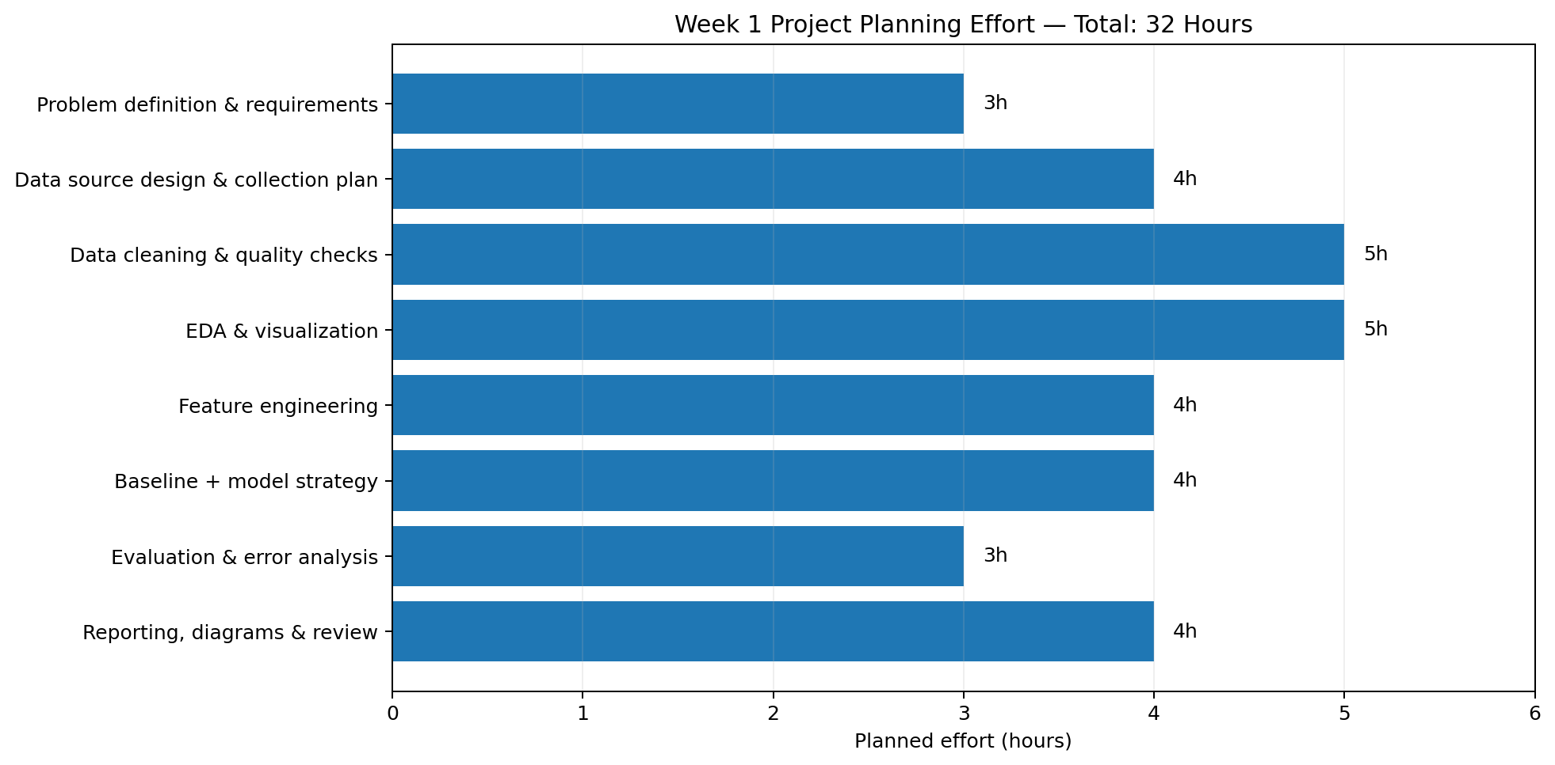
Figure 3. Planned 32-hour effort distribution.
Work Package | Hours | Main Deliverable
Problem definition & requirements | 3 | Problem statement, target, stakeholders, success criteria
Data source design & collection plan | 4 | Data dictionary and collection strategy
Data cleaning & quality strategy | 5 | Quality checklist and preprocessing design
EDA & visualization strategy | 5 | Analysis questions and visualization plan
Feature engineering | 4 | Candidate feature definitions and leakage controls
Baseline + model strategy | 4 | Model shortlist and validation approach
Evaluation & error analysis | 3 | Metric framework and error-analysis plan
Reporting, diagrams & review | 4 | Final Week 1 DOC and strategic diagrams
TOTAL | 32 | Complete project plan

9. Expected Outcomes, Challenges and Mitigation

9.1 Expected Outcomes
- A clearly defined data science problem with measurable objectives.
- A documented data pipeline from raw inputs to analysis-ready features.
- A defensible modeling and evaluation strategy.
- A prioritized set of candidate features and hypotheses for later testing.
- A model comparison framework rather than a single-model assumption.
- A reproducible project architecture suitable for future technical implementation.
- Action-oriented insights that can support academic intervention without replacing human judgment.

9.2 Key Challenges and Mitigation
Challenge | Potential Impact | Mitigation
Missing or inconsistent data | Biased or unstable results | Profile missingness, validate ranges, document imputation
Class imbalance | Poor detection of minority risk class | Use PR-AUC, class-aware metrics, threshold analysis, suitable resampling only within training
Data leakage | Unrealistically high validation performance | Define prediction cutoff and audit every feature for availability at that time
Overfitting | Weak generalization | Cross-validation, regularization, simpler baselines, held-out test set
Concept drift | Performance decreases over time | Monitor performance and reassess features/model periodically
Bias / unfair outcomes | Unequal impact across groups | Data governance, subgroup evaluation, feature review, human oversight
Low interpretability | Stakeholders cannot act on results | Prefer interpretable baselines and use feature/model explanation methods
Privacy concerns | Unauthorized or harmful use | Data minimization, access control, de-identification and governance
False alarms | Unnecessary interventions | Threshold tuning and capacity-aware intervention design

10. Ethics, Privacy and Responsible Data Science
Because the hypothetical project concerns students, responsible data use is a core design requirement rather than an optional add-on. Predictions should be treated as probabilistic signals, not facts about a student's ability, motivation, or future.
- Collect only data that has a legitimate and documented analytical purpose.
- Avoid exposing identifiable student records in notebooks, charts, or reports.
- Separate model-development data from personally identifiable information where feasible.
- Define who can access predictions and for what purpose.
- Evaluate model performance across relevant groups where legally and ethically appropriate.
- Do not use the system to stigmatize, punish, or automatically deny opportunities.
- Provide a human review process and a way to question or contextualize a prediction.
- Document limitations clearly so stakeholders do not mistake statistical association for causation.

11. Week 1 Deliverables Checklist
- ☐ Project background and motivation
- ☐ Problem statement
- ☐ Objectives and success criteria
- ☐ In-scope and out-of-scope definitions
- ☐ Stakeholder map
- ☐ Data-source and data-dictionary plan
- ☐ Data cleaning strategy
- ☐ EDA strategy
- ☐ Feature engineering strategy
- ☐ Model shortlist
- ☐ Evaluation metric framework
- ☐ End-to-end flowchart
- ☐ Project strategy architecture diagram
- ☐ 32-hour timeline chart
- ☐ Tools and technology stack
- ☐ Expected outcomes
- ☐ Risk and mitigation matrix
- ☐ Ethics, privacy, fairness and reproducibility considerations

12. Conclusion
This Week 1 plan establishes a complete strategic foundation for a hypothetical Python-based data science project. The proposed Student Academic Performance Prediction and Early-Warning System provides a realistic setting in which the full data science lifecycle can be planned without requiring a dataset at this stage.
The most important design choice is to treat the project as an iterative analytical process: define the question carefully, collect only defensible data, prevent leakage, understand the data before modeling, compare models against a baseline, evaluate using metrics aligned with the real objective, and communicate uncertainty and limitations. The resulting architecture can later be implemented technically when an appropriate dataset becomes available.

Appendix A — Proposed Analysis Questions
- How strongly does attendance relate to end-of-term performance?
- Does a declining assessment trend provide earlier warning than a single low score?
- Which engagement indicators add predictive value beyond prior academic performance?
- How does model performance change under different prediction thresholds?
- Which types of errors are most common and what practical consequences might they have?
- Are predictions stable across courses or cohorts?
- Which variables remain important when highly correlated features are controlled?
- Does the model remain calibrated when applied to a later cohort?

Appendix B — Recommended Future Technical Tasks
- Acquire or construct a suitable de-identified dataset.
- Implement the data dictionary and validation checks.
- Build the cleaning and preprocessing pipeline in Python.
- Perform EDA and document findings.
- Engineer candidate features while enforcing the prediction cutoff.
- Train baseline and candidate models.
- Tune models using cross-validation without touching the final test set.
- Perform threshold, calibration, subgroup and error analysis.
- Package the final pipeline and produce a technical report/dashboard.

