Laboratory for Electrical Instrumentation and Embedded Systems IMTEK – Department of Microsystems Engineering

University of Freiburg

Sensors Lab Course Winter term 2022/23

Lab Report M1

**Pressure and Acceleration Sensors**

**Deepu Krishnareddy (5367859)**

January 06, 2022



Data generated in a team together with

* Deepu Krishnareddy (5367859)
* Bhoomika Subramani (5366969)
* Sneha Ganganna (5579362)

# Introduction

The altitude calculation plays a key role in many small to critical applications. In this module, we calculate altitude for floor detection and indoor localization by two different methods and compare them. One method uses the relation between pressure and altitude and the other one uses acceleration readings in the z-direction from the sensors embedded into Arduino Nicla ME

# Theory

The barometric formula gives the relation between altitude and pressure. Altitude can be calculated by using a barometric formula at any instant by either using the temperature at that instant the effect of which doesn’t significantly change our results as our altitude difference is very small.

(1)

where p0 is the reference pressure, and T is the absolute temperature. The constants are standard gravity = 9.81 m s–2, the molar mass of air M = 0.02896 kg mol–1, and the universal gas constant R = 8.314 J mol–1 K–1

The altitude can also be calculated using acceleration values only if there is an acceleration change in the z-direction. By definition the integration of acceleration gives velocity and integrating that again gives the displacement. Displacement in the z-direction can be considered as height.

## Pressure Sensor

Pressure sensors are used in everyday applications for control and monitoring and other application like fluid flow, altitude, and water level measurement. There are drastic varieties of pressure sensors varies in performance, design, stability, cost, etc.. There are around 50 technologies and at least 300 companies that make pressure sensors all over the world [1]

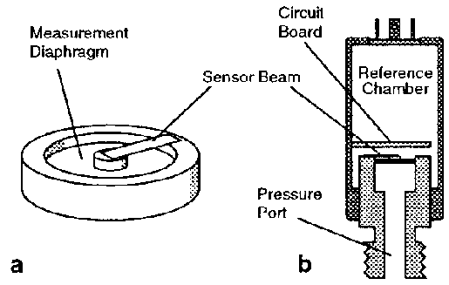

Figure 1: Schematic diagram of the pressure transducer. (a) Detail of measurement of diaphragm and sensor beam, shown at approximately 26 scales. (b) Cross-section, shown at approximately 1/2 scale [2]

The Pressure sensors are classified in terms of various parameters. There are different types of pressure sensors basis on how they measure pressure. Some examples are the Absolute pressure sensor, Gauge pressure sensor, and vacuum pressure sensor. In our experiments, we use BMP390 which is an absolute pressure sensor. The BMP390 is a very small, low-power, and low-noise 24-bit absolute barometric pressure sensor. The digital, high-performance sensor is ideally suited for a wide range of altitude-tracking applications which has a pressure range of 300 to 1250 hPa [3]

## Acceleration Sensor

Accelerometers are sensing transducers that provide an output proportional to acceleration, vibration1, and shock. A 3-axis accelerometer is a device that is designed to measure acceleration along three axes in space — the forward and back X-axis, the left and right Y-axis, and the up and down Z-axis**.**Capacitive accelerometers are similar in operation to piezoresistive accelerometers, in that they measure a change across a bridge; however, instead of measuring a change in resistance, they measure a change in capacitance. The sensing element consists of two parallel plate capacitors acting in a differential mode. These capacitors operate in a bridge configuration and are dependent on a carrier demodulator circuit or its equivalent to producing an electrical output proportional to acceleration.

Several different types of capacitive elements exist. One type, which utilizes a metal sensing diaphragm and alumina capacitor plates, can be found in Figure 2. Two fixed plates sandwich the diaphragm, creating two capacitors, each with an individual fixed plate and each sharing the diaphragm as a movable plate.

An accelerometer Sensor is a transducer that measures acceleration or change in velocity in X, Y, and Z directions. Accelerometer converts mechanical energy to electrical energy. When a mass is kept on the sensor which is actually just like a spring it starts moving down. Since it is moving down it starts experiencing acceleration. That acceleration hen gets converted into an amount of electric signal which is used for the measurements of variation in the position of the device. The accelerometer can be found in both the forms analog as well as digital form devices

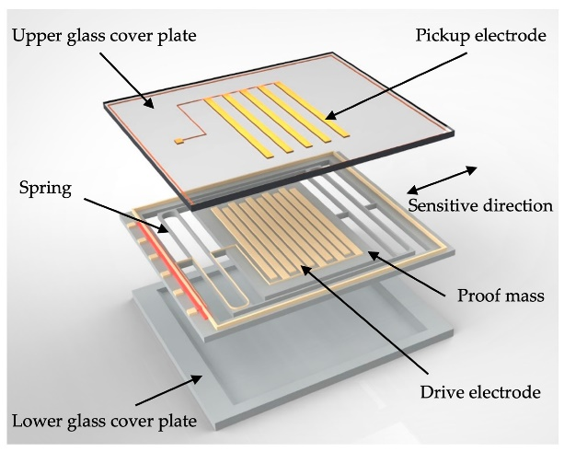

Figure 2: MEMS Accelerometer [4]

MEMS accelerometers are used wherever there is a need to measure linear motion, either movement, shock, or vibration but without a fixed reference. They measure the linear acceleration of whatever they are attached to. Acceleration is measured in m s-2, but the convention for accelerometers is in ‘g’, or units of gravity, 1g being 9.81 m s-2

# Methods

For all our sensor data acquisition, we use Arduino Nicla ME in standalone mode and we sample data every 100ms. Data is transmitted serially using USB also the module is powered using a USB.

Arduino Nicla embedded BP390 pressure sensor and BHI260AP which has an accelerometer. These two sensors are used in this module for various experiments, data acquisition, etc. The board was programmed using the Arduino IDE version 2.0 with the Arduino_BHY2 library version 1.5 (Bosch Sensortec).

We used the pyserial library in python for receiving the transmitted data from Arduino Nicla Me to python for further processing and plotting. We also used Arduino’s serial monitor for basic visualization.

The Arduino program read the sensors using the sensors SENSOR_ID_ACC for the acceleration sensors in BHI260AP and SENSOR_ID_BARO for the pressure sensor BMP390 each 100 ms resulting in an acquisition rate of 10 Hz.

For the first 2 tasks which have basic data acquisition and plotting. The sensor was placed in a stable position and the transmitted sensor reading were taken in python using the pyserial library the data was stored in a NumPy array in a .npz file for further processing, plotting, and reproducing the plots in the future.

For task 3, the Nicla ME board was placed parallel to the floor in the elevator. Then on the ground floor, some initial readings of pressure and acceleration in the z-direction were taken after some seconds elevator was moved from zero to the tenth floor while the sensor values were continuously transmitted from the Nicla which records the upward motion and acceleration. For recording downward movement the elevator ride from the tenth floor to the ground was taken.

With acceleration and pressure values, temperature values were also recorded which were needed to substitute in the barometric formula to get altitude.

After getting the sensor data further processing of data was made. The altitude was measured in 2 ways. One used pressure data and barometric formula and the other one was using linear acceleration in the z-direction which was then double-integrated to get the altitude.

Tenth Floor

Moving upwards (+Z)

Elevator

X

Y

Z

Moving downwards(-Z)

Ground Floor

BHI260AP

BMP390

Figure 3: Setup of elevator task

# Results and Discussion

## Task 1

The first part of task 1 addresses the performance of the pressure sensor. The Nicla Sense Me board is placed flat on the table and the values are logged using the Putty. Figure 5 shows the reading for the 1000 samples taken. No drift or offset is visible. The mean value and the offset are calculated. The subtracted mean value is plotted in a histogram

Task 1 comprises of acquisition and plotting of data from the pressure sensor in frequent intervals of 100 ms for over 1000 samples. The mean and standard deviation is also calculated and mean subtracted data is plotted to get the idea of senor value distribution over a number of samples in a stable condition which helps in analyzing the drift of the sensor.

1000 readings are taken multiple times in order to observe changes in the value, however, there is no significant change, and only slight drift is observable when the sensor is in the rest position. 4. Mean and offset of these 1000 values are calculated and a histogram was plotted for p-p̅ using Python.

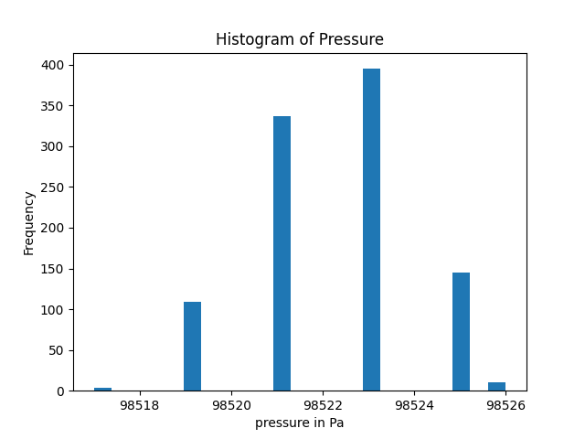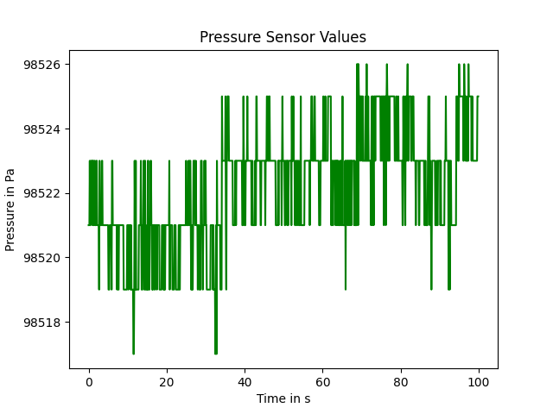

Figure 4: Pressure sensor reading at rest. Figure 5: Histogram of pressure values.

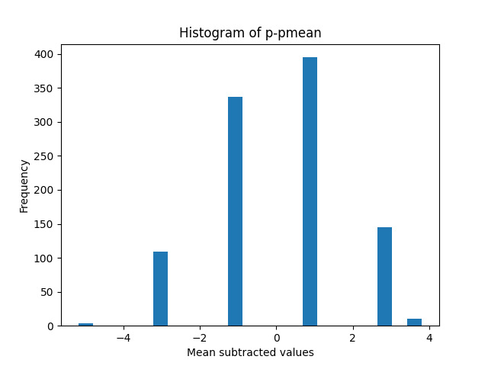

Figure 6: Histogram of mean subtracted pressure values (p-p̅) of 1000 readings.

Most of the Pressure readings are close to the mean. The measured mean pressure value is 98522 Pa. Most of the values lie around 0 in the mean subtracted histograph. which shows the samples don't drift much in the steady condition.

|  |  |
| --- | --- |
| Pressure mean value in Pa | Standard Deviation in Pa |
| 98522.186 | 1.800 |

## Task 2

The second task is similar to the task1 except that the accelerator values are sampled in X, Y, and Z directions, the processing is done on values of X, and Y directions and different graphs are plotted to analyze the sensor’s performance.

|  |  |  |
| --- | --- | --- |
| Direction | Mean (m s–2) | Standard deviation(m s–2) |
| X | 0.437 | 0.037 |
| Y | 0.350 | 0.015 |
| Z | 9.797 | 0.031 |

Table 2: Summary of the mean and standard deviation of 1000 values

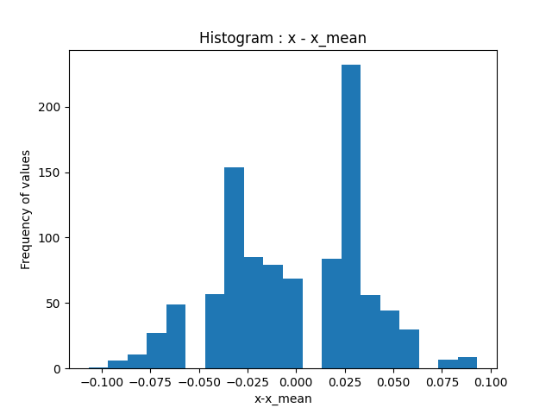

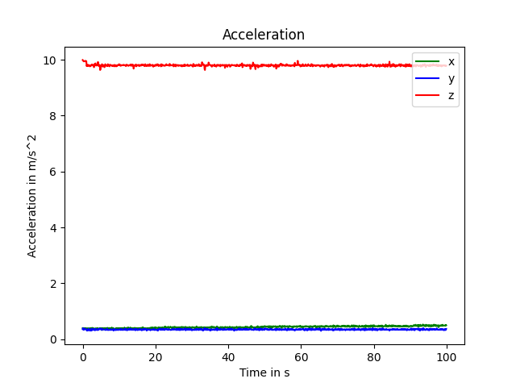

\

Figure 7: Acceleration values in x-y-z directions

Figure 8: Histogram of acceleration reading in x- x̅ values.

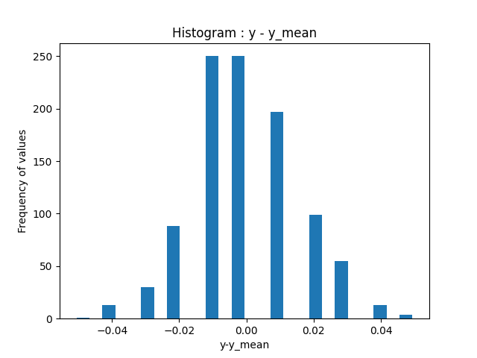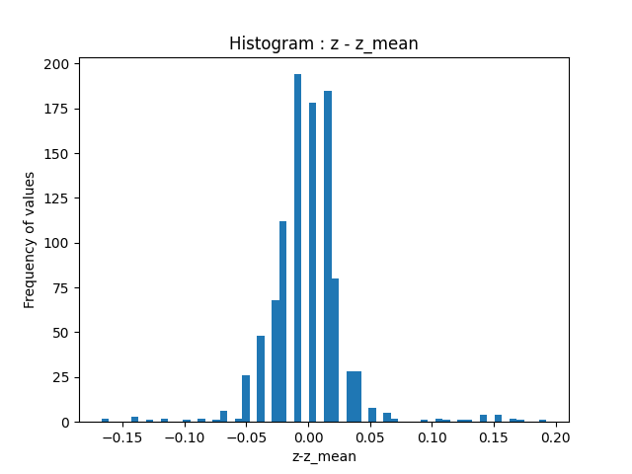

Figure 9: Histogram of acceleration Figure 10: Histogram of acceleration reading

reading in y-y̅ values. in z-z̅ values.

|  |  |  |
| --- | --- | --- |
| Direction | Mean value in m s–2 | Standard deviation value in m s–2 |
| x | 0.436 | 0.037 |
| y | 0.350 | 0.015 |
| z | 9.797 | 0.031 |

The mean and a-a̅ values show very low offset and there is an accordingly significant difference between the x,y directions, and z directions. Figure 8, 9, and 10 gives the histogram plot.

**TASK 3**

In this task, we make use of the acceleration sensor present on the board. The board is placed in the elevator and it is programmed to measure the pressure and the acceleration every 100ms for 1000 counts.

The measurements are taken while the elevator is moved from the ground floor to the tenth floor and back to the ground floor. The figure below shows the graph is a plot of acceleration vs time.

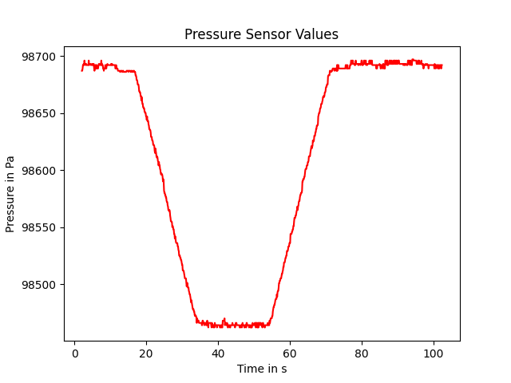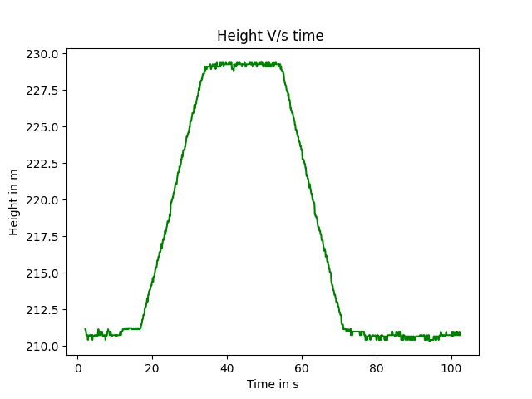Figure 11: Pressure sensor values Figure 12: Plot of height vs time

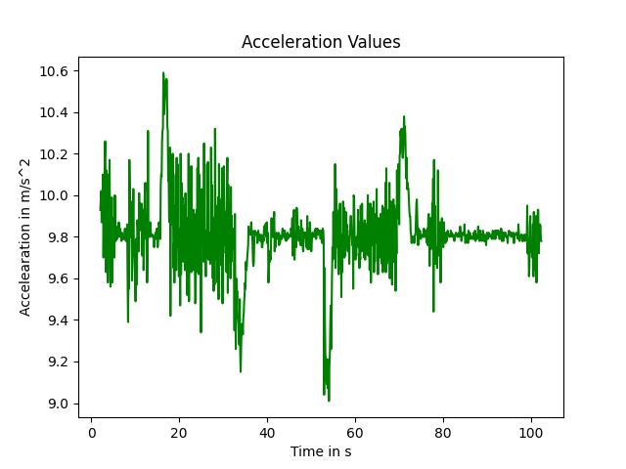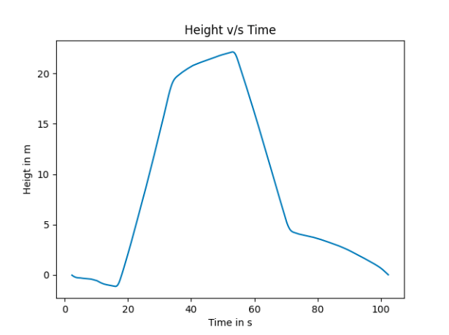

Figure 13: Acceleration sensor values Figure 14: Plot of height vs time, after

integrating the acceleration values twice

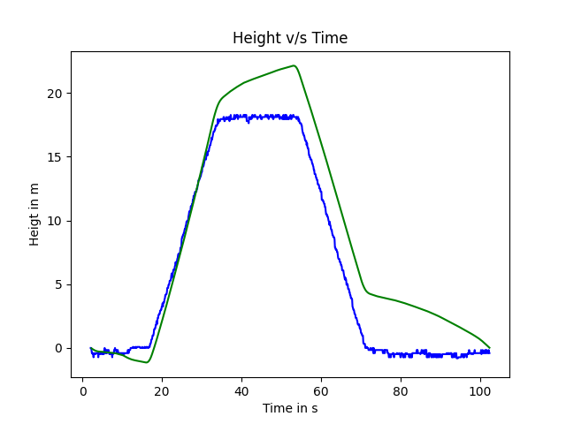

Figure 15: Comparison of both plots of height vs time taken from acceleration sensor and

barometric formula.

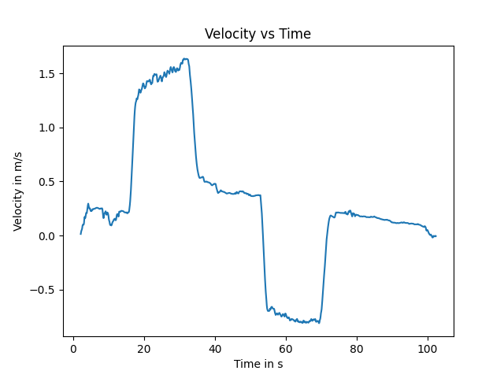

Figure 16: Plot of velocity vs time obtained after integrating the acceleration sensor output

For obtaining the height or position from the acceleration sensor values, we need to double integrate the obtained values twice. Plotting the obtained values gives the graph of position vs time as shown in figure 14

After the evaluation of samples, we obtain a height of 17m from pressure data, a velocity of 1.6 m s-1 for the upward direction, -0.9 m s-1 for the downward direction, and a height of 23m from acceleration data. The height obtained from both data is close to realistic but the height from acceleration data wasn’t stable because of the oversensitivity of the sensor as it was in the case of height obtained from pressure data. Altitude measurement from the pressure sensor is preferred over the double integrated values of accelerometer values.

# Summary

The pressure sensor and the accelerometer both showed very low offset. For the elevator experiment, the values from the pressure sensor are more accurate to measure the altitude as it is less noisy compared to the values obtained from the double-integrating accelerometer readings because of the accumulation of errors in numerical integration.

# References

1. Wikipedia contributors. (2023, January 4). Pressure sensor. Wikipedia. <https://en.wikipedia.org/wiki/Pressure_sensor>
2. Evidence for extreme pressure pulses in the subglacial water system - Scientific Figure on ResearchGate. Available from: [https://www.researchgate.net/figure/Schematic-diagram-of-pressure-transducer-a-Detail-of-measurement-diaphragm-and-sensor_fig3_233579403](https://www.researchgate.net/figure/Schematic-diagram-of-pressure-transducer-a-Detail-of-measurement-diaphragm-and-sensor_fig3_233579403%20) [accessed 6 Jan 2023]
3. Pressure Sensor BMP390. Bosch Sensortec. https://www.bosch-sensortec.com/products/environmental-sensors/pressure-sensors/pressure-sensors-bmp390.html
4. Micromachines A MEMS Micro-g Capacitive Accelerometer Based on Through-Silicon-Wafer-Etching Process - Scientific Figure on ResearchGate. Available from: [https://www.researchgate.net/figure/Schematic-of-the-proposed-MEMS-accelerometer_fig1_335227294](https://www.researchgate.net/figure/Schematic-of-the-proposed-MEMS-accelerometer_fig1_335227294%20) [accessed 6 Jan, 2023]