Laboratory for Electrical Instrumentation and Embedded Systems IMTEK – Department of Microsystems Engineering

University of Freiburg

Sensors Lab Course Winter term 2022/23

Lab Report M2

**Magnetic Sensors**

**Deepu Krishnareddy (5367859)**

January 13, 2023



Data generated in a team together with

* Bhoomika Subramani (5366969)
* Sneha Ganganna (5579362)

# Introduction

Magnetic sensors are used to detect and measure magnetic fields. They are used in wide range of applications which includes navigation, Industrial automation, MRI or Biomedical imaging. They can also be used for measuring geomagnetic intensity which is very useful in navigation by detecting the direction and intensity of earth’s magnetic field. In this module we use magnetic sensor in Arduino Nicla ME to calculate earth’s magnetic field and also, we will try to analyze the sensor performance.

# Theory

A magnetometer can operate in various methods, one example being a compass. A compass's needle aligns with the Earth's magnetic field's north when it's stationary. This is due to the sum of forces acting on it being zero and the weight of the compass's gravity counterbalancing the Earth's magnetic force acting on it. This principle of magnetism enables other magnetometers to function as well, such as electronic compasses which can indicate magnetic north through phenomena such as the Hall effect, magneto induction, or magnetoresistance [1]

The Earth's magnetic field is generated by the movement of molten iron in the core, which causes variations in its intensity across the Earth's surface. The strength of the field is measured in units called nanoTesla (nT) or microTesla (µT) and ranges from around 25,000 nT at the poles to about 65,000 nT at the equator. Additionally, the Earth's magnetic field changes over time due to factors such as solar flares and changes in the Earth's core which can lead to changes in intensity and direction.

The Earth's magnetic field can be broken down into two main components: the horizontal component and the vertical component. The horizontal component, also known as the X and Y components, refers to the magnetic field that runs parallel to the Earth's surface. It is responsible for the direction of the magnetic field and is used in navigation tools such as compasses. The vertical component, also known as the Z component, refers to the magnetic field that runs perpendicular to the Earth's surface. It is responsible for the strength of the magnetic field and is used in measuring the intensity of the magnetic field.

Both horizontal and vertical components are measured in units of nanoTesla (nT) or microTesla (µT). The horizontal component is measured in the direction of the magnetic north and south, while the vertical component is measured in the direction of the magnetic up and down.

## Magnetic Sensor

## 

Magnetic sensors work by detecting and measuring the strength and direction of a magnetic field in a specific area without physically coming into contact with it. This is achieved by using different physical principles to convert the magnetic field into an electrical signal that can be measured and analyzed.

For example, Anisotropic Magnetoresistance (AMR) sensors utilize the principle of anisotropic magnetoresistance, which is the change in electrical resistance of a material in response to an applied magnetic field. These sensors are typically based on thin-film structures of magnetic materials such as iron, cobalt, or nickel. When a magnetic field is applied to the sensor, it causes a change in the resistance of the material, which can be measured and used to determine the strength and direction of the magnetic field.

Hall Effect sensors utilize the Hall effect, which is the production of a voltage difference across an electrical conductor, transverse to an electric current in the conductor and a magnetic field perpendicular to the current. When a magnetic field is applied to the sensor, it produces a voltage difference that can be measured and used to determine the strength and direction of the magnetic field.

The Flip Core element technology simplifies the design of a magnetic sensor by using a thin-film core made of an iron-nickel alloy. This core typically consists of a stack of a few separated layers with a thickness of only a few tens of nanometres, each containing a single magnetic domain. The core is periodically excited, causing the magnetization to flip between its saturation states. An external magnetic field that is superimposed on the periodic excitation will cause a delay at the receiving coil, which allows for simpler time measurement compared to the detection principle used in fluxgate sensors.

This technology is also known as Flip Core Magnetometer and it is considered more energy efficient and less noisy than Hall sensors. Additionally, it can measure the magnetic field with high precision and sensitivity, as well as it can be applied in a wide range of applications such as navigation, industrial control, and scientific research. This technology is also widely used in aerospace and automotive applications where the size and power consumption of the sensor are critical.

## BMM150

The Bosch BMM150 is a highly precise magnetic sensor that can measure the magnetic field in three different directions. The BMM150 is a low-power, low-noise sensor that is ideal for compass applications, providing high-dynamic absolute spatial orientation and motion vectors through its hardware-specific sensor data fusion software. It is also well-suited for supporting drones with precise heading.[2]

## 

Figure 1: Figure of BMM150 package [2]

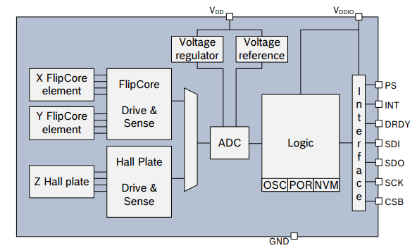

Figure 2 : BMM150 Block Diagram [2]

# Methods

We use the Arduino Nicla ME in standalone mode for acquiring data from all our sensors and we collect the data every 100 milliseconds. The data is then sent serially through USB, and the module is powered by a USB connection.The Arduino Nicla embedded module is equipped with the BMM150 magnetometer sensor. This sensor is utilized in various experiments and data acquisition applications. The board was programmed using the Arduino Integrated Development Environment (IDE) version 2.0 in conjunction with the Arduino_BHY2 library version 1.5 (Bosch Sensortec).

To receive the transmitted data from the Arduino Nicla Me and perform further processing and plotting, we utilized the pyserial library in Python. Additionally, we employed the use of the Arduino's built-in serial monitor for basic data analysis and visualization by simple plotting.

The Arduino program was written to acquire sensor data using the SENSOR_ID_MAG_PASS configuration at a rate of 10 Hz. The initial task entailed basic data acquisition and plotting procedures. The sensor was placed in a fixed location, and the transmitted sensor readings were collected using the pyserial library in Python. The data was subsequently stored in a NumPy array within a .npz file for future processing, plotting and reproducibility of the results.

Task 1 and Task 3 were similar the only difference was the task 3 was carried out in open environment.

For the Task 2 first sensor was kept in steady state and 100 reading were taken then the sensor was flipped in both X and Y direction and again other 100 readings were taken. Offset was calculated by taking the mean of readings of before flipping and after flipping. This offset will be used in Task 4 while calculating earth’s horizontal, vertical and total magnetic field for offset correction.

Task 5 was carried outdoor, initially the sensor was calibrated by taking offset using 8-point calibration method. Then the sensor is aligned to North direction, Bx and By are measured and used to calculate the direction in degree.

# Results and Discussion

## Task 1

Task 1 focuses on the evaluation of the magnetic sensor performance, specifically the comparison of flip core and hall effect technologies. The Nicla Sense ME board was placed on a flat surface, and sensor readings were logged using Python. A total of 1000 samples were collected, as depicted in Figure below. Task 1 comprises of acquisition and plotting of data from the magnetic sensor in frequent intervals of 100 ms for over 1000 samples. The mean and standard deviation is also calculated and mean subtracted data is plotted to get the idea of senor value distribution over a number of samples in a stable condition which helps in analyzing the drift of the sensor.

To monitor any variations in the sensor readings, multiple sets of 1000 readings were taken. However, only slight drift in the values was observed when the sensor was in a stable position. The mean and offset of these 1000 values were calculated and a histogram was plotted for B- $\overline{B}$ using Python. The histogram was plotted to show the deviation of the sensor readings from the mean value.

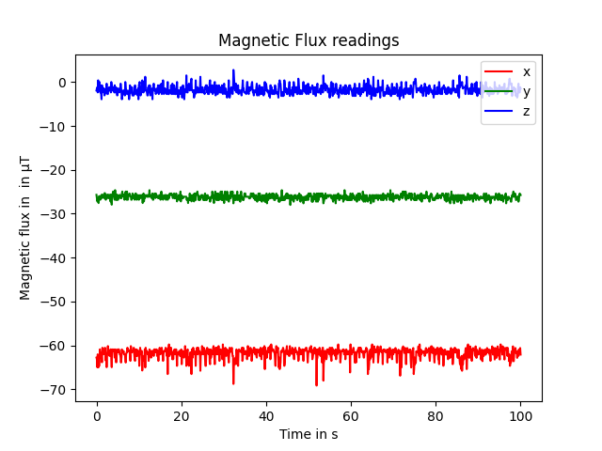

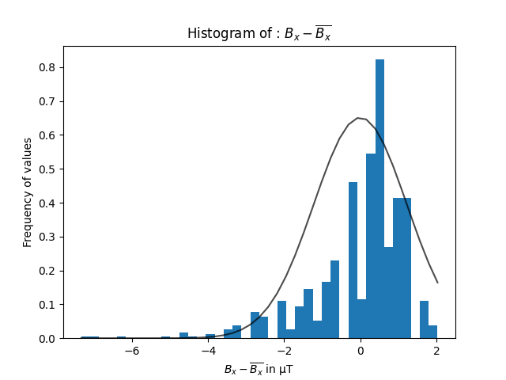

Fig 4: Histogram of Bx -

Fig 3: Magnetic Sensor readings for 1000 values

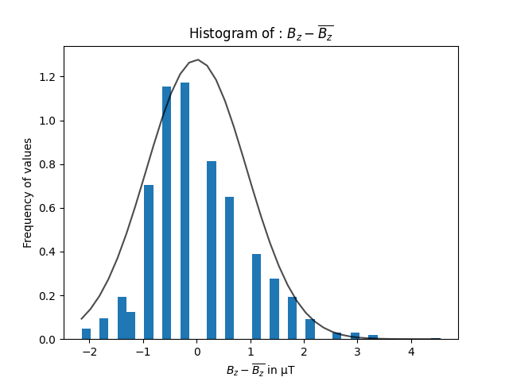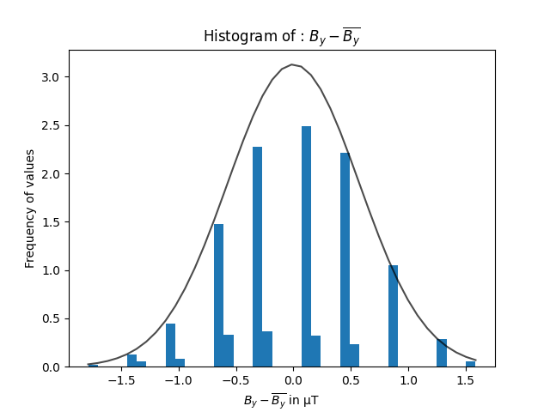

Fig 6 : Histogram of Bz -

Fig 5 : Histogram of By -

The majority of the sensor readings were found to be close to the mean value. The mean of all 3 directions, as measured, is presented in the table below. In the histogram of the mean subtracted data, a majority of the values were observed to be near zero, indicating minimal drift in the sensor readings under stable conditions for X and Y with flip core technology but for Z the values were more spread indicating higher noise than other two directions. From experiment it is found the performance in terms of noise is better for readings from axes which uses flip core technology

|  |  |  |
| --- | --- | --- |
| Direction | Mean ($μT$) | Standard deviation ($μT$) |
| X | -61.7 | 1.2 |
| Y | -26.2 | 0.7 |
| Z | -1.79 | 0.9 |

Table 1: Summary of the mean and standard deviation of 1000 values of magnetic sensor

## Task 2

In task 2, 100 readings were initially taken with keeping sensors in stable condition and then the sensor is flipped around X and Y axis with 180 degree and then other 100 readings were taken to calculate the offset. The offset can be used for correction in the later experiments.

|  |  |
| --- | --- |
| Direction | Mean ($μT$) |
| X | -63.7 |
| Y | -26.4 |
| Z | -64.31 |

Table 2: Summary of the mean of 100 values before flipping

|  |  |
| --- | --- |
| Direction | Mean ($μT$) |
| X | -37.3 |
| Y | -32.6 |
| Z | -66.8 |

Table 3: Summary of the mean of 100 values after flipping

|  |  |
| --- | --- |
| Direction | Offset ($μT$) |
| X | -50.5 |
| Y | -29.5 |
| Z | -65.5 |

Table 4: Offset for correction

In task 3 and 4 contains mean values of before and after flipping the sensor in X and Y directions for 180 degrees whose values were used to calculate the offset and in the Table 4 offset values in each direction are presented. The offset values are pretty much deviating from the values given in the BMM150 datasheet [2] may be because of the reason that the values in the datasheet were given for temperature of 25 $℃$ which was not maintained while conducting experiment and changes and movement in surrounding environment were not stable

## Task 3

Task 3 was similar to task 1 but conducted in outdoor environment avoiding metals and other parameters which influence the sensors readings so to calculate earth’s magnetic field which is much weaker compared to the other influences like metals around etc. The mean and standard deviation for 1000 values were calculated.

Magnetic intensity in X direction = -45.3 ± 0.5 µT

Magnetic intensity in Y direction = 4.5 ± 0.5 µT

Magnetic intensity in Z direction = -39.5 ± 0.6 µT

The values are very different from Task 1 as Task 1 was influenced by local magnetic field.

## Task 4

## Table 4 represents the comparison of expected and calculated values of Bhor, Bvert and Btotal. It is seen that there is a deviation of expected value [3] and the calculated value. It may be because of improper calibration of sensor or the surrounding metals influencing the magnetic field

|  |  |  |  |
| --- | --- | --- | --- |
|  | Bhor () | Bvert () | Btotal () |
| Expected | 21.26 | 43.4 | 48.3 |
| Calculated | 34.4 | 39.5 | 52.3 |

Table 4: Comparison of expected and calculated values of Bhor, Bvert and Btotal

## Task 5

## The experiment was carried by placing the sensor in north direction which was showed from the satellite image of Google Earth Pro. The sensor was showing a deviation of 4 $°$ and the expected deviation at the location of experiment was 2.8 $°$ according to national centers for environmental information [3]. There is small difference between expected deviation and calculated deviation may be due to magnetic heading accuracy which is $±2.5°$ according to the datasheet [2]

# Summary

The sensor readings show that it is precise and less noisy in X and Y direction which used Bosch’s flip core technology compared to Z direction which has hall sensor. It is seen that the values differ a lot when readings were taken outdoor showing the weakness of earth’s magnetic field when compared to the local magnetic fields due to metals.

The results shows that the Bhor  , Bver and Btotal values were similar to expected values, with only slight deviations observed. It is also seen that the there is slight magnetic deviation of 4 degree at the place of experiment

# References

1. https://www.youngwonks.com/blog/What-is-a-Magnetometer-and-How-Does-It-WorkEvidence for extreme pressure pulses in the subglacial water system - Scientific Figure on ResearchGate. Available from: [https://www.researchgate.net/figure/Schematic-diagram-of-pressure-transducer-a-Detail-of-measurement-diaphragm-and-sensor_fig3_233579403](https://www.researchgate.net/figure/Schematic-diagram-of-pressure-transducer-a-Detail-of-measurement-diaphragm-and-sensor_fig3_233579403%20) [accessed 6 Jan 2023]
2. Global, B. (n.d.). Magnetometer BMM150. Bosch Sensortec. <https://www.bosch-sensortec.com/products/motion-sensors/magnetometers-bmm150/>
3. U.S. Department of Commerce. (n.d.). NCEI Geomagnetic Calculators. Available from: <https://www.ngdc.noaa.gov/geomag/calculators/magcalc.shtml> [accessed 6 Jan 2023]