**Banking Fundamentals**

Need of banks: Financial intermediaries, risk assessment of borrowers, currency exchange, distribution of money across the market.

Net Interest margin: If a depositor gains x% from a bank on his deposit and bank earns (x+4) % from borrower, the net interest rate earned by bank is 4%.

Risks: Rate exchange risk, interest rate risk.

Primary functions of a bank: Accepting deposits (liability) and lending money (asset products).

Secondary functions of a bank: Agency (banks acting as an agent of some other organization) functions and Utility (assurance service) functions.

Business lines of banks:

1. Retail banking – Mass customers.
2. Private banking – Customized services for high class individuals.
3. Commercial banking – Banking services for businesses.
4. Corporate finance – Helping corporate to raise money from others (loan syndication, help in IPO, merging and acquisition)
5. Trading and sales – Treasury i.e., handling the deposited money.
6. Payment services – RTGS, NEFT.
7. Agency services
8. Retail brokerage services

Types of banks:

1. Commercial banks – Regulated by RBI
2. Payment banks – Fund transfers
3. Savings and Loan companies (Not in India)
4. Building societies – Loans are given to members for the purpose of acquiring houses.
5. Scheduled banks

Types of customers:

1. Natural customer – Individuals.
2. Artificial customer – Legal entities.

Classification of businesses as small/large:

1. Every bank has its own criteria.
2. RBI prescribes exposure norm of Rs. 5 crores for getting classified as a corporate customer.

Channels of delivery:

1. Physical – Branches.
2. Virtual – Business (SWIFT, Client Server) and personal (ATM/POS, call centers, mobile banking) banking channels. These have certain limits due to lack of human interaction.

Digital banking and use of technology in banks

1. Consistency is maintained.
2. Use of AI/ML and technologies like cloud.

Interest rates, policy rates and reserve requirements

Parameters to finalize the rate of interest: Credit worthiness of the customer, cost of funds for the bank, desired profit margin, default premium (add burden on good borrowers based on historical transactions), regulation like capital adequacy ratio.

Compounding interest:

1. Deciding Principal
2. Fixed/Flat principal: It remains same throughout the period irrespective of repayments.
3. Reducing balance principal: Principal is reduced as per defined frequency (daily, monthly, half yearly, annual etc.)
4. Deciding Rate of Interest
5. Fixed ROI: i. ROI remains same till end of tenor.

ii. Reset clause can be applied.

1. Floating / Variable ROI: Rate linked with a certain benchmark.
2. Combination of above two: Fixed and floating for period or amount.
3. Deciding number of days
4. Day-Count conventions: i. 30/360: 30 days per month and 360 days per year.

ii. Actual/360: Actual days for month and 360 per year (Most preferred).

iii. Actual/365.

iv. Actual/Actual.

Central Bank

1. RBI is central bank as well as banking regulator in India.
2. In UK, Bank of England is the central bank, but Financial Conduct Authority is the banking regulator.

Functions of Central Banks

1. Implementation of monetary policies – Promoting financial system stability, control money supply and setting interest rates on loans.
2. Issuing currency. Central Government issues real money and RBI issues currency notes which are legal tenders.

Types of regulations: Prudential (risk management), Conduct (behavior with customers), Activity based, Disclosure.

Monetary policy:

Cash Reserve Ratio: Out of the deposit by a customer in a bank, the bank must keep a certain percentage of the deposit with RBI.

Statutory Liquidity Ratio: Out of the deposit by a customer in a bank, the bank must invest a certain amount in government approved securities.

Bank Rate: The rate at which banks invest money in RBI.

Repurchase Agreement: An agreement which involves temporary sale of securities from one party to another, but it includes a promise of re-purchase of those securities by initial seller.

Over The Counter (OTC) deal: Deal without any intermediary. Trust between parties is mandatory.

Deposit Insurance providers:

1. Deposit Insurance and Credit Guarantee Corporation (DICGC).
2. Federal Deposit Insurance Corporation (FDIC).

Interbank borrowings

1. Operated on treasury (Front office, back office).

Risks related to deposits:

1. Premature withdrawal of deposit.
2. Changes in deposit rates.
3. Rollover.
4. Change in currency exchange rates.

Liability products: Whatever the banks owe is a liability for the bank.

Life-cycle of a deposit: Open a deposit account -> Periodic payment or accrual of interest -> Closure/Renewal of deposit -> Amount claimed/unclaimed.

Demand Deposit – Withdrawable on demand

1. Savings account – Limited withdrawal per month, less interest paid, not used for business.
2. Current account – No restriction on withdrawals, no interest paid, can be used for business.

Negotiables are the instruments used for transfer of value.

Time deposit: Deposit which is not withdrawable till the completion of 6th day from deposit. It’s withdrawable but no interest will be paid for initial 6 days.

Types of deposits:

1. Negotiable and non-negotiable deposits.
2. Fixed deposits: Fixed date deposits, Floating rate/Inverse Floaters, step-up deposits, liquid deposits, callable deposits (bank can prematurely close a deposit), zero coupon deposits (deposits bought at face value), brokered deposits, Eurodollar deposits (a US Dollar deposit approved by US government outside USA).

Assets

1. Loans given by banks – Term loans (mortgages, educational loans, personal loans)
2. Gold trading.
3. Commodity trading.
4. Fixed assets like office buildings, ATMs etc.

Lending money

Goals of bank loans:

1. Loan Volume
2. Loan Quality

Banks must balance:

1. Liquidity requirements.
2. Risk constraints.
3. Return objectives.
4. Capital constraints.

Generic process of lending:

1. Determine Credit Policy
2. Loan Application
3. Credit Analysis
4. Underwriting decision – Credit scoring, affordability assessment, KYC, fraud check etc.
5. Documentation
6. Disbursement
7. Collection
8. Complete repayment/default

Security creation:

1. Pledge – Collateral is physically controlled by banks.
2. Hypothecation – Loan against movable property.
3. Mortgage – Loan against immovable property.
4. Lien – Deposit is freeze.
5. Assignment – Transfer of right to claim to the bank.

Credit Rating:

* 1. Two dimensional:

1. Quantitative and Qualitative.
2. Backward and forward looking.
   1. Internally by bank and externally through agencies. Example of agencies are Moody’s, Fitch and S&P.

Credit Scoring:

1. Individuals and small entities.
2. Only quantitative, backward looking, external as well as internal.
3. Credit scoring agencies: Fair Isaac, TransUnion, Equifax, CIBIL (India).

Problem Loans

1. Delinquency (installment not paid) vs default (90 days).
2. Non-performing loans and provisioning for NPAs.
3. No accounting of interest accrual post 90 days.

Solutions

1. Debt restructuring
2. One time settlement
3. Sale of collateral activity
4. Credit derivatives and credit insurance
5. Suit filing and recovery/resolution proceedings

Classification of loans/facilities:

1. Based on purpose: Business/commercial, Retail/personal.
2. Based on time: Long, medium and short term.
3. Based on method of utilization: Revolving and non-revolving.
4. Based on repayment: Installments – EMI/Balloon/Irregular or lifestyle, Bullet payment – Single payment.
5. Based on currency: Local/Foreign currency.
6. Based on interest: Fixed/Floating/Stepped.
7. Based on end-use: Discretionary and Non-discretionary.
8. Based on funding: Fund based/On balance sheet, non-fund based/Off balance sheet.
9. Based on security: Secured/unsecured.

Need of banks for corporates

1. Money
2. Capex: Fixed assets.
3. Opex: Current assets like raw material, SFG, FG, debtors.
4. Services
5. Documentary credits and bank guarantees
6. Collection from customers (debtors)
7. Payments to vendors (creditors) and others
8. Foreign exchange services
9. Advisory services

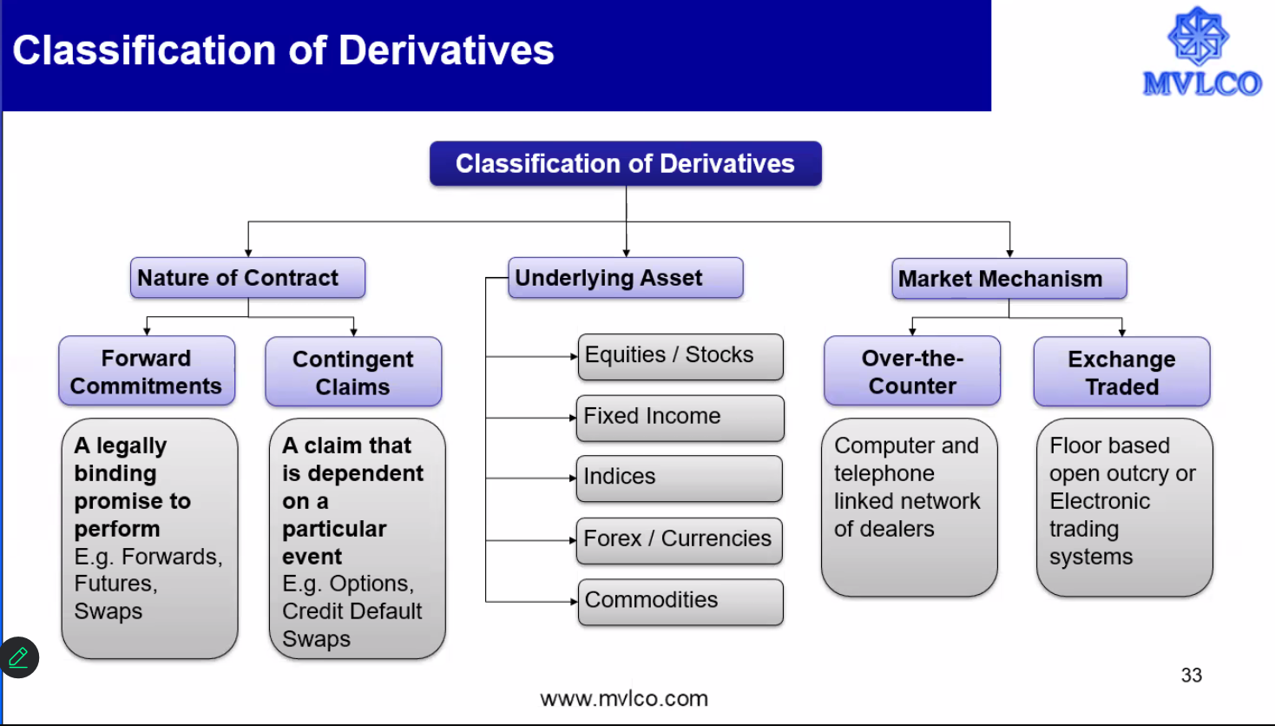

Domestic Banking

1. Book Transfer (Customer)
2. Within same bank: No interference from external entity needed.
3. With other bank: Banks are needed to be connected.

