Capstone Project Report

Title
Bash Scripting Suite for System Maintenance

Objective
This project automates Linux system maintenance tasks such as backups, updates, cleanup, and log monitoring using Bash scripting. It is designed to simplify routine administrative work through automation and improve system reliability by scheduling essential maintenance tasks.

Tools and Technologies
  - Programming Language: Bash (v4.0+)
  - Platform: Linux (Ubuntu, Debian, Fedora, Arch)
  - Tools: tar, apt, dnf, pacman, grep, journalctl, cron, systemd
  - Editor: Visual Studio Code
  - Version Control: GitHub

Codes
Below are the implemented Bash scripts used in the project:

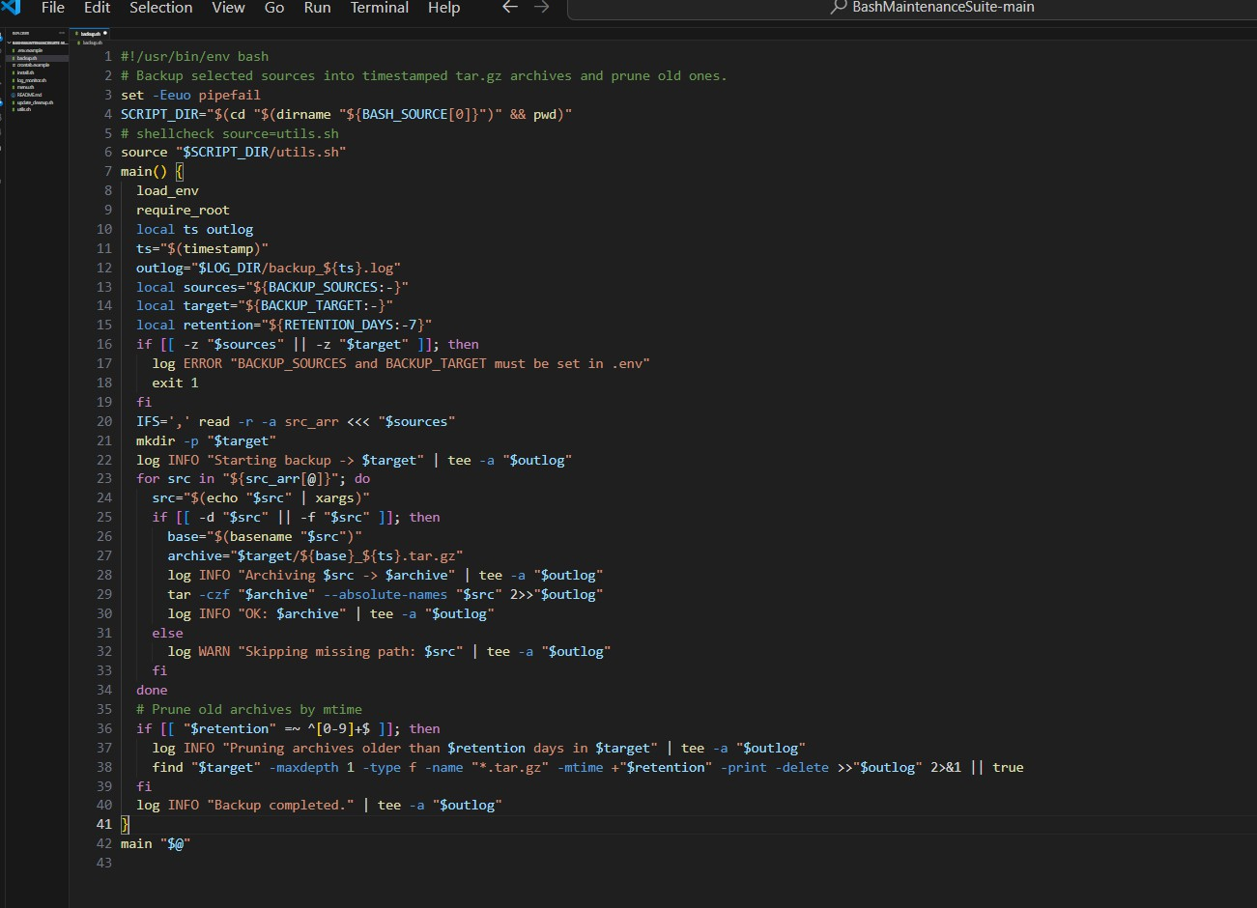

backup.sh

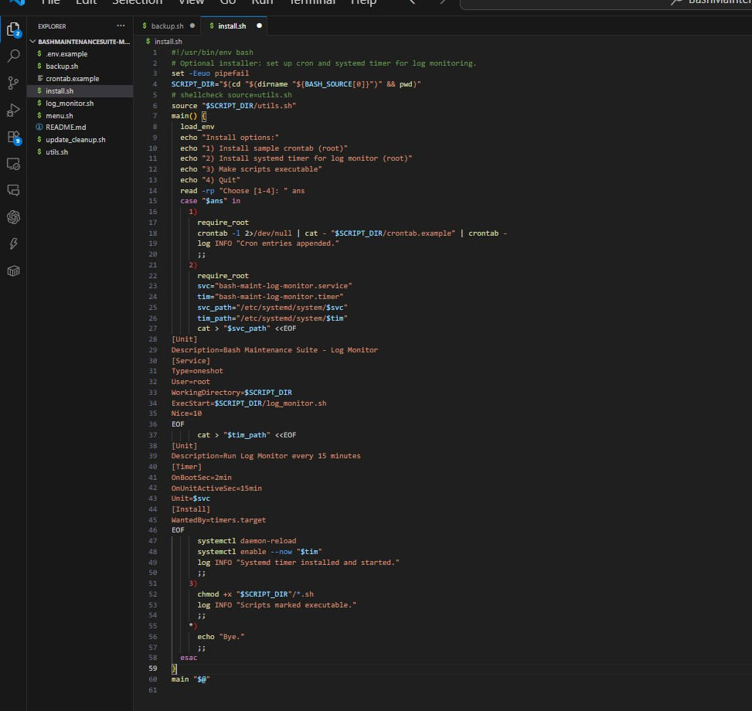

install.sh

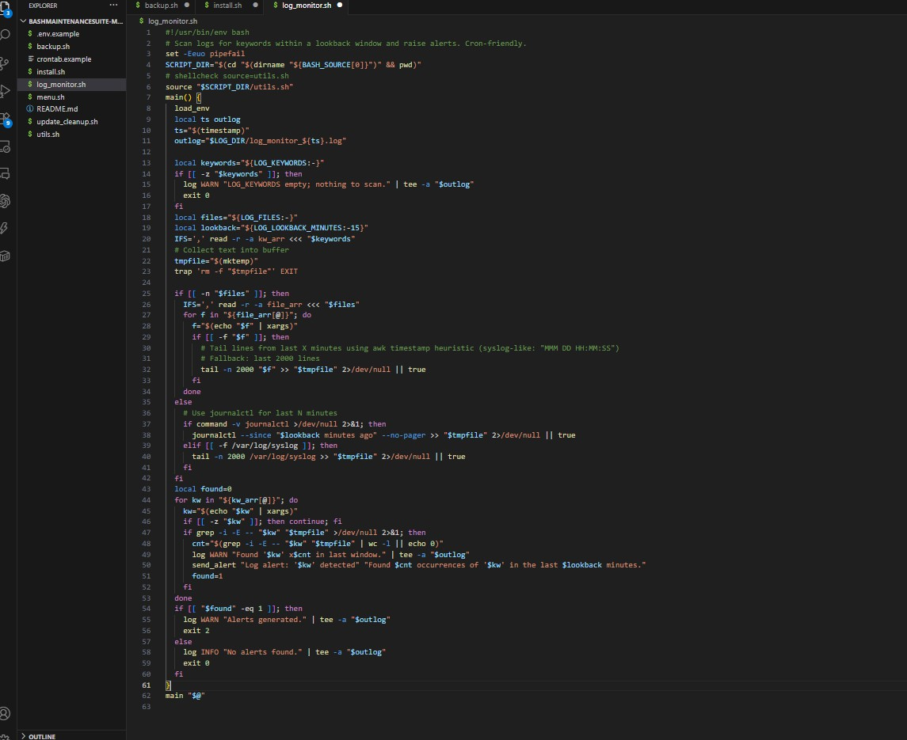

logmonitor.sh

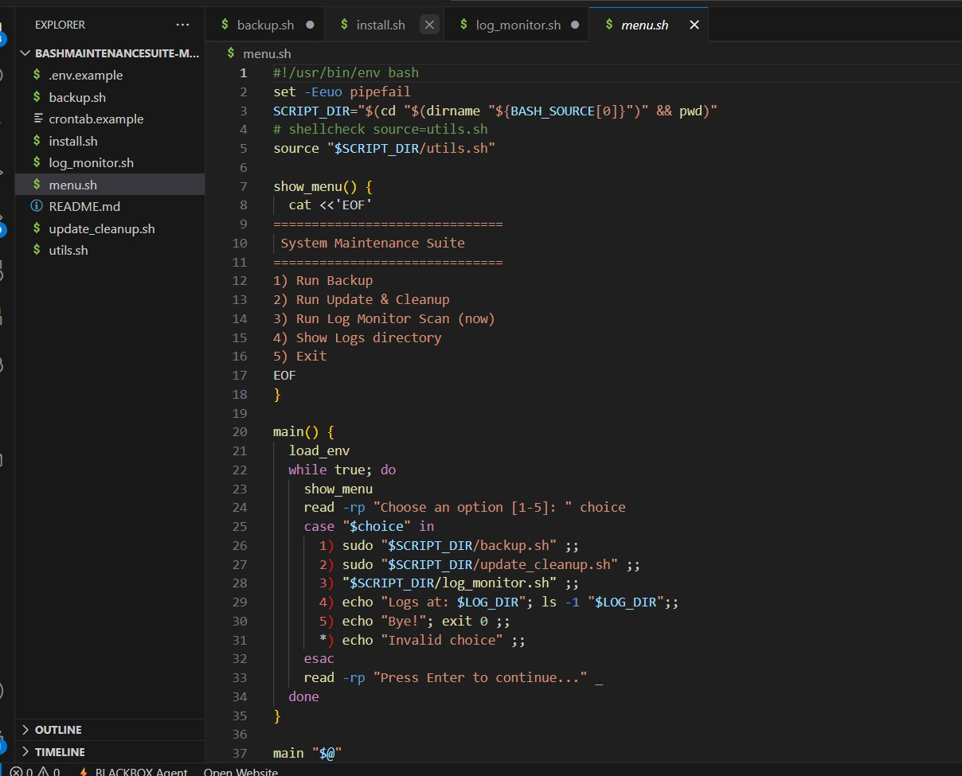

menu.sh

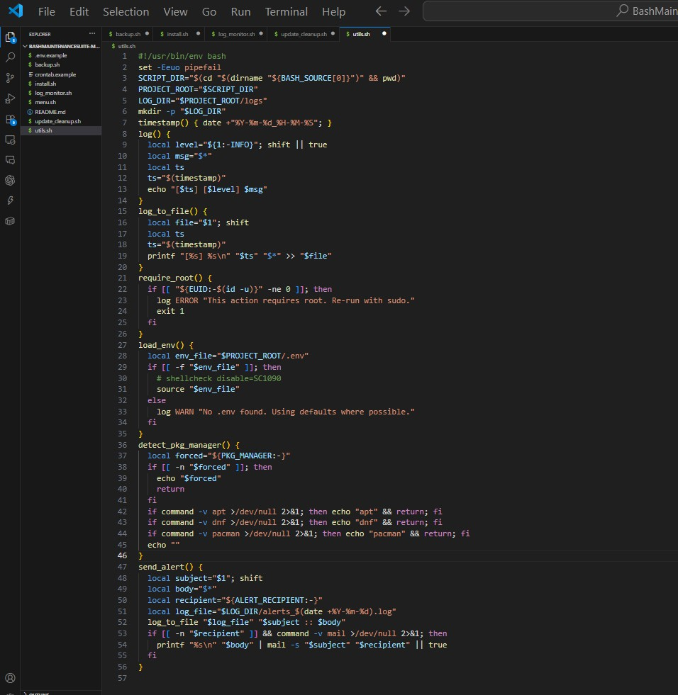

ulta.sh

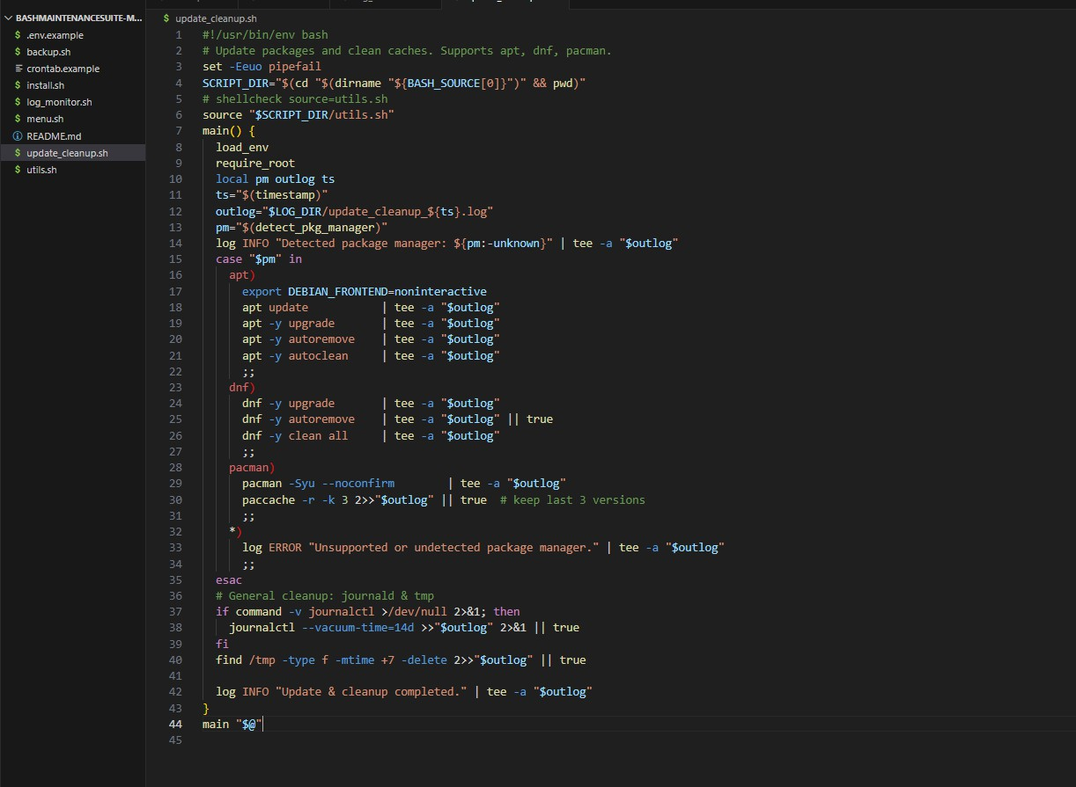

updatecleanup.sh

Full Execution Screenshots
The following screenshots demonstrate the successful execution of the scripts and their outputs:

️ Backup File Output

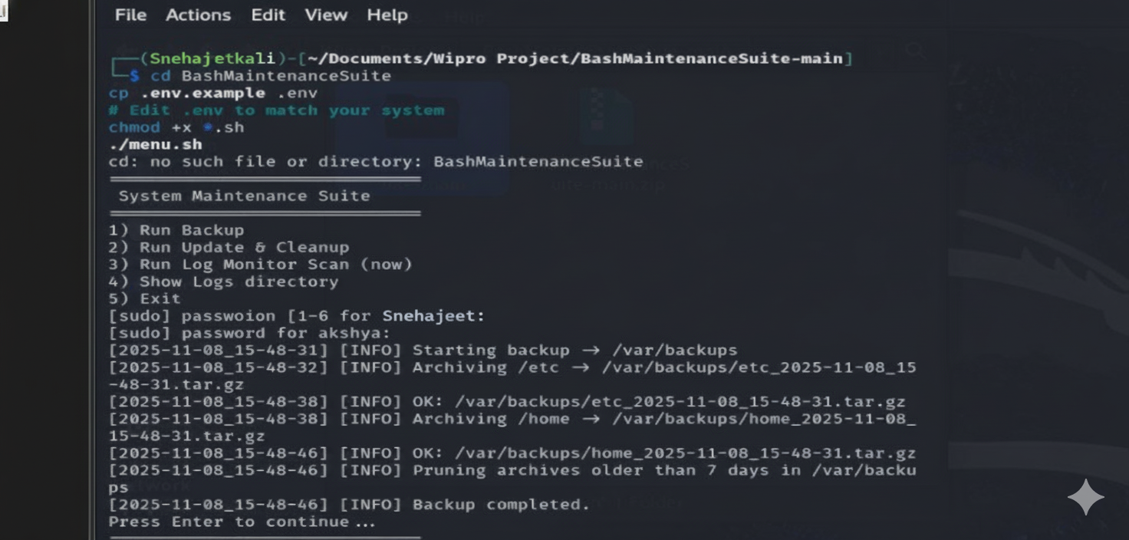
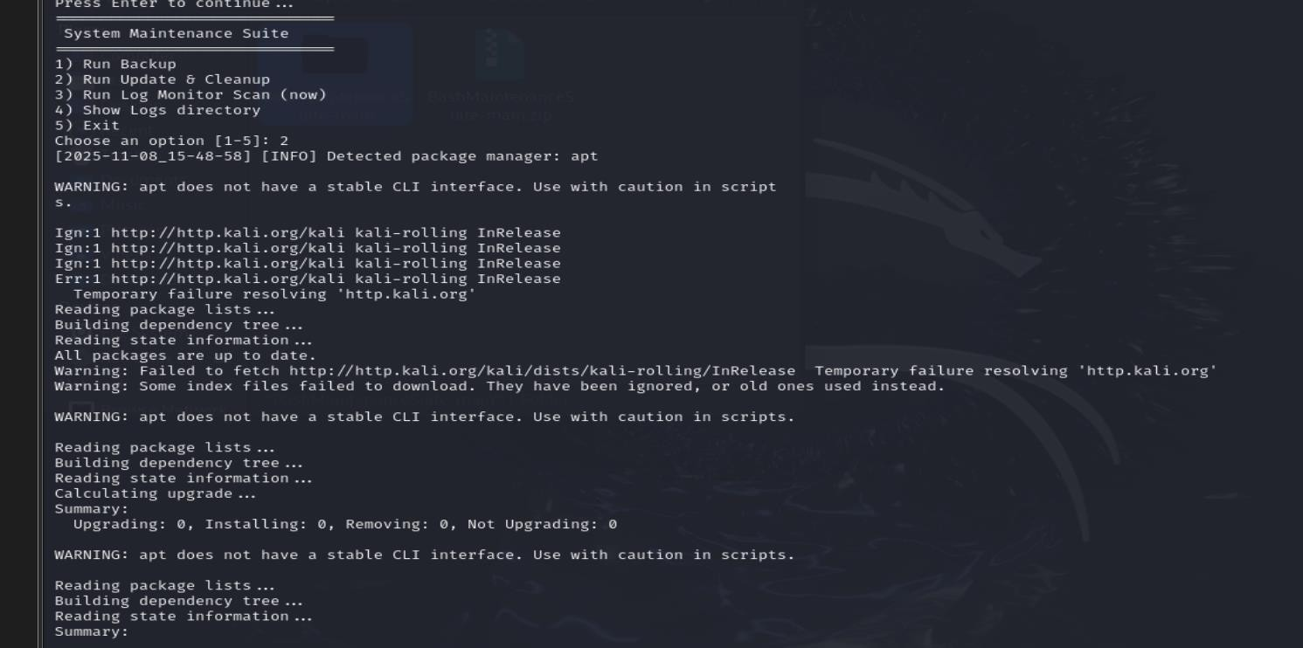
️ System Update and Cleanup Output

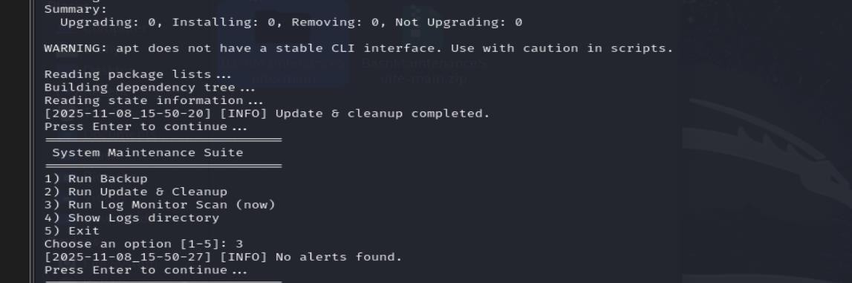
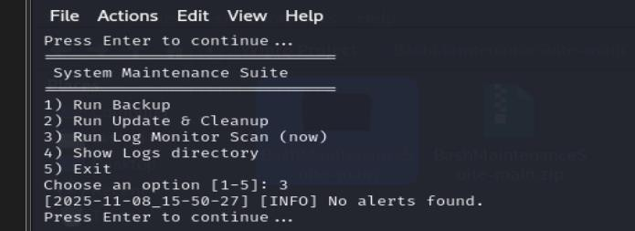
️ Log Monitoring Output

️ Show log directory

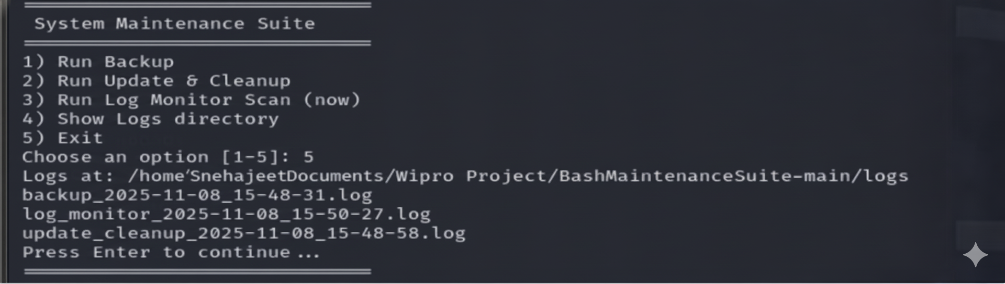
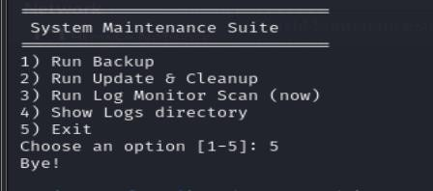
️ Exit

- GitHub Repository

Link- “ https://github.com/SnehajeetJena/Linux-System-Maintenance-Suite“

- Conclusion
The Bash Scripting Suite for System Maintenance provides a practical and efficient automation solution for routine Linux system tasks. It improves system uptime, reduces manual effort, and demonstrates real-world DevOps and shell scripting skills.

