**Details:**

Name: K.S.J.Sneha

College: Rajalakshmi Engineering College

Tech Stack:

Frontend: ReactJS

Backend: NodeJS, ExpressJS

Database: MongoDB

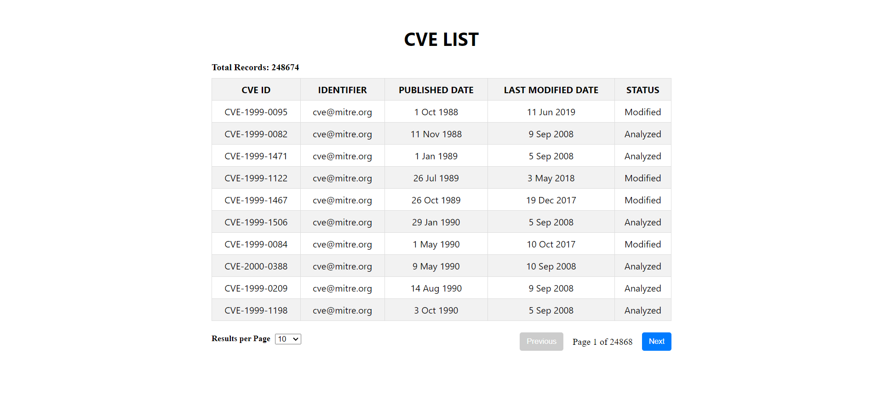

**API Documentation**

**1. Overview**

This documentation outlines the APIs available for managing and querying CVE (Common Vulnerabilities and Exposures) data.

**2. Base URL**

The base URL for accessing the APIs is http://localhost:3000.

**3. Endpoints**

**3.1 POST /populate**

**Description**

This endpoint triggers the population of the CVE collection by fetching data from an external API.

**Request**

Method: POST

Endpoint: /populate

Response

Status Code: 200 OK

Description: Indicates successful population of the CVE collection.

Status Code: 500 Internal Server Error

Description: Indicates an error occurred during the population process.

Example

http:localhost:3000/populate

**3.2 GET /cve**

**Description**

This endpoint retrieves a paginated list of CVE records.

**Request**

Method: GET

Endpoint: /cve

Query Parameters:

page: Page number (integer, default: 1)

pageSize: Number of records per page (integer, default: 10)

Response

Status Code: 200 OK

Description: Returns a paginated list of CVE records.

Status Code: 500 Internal Server Error

Description: Indicates an error occurred while fetching the records.

Example

http

GET /cve?page=1&pageSize=10

**3.3 GET /cve/id/:id**

**Description**

This endpoint retrieves CVE data based on a specific CVE ID.

**Request**

Method: GET

Endpoint: /cve/id/:id

Params:

:id: CVE ID (string)

Response

Status Code: 200 OK

Description: Returns CVE data for the specified ID.

Status Code: 404 Not Found

Description: Indicates that the specified ID was not found in the database.

Status Code: 500 Internal Server Error

Description: Indicates an error occurred while searching by ID.

Example

http

GET /cve/id/CVE-2021-1234

**3.4 GET /cve/year/:year**

**Description**

This endpoint retrieves CVE data published in a specific year.

**Request**

Method: GET

Endpoint: /cve/year/:year

Params:

:year: Publication year (integer)

Response

Status Code: 200 OK

Description: Returns CVE data published in the specified year.

Status Code: 404 Not Found

Description: Indicates that no records were found for the specified year.

Status Code: 500 Internal Server Error

Description: Indicates an error occurred while searching by year.

Example

http

GET /cve/year/2021

**3.5 GET /cve/baseScore/:score**

**Description**

This endpoint retrieves CVE data based on a specific CVSS base score.

**Request**

Method: GET

Endpoint: /cve/baseScore/:score

Params:

:score: Base score (string)

Response

Status Code: 200 OK

Description: Returns CVE data with the specified base score.

Status Code: 404 Not Found

Description: Indicates that no records were found for the specified score.

Status Code: 500 Internal Server Error

Description: Indicates an error occurred while searching by score.

Example

http

GET /cve/baseScore/7.5

**3.6 GET /cve/lastModified/:days**

**Description**

This endpoint retrieves CVE data modified within the specified number of days.

**Request**

Method: GET

Endpoint: /cve/lastModified/:days

Params:

:days: Number of days (integer)

Response

Status Code: 200 OK

Description: Returns CVE data modified within the specified days.

Status Code: 400 Bad Request

Description: Indicates an invalid parameter value.

Status Code: 500 Internal Server Error

Description: Indicates an error occurred while searching by last modified.

Example

http

GET /cve/lastModified/30

**4. Error Handling**

If the requested resource is not found, the server returns a 404 Not Found response.

If an error occurs during the request processing, the server returns a 500 Internal Server Error response.

**5. Usage**

To interact with the APIs, use the provided endpoints with appropriate HTTP methods and parameters.

**6. Additional Notes**

Ensure that parameters provided in the requests are valid and within the expected range.

Check the response body for detailed information about the returned CVE data.