1. Write a program to read two numbers from the user and swap/exchange them.Use two Methods to swap them
Method 1 – with temporary variable
Method 2 – without temporary variable

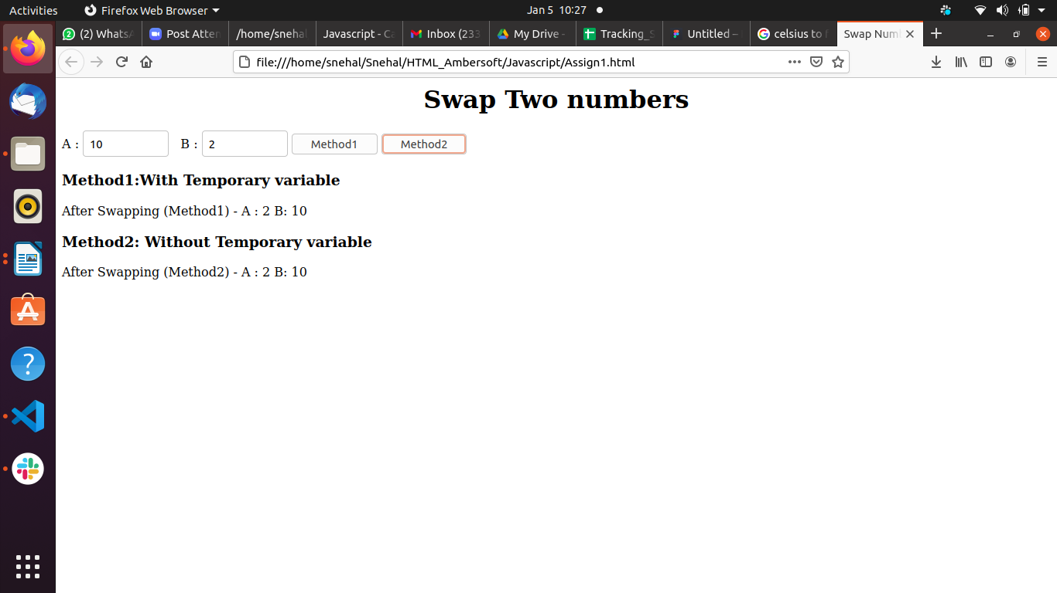
2. Write a program to read the temperature in Celcius and convert it into Fahrenite.
Formula : (Celcius × 9/5) + 32 = __°F

