Ques1. Write a program to get the following output

Ambersoft
- MI-MEAN
  - MI-MEAN-6
    - Shweta
    - Ajay
    - Trupti
  - MI-MEAN-7
    - Sagar
    - Umesh
  - MI-MEAN-8
    - Mihika
    - Pallavi
    - Reva
  - MI-MEAN-9
    - Anil
    - Manoj
- SYSTEM
  - SYSTEM-1
    - Anu
    - Dipti
  - SYSTEM-2
    - Triveni
    - Kalyani

Ques 2: Write a html program to create a simple website with 3 pages.Home page,MI-MEAN-9,Contact us page.Link these three pages.Home Page should look something like this
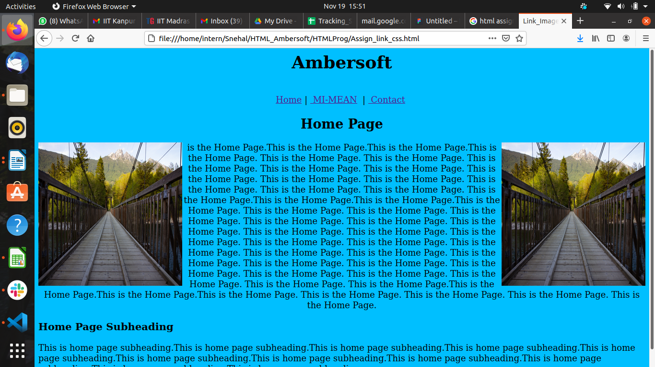
MI-MEAN-9 screen should look like the following
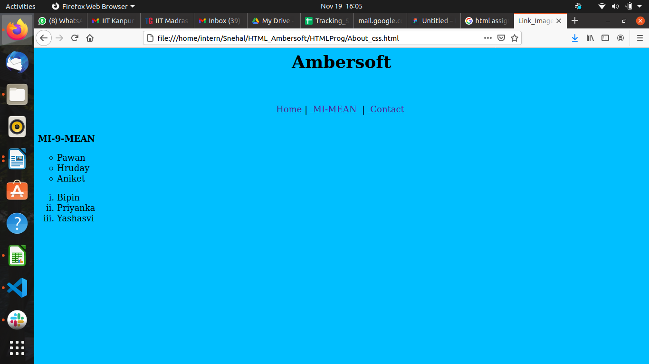
and the Contact page should look like the following
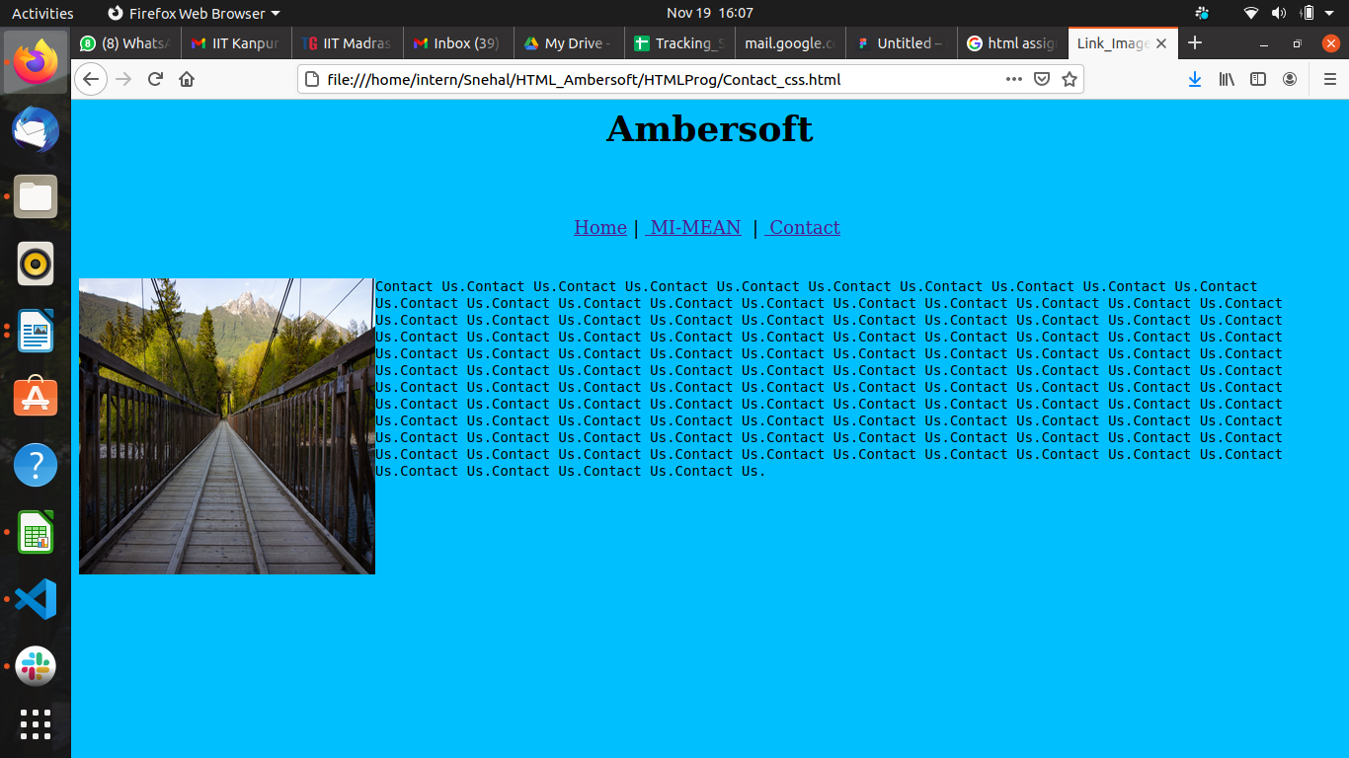
You can give the color and image of your choice.Also can add additional elements if you want.
You can also add a photo gallery page and add its link.

