Que1. Write a html program to get the following output.

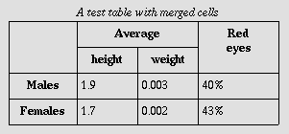

Que2. Write a html program to get the following output.

Jan's Spring Term Afternoon Schedule
 | Monday | Tuesday | Wednesday | Thursday | Friday
1:00 | Office |  | Office | Office  Hours  by  Appt | Office
1:30 | Office | Dept Meeting | Office | Office  Hours  by  Appt | Office
2:00 | MAT 108 | Dept Meeting | MAT 108 | Office  Hours  by  Appt | MAT 108
2:30 | MAT 108 |  | MAT 108 | Office  Hours  by  Appt | MAT 108
3:00 | MAT 108 | EC Meeting | MAT 108 | Office  Hours  by  Appt | MAT 108
3:30 | CSC 205 | EC Meeting | CSC 205 | Office  Hours  by  Appt | CSC 205
4:00
4:30 | CSC 205 |  | CSC 205 | Office  Hours  by  Appt | CSC 205

Ques3 .Write html program to get the following ouput.

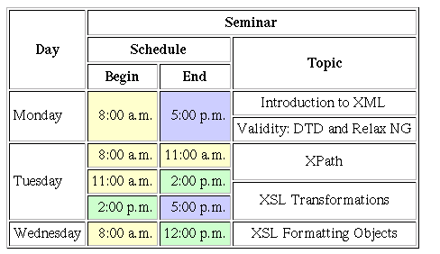

<table>
<tr>
<td rowspan=”5”>Tuesday</td>
<td rowspan=”2”>8.00</td>
<td rowspan=”2”>11</td>
<td rowspan=”3”>xpath</td>
</tr>
<tr></tr>
<tr>
<td rowspan=”2”>11</td>
<td rowspan=”2>2</td>
</tr>
<tr>
<td rowspan=”2”>XSL</td>
</tr>
<tr>
<td>2.00</td>
<td>5.00</td>
</tr>

