Ques 1 : Write a html program to get the following output.Follow the guidelines:
1.The entire document should be set in Arial/Helvetica/sans-serif type.
2. Use class in external css for all the style effects.
3. Make First Name,Last Name,Gender,Age and Skill Set aapear Bold.
4. Age 18-25 must be selected by default for the first time, the user can however change it later.
5. Format the borders properly.

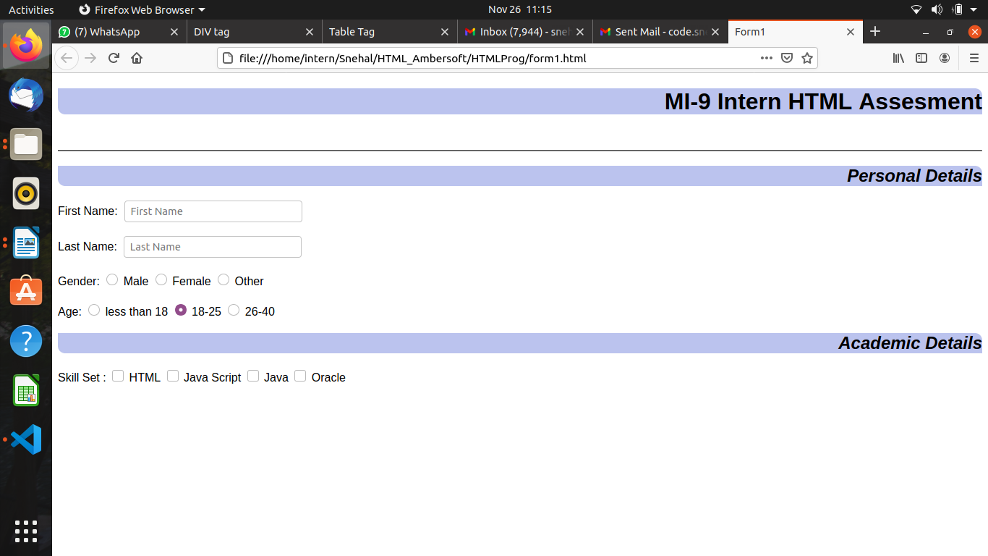
Ques2: Continue the above html page to get the following output.You can continue inn the same file. Follow the guidelines:
1. Highest Qualification is a drop down. - User has to select from the list
Diploma in Computer Science
Science Graduate
Bachelor in Engg.
Masters in Computer Science
Masters in Engg.
Other

2. University is a datalist – User is allowed to enter the university name if not in the list
Mumbai University
Pune University
Chennai University
Nagpur University
Badoda University

3. Areas of Expertise – User can select multiple options
Software
Training
Networking
Management
Marketing

