LAB 1 - COMPUTER NETWORKING (1BM21CS214)

Create a Topology consisting of two or more end devices connected with the help of hub and switch and stimulating simple PDU.

**Hub network**

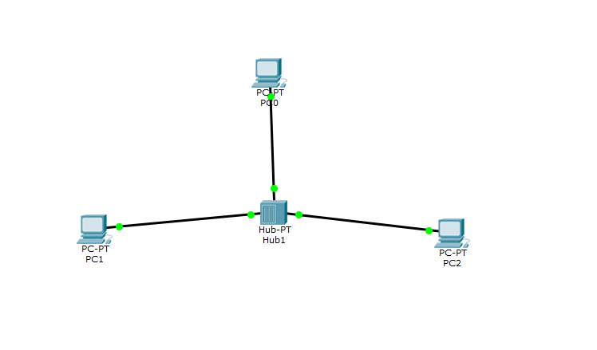

**OUTPUT**

In real time, when we use the ping command, we notice that a response is received from the destination.

In simulation mode, the hub gets PDU, it broadcasts to all the connected devices. Then one device accepts and other devices reject the message.

**Switch network**

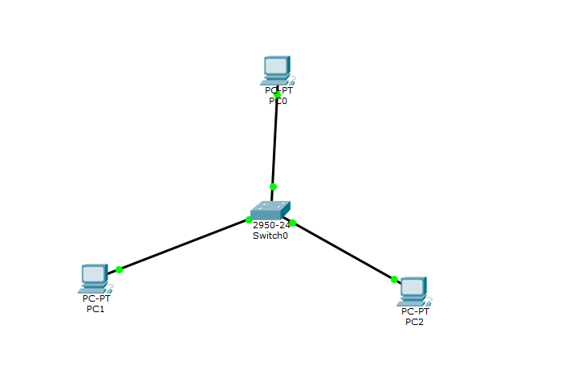

**OUTPUT**

In simulation mode, as it receives the PDU switch only transmits or forwards to the destination / mentioned end devices.

Hub and switch network

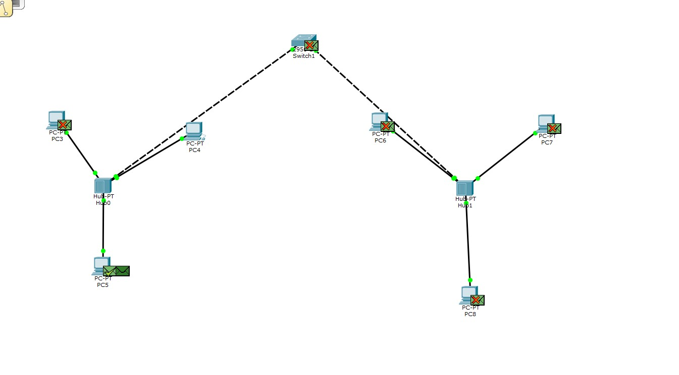

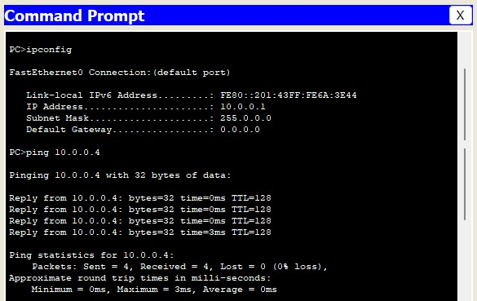

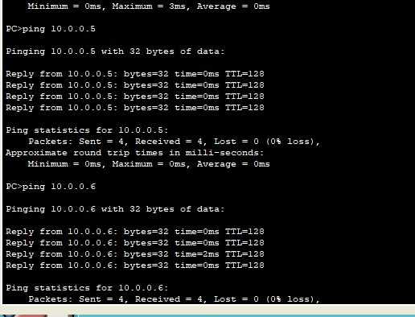

OUTPUT

The hub broadcast to all the connected devices including the switch then the switch forwards the PDU only to the destination device.