Assignment 9.b:
Jenkins Master, Slave-1
Create war on Jenkins master, publish to s3 bucket and deploy on slave1 (tomcat)

Step 1:
On Jenkins master – install java, Jenkins [Note tried installing Jenkins with yum command and changed the tomcat default port to 8081]
yum install java-17-amazon-corretto.x86_64 -y
sudo wget -O /etc/yum.repos.d/jenkins.repo https://pkg.jenkins.io/redhat-stable/jenkins.repo
sudo rpm --import https://pkg.jenkins.io/redhat-stable/jenkins.io.key
sudo yum install jenkins -y
systemctl start jenkins
systemctl enable jenkins

Now the Jenkins home will be also diff. It will be
/var/lib/jenkins

Step 2:
Install tomcat and change it’s default port to 8081 as it also uses 8080
wget https://dlcdn.apache.org/tomcat/tomcat-11/v11.0.20/bin/apache-tomcat-11.0.20.zip
chmod -R 777 apache-tomcat-11.0.20/
cd apache-tomcat-11.0.20/
cd conf/
vi server.xml
<Connector port=" 8081 " protocol="HTTP/1.1"

Step 3:
Install maven and git on master

Step 4:
Add maven in tools and set the git credentials

Step 5:
Create a free style project -> enter git details -> invoke top level maven targets (clean install)
This will build the war

Step 6:
Create s3 bucket using CLI
First create a aws to s3 full access role and attach it to ec2 instance
yum install aws-cli -y
aws s3 mb s3://snehal-assignment9.b

Step 7:
Copy the file to s3 bucket by adding execute shell to above free style project
aws s3 cp /var/lib/jenkins/workspace/assignment9.b/target/LoginWebApp s3://snehal-assignment9.b
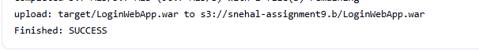

Step 8:
Create a job to run on slave node
Give the slave instance awstos3full access
Execute shell on slave node:
aws s3 cp s3://snehal-assignment9.b/LoginWebApp.war /mnt/jenkins-slave/servers/apache-tomcat-11.0.20/webapps/
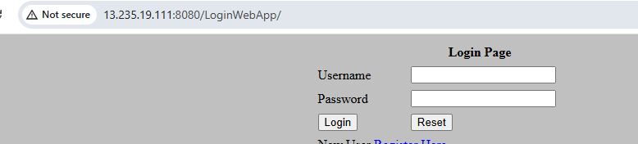

Challenges:
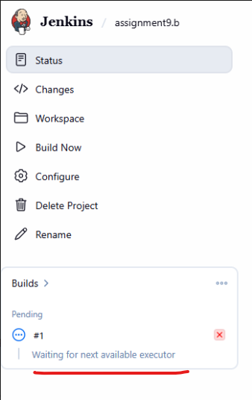
If build stuck like above, try below things
- Try to bring the node online
- In nodes, change the number of executors to 1 or 2
- Restart Jenkins and try to bring the node online
system restart jenkins

