Jenkins Assignment 3

We have 3 repos in github (private) -> repo1 -2026Q1, repo2-2026Q2, repo3-2026Q3
Write in those index.html as repo1 Q1 branch etc
Jenkins master should have httpd running
Create 3 jobs – If I run 1st job Q1 index will deploy, If I run 2nd job previous repo is deleted and new is deployed , if I run 3rd job it should remove previous and deploy new

Step 1:
Create 3 repos repo1 -2026Q1, repo2-2026Q2, repo3-2026Q3

Step 2:
Create Jenkins job 1 -> in SCM provide link of repo1 and branch as 2026-Q1 add credentials -> Add below details in execute shell

yum install httpd -y
systemctl start httpd
systemctl enable httpd
chkconfig httpd on
rm -f /var/www/html/index.html
cp index.html /var/www/html/index.html
chmod -R 777 /var/www/html/index.html

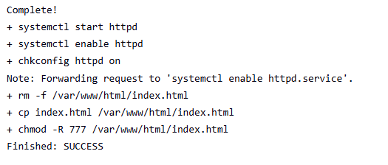



Step 3:
Create Jenkins job 2 -> in SCM provide link of repo2 and branch as 2026-Q2 add credentials -> Add same details in execute shell

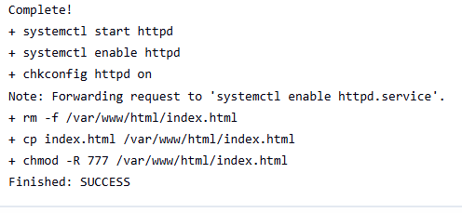

Step 4:
Create Jenkins job 3 -> in SCM provide link of repo3 and branch as 2026-Q3 add credentials -> Add same details in execute shell

