Assignment 6:
In Jenkins Master create war file from the git repo. Deploy the war file another EC2 instance

Step 1:
Install Java, Jenkins, Git, Maven on master

Step 2:
On Master
ssh-keygen
key is saved to /root/.ssh/id_rsa.pub
Copy this key to /root/.ssh/authorized_keys below the original key

Step 3:
Create free style project
Add git details -> in build steps execute shell
rm -rf /root/.m2/repository

-> invoke to level maven targets (clean install) -> execute shell

rm -rf /mnt/servers/apache-tomcat-10.1.53/webapps/LoginWebApp*
scp target/LoginWebApp.war root@172.31.35.53:/mnt/servers/apache-tomcat-10.1.53/webapps

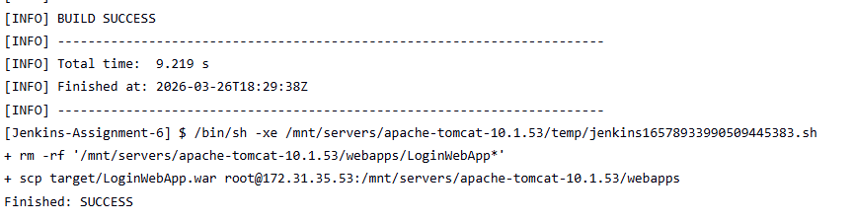
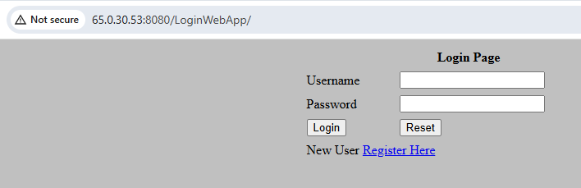

Error:
[project] $ /bin/sh -xe /mnt/servers/apache-tomcat-10.1.53/temp/jenkins2786165823576256348.sh
+ scp /mnt/project/target/LoginWebApp.war root@172.31.39.80:/mnt/servers/apache-tomcat-10.1.53/webapps
Host key verification failed.
Connection closed
Build step 'Execute shell' marked build as failure
Finished: FAILURE

Solution:
Make sure the key gets copied properly.
Verify manually if the command working on Jenkins master
Make sure maven dir is cleaned before next build

