Challenges:
If plugins throw error
Try: Installing Jenkins war instead of yum , Restart Jenkins , Restart EC2 , Try with latest version of Java , Try with older version of Jenkins (this worked)

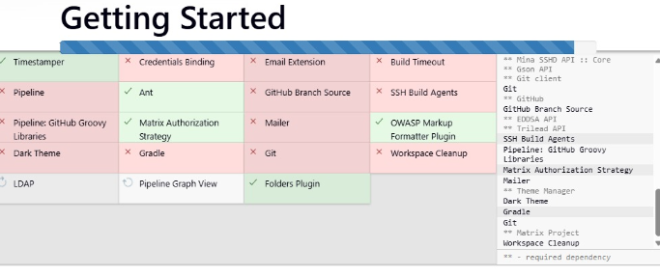

Webhook error:
Error1:
Jenkins is redirecting the request to another URL, usually because of:
Jenkins webhook endpoint must end with /
✅ Correct:
http://13.201.50.49:8080/jenkins/github-webhook/
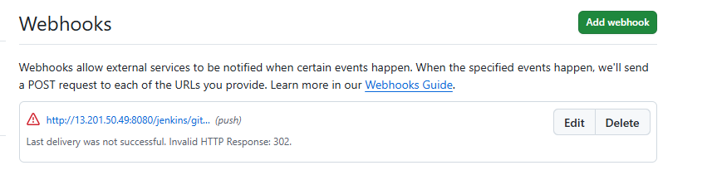

Warning1: It means the repo needs atleast 1 push to confirm if webhook got configured

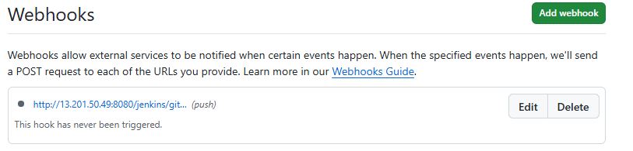

Git Repo:
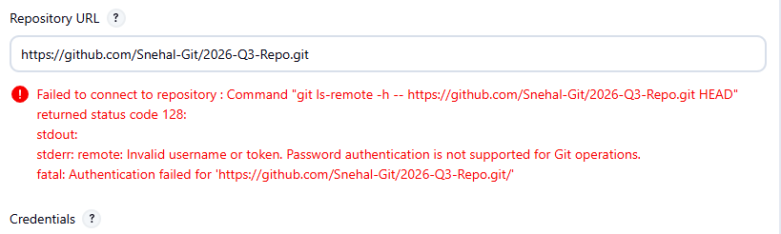
Regenerate the token and create new credentials with it

Console errors:

- Sometimes we need to rename the branch to main instead of master
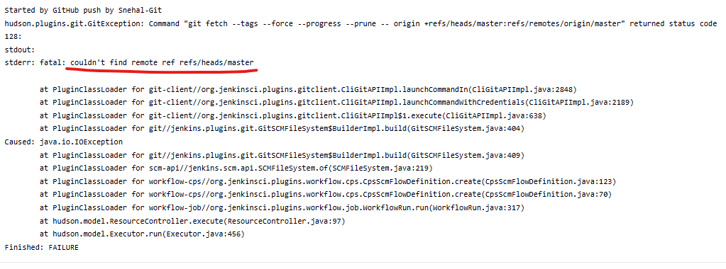

Slave launch errors:
We may get below error if we miss to provide remote dir while creating slave. It’s mandatory

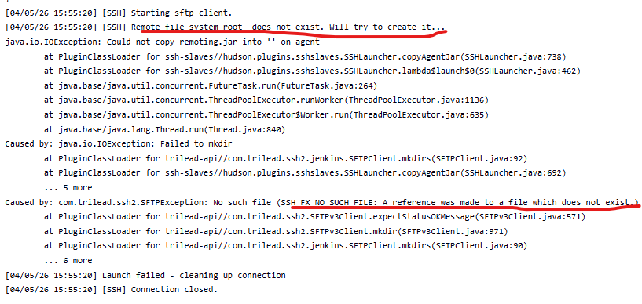

Error:
[project] $ /bin/sh -xe /mnt/servers/apache-tomcat-10.1.53/temp/jenkins2786165823576256348.sh
+ scp /mnt/project/target/LoginWebApp.war root@172.31.39.80:/mnt/servers/apache-tomcat-10.1.53/webapps
Host key verification failed.
Connection closed

Solution:
Make sure the key gets copied properly.
Verify manually if the command working on Jenkins master
Make sure maven dir is cleaned before next build

