Assignment-15:
We have github repo - https://github.com/Snehal-Git/Pipeline-Repo.git
Create war file using the job and upload the war file to S3 bucket and then download the war to tomcat
LoginWebApp_date -> upload date wise then rename and download to tomcat

Steps:
Create awstos3full access role and attach it to EC2 instance
Download tomcat and maven on ec2 instance
Create pipeline job and add git details to it
In manage Jenkins -> tools-> install maven automatically
or add below tag in pipeline
tools {
maven 'apache-maven-3.9.14'
}

Pipeline syntax:
pipeline{
agent{
label "built-in"
}
tools {
maven 'apache-maven-3.9.14'
}
stages{
stage("Build war"){
steps{
sh "mvn clean install"
}
}
stage("Create s3"){
steps{
sh'''
aws s3 mb s3://snehal-assignment-15 2>/dev/null || true
'''
}
}
stage("Copy to s3"){
steps{
sh '''
Date=$(date +"%Y%m%d-%H%M%S")
mv /var/lib/jenkins/workspace/Assignment-15/target/LoginWebApp.war LoginWebApp-$Date.war
aws s3 cp LoginWebApp-$Date.war s3://snehal-assignment-15
aws s3 cp s3://snehal-assignment-15/LoginWebApp-$Date.war /mnt/servers/apache-tomcat-11.0.20/webapps/
'''
}
}
}
}

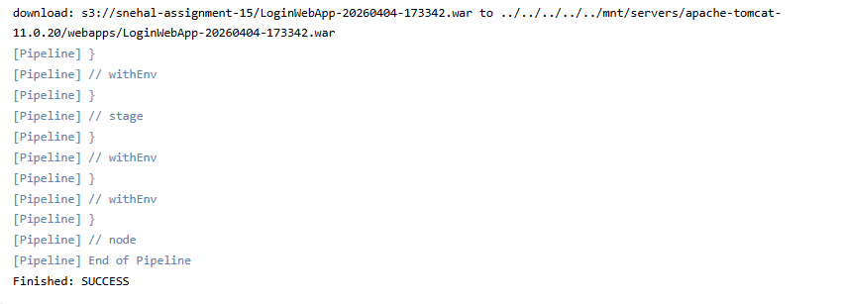
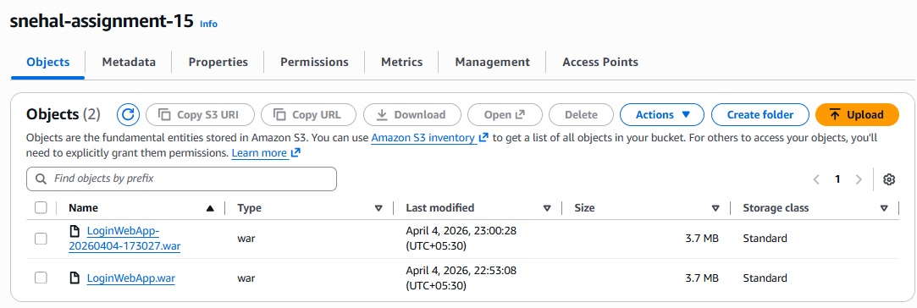
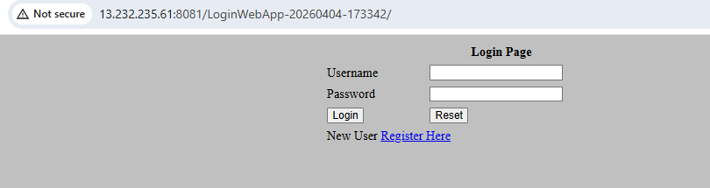

Challenges:
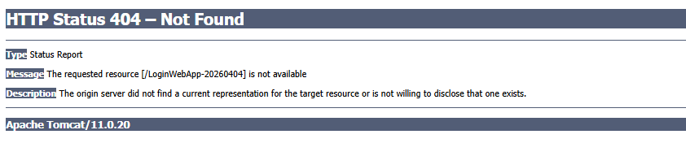
It means we are accessing the wrong application. Check the name of the application

