Assignment 10:
Jenkins Master, Slave-1
Create war on slave1 and deploy on slave1

Step 1:
On Jenkins master – install java, Jenkins [Note tried installing Jenkins with yum command and changed the tomcat default port to 8081]
yum install java-17-amazon-corretto.x86_64 -y
sudo wget -O /etc/yum.repos.d/jenkins.repo https://pkg.jenkins.io/redhat-stable/jenkins.repo
sudo rpm --import https://pkg.jenkins.io/redhat-stable/jenkins.io.key
sudo yum install jenkins -y
systemctl start jenkins
systemctl enable jenkins

Now the Jenkins home will be also diff. It will be
/var/lib/jenkins

Step 2:
Install Java, tomcat, maven and git on slave

Step 3:
Create free style project -> provide git credentials -> invoke top level maven targets -> build steps -> execute shell
sudo cp /mnt/project/target/LoginWebApp.war /mnt/jenkins-slave/servers/apache-tomcat-11.0.20/webapps/

Note: When running on slave, we need to run via sudo

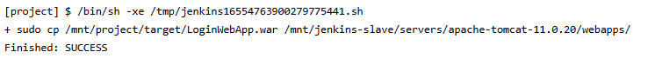
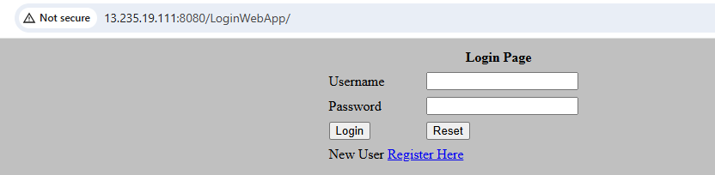

Challenges:

Error in Catalina.out

03-Apr-2026 10:15:59.778 INFO [http-nio-8080-exec-1] org.apache.coyote.http11.Http11Processor.service Error parsing HTTP request header
Note: further occurrences of HTTP request parsing errors will be logged at DEBUG level.
java.lang.IllegalArgumentException: Invalid character found in method name [0x160x030x010x060xe00x010x000x060xdc0x030x030x170x94D]ko0xb90xce=0x870x9c7q0xdd0x1a0x9f0xfe0xa70xfb0xba0xce0x900xd90xda0xf40xfeU0x8a0x920xef0xe50xc0 ]. HTTP method names must be tokens

This means we were hitting the endpoint on https instead of http

