Assignment 7:
3 repos -> 2026-Q1 branch, 2026-Q2 branch, 2026-Q3 branch
Every branch is having index.html
Jenkins master having httpd installed
For whichever index.html I do the changes that index.html should get deployed

- Managed Jenkins -> system -> git hub server -> add -> give url (https://api.github.com) -> add credentials -> secret text -> in secret give token
- In github -> settting -> repo settings -> webhook -> add webhook -> in payload url given Jenkins url and append github-webhook (http://IP:8080/jenkins/github-webhook/ -> content type (json) -> ssl verification (disable) -> events to trigger (just the push event) -> add webhook -> tick should come
- Create job -> freestyle -> provide git repo -> branch as 2026-Q1 -> build periodically (H/2 * * * * *) -> triggers (github hook trigger for scm polling ) -> execute shell with below commands

rm -rf /var/www/html/index.html
cp index.html /var/www/html/
chmod -R 777 /var/www/html/index.html

Challenges:

- Got below error:
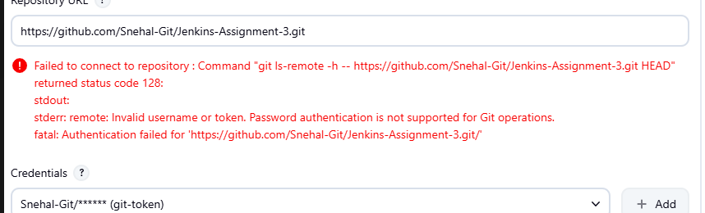
had to regenerate the token and then set the credentials again.

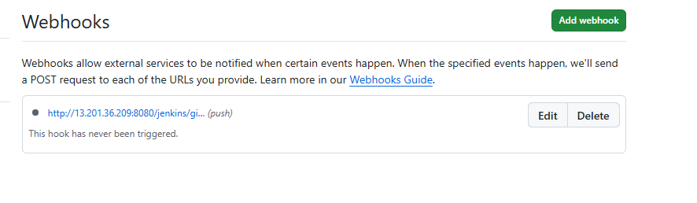
-- “This hook has never been triggered.”
means GitHub has never sent any event to Jenkins yet — so no green tick ❌
--when we create webhook, sometimes it may not get a green tick at same time, it’s needs one push to the repo

- Was getting below error while accessing index.html.
Had forgotten to give permissions using chmod

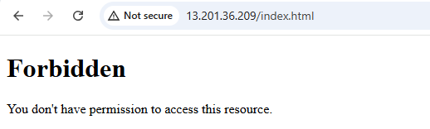

- In branches to build I had to give main instead of master for it to work

Notes:
--Index.html gets created in workspace and not the targets folder – Reason to be checked
--we deploy index.html on httpd and not on tomcat, this is because httpd is used for static files, while tomcat is used for java servlet/container/app

SS:

