Assignment-13:
We have 3 repos in github (private) -> repo1 -2026Q1, repo2-2026Q2, repo3-2026Q3
Write in those index.html as repo1 Q1 branch etc
Jenkins master should have httpd running
Create 3 jobs – If I run 1st job Q1 index will deploy, If I run 2nd job previous repo is deleted and new is deployed , if I run 3rd job it should remove previous and deploy new

Steps:
Create 3 pipeline jobs. Add git repo in them. In the git repo, in the script path give Jenkinsfile

pipeline{
agent{
label {
label "built-in"
}
}
stages{
stage("Install httpd"){
steps{
sh "sudo yum install httpd -y"
}
}
stage("Enable httpd"){
steps{
sh "sudo systemctl start httpd"
sh "sudo systemctl enable httpd"
}
}
stage("Deploy Index"){
steps{
sh '''
sudo chmod 777 /var/www/html/index.html
sudo rm -rf /var/www/html/index.html
sudo cp index.html /var/www/html/
'''
}
}
}
}
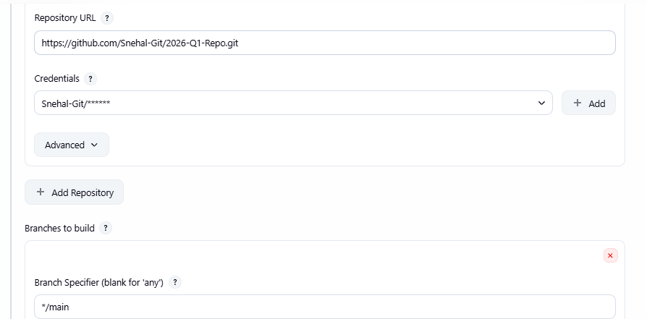
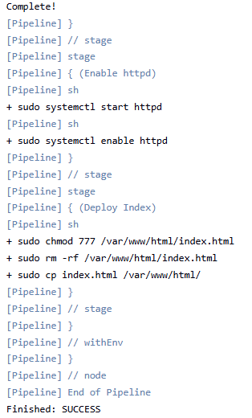

Challenges:
stderr: fatal: couldn't find remote ref refs/heads/master
This means we need to give the branch as main and not master

