Assignment-17:
3 repos -> 2026-Q1 branch, 2026-Q2 branch, 2026-Q3 branch
Every branch is having index.html
Jenkins master having httpd installed
For whichever index.html I do the changes that index.html should get deployed
3 repositories use webhook and deploy on webserver httpd.

Step1: Adding webhook in Git-Hub:
In github -> settting -> repo settings -> webhook -> add webhook -> in payload url given Jenkins url and append github-webhook (http://IP:8080/jenkins/github-webhook/ -> content type (json) -> ssl verification (disable) -> events to trigger (just the push event) -> add webhook -> tick should come
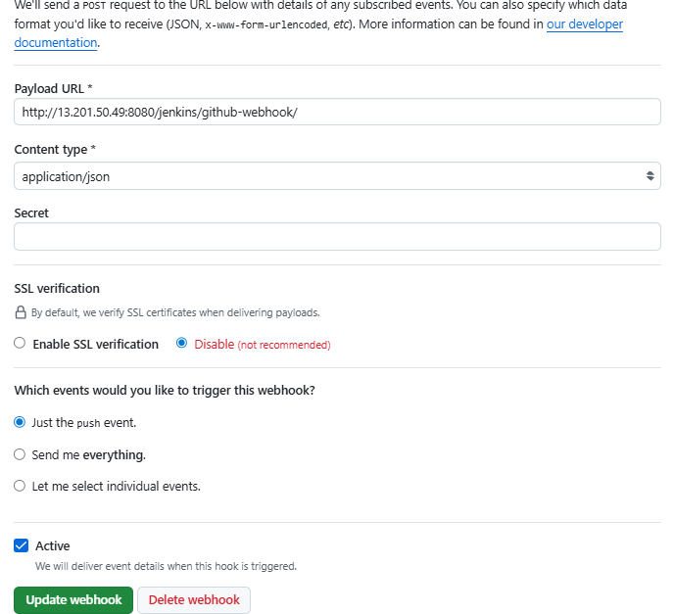

Step 2: Create pipeline job -> select “GitHub hook trigger for GITScm polling” -> provide all 3 urls in git sction with creds
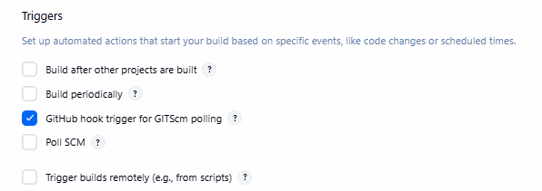
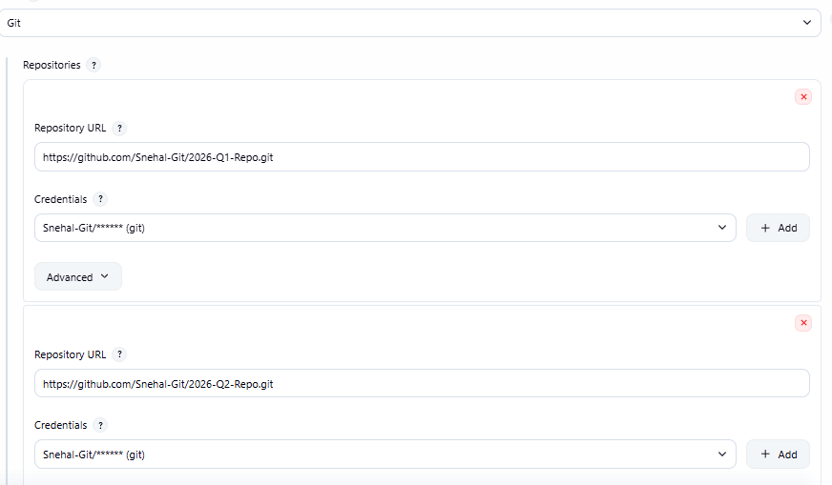
Pipeline:
pipeline{
agent{
label {
label "built-in"
}
}
stages{
stage("Deploy Index"){
steps{
sh '''
sudo chmod 777 /var/www/html/index.html
sudo rm -rf /var/www/html/index.html
sudo cp /root/.jenkins/workspace/Assignment-17/index.html /var/www/html/
echo "new changes"
'''
}
}
}
}

