DecodeLabs Internship Project
Exploratory Data Analysis (EDA) Project

Submitted By
Snehal Jagdale

Domain
Data Analytics

Tools Used
Python, Pandas, NumPy, Matplotlib, VS Code, Jupyter Notebook

Submission Date
May 2026

Introduction
This project focuses on Exploratory Data Analysis (EDA) of an e-commerce dataset using Python. The objective was to identify trends, patterns, and business insights using statistical analysis and visualizations.

Project Objectives
• Perform Exploratory Data Analysis
• Generate statistical summaries
• Create professional visualizations
• Analyze customer purchasing behavior
• Generate business insights

Dataset Overview
The dataset contains order details, products, prices, payment methods, quantities, and revenue-related information from an e-commerce platform.

Tools & Technologies Used
• Python
• Pandas
• NumPy
• Matplotlib
• VS Code
• Jupyter Notebook

Analysis Performed
• Dataset inspection
• Statistical analysis
• Missing value checking
• Duplicate analysis
• Trend analysis
• Revenue analysis
• Product performance analysis

Visualizations Created
• Order Status Distribution
• Top Products Analysis
• Monthly Sales Trend
• Payment Method Distribution
• Revenue by Product
• Quantity Distribution

Key Insights
• Some products generated significantly higher revenue.
• Customer purchasing behavior varied across months.
• Online payment methods were more preferred.
• Certain products had consistently high order volumes.

Conclusion
This project improved understanding of Exploratory Data Analysis, business insights generation, and data visualization techniques used in real-world analytics projects.

Add Screenshots Here

Dataset Overview
👉
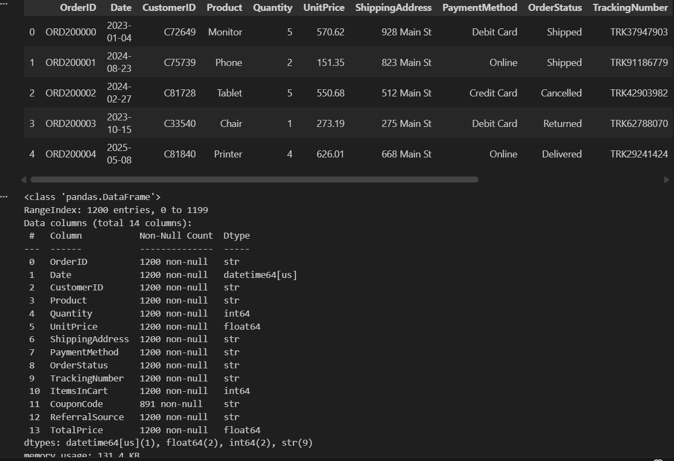
Statistical Summary
👉
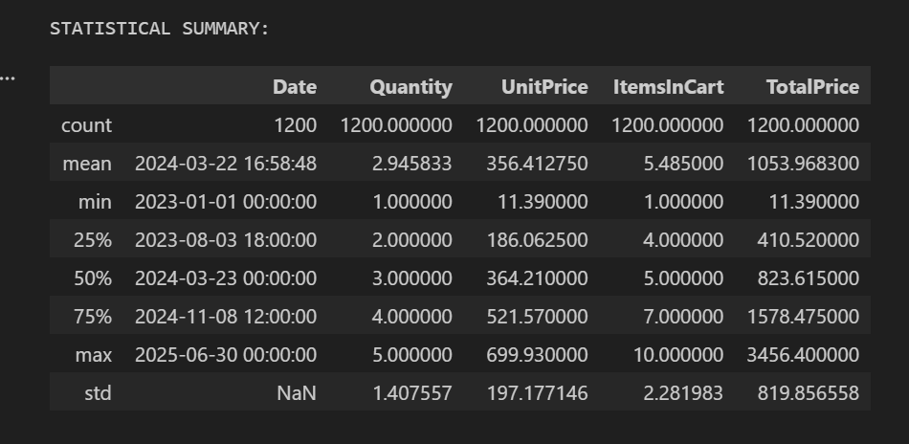
Monthly Sales Trend
👉
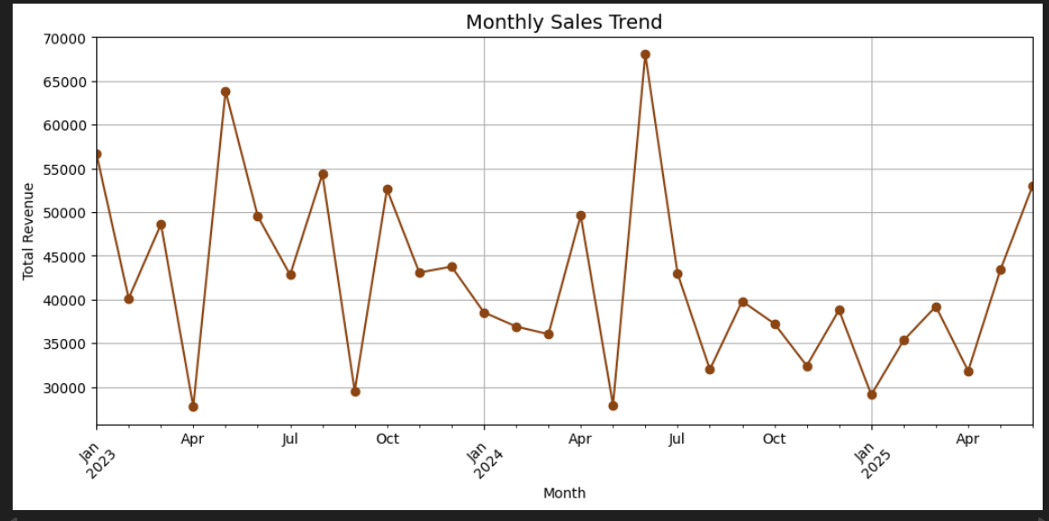
Order Status Distribution
👉
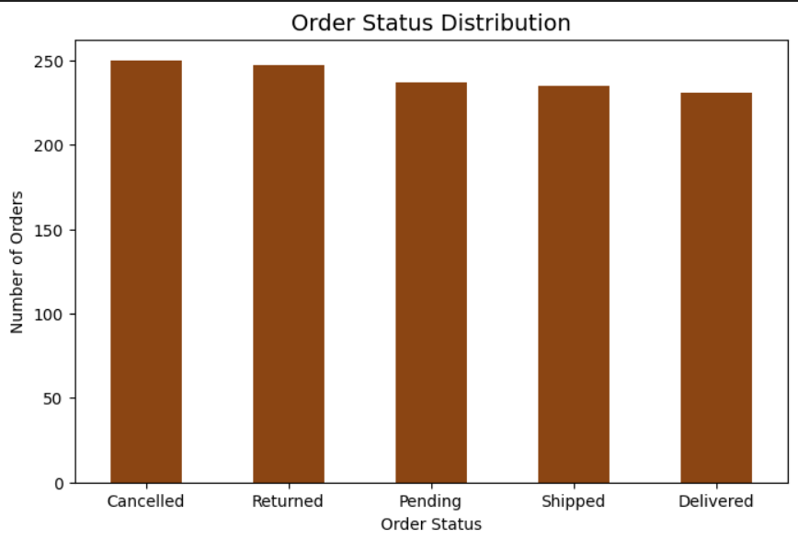
Top Products Analysis
👉
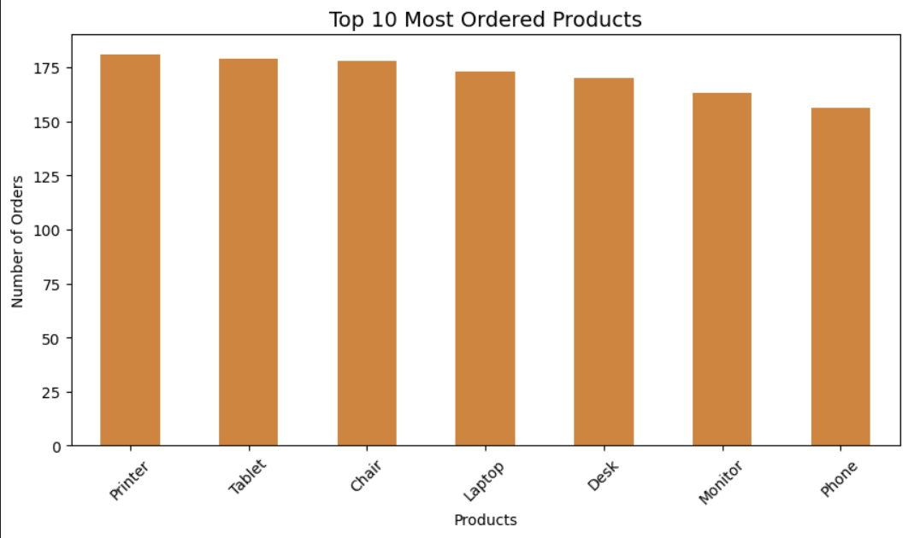
Revenue Analysis
👉
