EXPERIMENT NO.: - 9
Title: Software Engineering Tools and Technologies – Compare and Contrast Different Software Engineering Tools and Technologies

Program A: Login using Python
File1-login.py
STATIC_EMAIL = "test@gmail.com"
STATIC_PASSWORD = "123456"
MAX_ATTEMPTS = 3
def login(email, password):
if email == STATIC_EMAIL and password == STATIC_PASSWORD:
return True
return False
print("========== LOGIN ==========")
attempts = 0
while attempts < MAX_ATTEMPTS:
email = input("Enter Email : ").strip()
password = input("Enter Password : ").strip()
if login(email, password):
print("Login Successful")
break
else:
attempts += 1
print("Login Failed: Invalid email or password")
print("Attempts left:", MAX_ATTEMPTS - attempts)
else:
print("Too many failed attempts. Access blocked.")

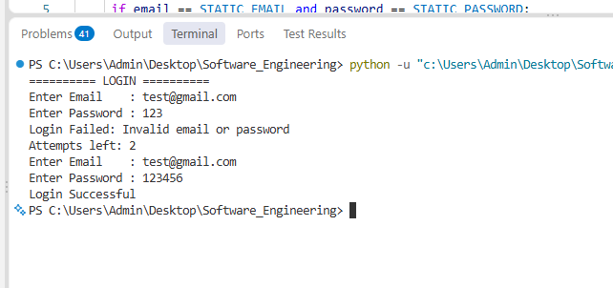
Program B: Login using React.js + Node.js
The backend (Node.js + Express) holds the static email and password and checks them. The frontend (React.js) shows the login form and sends the data to the backend using a POST request.
File1- Server.js
const express = require("express");
const cors = require("cors");

const app = express();

// Middleware
app.use(cors());
app.use(express.json());

// Static login credentials
const STATIC_EMAIL = "test@gmail.com";
const STATIC_PASSWORD = "123456";

// Login API
app.post("/api/login", (req, res) => {
const { email, password } = req.body || {};

if (
email === STATIC_EMAIL &&
password === STATIC_PASSWORD
) {
return res.status(200).json({
success: true,
message: "Login Successful"
});
}

return res.status(401).json({
success: false,
message: "Login Failed: Invalid email or password"
});
});

// Start server
app.listen(5000, () => {
console.log("Server running on http://localhost:5000");
});
File2: App.jsx

import { useState } from "react";
export default function App() { const [email, setEmail] = useState("");
const [password, setPassword] = useState(""); const [message, setMessage] = useState("");
const [loggedIn, setLoggedIn] = useState(false);
const handleLogin = async (e) => { e.preventDefault();
try { const res = await fetch("http://localhost:5000/api/login", {
method: "POST", headers: { "Content-Type": "application/json" },
body: JSON.stringify({ email, password }), });
const data = await res.json();
setMessage(data.message); setLoggedIn(data.success);
} catch (err) {
setMessage("Server not reachable. Start the backend first.");
} };
if (loggedIn) { return ( <div style={{ textAlign: "center", marginTop: 80 }}>
<h2>Welcome, {email}</h2> <p>{message}</p> <button onClick={() => { setLoggedIn(false); setPassword(""); }}> Logout </button> </div> ); }
return ( <form onSubmit={handleLogin}
style={{ maxWidth: 320, margin: "80px auto" }}>
<h2>Login</h2>
<input type="email" placeholder="Email" value={email}
onChange={(e) => setEmail(e.target.value)} required /> <br /><br /> <input type="password" placeholder="Password" value={password}
onChange={(e) => setPassword(e.target.value)} required />
<br /><br />
<button type="submit">Login</button>
<p>{message}</p> </form> ); }
