* **Import the zips.json file into your MongoDB. Database name is "population" and collection name is "zipcodes".:-**

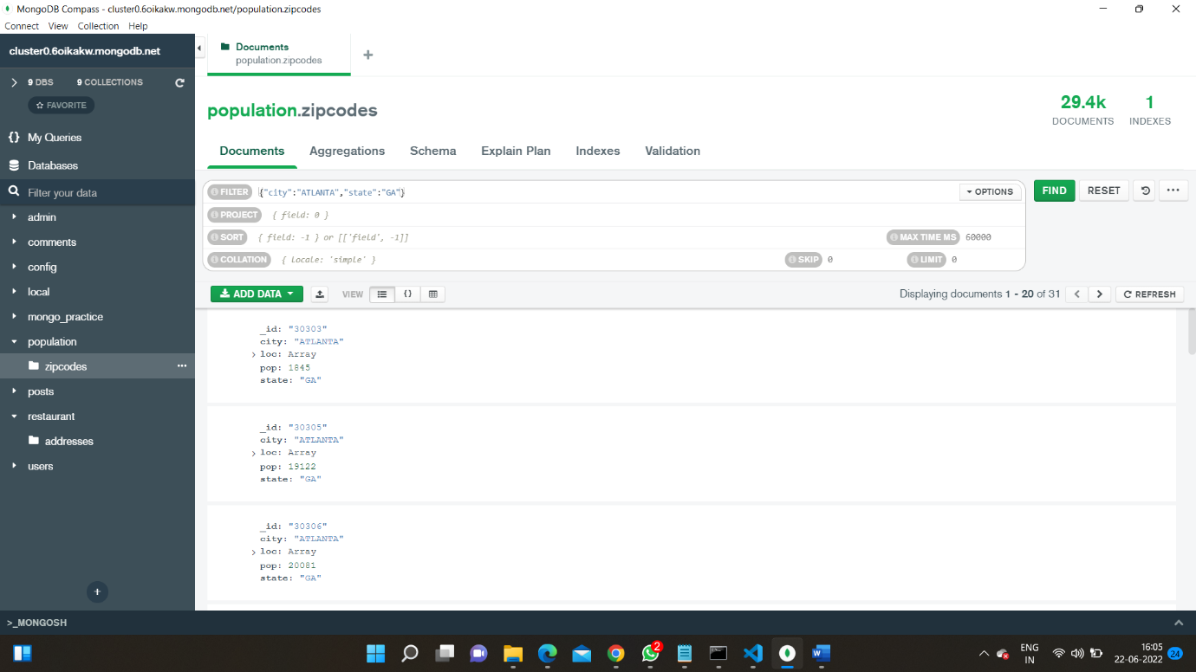

* **Atlanta Population:-**

Atlas atlas-lzt1ql-shard-0 [primary] population> db.zipcodes.find({city:"ATLANTA",state:"GA"})

[

{

_id: '30303',

city: 'ATLANTA',

loc: [ -84.388846, 33.752504 ],

pop: 1845,

state: 'GA'

},

{

_id: '30305',

city: 'ATLANTA',

loc: [ -84.385145, 33.831963 ],

pop: 19122,

state: 'GA'

},

{

_id: '30306',

city: 'ATLANTA',

loc: [ -84.351418, 33.786027 ],

pop: 20081,

state: 'GA'

},

{

_id: '30307',

city: 'ATLANTA',

loc: [ -84.335957, 33.769138 ],

pop: 16330,

state: 'GA'

},

{

_id: '30308',

city: 'ATLANTA',

loc: [ -84.375744, 33.771839 ],

pop: 8549,

state: 'GA'

},

{

_id: '30309',

city: 'ATLANTA',

loc: [ -84.388338, 33.798407 ],

pop: 14766,

state: 'GA'

},

{

_id: '30310',

city: 'ATLANTA',

loc: [ -84.423173, 33.727849 ],

pop: 34017,

state: 'GA'

},

{

_id: '30311',

city: 'ATLANTA',

loc: [ -84.470219, 33.722957 ],

pop: 34880,

state: 'GA'

},

{

_id: '30312',

city: 'ATLANTA',

loc: [ -84.378125, 33.746749 ],

pop: 17683,

state: 'GA'

},

{

_id: '30313',

city: 'ATLANTA',

loc: [ -84.39352, 33.76825 ],

pop: 8038,

state: 'GA'

},

{

_id: '30314',

city: 'ATLANTA',

loc: [ -84.425546, 33.756103 ],

pop: 26649,

state: 'GA'

},

{

_id: '30315',

city: 'ATLANTA',

loc: [ -84.380771, 33.705062 ],

pop: 41061,

state: 'GA'

},

{

_id: '30316',

city: 'ATLANTA',

loc: [ -84.333913, 33.721686 ],

pop: 34668,

state: 'GA'

},

{

_id: '30317',

city: 'ATLANTA',

loc: [ -84.31685, 33.749788 ],

pop: 16395,

state: 'GA'

},

{

_id: '30318',

city: 'ATLANTA',

loc: [ -84.445432, 33.786454 ],

pop: 53894,

state: 'GA'

},

{

_id: '30319',

city: 'ATLANTA',

loc: [ -84.335091, 33.868728 ],

pop: 32138,

state: 'GA'

},

{

_id: '30324',

city: 'ATLANTA',

loc: [ -84.354867, 33.820609 ],

pop: 15044,

state: 'GA'

},

{

_id: '30326',

city: 'ATLANTA',

loc: [ -84.358232, 33.848168 ],

pop: 125,

state: 'GA'

},

{

_id: '30327',

city: 'ATLANTA',

loc: [ -84.419966, 33.862723 ],

pop: 18467,

state: 'GA'

},

{

_id: '30329',

city: 'ATLANTA',

loc: [ -84.321402, 33.823555 ],

pop: 17013,

state: 'GA'

}

]

Atlas atlas-lzt1ql-shard-0 [primary] population> db.zipcodes.aggregate([{$match:{city:"ATLANTA",state:"GA"}}])

[

{

_id: '30303',

city: 'ATLANTA',

loc: [ -84.388846, 33.752504 ],

pop: 1845,

state: 'GA'

},

{

_id: '30305',

city: 'ATLANTA',

loc: [ -84.385145, 33.831963 ],

pop: 19122,

state: 'GA'

},

{

_id: '30306',

city: 'ATLANTA',

loc: [ -84.351418, 33.786027 ],

pop: 20081,

state: 'GA'

},

{

_id: '30307',

city: 'ATLANTA',

loc: [ -84.335957, 33.769138 ],

pop: 16330,

state: 'GA'

},

{

_id: '30308',

city: 'ATLANTA',

loc: [ -84.375744, 33.771839 ],

pop: 8549,

state: 'GA'

},

{

_id: '30309',

city: 'ATLANTA',

loc: [ -84.388338, 33.798407 ],

pop: 14766,

state: 'GA'

},

{

_id: '30310',

city: 'ATLANTA',

loc: [ -84.423173, 33.727849 ],

pop: 34017,

state: 'GA'

},

{

_id: '30311',

city: 'ATLANTA',

loc: [ -84.470219, 33.722957 ],

pop: 34880,

state: 'GA'

},

{

_id: '30312',

city: 'ATLANTA',

loc: [ -84.378125, 33.746749 ],

pop: 17683,

state: 'GA'

},

{

_id: '30313',

city: 'ATLANTA',

loc: [ -84.39352, 33.76825 ],

pop: 8038,

state: 'GA'

},

{

_id: '30314',

city: 'ATLANTA',

loc: [ -84.425546, 33.756103 ],

pop: 26649,

state: 'GA'

},

{

_id: '30315',

city: 'ATLANTA',

loc: [ -84.380771, 33.705062 ],

pop: 41061,

state: 'GA'

},

{

_id: '30316',

city: 'ATLANTA',

loc: [ -84.333913, 33.721686 ],

pop: 34668,

state: 'GA'

},

{

_id: '30317',

city: 'ATLANTA',

loc: [ -84.31685, 33.749788 ],

pop: 16395,

state: 'GA'

},

{

_id: '30318',

city: 'ATLANTA',

loc: [ -84.445432, 33.786454 ],

pop: 53894,

state: 'GA'

},

{

_id: '30319',

city: 'ATLANTA',

loc: [ -84.335091, 33.868728 ],

pop: 32138,

state: 'GA'

},

{

_id: '30324',

city: 'ATLANTA',

loc: [ -84.354867, 33.820609 ],

pop: 15044,

state: 'GA'

},

{

_id: '30326',

city: 'ATLANTA',

loc: [ -84.358232, 33.848168 ],

pop: 125,

state: 'GA'

},

{

_id: '30327',

city: 'ATLANTA',

loc: [ -84.419966, 33.862723 ],

pop: 18467,

state: 'GA'

},

{

_id: '30329',

city: 'ATLANTA',

loc: [ -84.321402, 33.823555 ],

pop: 17013,

state: 'GA'

}

]

* **Populations By State:-**

Atlas atlas-lzt1ql-shard-0 [primary] population> db.zipcodes.aggregate([{$group:{_id:"$state",Totalpopulation:{$sum:"$pop"}}}])

[

{ _id: 'IN', Totalpopulation: 5544136 },

{ _id: 'TN', Totalpopulation: 4876457 },

{ _id: 'MI', Totalpopulation: 9295297 },

{ _id: 'DE', Totalpopulation: 666168 },

{ _id: 'DC', Totalpopulation: 606900 },

{ _id: 'KS', Totalpopulation: 2475285 },

{ _id: 'MT', Totalpopulation: 798948 },

{ _id: 'UT', Totalpopulation: 1722850 },

{ _id: 'CO', Totalpopulation: 3293755 },

{ _id: 'RI', Totalpopulation: 1003218 },

{ _id: 'AL', Totalpopulation: 4040587 },

{ _id: 'GA', Totalpopulation: 6478216 },

{ _id: 'WA', Totalpopulation: 4866692 },

{ _id: 'HI', Totalpopulation: 1108229 },

{ _id: 'MD', Totalpopulation: 4781379 },

{ _id: 'WI', Totalpopulation: 4891769 },

{ _id: 'WY', Totalpopulation: 453528 },

{ _id: 'ND', Totalpopulation: 638272 },

{ _id: 'KY', Totalpopulation: 3675484 },

{ _id: 'AK', Totalpopulation: 544698 }

]

Type "it" for more

Atlas atlas-lzt1ql-shard-0 [primary] population> db.zipcodes.aggregate([{$group:{_id:"$state",Totalpopulation:{$sum:"$pop"}}},{$sort:{Totalpopulation:-1}}])

[

{ _id: 'CA', Totalpopulation: 29754890 },

{ _id: 'NY', Totalpopulation: 17990402 },

{ _id: 'TX', Totalpopulation: 16984601 },

{ _id: 'FL', Totalpopulation: 12686644 },

{ _id: 'PA', Totalpopulation: 11881643 },

{ _id: 'IL', Totalpopulation: 11427576 },

{ _id: 'OH', Totalpopulation: 10846517 },

{ _id: 'MI', Totalpopulation: 9295297 },

{ _id: 'NJ', Totalpopulation: 7730188 },

{ _id: 'NC', Totalpopulation: 6628637 },

{ _id: 'GA', Totalpopulation: 6478216 },

{ _id: 'VA', Totalpopulation: 6181479 },

{ _id: 'MA', Totalpopulation: 6016425 },

{ _id: 'IN', Totalpopulation: 5544136 },

{ _id: 'MO', Totalpopulation: 5110648 },

{ _id: 'WI', Totalpopulation: 4891769 },

{ _id: 'TN', Totalpopulation: 4876457 },

{ _id: 'WA', Totalpopulation: 4866692 },

{ _id: 'MD', Totalpopulation: 4781379 },

{ _id: 'MN', Totalpopulation: 4372982 }

]

Type "it" for more

Atlas atlas-lzt1ql-shard-0 [primary] population> db.zipcodes.aggregate([{$group:{_id:"$state",Totalpopulation:{$sum:"$pop"}}},{$sort:{Totalpopulation:-1}},{$limit:3}])

[

{ _id: 'CA', Totalpopulation: 29754890 },

{ _id: 'NY', Totalpopulation: 17990402 },

{ _id: 'TX', Totalpopulation: 16984601 }

]

* **Populations by City:-**

Atlas atlas-lzt1ql-shard-0 [primary] population> db.zipcodes.aggregate([{$group:{_id:"$city",population:{$sum:"$pop"}}}])

[

{ _id: 'SAUSALITO', population: 10032 },

{ _id: 'ROCK HALL', population: 2770 },

{ _id: 'PAGE', population: 1130 },

{ _id: 'BAILEYTON', population: 41006 },

{ _id: 'MOOSEHEART', population: 371 },

{ _id: 'VALLEY COTTAGE', population: 9132 },

{ _id: 'ORINDA', population: 16883 },

{ _id: 'GILROY', population: 39878 },

{ _id: 'BERGHEIM', population: 763 },

{ _id: 'FORT WASHAKIE', population: 1131 },

{ _id: 'DAUPHIN ISLAND', population: 824 },

{ _id: 'COLD SPRING HARB', population: 2860 },

{ _id: 'NORTH FORK', population: 2808 },

{ _id: 'NORTH SPRING', population: 226 },

{ _id: 'CALUMET PARK', population: 63953 },

{ _id: 'MERSHON', population: 365 },

{ _id: 'HAYDENVILLE', population: 1387 },

{ _id: 'SCALF', population: 600 },

{ _id: 'BEAVER MEADOWS', population: 2470 },

{ _id: 'CHESNEE', population: 14714 }

]

Type "it" for more

Atlas atlas-lzt1ql-shard-0 [primary] population> db.zipcodes.aggregate([{$group:{_id:{city:"$city",state:"$state"},population:{$sum:"$pop"}}},{$sort:{"population":-1}}])

[

{ _id: { city: 'CHICAGO', state: 'IL' }, population: 2452177 },

{ _id: { city: 'BROOKLYN', state: 'NY' }, population: 2300504 },

{ _id: { city: 'LOS ANGELES', state: 'CA' }, population: 2102295 },

{ _id: { city: 'HOUSTON', state: 'TX' }, population: 2095918 },

{ _id: { city: 'PHILADELPHIA', state: 'PA' }, population: 1610956 },

{ _id: { city: 'NEW YORK', state: 'NY' }, population: 1476790 },

{ _id: { city: 'BRONX', state: 'NY' }, population: 1209548 },

{ _id: { city: 'SAN DIEGO', state: 'CA' }, population: 1049298 },

{ _id: { city: 'DETROIT', state: 'MI' }, population: 963243 },

{ _id: { city: 'DALLAS', state: 'TX' }, population: 940191 },

{ _id: { city: 'PHOENIX', state: 'AZ' }, population: 890853 },

{ _id: { city: 'MIAMI', state: 'FL' }, population: 825232 },

{ _id: { city: 'SAN JOSE', state: 'CA' }, population: 816653 },

{ _id: { city: 'SAN ANTONIO', state: 'TX' }, population: 811792 },

{ _id: { city: 'BALTIMORE', state: 'MD' }, population: 733081 },

{ _id: { city: 'SAN FRANCISCO', state: 'CA' }, population: 723993 },

{ _id: { city: 'MEMPHIS', state: 'TN' }, population: 632837 },

{ _id: { city: 'SACRAMENTO', state: 'CA' }, population: 628279 },

{ _id: { city: 'JACKSONVILLE', state: 'FL' }, population: 610160 },

{ _id: { city: 'ATLANTA', state: 'GA' }, population: 609591 }

]

Type "it" for more

Atlas atlas-lzt1ql-shard-0 [primary] population> db.zipcodes.aggregate([{$group:{_id:{city:"$city",state:"$state"},population:{$sum:"$pop"}}},{$sort:{"population":-1}},{$limit:3}])

[

{ _id: { city: 'CHICAGO', state: 'IL' }, population: 2452177 },

{ _id: { city: 'BROOKLYN', state: 'NY' }, population: 2300504 },

{ _id: { city: 'LOS ANGELES', state: 'CA' }, population: 2102295 }

]

* **Bonus:-**

Atlas atlas-lzt1ql-shard-0 [primary] population> db.zipcodes.aggregate([{$group:{_id:"$city",AvgPopulation:{$avg:"$pop"}}}])

[

{ _id: 'INDORE', AvgPopulation: 1173 },

{ _id: 'SPRINGVILLE', AvgPopulation: 5097.125 },

{ _id: 'FAIRPORT', AvgPopulation: 37337 },

{ _id: 'MAPLE', AvgPopulation: 482 },

{ _id: 'SADIEVILLE', AvgPopulation: 2694 },

{ _id: 'ROBBINS', AvgPopulation: 5384.666666666667 },

{ _id: 'OOLTEWAH', AvgPopulation: 17419 },

{ _id: 'NAPER', AvgPopulation: 521 },

{ _id: 'BRIAN HEAD', AvgPopulation: 111 },

{ _id: 'MANSFIELD CENTER', AvgPopulation: 4306 },

{ _id: 'LUCERNE VALLEY', AvgPopulation: 4353 },

{ _id: 'NEW ORLEANS', AvgPopulation: 29231.58823529412 },

{ _id: 'HOTEVILLA', AvgPopulation: 271 },

{ _id: 'NEW LENOX', AvgPopulation: 17470 },

{ _id: 'PEARL RIVER', AvgPopulation: 12009.5 },

{ _id: 'ANDREAS', AvgPopulation: 1235 },

{ _id: 'GOODWELL', AvgPopulation: 1857 },

{ _id: 'BARSTOW', AvgPopulation: 16888.5 },

{ _id: 'SHENANGO', AvgPopulation: 19982 },

{ _id: 'CORAL SPRINGS', AvgPopulation: 43659 }

]

Type "it" for more

Atlas atlas-lzt1ql-shard-0 [primary] population> db.zipcodes.aggregate([{$group:{_id:"$city",AvgPopulation:{$avg:"$pop"}}},{$sort:{AvgPopulation:-1}},{$limit:3}])

[

{ _id: 'BELL GARDENS', AvgPopulation: 99568 },

{ _id: 'ARLETA', AvgPopulation: 88114 },

{ _id: 'SOUTH GATE', AvgPopulation: 87026 }

]