Task3 : login and registration form using javascript

Code :

<!DOCTYPE html>

<html lang="en">

<head>

    <meta charset="UTF-8">

    <meta http-equiv="X-UA-Compatible" content="IE=edge">

    <meta name="viewport" content="width=device-width, initial-scale=1.0">

    <title>TGC Login and Register</title>

    <link rel="stylesheet" href="style2.css">

</head>

<body>

    <div class="container">

    <div class="card">

        <div class="inner-box" id="card">

            <div class="card-front">

                    <h2>LOGIN</h2>

                    <form>

                        <input type="email" class="input-box" placeholder="Your Email Id" required>

                        <input type="password" class="input-box" placeholder="Password" required>

                        <button type="submit"class="submit-btn">Submit</button>

                        <input type="checkbox"><samp>Remember Me</samp>

                  </form>

                    <button type="button" class="btn" onclick="openRegister()">I'm New Here </button>

                    <a href="#">Forgot Password</a>

                   </div>

                   <div class="card-back">

                    <h2>REGISTER</h2>

                    <form>

                        <input type="text" class="input-box" placeholder="Your Name" required>

                        <input type="email" class="input-box" placeholder="Your Email Id" required>

                        <input type="password" class="input-box" placeholder="Password" required>

                        <button type="submit"class="submit-btn">Submit</button>

                        <input type="checkbox"><samp>Remember Me</samp>

                    </form>

                    <button type="button" class="btn" onclick="openLogin()">I've an account </button>

                    <a href="">Forgot Password</a>

                </div>

            </div>

        </div>

    </div>

    <script>

        var card= document.getElementById("card");

        function openRegister(){

            card.style.transform= "rotateY(-180deg)";

        }

        function openLogin(){

            card.style.transform= "rotateY(0deg)";

        }

    </script>

</body>

</html>

Output :

Login page :

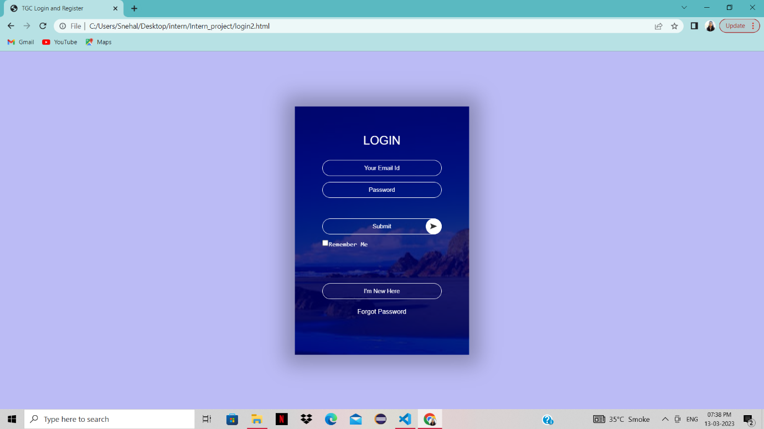

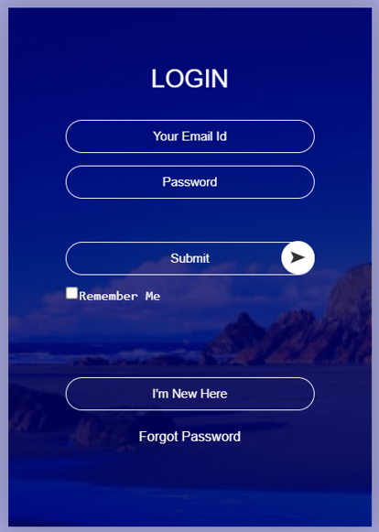

Registration page :



