**Move Files from 1 folder to another**

for files in *.txt

do

folderName=`echo $files | awk -F. '{print $1}'`;

echo $files;

echo $folderName;

printf "\n";

if [ -d $folderName ]

then

rm -r $folderName;

fi

mkdir $folderName;

cp $files $folderName/$files;

done

Output :=

admin@Feb-01 MINGW64 ~/Desktop/practice/Assignment/DAY3

$ bash solution.sh

abc.txt

abc

def.txt

def

jkl.txt

jkl

solution.sh.txt

solution

**append current date to all log files name which has extension .log.1 from a folder**

**date=$(date +%Y%m%d)**

**for file in *.log.1 ; do**

**basename=${file%.*} # Remove extension**

**extension=${file##*.} # Remove basename**

**mv "$file" "$basename"_"$date.$extension"**

**done**

admin@Feb-01 MINGW64 ~/Desktop/practice/Assignment/DAY3

$ touch ghi.log.1 jkl.log.1 mno.log.1

admin@Feb-01 MINGW64 ~/Desktop/practice/Assignment/DAY3

$ ls

AppendDate.sh ghi_20211028.xt

Day3_Assignment.docx jkl/

abc/ jkl.log.1

abc.txt jkl.txt

basename/ mno.log.1

def/ solution/

def.txt solution.sh

file123_20211028.java solution.sh.txt

ghi.log.1 '~$y3_Assignment_20211028.docx'

admin@Feb-01 MINGW64 ~/Desktop/practice/Assignment/DAY3

$ touch abc.log.1 def.log.1

admin@Feb-01 MINGW64 ~/Desktop/practice/Assignment/DAY3

$ ls

AppendDate.sh ghi.log.1

Day3_Assignment.docx ghi_20211028.xt

abc/ jkl/

abc.log.1 jkl.log.1

abc.txt jkl.txt

basename/ mno.log.1

def/ solution/

def.log.1 solution.sh

def.txt solution.sh.txt

file123_20211028.java '~$y3_Assignment_20211028.docx'

admin@Feb-01 MINGW64 ~/Desktop/practice/Assignment/DAY3

$ bash AppendDate.sh

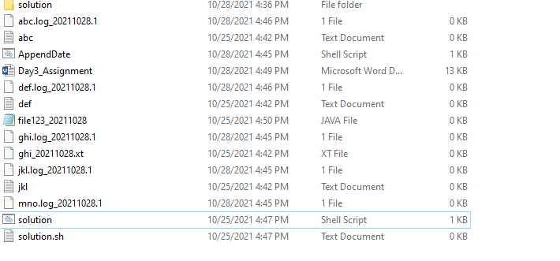

**archive the files from folder which have modified 7 days ago and move it to backup folder in linux**

find /Assignment -maxdepth 1 -mtime +7 -type f -exec mv "{}" /Assignment/Backup/ \

**Hello And ls command execution status**

echo "Hello"

echo $?

ls

echo $?

admin@Feb-01 MINGW64 ~/Desktop/practice/Assignment/DAY3

$ bash hello.sh

Hello

0

AppendDate.sh ghi_20211028.xt

Day3_Assignment.docx hello.sh

abc jkl

abc.log_20211028.1 jkl.log_20211028.1

abc.txt jkl.txt

basename mno.log_20211028.1

def solution

def.log_20211028.1 solution.sh

def.txt solution.sh.txt

file123_20211028.java '~$y3_Assignment_20211028.docx'

ghi.log_20211028.1 '~WRL0005.tmp'

0

**use linux command to search word and print occurrences in linux**

admin@Feb-01 MINGW64 ~/Desktop/practice/Assignment/DAY3

$ grep -c basename AppendDate.sh

3