Q1. Use Random Function (( RANDOM )) to get Single Digit

Answer:=

number=$((RANDOM%10))

echo $number

Output:=

HP@DESKTOP-EJVD731 MINGW64 ~/Desktop/Assignments/Day5 (master)

$ bash Q1.sh

1

HP@DESKTOP-EJVD731 MINGW64 ~/Desktop/Assignments/Day5 (master)

$ bash Q1.sh

2

HP@DESKTOP-EJVD731 MINGW64 ~/Desktop/Assignments/Day5 (master)

$ bash Q1.sh

7

Q.2 Use Random to get Dice Number between 1 to 6

Answer:=

number=$((RANDOM%6+1))

echo $number

Output:=

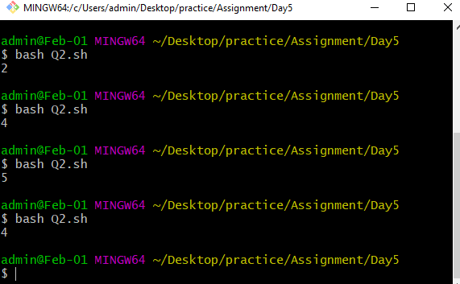

Q.3) Add two Random Dice Number and Print the Result

Answer:=

number=$((RANDOM))

num1=$((RANDOM))

echo $number

echo $num1

echo "Addition=$((number+num1))"

Output:=

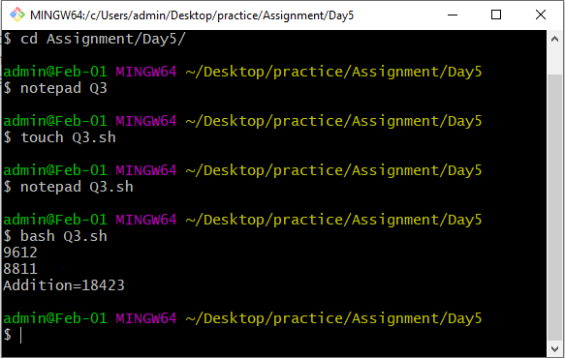

Q.4 Write a program that reads 5 Random 2 Digit values , then find their sum and the average

Answer:=

add=0

avg=0

for i in `seq 5`

do

number=$((RANDOM%100))

echo $number

add=$((add+number))

done

avg=$((add/5))

echo "Addition of 5 2digit Random No is:" $add

echo "Aerage of this Random No:" $avg

Output:=

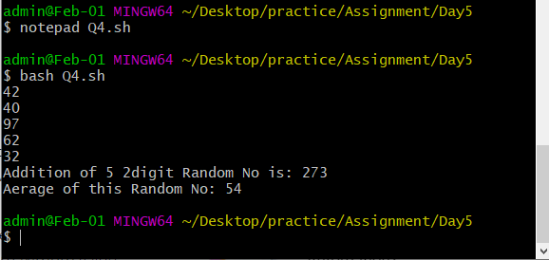

Q.5 Unit Conversion

a. 1ft = 12 in then 42 in = ? ft

b. Rectangular Plot of 60 feet x 40 feet in meters

c. Calculate area of 25 such plots in acres

Answer:=

inch=42

feet=`awk 'BEGIN{echo ("%0.2f",'$inch' / 12)}'`

echo $feet

height=60

width=40

area=$((height*width))

echo "Area of Rectangle: $area"

Output:=

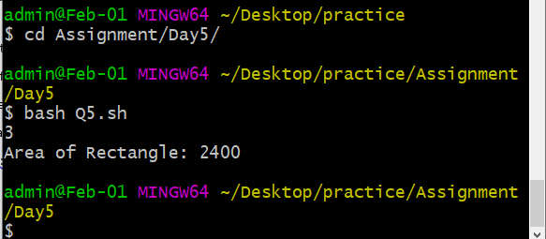

Q.6 Write a program that reads 5 Random 3 Digit values and then outputs the minimum

and the maximum value

Answer:=

min=0

max=0

for i in `seq 5`

do

number=$((RANDOM%1000))

echo $number

if [[ $number -ge $max ]]

then

max=$number

fi

if [[ $number -lt $min ]]

then

min=$number

fi

done

echo "max no. is: $max"

echo "min no. is: $min"

Output:=

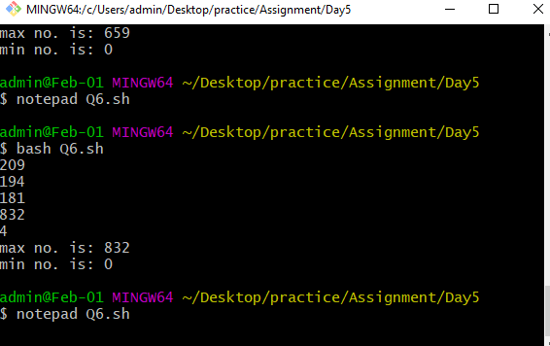

Q.7 Write a program that takes day and month from the command line and prints true if

day of month is between March 20 and June 20, false otherwise.

Amswer:=

read -p "Enter Date: " date

read -p "Enter Month: " Month

combo=0

res="false"

st=1

if [ $Month -ge 3 -a $Month -le 6 ]

then

dlimit=$((30 + (Month % 2)))

if [ $date -ge 1 -a $date -le $dlimit ]

then

combo=$(((Month * 100) + date))

if [ $combo -ge 320 -a $combo -le 620 ]

then

res="true"

st=0

fi

fi

fi

echo "$Month/$date $res"

exit $st

output:=

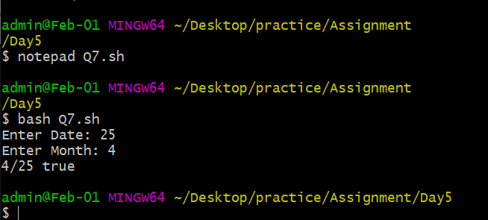

Q.8 Write a program that takes a year as input and outputs the Year is a Leap Year or not

a Leap Year. A Leap Year checks for 4 Digit Number, Divisible by 4 and not 100 unless

divisible by 400.

Answer :=

echo "LEAP YEAR SHELL SCRIPT"

echo -n "Enter a year:"

read year_checker

if [ `expr $year_checker % 4` -eq 0 ]

then

echo "$year_checker is a leap year"

else

echo "$year_checker is not a leap year"

fi

output:=

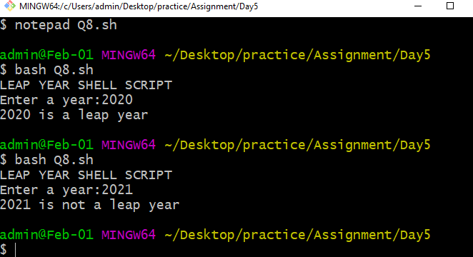

Q.9 Write a program to simulate a coin flip and print out "Heads" or "Tails" accordingly.

Answer:=

Result=$((RANDOM%2))

if [[ ${Result} -eq 0 ]]; then

echo HEADS

elif [[ ${Result} -eq 1 ]]; then

echo TAILS

fi

output:=

