1)What is Automation Testing?
Automation Testing is the process of using software tools (like selenium) to run tests on applications automatically.
It checks whether the actual output matches the expected output, without manual efforts each time.
Example: Instead of clicking buttons or entering data manually every time, a script does it for you.

2)Which are the Browsers Supported by Selenium IDE?
Selenium IDE supports:
- Google Chrome
- Mozilla Firefox
Note: Selenium IDE is mainly used as a browser extension in Chrome and Firefox

3)What are the Benefits of Automation Testing?
- Saves Time: Faster than manual testing
- Reuseable: Test scripts
- Accuracy: Reduces human errors
- Supports Repeated Execution: Ideal for regression testing
- Increase Test Coverage
- Cost-effective in the long run

4)What are the Advantages of Selenium?
- Open-source and free
- Support multiple browsers (Chrome. Firefox, Edge, Safari)
- Support multiple languages (Java, Python, C#, etc.)
- Cross-platform testing (Windows, macOS, Linux)
- Can be integrated with testing tools Like TestNG, Junit, Maven, Jenkins
- Large community support

5)Why Should Testers opt for Selenium Instead of QTP?
1)Cost-Effective
Selenium is open source and free to use
QTP is paid tool by Micro Focus, which requires a license.
2)Cross Browser Support
Selenium supports Chrome, Firefox, Safari, Edge Opera etc.
QTP mainly supports Internal Explorer (limited browser support).
3)Multi-language support
Selenium supports multiple programming languages like Java, Python, C#, Ruby, JavaScript, etc.
QTP only supports VBScript.
4)Platform Independent
Selenium runs on Windows, macOS, Linux.
QTP works only on Windows.
5)Community and Integration
Selenium has large community and integrates well with tools like TestNG, Maven, Jenkins, Git,
QTP has limited integration and a smaller user community.
6)Better for Web Testing
Selenium is built for web application testing
QTP is heavier and mainly used for desktop apps or older enterprise systems.

6) To validate the tops technologies website Contact us page and enter your friend detail at last “Login and side menu” Sauce demo website.
1)Tops Technologies Contact Us Page
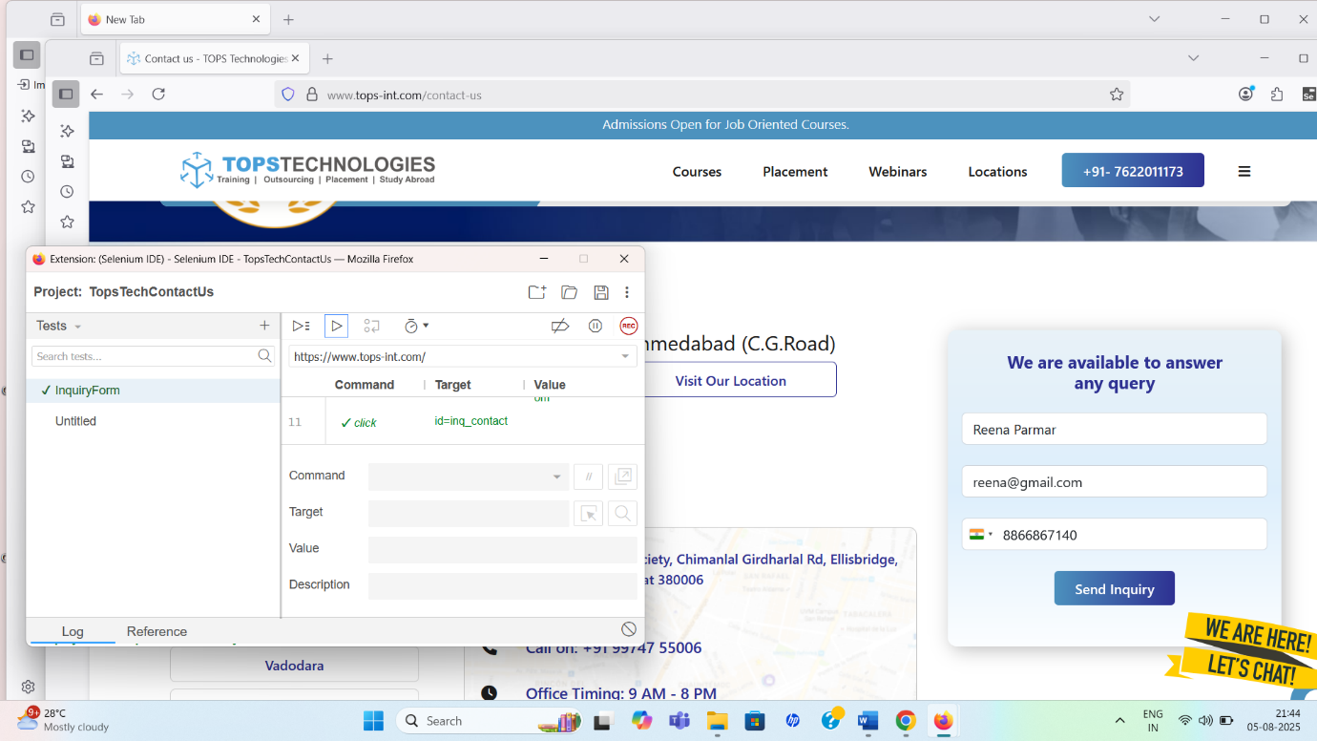
“Tops Technologies Contact Us page”
2) Sauce Demo Website
i) Sauce Demo Login Menu
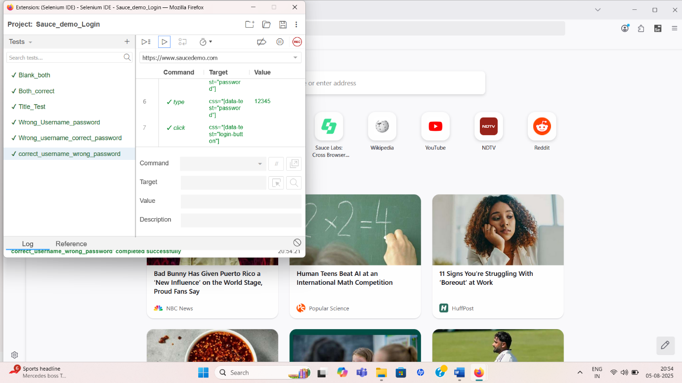
“Sauce Demo Login Menu”
ii) Sauce Demo Side Menu
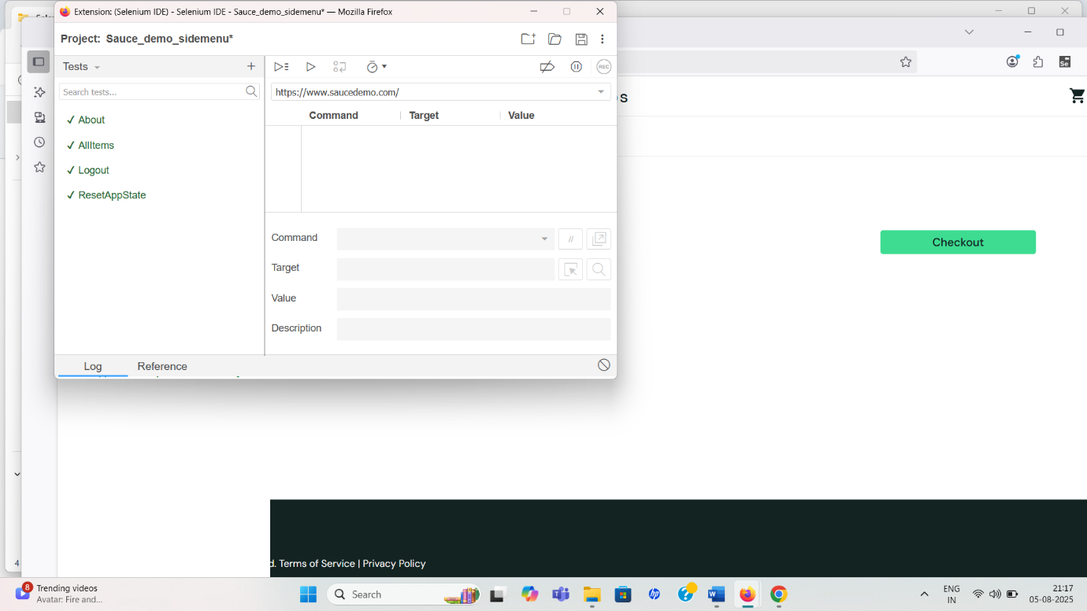
“Sauce Demo Side Menu”

Selenium WebDriver:
1)W.A.J.Script for Locating links by linkText() and partialLinkText()
package WebDriverAssignment;
import org.openqa.selenium.By;
import org.openqa.selenium.WebDriver;
import org.openqa.selenium.WebElement;
import org.openqa.selenium.chrome.ChromeDriver;
public class LinkText_PartialLinkText_1 {
public static void main(String[] args) {
// TODO Auto-generated method stub
String path = System.getProperty("user.dir");
System.out.println(path);
String fullpath = path + "//src//main//java//webdriver//chromedriver_137.exe";
System.out.println(fullpath);
System.setProperty("webdriver.chrome.driver", fullpath);
WebDriver driver = new ChromeDriver();
driver.get("https://the-internet.herokuapp.com/");
//1.LinkText()
WebElement link= driver.findElement(By.linkText("Broken Images"));
System.out.println("Broken Images href " + link.getAttribute("href"));

//2.PartialLinkText()
WebElement partiallink = driver.findElement(By.partialLinkText("Basic"));
System.out.println(("Basic Auth href " + partiallink.getAttribute("href")));
}
}
2) W.A.J.Script for Selecting multiple items in a drop dropdown
package WebDriverAssignment;
import java.time.Duration;
import org.openqa.selenium.By;
import org.openqa.selenium.WebDriver;
import org.openqa.selenium.WebElement;
import org.openqa.selenium.chrome.ChromeDriver;
import org.openqa.selenium.support.ui.ExpectedConditions;
import org.openqa.selenium.support.ui.Select;
import org.openqa.selenium.support.ui.WebDriverWait;
public class MultiSelectDropdown_2{
public static void main(String[] args) throws InterruptedException {
String path = System.getProperty("user.dir");
System.out.println(path);
String fullpath = path + "//src//main//java//webdriver//chromedriver_137.exe";
System.out.println(fullpath);
System.setProperty("webdriver.chrome.driver", fullpath);
WebDriver driver = new ChromeDriver();
driver.get("https://testautomationpractice.blogspot.com/");
driver.manage().window().maximize();
WebElement multiSelect = driver.findElement(By.id("colors"));
// Select class object
Select select = new Select(multiSelect);
if (select.isMultiple()) {
select.selectByVisibleText("Red");
Thread.sleep(1000);
select.selectByVisibleText("Green");
Thread.sleep(1000);
select.selectByVisibleText("Blue");
System.out.println("Selected: Red");
System.out.println("Selected: Green");
System.out.println("Selected: Blue");
} else {
System.out.println("Dropdown is NOT multi-select.");
}
//driver.quit();
}
}
3) W.A.J. script to use different methods to manage the windows-alerts and pop ups.

package WebDriverAssignment;
import org.openqa.selenium.Alert;
import org.openqa.selenium.By;
import org.openqa.selenium.WebDriver;
import org.openqa.selenium.chrome.ChromeDriver;
public class AlertsExample {
public static void main(String[] args) throws InterruptedException {
String path = System.getProperty("user.dir");
System.out.println(path);
String fullpath = path + "\\src\\main\\java\\webdriver\\chromedriver_137.exe";
System.out.println(fullpath);
System.setProperty("webdriver.chrome.driver", fullpath);
WebDriver driver = new ChromeDriver();
// 3. Open test page with alerts
driver.get("https://the-internet.herokuapp.com/javascript_alerts");
driver.manage().window().maximize();
// 1.Alert Simple driver.findElement(By.xpath("//*[@id=\"content\"]/div/ul/li[1]/button")).click();
Thread.sleep(1000); // just to see alert
Alert alert1 = driver.switchTo().alert(); // Switch to alert
System.out.println("Alert text: " + alert1.getText());
alert1.accept(); // OK click
// 2.Confirm driver.findElement(By.xpath("//*[@id=\"content\"]/div/ul/li[2]/button")).click();
Thread.sleep(1000);
Alert alert2 = driver.switchTo().alert();
System.out.println("Confirmation text: " + alert2.getText());
alert2.dismiss(); // Cancel click
// 3.Prompt driver.findElement(By.xpath("//*[@id=\"content\"]/div/ul/li[3]/button")).click();
Thread.sleep(1000);
Alert alert3 = driver.switchTo().alert();
System.out.println("Prompt text: " + alert3.getText());
alert3.sendKeys("Snehal Solanki"); // Type text
alert3.accept();
// Close browser
//driver.quit();
}
}
4) W.A.J.script to register your self in Gmail.
package WebDriverAssignment;
import org.openqa.selenium.By;
import org.openqa.selenium.WebDriver;
import org.openqa.selenium.WebElement;
import org.openqa.selenium.chrome.ChromeDriver;
import org.openqa.selenium.support.ui.ExpectedConditions;
import org.openqa.selenium.support.ui.WebDriverWait;
import java.time.Duration;
public class GmailSignupAutoFill_4 {
public static void main(String[] args) throws InterruptedException {
String path = System.getProperty("user.dir");
System.out.println(path);
String fullpath = path + "\\src\\main\\java\\webdriver\\chromedriver_137.exe";
System.out.println(fullpath);
System.setProperty("webdriver.chrome.driver", fullpath);
WebDriver driver = new ChromeDriver();
driver.get("https://accounts.google.com/signup");
// WebDriverWait wait = new WebDriverWait(driver, Duration.ofSeconds(10));
Thread.sleep(2000);

WebElement fn = driver.findElement(By.id("firstName"));
fn.sendKeys("Reena");
WebElement ln = driver.findElement(By.id("lastName"));
ln.sendKeys("Parmar");
WebElement btn = driver.findElement(By.xpath("//*[@id=\"collectNameNext\"]/div/button/span"));
btn.click();
Thread.sleep(2000);
WebElement monthDropdown = driver.findElement(By.id("month"));
monthDropdown.click(); driver.findElement(By.xpath("//*[@id=\"month\"]/div/div[2]/ul/li[11]")).click();
WebElement day = driver.findElement(By.name("day"));
day.sendKeys("25");
WebElement year = driver.findElement(By.name("year"));
year.sendKeys("2001");
driver.findElement(By.id("gender")).click(); driver.findElement(By.xpath("//*[@id=\"gender\"]/div/div[2]/ul/li[1]")).click();
WebElement btn2 = driver.findElement(By.xpath("//*[@id=\"birthdaygenderNext\"]/div/button/span"));
btn2.click();
Thread.sleep(3000);
WebElement username = driver.findElement(By.name("Username"));
username.sendKeys("reenaparamar25");
Thread.sleep(3000);
WebElement btn3 = driver.findElement(By.xpath("//*[@id='next']/div/button/span"));
btn3.click();
Thread.sleep(3000);
WebElement pass = driver.findElement(By.name("Passwd"));
pass.sendKeys("Reena#123");
WebElement cpass = driver.findElement(By.name("PasswdAgain"));
cpass.sendKeys("Reena#123");
WebElement btn4 = driver.findElement(By.xpath(" //*[@id=\"createpasswordNext\"]/div/button/span"));
btn4.click();
//note:From this point,CAPTCHA and phone verification appear_cant be bypassed
Thread.sleep(5000);
System.out.println("Filled Gmail sign-up from (CAPTCH & verification pending).");
// driver.quit();
}
}
5) W.A.J. Script To perform the radio button to select one by one in loop https://demo.automationtesting.in/Register.html
package WebDriverAssignment;

import org.openqa.selenium.By;
import org.openqa.selenium.WebDriver;
import org.openqa.selenium.WebElement;
import org.openqa.selenium.chrome.ChromeDriver;
import java.util.List;
public class RadioButtonLoop_4{
public static void main(String[] args) throws InterruptedException {
String path = System.getProperty("user.dir");
System.out.println(path);
String fullpath = path + "\\src\\main\\java\\webdriver\\chromedriver_137.exe";
System.out.println(fullpath);
System.setProperty("webdriver.chrome.driver", fullpath);
WebDriver driver = new ChromeDriver();
driver.get("https://demo.automationtesting.in/Register.html");
driver.manage().window().maximize();
List<WebElement> radioButtons = driver.findElements(By.name("radiooptions"));
for (WebElement radio : radioButtons) {
radio.click();
Thread.sleep(1000); // 1 second wait just to see effect
}
// driver.quit();
}
}
6) W.A.J Script to write the script for image of logo facebook using xpath
package WebDriverAssignment;
import org.openqa.selenium.By;
import org.openqa.selenium.WebDriver;
import org.openqa.selenium.WebElement;
import org.openqa.selenium.chrome.ChromeDriver;
public class FacebookLogoXPath_5 {
public static void main(String[] args) {
String path = System.getProperty("user.dir");
System.out.println(path);
String fullpath = path + "//src//main//java//webdriver//chromedriver_137.exe";
System.out.println(fullpath);
System.setProperty("webdriver.chrome.driver", fullpath);
WebDriver driver = new ChromeDriver();
driver.get("https://www.facebook.com/");
driver.manage().window().maximize();
WebElement logo = driver.findElement(By.xpath("//*[@id=\"content\"]/div/div/div/div[1]/div/img"));
if (logo.isDisplayed()) {
System.out.println("Facebook logo is displayed.");
} else {
System.out.println("Facebook logo is NOT displayed.");
}
// driver.quit();
}
}
7) W.A.J.Script To write a script for drop down. https://demo.automationtesting.in/Register.html
package WebDriverAssignment;
import org.openqa.selenium.chrome.*;
import org.openqa.selenium.support.ui.Select;
import org.openqa.selenium.By;
import org.openqa.selenium.WebDriver;
import org.openqa.selenium.WebElement;
public class DropDown_7 {
public static void main(String[] args) {
// TODO Auto-generated method stub
String path = System.getProperty("user.dir");
System.out.println(path);
String fullpath = path + "//src//main//java//webdriver//chromedriver_137.exe";
System.out.println(fullpath);
System.setProperty("webdriver.chrome.driver", fullpath);
WebDriver driver = new ChromeDriver();
driver.get("https://demo.automationtesting.in/Register.html ");
driver.manage().window().maximize();
WebElement fn = driver.findElement(By.xpath("//*[@id=\"basicBootstrapForm\"]/div[1]/div[1]/input"));
fn.sendKeys("Snehal");
WebElement ln = driver.findElement(By.xpath("//*[@id=\"basicBootstrapForm\"]/div[1]/div[2]/input"));
ln.sendKeys("Solanki");
WebElement add = driver.findElement(By.xpath("//*[@id=\"basicBootstrapForm\"]/div[2]/div/textarea"));
add.sendKeys("Ahmedabad");
Select drp = new Select (driver.findElement(By.id("Skills")));
drp.selectByValue("CSS");
}
}
8) W.A.J.Script To use Mouse and Keyboard event using Action class 1. Mouse Hover Event 2. Keyboard event
package WebDriverAssignment;
import java.io.IOException;
import org.openqa.selenium.By;
import org.openqa.selenium.Keys;
import org.openqa.selenium.WebDriver;
import org.openqa.selenium.WebElement;
import org.openqa.selenium.chrome.ChromeDriver;
import org.openqa.selenium.interactions.Actions;
public class Mouse_Keyboard_Actions_8 {
public static void main(String[] args) throws InterruptedException, IOException {
// TODO Auto-generated method stub
String path = System.getProperty("user.dir");
System.out.println(path);
String fullpath = path + "\\src\\main\\java\\webdriver\\chromedriver_137.exe";
System.out.println(fullpath);
System.setProperty("webdriver.chrome.driver", fullpath);
WebDriver driver = new ChromeDriver();
driver.get("https://demo.automationtesting.in/Register.html ");
WebElement mouse= driver.findElement(By.xpath("//*[@id=\"header\"]/nav/div/div[2]/ul/li[5]/a"));
Actions action = new Actions(driver);
System.out.println("Widgets: " + mouse.getCssValue("background-color"));
action.moveToElement(mouse).perform();

//keyboard
WebElement a = driver.findElement(By.xpath("//*[@id=\"header\"]/nav/div/div[2]/ul/li[5]/a"));
a.click();
WebElement b = driver.findElement(By.xpath("//*[@id=\"header\"]/nav/div/div[2]/ul/li[5]/ul/li[2]/a"));
b.click();
action.moveToElement(driver.findElement(By.xpath("/html/body/section/div[1]/div[2]/div[1]/div"))).click().keyDown(Keys.SHIFT).sendKeys("Ahemedabad ").build().perform();
Thread.sleep(3000);
action.sendKeys(Keys.BACK_SPACE).sendKeys(Keys.BACK_SPACE).build().perform();
}
}
9) W.A.J. Script How to handled Alert in selenium
"https://demo.automationtesting.in/Alerts.html "
package WebDriverAssignment;
import org.openqa.selenium.Alert;
import org.openqa.selenium.By;
import org.openqa.selenium.WebDriver;
import org.openqa.selenium.WebElement;
import org.openqa.selenium.chrome.ChromeDriver;

public class AlertBox_9 {
public static void main(String[] args) throws InterruptedException {
// TODO Auto-generated method stub
String path = System.getProperty("user.dir");
System.out.println(path);
String fullpath = path + "\\src\\main\\java\\webdriver\\chromedriver_137.exe";
System.out.println(fullpath);
System.setProperty("webdriver.chrome.driver", fullpath);
WebDriver driver = new ChromeDriver();
// 3. Open test page with alerts
driver.get("https://demo.automationtesting.in/Register.html");
driver.manage().window().maximize();
WebElement a = driver.findElement(By.xpath("//*[@id=\"header\"]/nav/div/div[2]/ul/li[4]/a"));
a.click();
WebElement b = driver.findElement(By.xpath("//*[@id=\"header\"]/nav/div/div[2]/ul/li[4]/ul/li[1]/a"));
b.click();
// 1.Alert Simple Box
driver.findElement(By.xpath("/html/body/div[1]/div/div/div/div[1]/ul/li[1]/a")).click();
// just to see alert
WebElement c = driver.findElement(By.xpath("//*[@id=\"OKTab\"]/button"));
c.click();
Thread.sleep(1000);
Alert alert1 = driver.switchTo().alert(); // Switch to alert
System.out.println("Alert text: " + alert1.getText());
alert1.accept(); // OK click
// 2.Confirm Box
driver.findElement(By.xpath("/html/body/div[1]/div/div/div/div[1]/ul/li[2]/a")).click();
WebElement d = driver.findElement(By.xpath("//*[@id=\"CancelTab\"]/button"));
d.click();
Thread.sleep(1000);
Alert alert2 = driver.switchTo().alert();
System.out.println("Confirmation text: " + alert2.getText());
alert2.dismiss(); // Cancel click
// 3.Prompt Box
driver.findElement(By.xpath("/html/body/div[1]/div/div/div/div[1]/ul/li[3]/a")).click();
WebElement e = driver.findElement(By.xpath("//*[@id=\"Textbox\"]/button"));
e.click();
Thread.sleep(1000);

Alert alert3 = driver.switchTo().alert();
System.out.println("Prompt text: " + alert3.getText());
alert3.sendKeys("Snehal Solanki"); // Type text
alert3.accept();
// Close browser
//driver.quit();
}
}
10) W.A.J. Script To find the total hyperlink from this web page https://qavbox.github.io/demo/webtable/
package WebDriverAssignment;
import java.util.List;
import org.openqa.selenium.By;
import org.openqa.selenium.WebDriver;
import org.openqa.selenium.WebElement;
import org.openqa.selenium.chrome.ChromeDriver;
public class FindHyperLinks_10 {
public static void main(String[] args) {
// TODO Auto-generated method stub
String path = System.getProperty("user.dir");
System.out.println(path);
String fullpath = path + "//src//main//java//webdriver//chromedriver_137.exe";
System.out.println(fullpath);
System.setProperty("webdriver.chrome.driver", fullpath);
WebDriver driver = new ChromeDriver();
driver.get("https://qavbox.github.io/demo/webtable/");
driver.manage().window().maximize();
//Get list of webelements with tagName -a
List<WebElement> allLinks = driver.findElements(By.tagName("a"));
System.out.println("Total Links found: " + allLinks.size());
//Traversing through the list and printing its along with link address
for(WebElement link:allLinks) {
System.out.println(link.getText() + " - " + link.getAttribute("href"));
}
//driver.quit();
}
}
11) W.a.junit program to handled Assert class with all method to check its pass or fail
package WebDriverAssignment;
import static org.testng.Assert.assertEquals;
import org.junit.After;
import org.junit.Before;
import org.junit.Test;
class Calculator {
int add(int a,int b) {
return (a+b);
}
int sub(int a,int b) {
return(a-b);
}
}
public class Assert_11 {
@Before
public void before() {
System.out.println("Before");
}
@Test
public void testAdd() {
Calculator c =new Calculator();
int res =c.add(2,3);
System.out.println("Addition");
assertEquals(5, res, "Addition of 2 and 3 should be 5");
}
@Test
public void testSub() {
Calculator c = new Calculator();
int res = c.sub(5,2);
System.out.println("Subtraction");
assertEquals(3,res, "Subtraction of 5 and 2 should be 3");
}
@After
public void after() {
System.out.println("After");
}
}
12)W.a. junit program to perform test with webdriver to login process of facebook
import org.junit.After;
import org.junit.Before;
import org.junit.Test;
import org.openqa.selenium.By;
import org.openqa.selenium.WebDriver;
import org.openqa.selenium.WebElement;
import org.openqa.selenium.chrome.ChromeDriver;

public class Facebook_junit_12 {
WebDriver driver;

@Before
public void setup() {
driver = new ChromeDriver();
driver.manage().window().maximize();
driver.get("https://www.facebook.com/");
}
@Test
public void testLogin() {

WebElement email = driver.findElement(By.id("email"));
email.sendKeys("dummyemail@example.com");

WebElement pass = driver.findElement(By.name("pass"));
pass.sendKeys("dummyPassword123");

// Click Login
WebElement btn = driver.findElement(By.name("login"));
btn.click();
}
@After
public void tearDown() {
// driver.quit();
}
}
13) W.a. junit program to check gmail login using with
@before,@after,@Test
import org.junit.After;
import org.junit.Before;
import org.junit.Test;
import org.openqa.selenium.By;
import org.openqa.selenium.WebDriver;
import org.openqa.selenium.WebElement;
import org.openqa.selenium.chrome.ChromeDriver;

public class Annotation_Gmail_13 {
WebDriver driver;

@Before
public void setup() {
driver = new ChromeDriver();
driver.manage().window().maximize();
driver.get("https://mail.google.com/");
}

@Test
public void testLogin() {
WebElement email = driver.findElement(By.xpath("//*[@id='identifierId']"));
email.sendKeys("dummyemail@example.com");

WebElement btn = driver.findElement(By.xpath("//*[@id='identifierNext']/div/button/span"));
btn.click();
}
@After
public void tearDown() {
driver.quit();
}
}
14)W.a. junit program to use parameterized demo with multiple parameter of Facebook login in junit.
import java.util.Arrays;
import java.util.Collection;
import org.junit.*;
import org.junit.runner.RunWith;
import org.junit.runners.Parameterized;
import org.openqa.selenium.By;
import org.openqa.selenium.WebDriver;
import org.openqa.selenium.chrome.ChromeDriver;
@RunWith(Parameterized.class)
public class FacebookLoginJunit_14 {
String email, pass;
WebDriver driver;

// Constructor for parameters
public FacebookLoginJunit_14(String email, String pass) {
this.email = email;
this.pass = pass;
}

// Test data
@Parameterized.Parameters
public static Collection<Object[]> data() {
return Arrays.asList(new Object[][] {
{"Riddhi@gmail.com", "pass1"},
{"Lakhani@gmail.com", "pass2"}
});
}

@Before
public void setUp() {
System.setProperty("webdriver.chrome.driver","C:\\Users\\sneha\\eclipse-workspace\\SeleniumWebDriver\\src\\main\\java\\webdriver\\chromedriver_137.exe");
driver = new ChromeDriver();
}

@Test
public void loginTest() throws Exception {
driver.get("https://www.facebook.com/");
driver.findElement(By.id("email")).sendKeys(email);
driver.findElement(By.id("pass")).sendKeys(pass);
driver.findElement(By.name("login")).click();
Thread.sleep(2000); // just for demo
}

@After
public void tearDown() {
//driver.quit();
}
}
15) W.a. TestNG program to perform test with webdriver to login process of facebook
import org.openqa.selenium.By;
import org.openqa.selenium.WebDriver;
import org.openqa.selenium.WebElement;
import org.openqa.selenium.chrome.ChromeDriver;
import org.testng.annotations.AfterClass;
import org.testng.annotations.BeforeClass;
import org.testng.annotations.Test;

public class Facebook_Testng_15 {
WebDriver driver;

@BeforeClass
public void setup() {
driver = new ChromeDriver();
driver.manage().window().maximize();
driver.get("https://www.facebook.com/");
}
@Test
public void testLogin() {
WebElement email = driver.findElement(By.id("email"));
email.sendKeys("dummyemail@example.com");

WebElement pass = driver.findElement(By.name("pass"));
pass.sendKeys("dummyPassword123");

WebElement btn = driver.findElement(By.name("login"));
btn.click();
}
@AfterClass
public void tearDown() {
// driver.quit();
}
}
16) W.a. TestNG program to check gmail login using with @beforetest,@aftertest,@Test
import org.openqa.selenium.By;
import org.openqa.selenium.WebDriver;
import org.openqa.selenium.WebElement;
import org.openqa.selenium.chrome.ChromeDriver;
import org.testng.annotations.Test;
import org.testng.annotations.BeforeTest;
import org.testng.annotations.AfterTest;
public class Gmail_Testng_16 {
WebDriver driver;

@BeforeTest
public void setup() {
driver = new ChromeDriver();
driver.manage().window().maximize();
driver.get("https://mail.google.com/");
}
@Test
public void testLogin() {
WebElement email = driver.findElement(By.xpath("//*[@id='identifierId']"));
email.sendKeys("dummyemail@example.com");

WebElement btn = driver.findElement(By.xpath("//*[@id='identifierNext']/div/button/span"));
btn.click();
}
@AfterTest``
public void tearDown() {
//driver.quit();
}
}
17) W.a. TestNG program to use parameterized demo with multiple parameter of Facebook login with TestNG.
Fbtestng.xml
<suite name="FacebookLoginSuite">
<test name="FacebookLoginTest">
<parameter name="username" value="testuser123" />
<parameter name="password" value="pass@123" />
<classes>
<class name="WebDriverAssignment.FacebookLogin" />
</classes>
</test>
</suite>
FacebookLogin.java
package WebDriverAssignment;
import org.testng.annotations.Parameters;
import org.testng.annotations.Test;
public class FacebookLogin {
@Test
@Parameters({"username", "password"})
public void loginTest(String uname, String pass) {
System.out.println("Username: " + uname);
System.out.println("Password: " + pass);
}
}
18) W.a. TestNG program to create group with testing.xml file
Testng.xml
<suite name="MyTestSuite" parallel="methods" thread-count="2">
<test name="LoginTests">
<classes>
<class name="WebDriverAssignment.LoginTest">
<methods>
<include name="testValidLogin"/>
<exclude name="testInvalidLoginWithEmptyPassword"/>
</methods>
</class>
</classes>
</test>
<test name="ProductTests">
<classes>
<class name="WebDriverAssignment.ProductSearchTest"/>
<class name="WebDriverAssignment.ProductDetailsTest"/>
</classes>
</test>
<test name="ParameterizedLoginTest">
<parameter name="username" value="testUser"/>
<parameter name="password" value="testPass"/>
<classes>
<class name="WebDriverAssignment.LoginTest"/>
</classes>
</test>
</suite>
LoginTest.java
package WebDriverAssignment;
import org.testng.annotations.Optional;
import org.testng.annotations.Parameters;
import org.testng.annotations.Test;
public class LoginTest {
@Test
public void testValidLogin() {
System.out.println("Executing testValidLogin");
// Add actual login logic here
}
@Test
public void testInvalidLoginWithEmptyPassword() {
System.out.println("Executing testInvalidLoginWithEmptyPassword");
}
@Test
@Parameters({"username", "password"})
public void testLoginWithParameters(@Optional("default_username") String username,@Optional("default_password") String password) {
System.out.println("Executing testLoginWithParameters with username: " + username + " and password: " + password);
// Add actual login logic here using parameters
}
}
ProductDetailsTest.java
package WebDriverAssignment;
import org.testng.annotations.Test;
public class ProductDetailsTest {
@Test
public void testViewProductDetails() {
System.out.println("Executing testViewProductDetails");
// Add actual product details viewing logic
}
}
ProductSearchTest.java
package WebDriverAssignment;
import org.testng.annotations.Test;
public class ProductSearchTest {
@Test
public void testSearchProduct() {
System.out.println("Executing testSearchProduct");
// Add actual product search logic
}
}
19) w.a. TestNG program to create dataprovider.
package WebDriverAssignment;
import org.testng.annotations.DataProvider;
import org.testng.annotations.Test;
public class DataProvider_last {
@DataProvider(name = "loginData")
public Object[][] provideLoginData(){
return new Object[][] {
{"user1","pass1"},
{"user2","pass2"},
{"user3","pass3"}
};
}
@Test(dataProvider = "loginData")
public void testLogin(String username, String password) {
System.out.println("Testing login with username: " + username + " and password: " + password);
}
}

