**Problem Statement**

Run queries so as to do analysis of the Netflix data using various queries to pull various metrics.

* Every content has ContentID which uniquely identifies the content, content title, Release date, ratings.
* To view the content, a customer must buy a subscription by making a payment. Customers can be identified by a unique identifier CustomerID.   
  Other attributes include Name, which is a combination of first and last name, Address, Email, Phone Number.
* Subscription has a unique identifier SubscriptionID. Other attributes are Subscription type, Price and Resolution.
* Genre has attribute GenreID and Description.
* Payment is made by the customer to buy a subscription.
* It is uniquely identified by PaymentID, and other attributes are Payment Method, Billing Date and Amount Paid.
* A Customer must make at least one payment and a payment must have one and only one customer.
* A subscription can have many customers and a customer should have at least one subscription.
* A content must have at least one or many genres, and a genre should belong to one or many contents.
* A subscription may have at least one or many contents and a content must be part of at least one subscription.

Entity-Relationship Model.

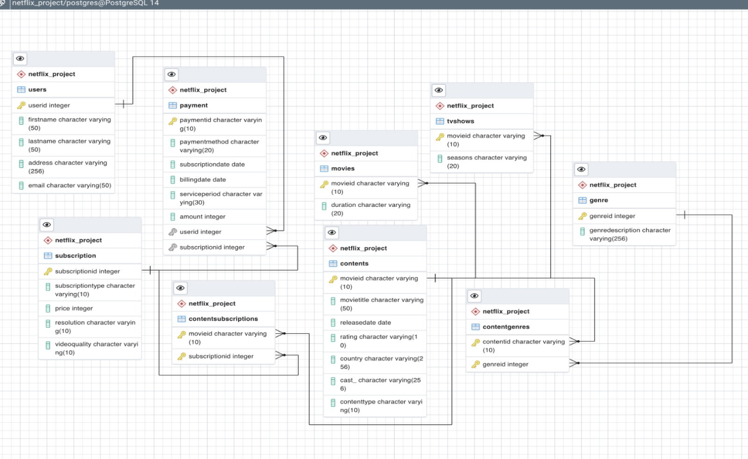

**TEST DATA GENERATION**

**As there is limited data available for the process of test data generation, we have taken few datasets from Kaggle in order to perform analysis on the tables.**

**Query 1**

**Creation of Tables :**

1. The List of tables created in the screenshot and attached queries for the Creation of tables.

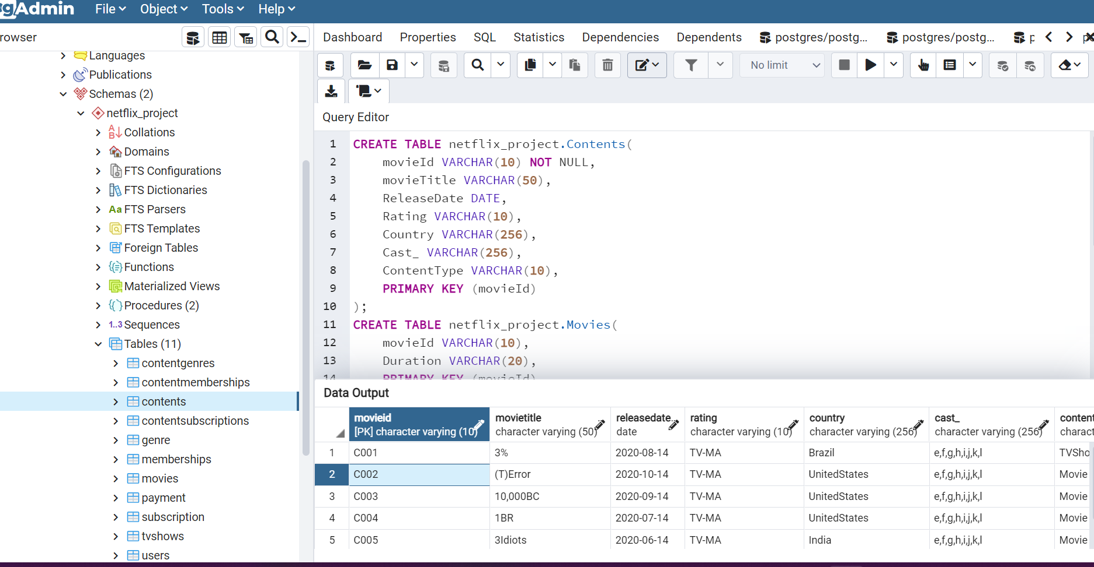

2. Query towe find the availability of a particular content amongst the other content types. To achieve the result, we have used Natural Join, Group by and Order By.

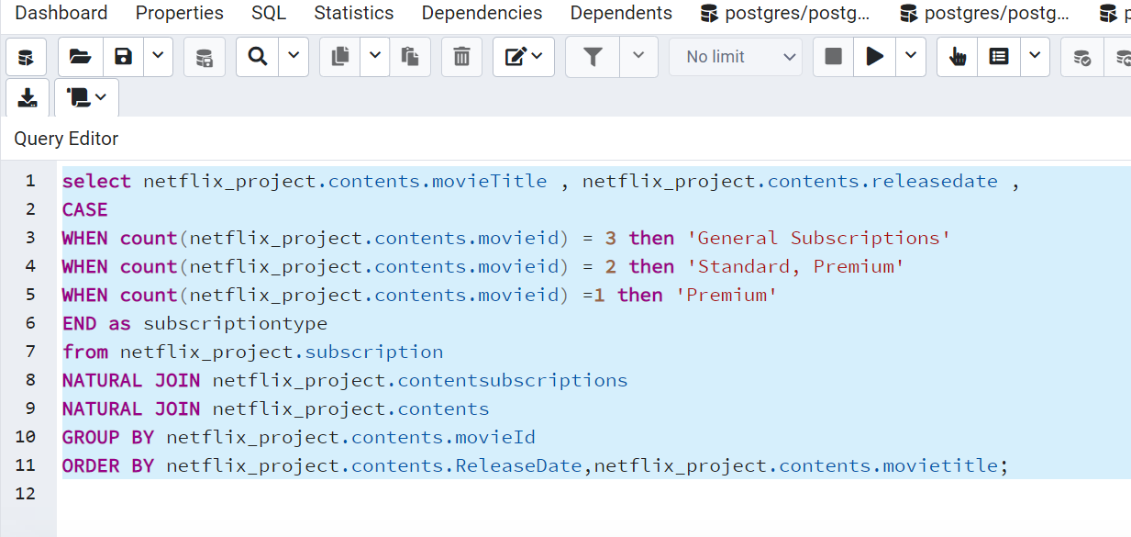

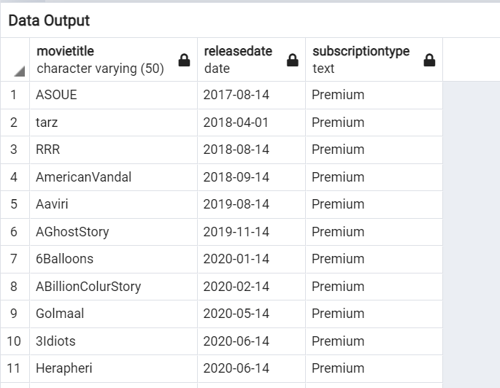

3.Use of Inner Join to extract data of customers and the tenure of their remaining subscription period along with the amount they have paid so far for their subscription.

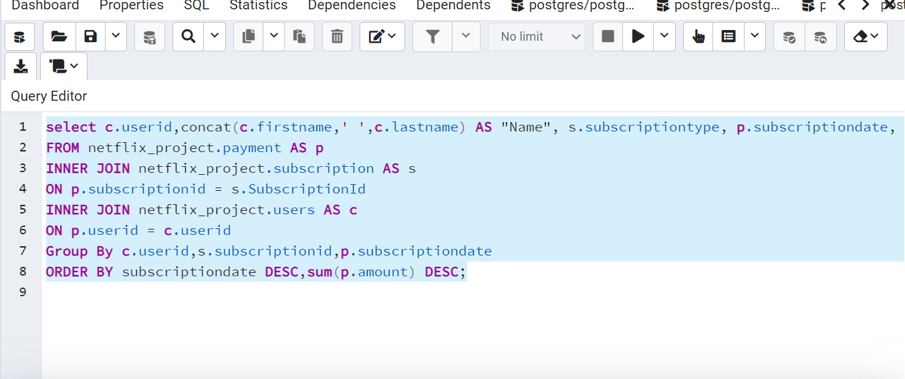

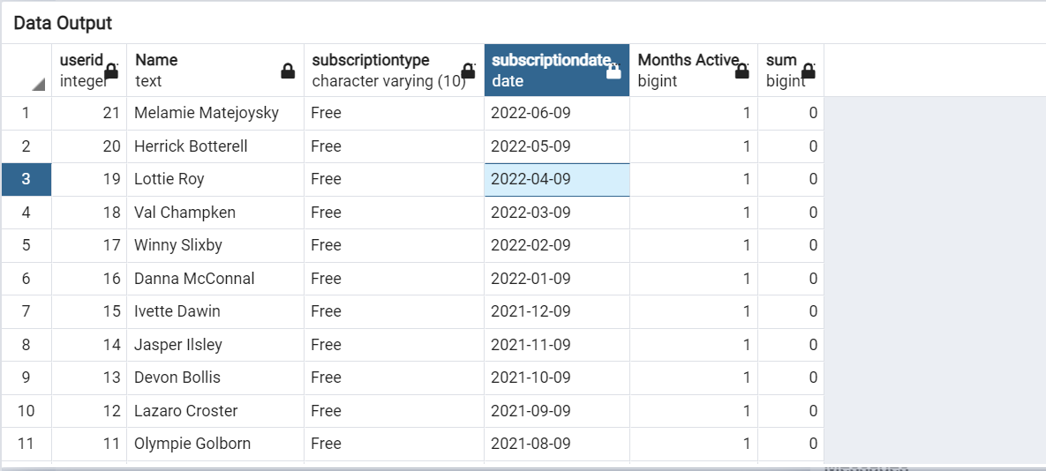

4. The query returns count of content being produced by different countries. This is achieved by using Group By and Order By

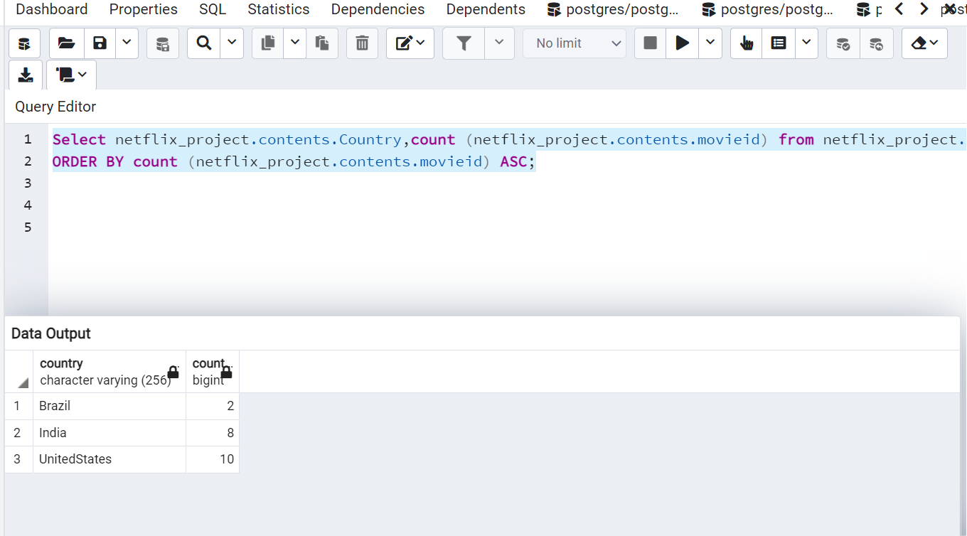

5. This query gives us a result of genre description, its relative content type along with the count of it that is present in the Netflix database

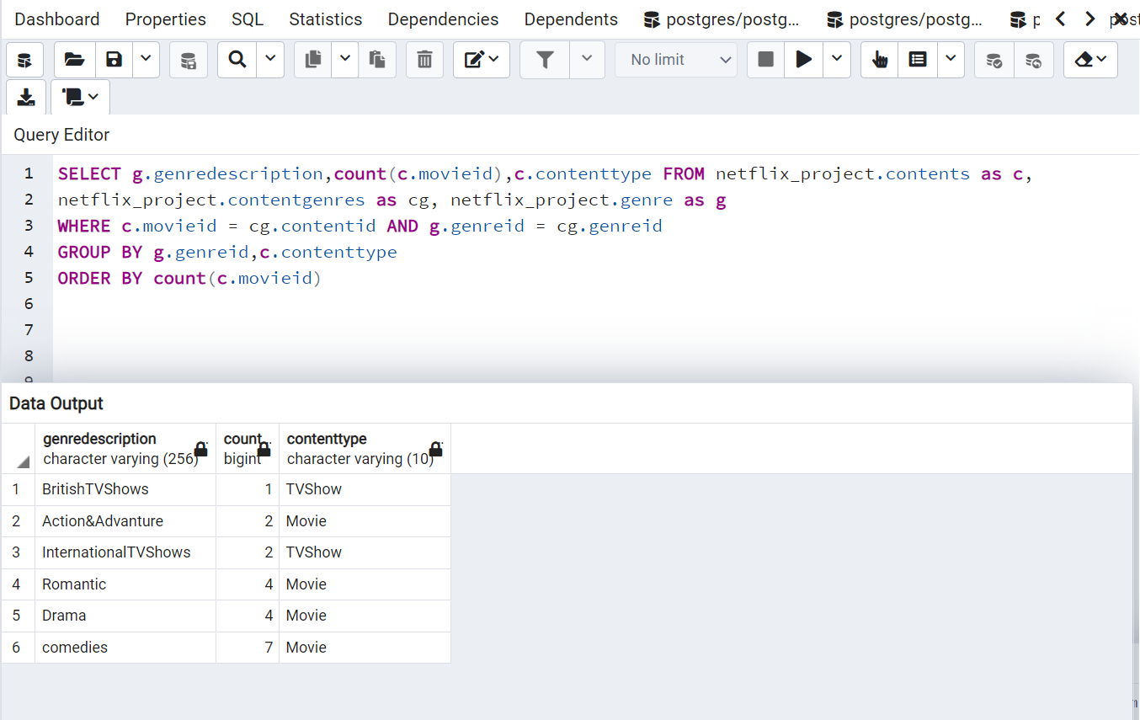

5. This is a view created to display all the unsubscribed customers who have not paid for their subscription past their billing date.

