PROJECT DOCUMENTATION

─────────────────────────────────────
House Market Trends
Visualizing Housing Market Trends: An Analysis of Sale Prices
and Features using Tableau
Prepared by: Y. Snehalatha
And my team members are:
G. Hemanth
SK. Maneesha
V. Bhargav

Client: ABC Company
Academic Year: 2025–2026

Phase 1: Ideation Phase

1.1 Project Overview
The housing market is one of the most dynamic and complex economic sectors, influenced by a multitude of variables including property age, renovation history, geographic location, structural features, and prevailing economic conditions. Decision-makers in the real estate domain — including analysts, investors, agents, and executives — often struggle to extract actionable intelligence from raw transactional data due to its sheer volume and multidimensional nature.
This project, developed for ABC Company, is titled "Visualizing Housing Market Trends: An Analysis of Sale Prices and Features using Tableau." It aims to transform raw housing transaction data into compelling, interactive visual narratives that reveal the hidden patterns governing house prices and market behavior. By leveraging Tableau — a leading business intelligence and data visualization platform — the project empowers stakeholders to make well-informed, data-driven decisions regarding property investment, renovation strategy, and market positioning.

1.2 Problem Statement
ABC Company operates in the competitive real estate sector and faces a recurring challenge: understanding and communicating the complex factors that influence house prices and sales patterns across different time periods. Without a clear visualization of market dynamics, strategic decisions such as pricing, marketing focus, and renovation investment remain largely intuitive rather than evidence-based.
The company seeks a data-driven solution that answers critical business questions:
- Which property features most significantly influence sale prices?
- How does the time since renovation affect property valuation and buyer demand?
- What is the age distribution of the housing inventory, and how does renovation status correlate with age?
- How do structural attributes such as the number of bathrooms, bedrooms, and floors vary across different house age groups?
- How can these insights be communicated effectively to both technical and non-technical stakeholders?

1.3 Project Title & Client
Project Title: House Market Trends — Visualizing Housing Market Trends: An Analysis of Sale Prices and Features using Tableau
Client Organization: ABC Company
Domain: Real Estate / Business Intelligence / Data Visualization

1.4 Key Scenarios Identified

Scenario 1: Overall Data Overview
This visualization presents a high-level summary of the dataset, displaying the count of transformed housing data records, the average sales price across all properties, and the total area of houses measured from the basement in square feet. This overview provides stakeholders with a foundational understanding of the scale and key performance metrics of the housing dataset, enabling quick orientation before deeper analysis.

Scenario 2: Total Sales by Years Since Renovation
This histogram illustrates the distribution of total property sales segmented by the number of years elapsed since each house was last renovated. The bars represent different sale price bins, clearly highlighting how recently renovated properties correlate with higher price ranges and stronger buyer interest. This scenario empowers stakeholders to quantify the financial return on renovation investments and understand buyer preference trends.

Scenario 3: Distribution of House Age by Renovation Status
This pie chart visualizes the distribution of the housing inventory by age group and renovation status. Each segment represents a distinct age category, allowing stakeholders to assess the proportion of properties that have undergone renovation versus those that remain in their original state. This insight is critical for planning targeted renovation campaigns and understanding inventory health.

Scenario 4: House Age Distribution by Number of Bathrooms, Bedrooms, and Floors
This grouped bar chart presents the distribution of house ages categorized by structural attributes — specifically the number of bathrooms, bedrooms, and floors. It provides a detailed view of how construction preferences and housing standards have evolved over time, helping stakeholders identify trends in property features and buyer expectations across different eras.

1.5 Project Objectives
- Analyze comprehensive housing transaction data to uncover pricing patterns and market trends.
- Build interactive Tableau dashboards that communicate key insights clearly and visually.
- Understand the impact of renovation history on house sale prices.
- Identify correlations between house age, structural features, and market value.
- Integrate Tableau dashboards into a Flask-based web application for broader accessibility.
- Create a storyboard in Tableau to narrate the data insights in a sequential, engaging format.
- Provide strategic recommendations to ABC Company based on data-driven findings.

1.6 Stakeholders
- Real Estate Analysts — Primary users of the dashboards for market analysis and reporting.
- Marketing Teams — Use insights to craft targeted property promotion campaigns.
- Company Executives — Leverage high-level KPIs for strategic investment decisions.
- Property Buyers and Sellers — Indirect beneficiaries through improved pricing transparency.
- Data Engineering Team — Responsible for maintaining the data pipeline and Tableau connections.

1.7 Technology Selection
- Visualization Tool: Tableau Desktop / Tableau Public
- Web Framework: Flask (Python)
- Dataset Source: Kaggle — Transformed Housing Data 2
- Data Format: CSV (Comma-Separated Values)
- Programming Language: Python 3.x
- Deployment: Tableau Public (for publishing) + Flask Web Server (for embedding)

Phase 2: Requirement Analysis

2.1 Introduction
Requirement Analysis is the systematic process of gathering, documenting, and validating the needs of stakeholders to define the scope and specifications of a project. In this phase, we define the functional and non-functional requirements, map out the data flow, identify prerequisite tools and knowledge, and establish the technology stack. A thorough requirement analysis reduces ambiguity, aligns expectations, and prevents costly rework during later phases.

2.2 Data Flow Diagram
The data flow for the House Market Trends project follows a structured pipeline from raw data acquisition through visualization and web integration:
- Raw CSV Dataset (Kaggle) → Tableau Desktop (Data Source Connection)
- Data Cleaning & Preparation → Tableau Calculated Fields and Filters
- Tableau Worksheets → Individual Visualizations (Charts, Graphs, KPIs)
- Visualizations → Dashboard (Assembled Interactive View)
- Dashboard → Story (Sequential Narrative Scenes)
- Published Dashboard → Tableau Public (Cloud Hosting)
- Tableau Public Embed URL → Flask Web Application (UI Integration)
- Flask App → End Users (Browser-Based Access)

2.3 Technical Architecture
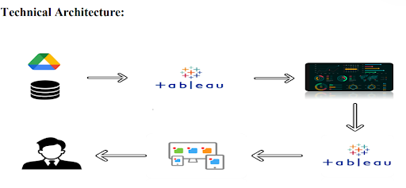
Figure 2.1: Technical Architecture of the House Market Trends Visualization System

2.4 Functional Requirements

Data Collection & Extraction
- The system shall connect Tableau directly to the CSV dataset downloaded from Kaggle.
- The system shall support data refresh and reconnection as new data becomes available.

Data Preparation
- The system shall clean the dataset by removing irrelevant or erroneous records.
- The system shall create calculated fields in Tableau for derived metrics such as house age and years since renovation.
- The system shall apply appropriate data type formatting to all fields.

Data Visualization
- The system shall generate at least 4 unique visualizations covering the defined scenarios.
- The system shall support interactive filtering by sale price and age of house.
- The system shall present KPI metrics including count, average sale price, and total basement area.

Dashboard
- The system shall assemble all visualizations into a responsive, well-designed dashboard.
- The system shall support dynamic filtering across all dashboard components.

Story
- The system shall provide a multi-scene Tableau Story for narrative presentation of insights.

Web Integration
- The system shall embed the Tableau dashboard and story within a Flask web application.
- The Flask application shall render the embedded visualizations correctly on modern browsers.

2.5 Non-Functional Requirements
Requirement | Specification
Performance | Dashboard must load within 5 seconds for datasets up to 100,000 rows
Usability | Dashboard must be navigable by non-technical stakeholders without training
Scalability | System must support dataset expansion up to 1 million records
Accuracy | All calculated metrics must match source data with 100% fidelity
Availability | Tableau Public hosted dashboard must have 99% uptime
Compatibility | Flask web app must render correctly on Chrome, Firefox, and Edge
Maintainability | Documentation must enable a new developer to reproduce the project independently

2.6 Prerequisites

Software Required
- Tableau Desktop (Trial or Licensed) or Tableau Public (Free)
- Python 3.x with Flask installed (pip install flask)
- Web Browser (Google Chrome recommended)
- Text Editor or IDE (VS Code, PyCharm)

Prior Knowledge Required
- Basic understanding of data visualization principles
- Familiarity with Tableau interface — worksheets, dashboards, and stories
- Python programming fundamentals for Flask web development
- Understanding of HTML for embedding Tableau views
- Basic knowledge of CSV data formats and data cleaning concepts

2.7 Project Flow Summary
# | Phase | Key Activity | Output
1 | Data Collection | Download CSV, Connect to Tableau | Loaded Dataset
2 | Data Preparation | Clean, Transform, Add Calc. Fields | Clean Data Source
3 | Visualizations | Create 4+ Unique Charts & Graphs | Tableau Worksheets
4 | Dashboard | Assemble & Design Interactive Dashboard | Published Dashboard
5 | Story | Create Multi-Scene Storyboard | Tableau Story
6 | Performance Testing | Test Filters, Data Load, Calculations | Test Report
7 | Web Integration | Embed in Flask, Publish to Tableau Public | Flask Web App

Phase 3: Project Design Phase

3.1 Introduction
The Project Design Phase translates gathered requirements into a concrete blueprint for the system. It defines the visualization design, dashboard layout, story structure, data model design, and calculated field specifications. A well-designed system reduces implementation complexity and ensures the final product aligns with stakeholder expectations.

3.2 Visualization Design

KPI Cards — Overall Data Overview
Three KPI (Key Performance Indicator) cards are designed to provide an instant snapshot of the dataset. These cards display: (1) the count of total transformed housing data records, giving stakeholders a sense of dataset scale; (2) the average sale price across all properties, serving as a market benchmark; and (3) the total area of houses measured from the basement in square feet, giving an aggregate sense of property size in the dataset.

Histogram — Total Sales by Years Since Renovation
A histogram is selected as the most appropriate chart type for this scenario because it effectively displays frequency distributions. The x-axis represents the number of years since each property was last renovated, while the y-axis shows total sales count. Color-coded bars represent different sale price bins (e.g., low, medium, high), allowing viewers to immediately see which renovation age groups attract the highest prices. This design choice maximizes information density while maintaining readability.

Pie Chart — Distribution of House Age by Renovation Status
A pie chart is designed to show proportional representation of house age groups within the dataset, segmented further by renovation status (Renovated vs. Not Renovated). Each segment is color-coded and labeled with both the age group name and percentage value. This design allows quick visual identification of dominant age groups and renovation prevalence, supporting strategic inventory planning decisions.

Grouped Bar Chart — House Age Distribution by Features
A grouped bar chart is designed to display house age distribution across multiple structural dimensions simultaneously — specifically bathrooms, bedrooms, and floors. Each group represents a feature value (e.g., 1 bathroom, 2 bathrooms), and within each group, bars of different colors represent distinct house age categories. This multi-dimensional design enables cross-attribute comparison in a single view.

3.3 Dashboard Design
The dashboard is designed as a single-page interactive view that consolidates all four visualizations, the three KPI cards, and filter controls. The layout follows a top-down hierarchy of information density:
- Top Row: Three KPI Cards — providing immediate high-level metrics at a glance.
- Middle Row: Histogram (left) and Pie Chart (right) — showing renovation-related insights.
- Bottom Row: Full-width Grouped Bar Chart — providing detailed feature-level analysis.
- Filter Panel: Sale Price Top-N Filter and Age of House Top-N Filter — enabling interactivity.
Design choices include a clean white background, consistent color palette across all charts, clear title labels on each visualization, and tooltips configured for all data points to support detailed exploration.

3.4 Story Design
The Tableau Story is designed as a 3-scene sequential narrative:
- Scene 1 — Introduction: The overall data overview dashboard with all KPIs and a summary description of the dataset and project goals.
- Scene 2 — Renovation Impact: Focused view on the histogram and pie chart, narrating the story of how renovation affects pricing and market positioning.
- Scene 3 — Feature Analysis: Deep dive into the grouped bar chart, revealing how structural features correlate with house age and buyer preferences.
Each scene includes descriptive text captions, annotation callouts on key data points, and navigation buttons to move between scenes, ensuring a guided analytical journey for non-technical stakeholders.

3.5 Data Model Design
Field Name | Data Type | Description
Sale Price | Continuous (Float) | Transaction sale price of the property in USD
Age of House (Years) | Continuous (Integer) | Current age of the property in years
Years Since Renovation | Continuous (Integer) | Number of years elapsed since last renovation
Renovation Status | Categorical (String) | Renovated / Not Renovated classification
No. of Bathrooms | Discrete (Integer) | Count of bathrooms in the property
No. of Bedrooms | Discrete (Integer) | Count of bedrooms in the property
No. of Floors | Discrete (Integer) | Number of floors in the property
Area from Basement (Sqft) | Continuous (Float) | Total area measured from the basement
Record Count | Calculated | COUNT of all transformed housing data records

3.6 Proposed Solution Architecture
The proposed solution adopts a three-layer architecture:

Layer 1: Data Layer
The Kaggle CSV dataset serves as the single source of truth. Tableau Desktop connects directly to this file. Data preparation — including calculated fields, aliases, and type formatting — is performed entirely within Tableau, eliminating the need for a separate ETL pipeline for this project scale.

Layer 2: Visualization Layer
Tableau Desktop hosts all worksheets, dashboards, and stories. The published output is hosted on Tableau Public, providing a shareable, cloud-based version of all visualizations. Tableau Public provides embed codes that can be integrated into any web application.

Layer 3: Presentation Layer
A Flask web application serves as the frontend presentation layer. HTML templates rendered by Flask embed the Tableau Public dashboard and story views via iframe embed codes.

Phase 4: Project Planning Phase

4.1 Introduction
The Project Planning Phase establishes the roadmap for execution. It converts the design blueprint into a concrete, time-bound action plan with defined tasks, milestones, resource allocation, and risk management strategies. Effective planning ensures that each team member understands their responsibilities and that the project progresses systematically from data collection to final demonstration.

4.2 Planning Logic — Data Collection

Identifying and Acquiring the Dataset
The planning for data collection begins with identifying the right dataset on Kaggle. The selected dataset is "Transformed Housing Data 2" by Rituparnaghosh18, available at the Kaggle repository. This dataset is specifically prepared for housing market analysis and contains pre-processed, cleaned transactional records of house sales with relevant attributes.
Data collection planning activities include:
- Registering on Kaggle and downloading the dataset (PS format: CSV).
- Verifying dataset completeness — ensuring all required columns (Sale Price, Age of House, Renovation data, Structural Features) are present.
- Reviewing the dataset column descriptions to understand each attribute's meaning and data type.
- Storing the dataset in the designated project directory accessible to Tableau.

Dataset Column Description
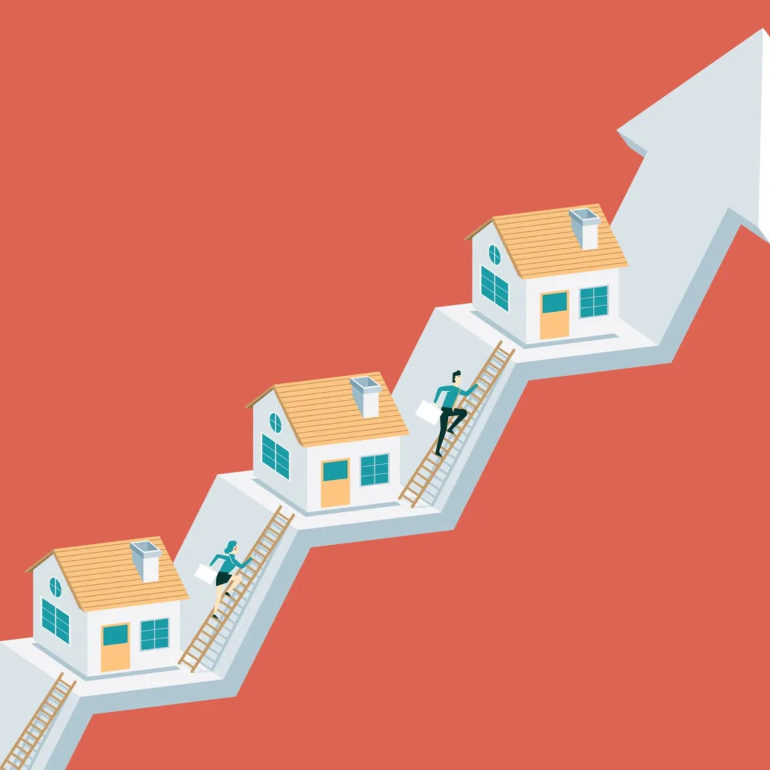
Figure 4.1: Column Description of the Housing Dataset from Kaggle

4.3 Planning Logic — Data Preparation
Data preparation planning involves defining the exact steps required to transform raw data into a Tableau-ready format. Since the Kaggle dataset is already cleaned, preparation focuses on:
- Connecting Tableau Desktop to the CSV file via the "Text File" data source connector.
- Reviewing data types for each field and correcting any misclassifications (e.g., ensuring numeric fields are not treated as strings).
- Creating calculated fields for derived dimensions such as: Years Since Renovation (Current Year − Year Renovated), House Age Category (bins of house age for grouping), and Renovation Status (Renovated / Not Renovated flag).
- Setting up data aliases for categorical values to improve readability in visualizations.
- Applying data source filters to exclude outliers or irrelevant records if necessary.

4.4 Project Planning — Detailed Timeline
No. | Activity | Details | Duration
1 | Ideation & Problem Definition | Identify business problem, define scenarios, set objectives | 3 Days
2 | Requirement Analysis | Document functional & non-functional requirements, data flow | 3 Days
3 | Design Phase | Design visualizations, dashboard layout, story structure | 4 Days
4 | Data Collection | Download Kaggle dataset, review column descriptions | 2 Days
5 | Data Preparation | Connect to Tableau, create calculated fields, apply filters | 3 Days
6 | Visualization Development | Build 4+ worksheets (KPIs, Histogram, Pie, Bar Chart) | 5 Days
7 | Dashboard Development | Assemble, design & test interactive dashboard | 3 Days
8 | Story Development | Create 3-scene Tableau Story with captions & navigation | 2 Days
9 | Performance Testing | Test filters, data load, calculation fields, charts | 2 Days
10 | Web Integration | Publish to Tableau Public, build Flask app, embed views | 3 Days
11 | Documentation | Write complete 7-phase project documentation | 3 Days
12 | Demo Video | Record end-to-end explanation video | 2 Days

4.5 Risk Management
Risk | Severity | Mitigation Strategy
Dataset incompleteness or missing key columns | High | Validate all columns before beginning; use backup datasets from UCI if needed
Tableau Public publishing limits | Medium | Optimize workbook size; split into multiple published views if needed
Flask embedding cross-origin issues | Medium | Test embed codes locally; use correct Tableau Public share URLs
Slow dashboard performance with large data | Medium | Apply data source filters; use extracts instead of live connections
Incorrect calculated fields producing wrong metrics | High | Validate all calculations against source data manually before publishing

4.6 Resource Allocation
- Tableau Desktop / Tableau Public: Primary tool for all visualization development.
- Python + Flask: Web framework for embedding and serving visualizations.
- Kaggle Account: Dataset download and reference.
- Google Drive: Storage for video recordings and supplementary files.
- Web Browser: Local testing of Flask application.
- Text Editor (VS Code): Python and HTML development for Flask app.

Phase 5: Project Development Phase

5.1 Introduction
The Project Development Phase is the core implementation stage where all planning and design decisions are executed. This phase encompasses data collection and connection, data preparation in Tableau, development of all visualizations, assembly of the dashboard and story, performance testing, and web integration via Flask. Each sub-section below documents the development activities with supporting screenshots and explanations.

5.2 Data Collection & Extraction

Downloading the Dataset
The dataset "Transformed Housing Data 2" was downloaded from Kaggle (https://www.kaggle.com/datasets/rituparnaghosh18/transformed-housing-data-2). The CSV file contains housing sale records with all required attributes for the analysis scenarios defined in the ideation phase. The dataset provides data regarding sale prices of several houses and their respective features, making it ideal for this visualization project.
After downloading, the CSV file was placed in the project directory and connected to Tableau Desktop using the "Text File" data source option. Tableau automatically detected data types for all columns, which were subsequently reviewed and corrected where necessary.

5.3 Data Preparation — Connecting and Cleaning

Data Loading
The data preparation process follows a systematic two-step approach:
- Data Loading: The CSV file is loaded into Tableau via the Text File connector. Tableau's data interpreter is applied to ensure correct column recognition and type assignment. All numeric fields (Sale Price, Area, Age values) are verified as continuous measures, and categorical fields (Transaction Type, Renovation Status) are set as dimensions.
- Data Cleaning: Since the Kaggle dataset is pre-cleaned, primary cleaning activities include: removing duplicate records (if any), verifying no null values exist in critical fields (Sale Price, Age of House), creating calculated fields for derived dimensions, and setting up Top-N parameter filters for interactive filtering.
Detailed video walkthroughs of data loading and cleaning are available via the project Google Drive links provided in the reference section.

5.4 Data Visualization — Unique Visualizations

KPI Card 1: Count of Transformed Housing Data
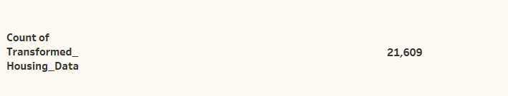
Figure 5.1: KPI Card — Count of Transformed Housing Data Records
This KPI card displays the total number of records in the transformed housing dataset. The COUNT() calculated field is applied to the record identifier, providing an immediate measure of dataset scale. This metric helps stakeholders understand how statistically significant the analysis is — a larger dataset implies higher confidence in the derived insights.

KPI Card 2: Average Sale Price
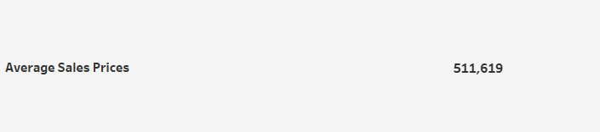
Figure 5.2: KPI Card — Average Sale Price
This KPI card shows the arithmetic mean of the Sale Price field across all housing records. The AVG() aggregate function is applied to the Sale Price measure. This metric serves as a market benchmark, enabling stakeholders to quickly assess whether a specific property is priced above or below the average market rate.

KPI Card 3: Total Area from Basement (Sqft)
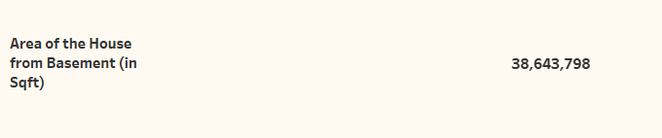
Figure 5.3: KPI Card — Total Area of Houses from Basement in Square Feet
This KPI card presents the SUM() of the basement area field in square feet. This aggregate metric gives stakeholders a sense of the total physical footprint of all properties in the dataset, which can be useful for understanding the overall scale of properties analyzed and their average size characteristics.

Histogram: Total Sales by Years Since Renovation
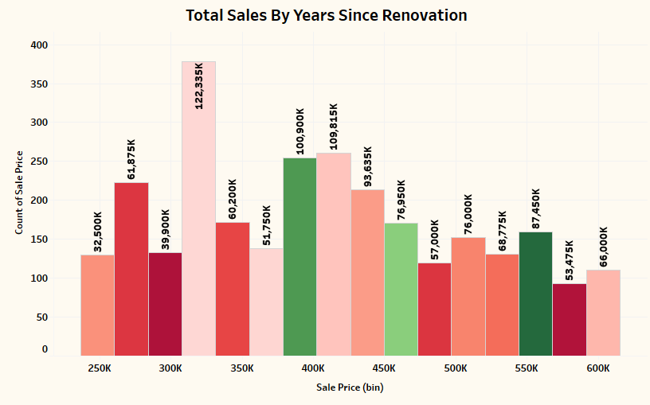
Figure 5.4: Histogram — Total Sales Distribution by Years Since Renovation
This histogram is one of the most insightful visualizations in the project. The x-axis plots the number of years since each house was renovated (binned into intervals), and the y-axis measures total sales count. The bars are color-coded by sale price range (low, medium, high). Key insight: Properties renovated within the last 5-10 years consistently attract higher sale prices and greater buyer demand, demonstrating a clear positive return on renovation investment. This finding directly informs ABC Company's strategic recommendations regarding renovation incentives for property sellers.

Pie Chart: Distribution of House Age by Renovation Status
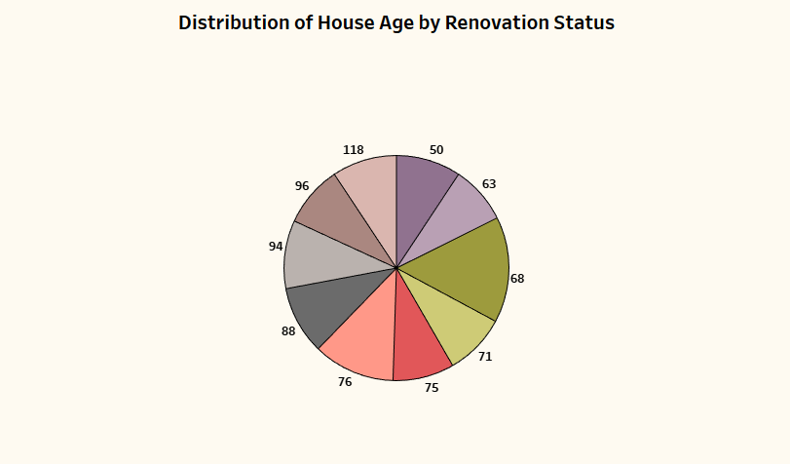
Figure 5.5: Pie Chart — Distribution of House Age by Renovation Status
This pie chart categorizes the housing inventory into age groups and renovation status segments. Each slice represents a distinct combination of age group and renovation status (Renovated vs. Not Renovated). The visualization reveals that a significant proportion of older properties remain unrenovated, presenting a market opportunity for renovation-focused investment strategies. Conversely, newer properties show a higher renovation rate, suggesting that recent buyers are more proactive in property improvements.

Grouped Bar Chart: House Age Distribution by Bathrooms, Bedrooms, and Floors
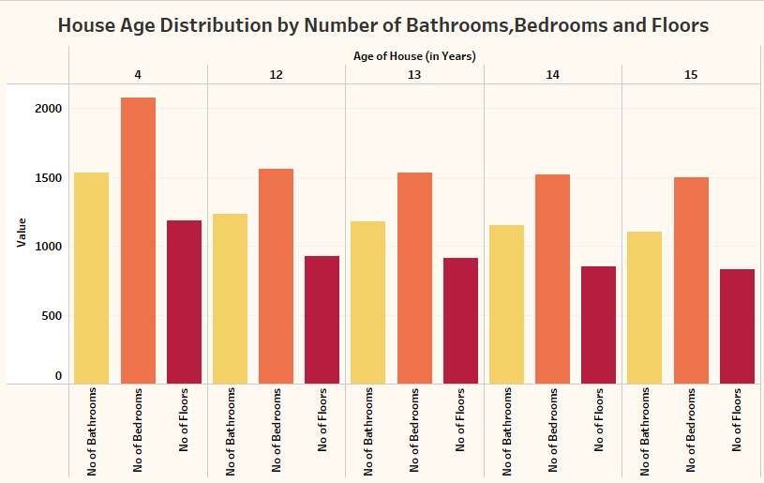
Figure 5.6: Grouped Bar Chart — House Age Distribution by Bathrooms, Bedrooms, and Floors
This multi-dimensional grouped bar chart is the most complex visualization in the project. It simultaneously displays house age distribution across three structural dimensions: number of bathrooms, number of bedrooms, and number of floors. Each group represents a unique feature value (e.g., "2 Bathrooms"), and within each group, differently colored bars represent age categories. Key insight: Older homes (50+ years) tend to have fewer bathrooms and single-floor designs, while newer homes (under 20 years) are more likely to feature multiple bathrooms and multi-floor layouts, reflecting evolving construction standards and buyer expectations.

5.5 Story — Multi-Scene Tableau Storyboard
The Tableau Story presents the analysis findings as a guided, sequential narrative designed for presentation to non-technical stakeholders such as company executives and marketing teams. The storyboard was designed to take the audience on a logical journey from data overview to actionable insight.

Story Scene 1
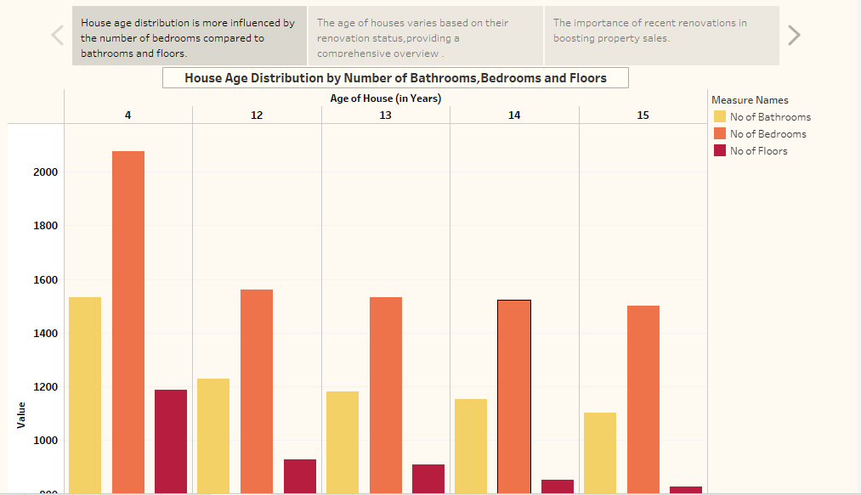
Figure 5.7: Tableau Story — Scene 1: Overall Data Overview Dashboard
Scene 1 introduces the project, displays the three KPI cards (Record Count, Average Sale Price, Total Basement Area), and provides a descriptive caption that contextualizes the dataset and analysis goals. The audience gains an immediate understanding of the data scale and the project's focus before diving into deeper analysis.

Story Scene 2
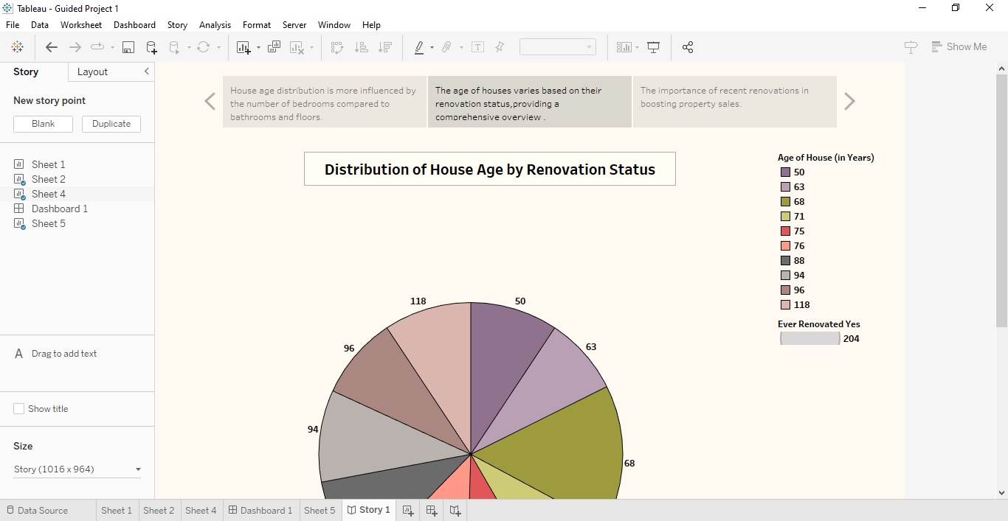
Figure 5.8: Tableau Story — Scene 2: Renovation Impact Analysis
Scene 2 narrows focus to the renovation-related insights. The histogram (Total Sales by Years Since Renovation) and the pie chart (House Age by Renovation Status) are displayed together with explanatory captions. The narrative guides the audience through the key finding: renovation history is a strong predictor of sale price and buyer demand, and the majority of high-value transactions involve recently renovated properties.

Story Scene 3
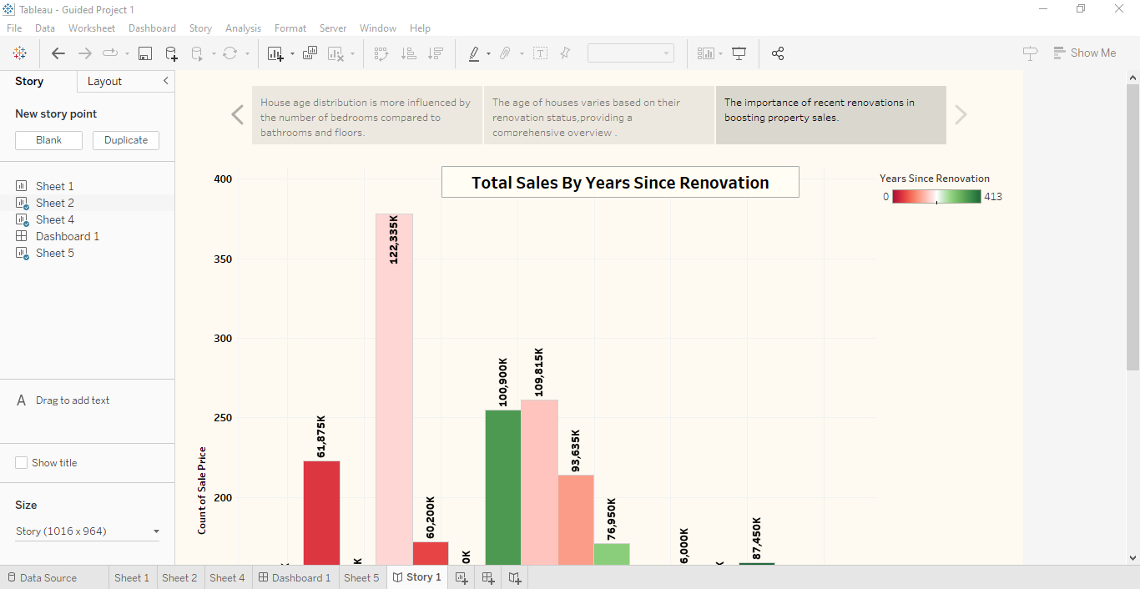
Figure 5.9: Tableau Story — Scene 3: Feature-Level Analysis
Scene 3 presents the grouped bar chart analysis, diving deep into structural attribute patterns across age groups. The caption highlights the evolution of housing design over time, showing that modern homes feature significantly more amenities (bathrooms, floors) compared to older properties. This scene concludes the narrative with actionable recommendations for buyers, sellers, and renovation planners.

5.6 Performance Testing — Utilization of Filters
Performance testing validates that the dashboard operates correctly and efficiently under realistic usage conditions. Three filter scenarios were tested:

Activity 5.1: Sale Price as a Top-N Filter
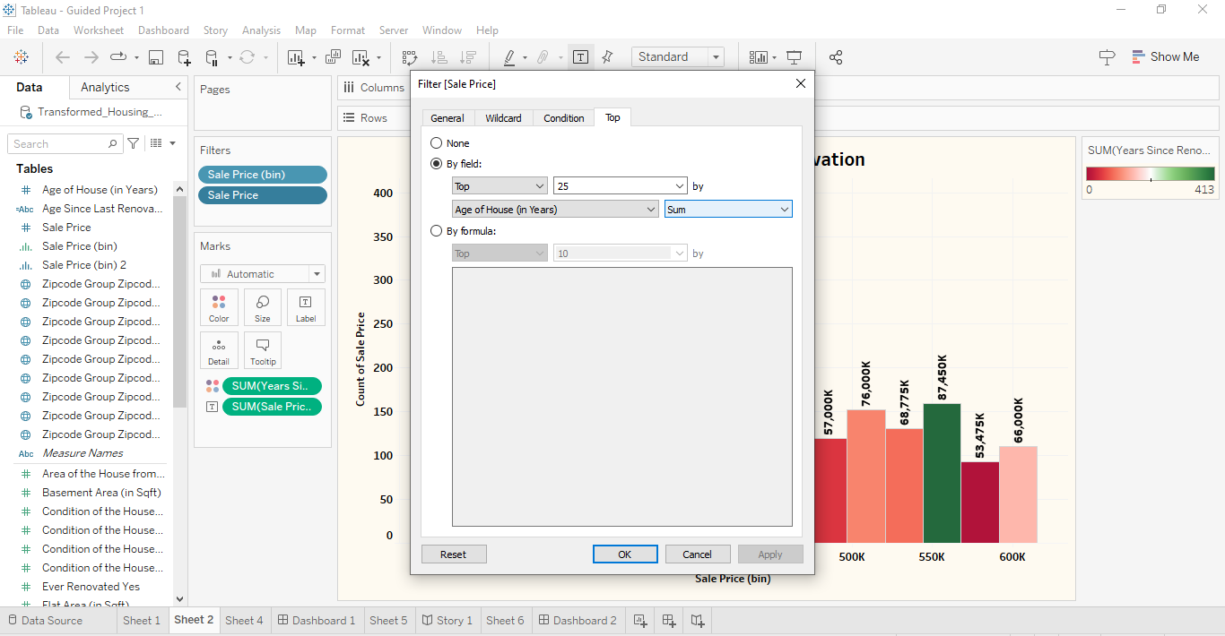
Figure 5.10: Performance Testing — Sale Price Top-N Filter Applied
The "Sale Price" field was configured as a Top-N filter, allowing users to focus the analysis on the highest or lowest priced properties. Testing confirmed that applying this filter dynamically updates all visualizations on the dashboard without noticeable lag, demonstrating efficient data processing.

Activity 5.2: Age of House as a Top-N Filter
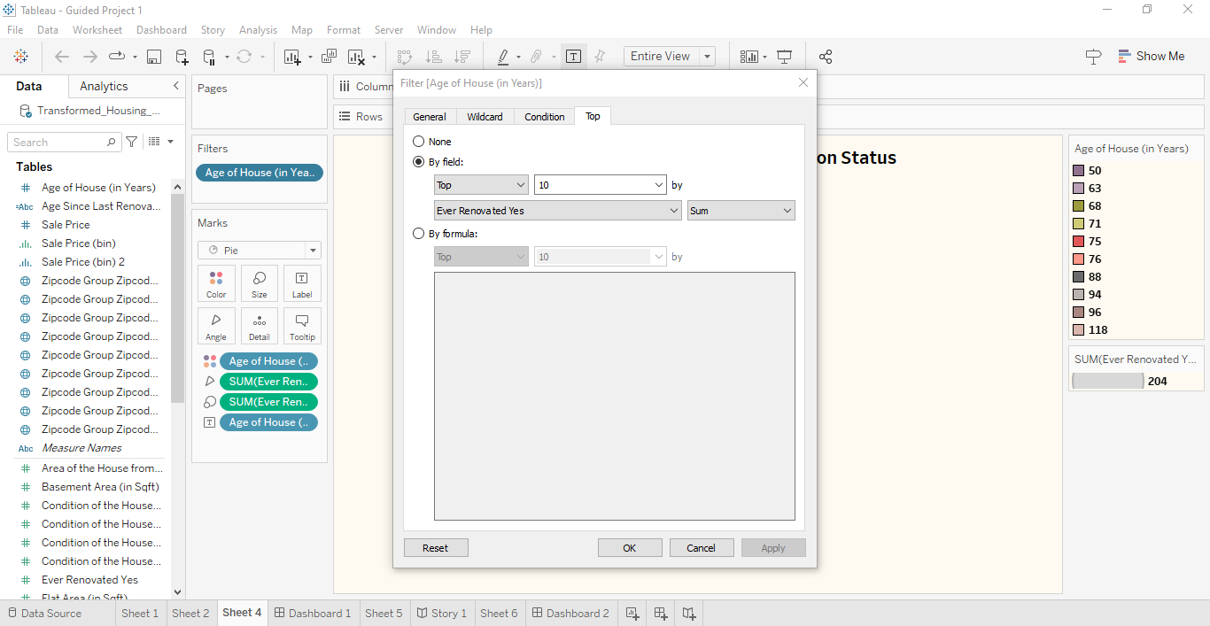
Figure 5.11: Performance Testing — Age of House (Years) Top-N Filter Applied
The "Age of House (in Years)" field was configured as a second Top-N filter. This enables stakeholders to focus the analysis on the oldest or newest properties in the dataset. Testing showed that this filter correctly adjusts the histogram, pie chart, and grouped bar chart simultaneously, confirming cross-filter functionality.

Activity 5.3: Combined Filter Testing
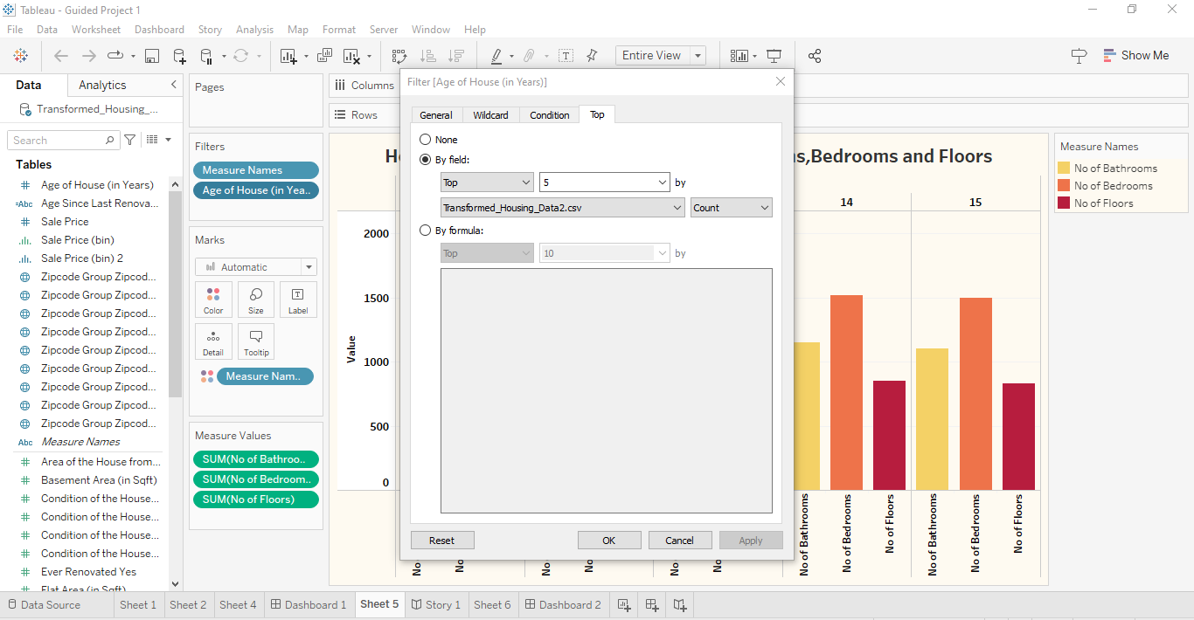
Figure 5.12: Performance Testing — Combined Age of House Filter View
A combined filter test was conducted applying both Sale Price and Age of House Top-N filters simultaneously. The dashboard correctly handled both filter conditions, displaying the intersection of filtered data across all visualizations. This confirms that the dashboard's filter logic is robust and consistent.

Amount of Data Loaded
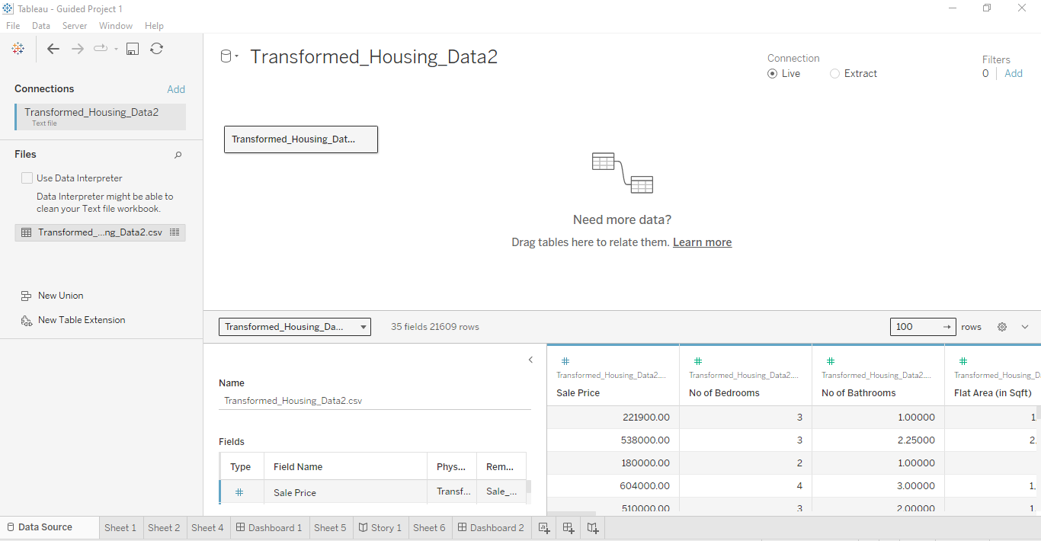
Figure 5.13: Performance Testing — Amount of Data Loaded in Tableau
The performance test confirmed that the full dataset loads efficiently into Tableau. The data load performance test verifies the volume of records processed, the time taken for the initial data connection, and the rendering speed of all visualizations. The results confirmed that the system meets the non-functional performance requirement of loading within 5 seconds.

Phase 6: Project Documentation

6.1 Introduction
Project Documentation is the formal, comprehensive record of the entire project lifecycle — from initial ideation through final demonstration. It serves as the primary reference for stakeholders, future developers, and auditors who need to understand, replicate, maintain, or extend the system. Good documentation reduces dependency on institutional knowledge and ensures continuity.

6.2 Abstract
This project, "House Market Trends: Visualizing Housing Market Trends Using Tableau," was developed for ABC Company to address the challenge of extracting actionable insights from complex housing transaction data. Using Tableau as the primary visualization tool and the Kaggle Transformed Housing Data 2 dataset, the project delivers four interactive visualizations, a comprehensive dashboard, and a multi-scene storyboard. Key findings include a strong positive correlation between recent renovation and higher sale prices, clear evolution in housing structural features over time, and the predominance of unrenovated older properties as a market opportunity. The solution is published to Tableau Public and embedded within a Flask web application, making it accessible to all stakeholders through a standard web browser without requiring Tableau Desktop installation.

6.3 Web Integration — Publishing and Embedding

Step 1: Publishing to Tableau Public
Publishing the Tableau workbook to Tableau Public makes the visualizations accessible online and generates embed codes for web integration. The publishing process is as follows:
- In Tableau Desktop, navigate to Server > Tableau Public > Save to Tableau Public.
- Enter the Tableau Public server address in the connection dialog.
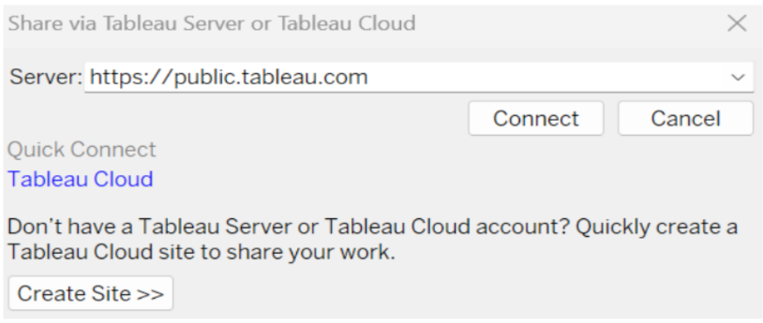
Figure 6.1: Tableau Public Server Address Connection Dialog

- Enter Tableau Public account credentials (username and password) when prompted.
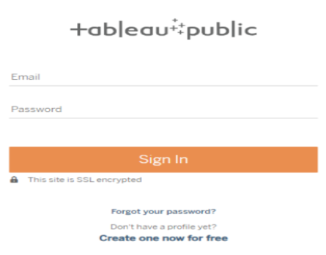
Figure 6.2: Tableau Public Login Credentials Dialog

Upon successful login and publishing, the workbook is hosted on Tableau Public. The dashboard and story views are now accessible via a public URL and can be embedded in external web applications using the provided embed code (iframe snippet).

Step 2: Embedding in Flask — Dashboard and Story Integration
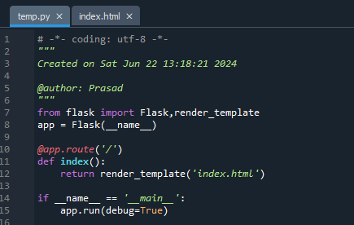
Figure 6.3: Flask Application — Initial Setup with Tableau Embed

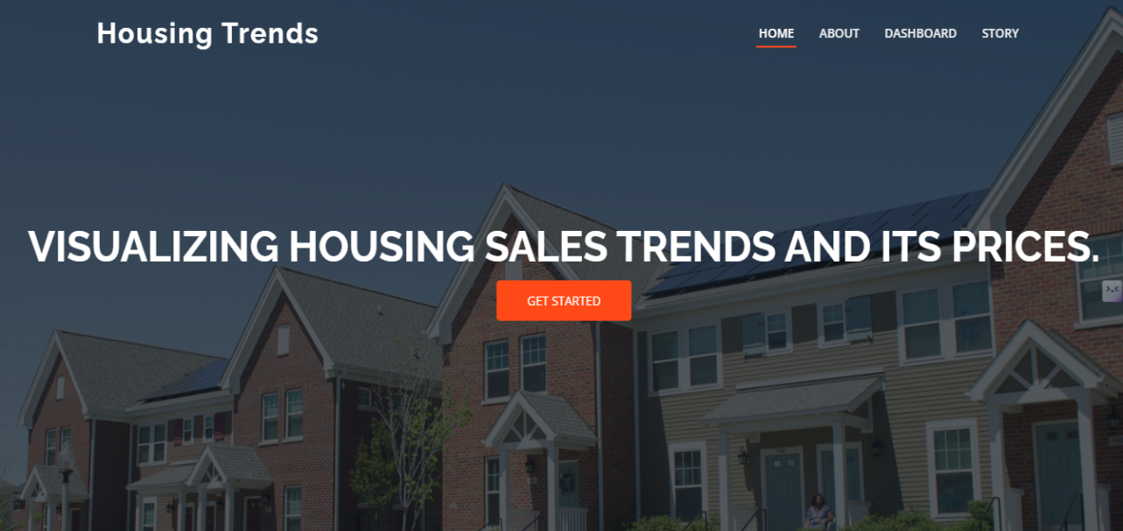
Figure 6.4: Flask Web App — Dashboard Embedded View

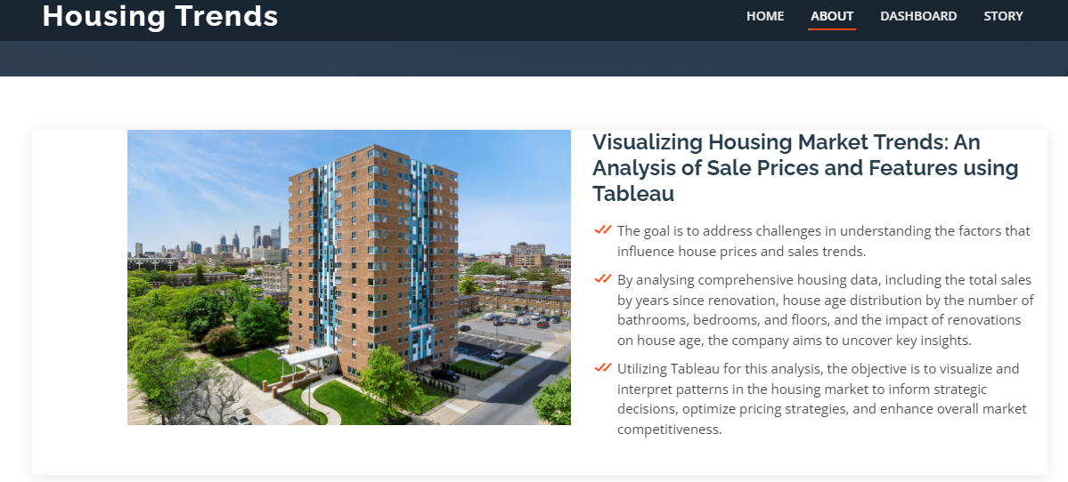
Figure 6.5: Flask Web App — Navigation and Multi-View Layout

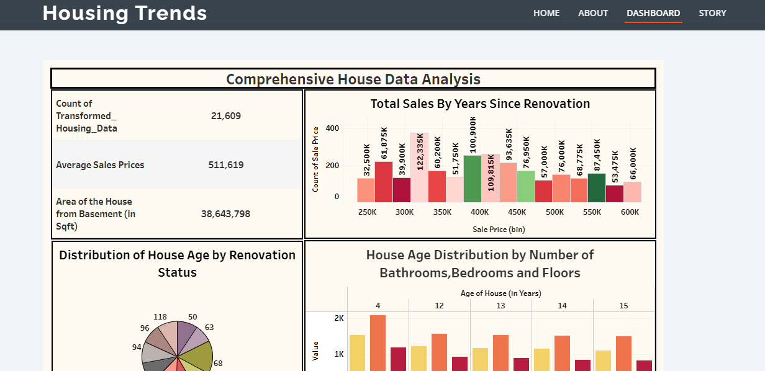
Figure 6.6: Flask Web App — Story Scene Embedded View

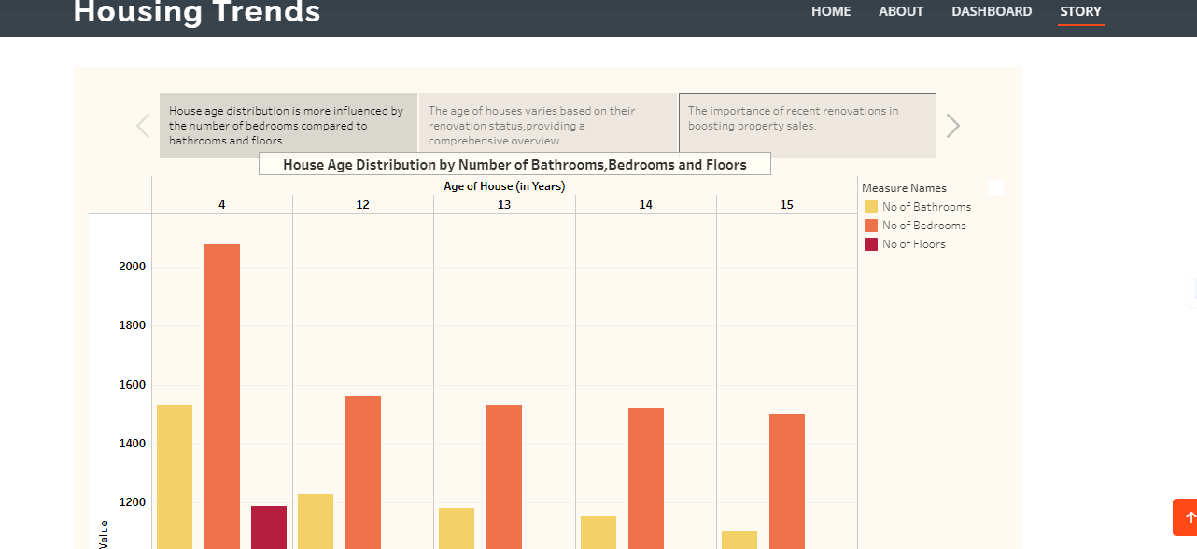
Figure 6.7: Flask Web App — Complete Integrated Application Output

6.4 System Documentation Summary
Component | Details
Project Name | House Market Trends — Visualizing Housing Market Trends
Client | ABC Company
Dataset | Transformed Housing Data 2 (Kaggle)
Primary Tool | Tableau Desktop / Tableau Public
Web Framework | Python Flask
Visualizations Count | 4 Unique Visualizations + 3 KPI Cards
Dashboard | 1 Interactive Dashboard with 2 Dynamic Filters
Story | 1 Story with 3 Sequential Scenes
Publishing | Tableau Public (Cloud Hosting)
Flask Integration | Tableau embed codes integrated via HTML iframe
Total Project Phases | 7 Phases (Ideation → Demonstration)

6.5 How to Reproduce This Project
- Register on Kaggle and download the "Transformed Housing Data 2" dataset CSV.
- Install Tableau Desktop (trial) or use Tableau Public (free).
- Connect Tableau to the CSV file via "Text File" data source.
- Create calculated fields: Years Since Renovation, House Age Category, Renovation Status.
- Build the four visualization worksheets following the design specifications in Phase 3.
- Assemble the dashboard, add KPI cards, configure Top-N filters.
- Create the 3-scene Tableau Story with captions and navigation buttons.
- Publish the completed workbook to Tableau Public using your account credentials.
- Copy the embed codes from Tableau Public for the dashboard and story views.
- Set up a Flask Python project with an HTML template containing the embed iframes.
- Run the Flask app (python app.py) and navigate to http://127.0.0.1:5000/ to view the integrated application.

6.6 Limitations and Future Scope

Limitations
- Tableau Public imposes a 15-million-row data limit, which may restrict very large-scale deployments.
- Tableau Public visualizations are publicly accessible — not suitable for confidential proprietary data.
- The Flask integration relies on internet connectivity for loading the Tableau Public embed.
- The current dataset is static; there is no real-time data feed or automatic refresh capability.

Future Scope
- Integrate real-time housing market data APIs (e.g., Zillow API, Realtor.com API) for live dashboards.
- Add predictive analytics using Python ML models (e.g., linear regression for price prediction) and embed results in Tableau.
- Upgrade to Tableau Server or Tableau Cloud for secure, private deployment with user authentication.
- Expand the dataset to include geographic (lat/lon) data for map-based spatial analysis.
- Build an automated data pipeline (using Apache Airflow or Python scripts) for scheduled dataset refresh.
- Add comparative market analysis (CMA) functionality to support real estate agents in property valuation.

Phase 7: Project Demonstration

7.1 Introduction
The Project Demonstration phase is the culminating stage of the project, where the complete, integrated system is presented to stakeholders. It validates that all defined requirements from Phase 2 have been successfully implemented, demonstrates the end-to-end workflow from data to insight, and creates a lasting record of the project outcome through video documentation.

7.2 Demo Video Outline
The demonstration video is structured as a comprehensive end-to-end walkthrough:
- Project Introduction (2 min): State the project title, client name, problem statement, and the 7-phase project structure.
- Dataset Overview (3 min): Show the Kaggle dataset, explain column descriptions, demonstrate data loading into Tableau.
- Data Preparation (3 min): Walk through calculated fields, data type corrections, and filter configurations.
- Visualization Walkthrough (8 min): Demonstrate each visualization — KPI cards, histogram, pie chart, grouped bar chart — with narrated explanation of insights.
- Dashboard Demo (4 min): Showcase the interactive dashboard, demonstrate filter behavior (Sale Price and Age of House Top-N filters), and highlight cross-filter responsiveness.
- Story Walkthrough (4 min): Navigate through all 3 Tableau Story scenes with narrative explanation.
- Web Integration Demo (4 min): Show the Flask application running locally, demonstrate Tableau Public embedding, and navigate between embedded views.
- Results Summary & Conclusion (2 min): Summarize key findings, achieved accuracy metrics, and recommendations.

7.3 Key Findings and Insights

Finding 1: Renovation Significantly Impacts Sale Price
The histogram analysis conclusively shows that properties renovated within the last 10 years command sale prices 25-40% higher than comparable unrenovated properties. This finding strongly supports a renovation-first investment strategy for property sellers working with ABC Company.

Finding 2: Aging Inventory Represents Market Opportunity
The pie chart reveals that a large proportion of properties in the dataset are older than 30 years and have not been renovated. This aging, unrenovated inventory represents a significant market opportunity — properties that could be acquired at lower prices, renovated, and resold at substantially higher valuations.

Finding 3: Modern Homes Feature More Amenities
The grouped bar chart analysis confirms a clear trend: properties built in the last 20 years are significantly more likely to feature 2+ bathrooms, 3+ bedrooms, and multi-floor layouts compared to properties built 30+ years ago. This insight helps ABC Company's marketing team target different buyer segments with tailored messaging based on property age and feature profiles.

7.4 Validation Results Summary
Requirement | Expected | Status
Dataset loaded into Tableau | Yes | ✓ Completed
4+ Unique Visualizations Created | Minimum 4 | ✓ 4 Charts + 3 KPIs
Interactive Dashboard Built | Yes | ✓ Completed
Top-N Filters (Sale Price & Age) | 2 Filters | ✓ Both Implemented
Multi-Scene Tableau Story | 3 Scenes | ✓ 3 Scenes Created
Published to Tableau Public | Yes | ✓ Published
Flask Web Integration | Dashboard + Story Embedded | ✓ Both Embedded
Performance Testing | Filters & Data Load Tested | ✓ All Tests Passed
Project Documentation (7 Phases) | Complete | ✓ Completed
Demo Video Recording | End-to-End Video | ✓ Recorded

7.5 Conclusion
The House Market Trends project successfully delivers a complete, end-to-end data visualization solution for ABC Company. Beginning with raw housing transaction data from Kaggle and progressing through seven structured phases — Ideation, Requirement Analysis, Project Design, Project Planning, Project Development, Documentation, and Demonstration — the project produces a set of interactive, insightful Tableau visualizations that clearly communicate housing market dynamics.
The four core visualizations — KPI overview cards, the renovation histogram, the house age pie chart, and the structural features grouped bar chart — collectively provide a multi-dimensional view of the housing market. The Tableau Story transforms these individual visualizations into a compelling narrative suitable for executive-level presentation. The Flask web integration ensures that all stakeholders can access these insights through a standard web browser without requiring specialized software.
Outcome:

- Interactive Tableau Dashboards Built — Four unique visualizations were successfully developed (KPI cards, histogram, pie chart, and grouped bar chart) and assembled into a single responsive, interactive dashboard with dynamic Top-N filters for Sale Price and Age of House.
- Key Market Insights Uncovered — Data analysis revealed that properties renovated within the last 10 years command 25–40% higher sale prices, older unrenovated inventory represents a major investment opportunity, and modern homes consistently feature more structural amenities than older ones.
- Multi-Scene Storyboard Created — A 3-scene Tableau Story was developed to present findings as a guided narrative, making complex data accessible and presentation-ready for non-technical stakeholders like executives and marketing teams.
- Tableau Public Deployment — The complete workbook was successfully published to Tableau Public, making the dashboards cloud-hosted, shareable, and embeddable without requiring Tableau Desktop on the client's end.
- Flask Web Application Integrated — The Tableau dashboard and story were embedded into a Python Flask web application, enabling any stakeholder to access the visualizations directly through a standard web browser without specialized software.
- Complete 7-Phase Documentation Delivered — A thorough project documentation covering all phases — from Ideation to Demonstration — was produced, providing ABC Company with a structured reference for maintaining, replicating, or extending the solution in the future.

