**ASSIGNMENT – AWS CLOUD 1**

Name: Snehal Dhulashetti

Trainer Name: Karna Gupta

Topic : AWS cloud

**L1** - Demonstrate the AWS EC2 Ubuntu Instance Creation steps and connect to EC2 Instance using Mobaxterm / putty agent

Step 1🡪Login into AWS console ,go to EC2 then click on launch instance

Step 2🡪Give instance name and other details.

Step 3🡪Select operating system which we prefer (I am selecting here ubuntu OS) and Amazon Machine Image(AMI) which is in free tier.

Step 4🡪Selecting instance type t3.micro which is also under free tier,and I am creating instance with key pair (test-ec2).

**Creating new key pair**

I have entered the key pair name ,selected the key pair type as RSA (ED25519 is for Mac),key file format is .pem(.ppk is for putty application)then .pem file will be downloaded.

Step 5🡪Inthe network settings I have selected the default VPC,existing Security group.(AWS will manage everything like creating vpc, security group,auto assigning the public ip it should be enabled).

Step 6🡪In storage volume should be 1gb or more than that, AWS wont accept less than that ,and we can create more than 1 instances at a time .Once with the advanced settings we can click on launch instance then instance will be created and it will come on running state in few seconds.

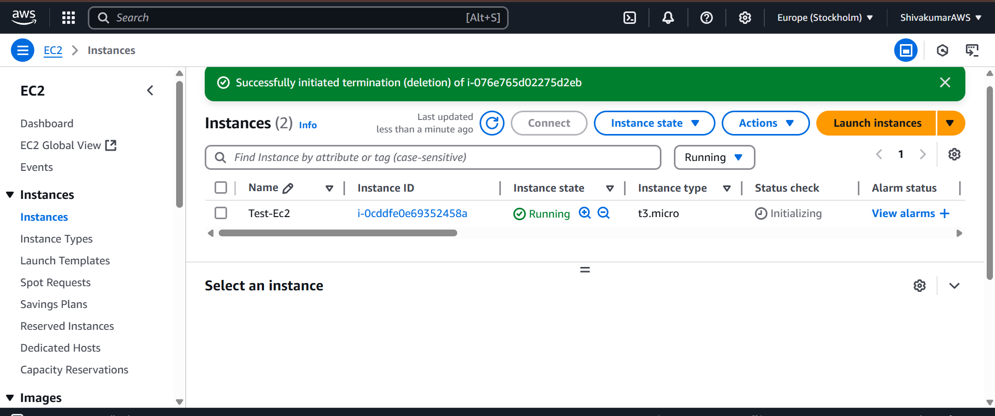

**L2** - Login to AWS Console and Create IAM User, Role, and Group

Login into your AWS console and search for user directly you will get users under IAM (Ifdentity and Access Management) tab

User is single person with specific permissions, it has its own unique credentials

**For creating users** ,click on create user

Step 1🡪Specifying user details

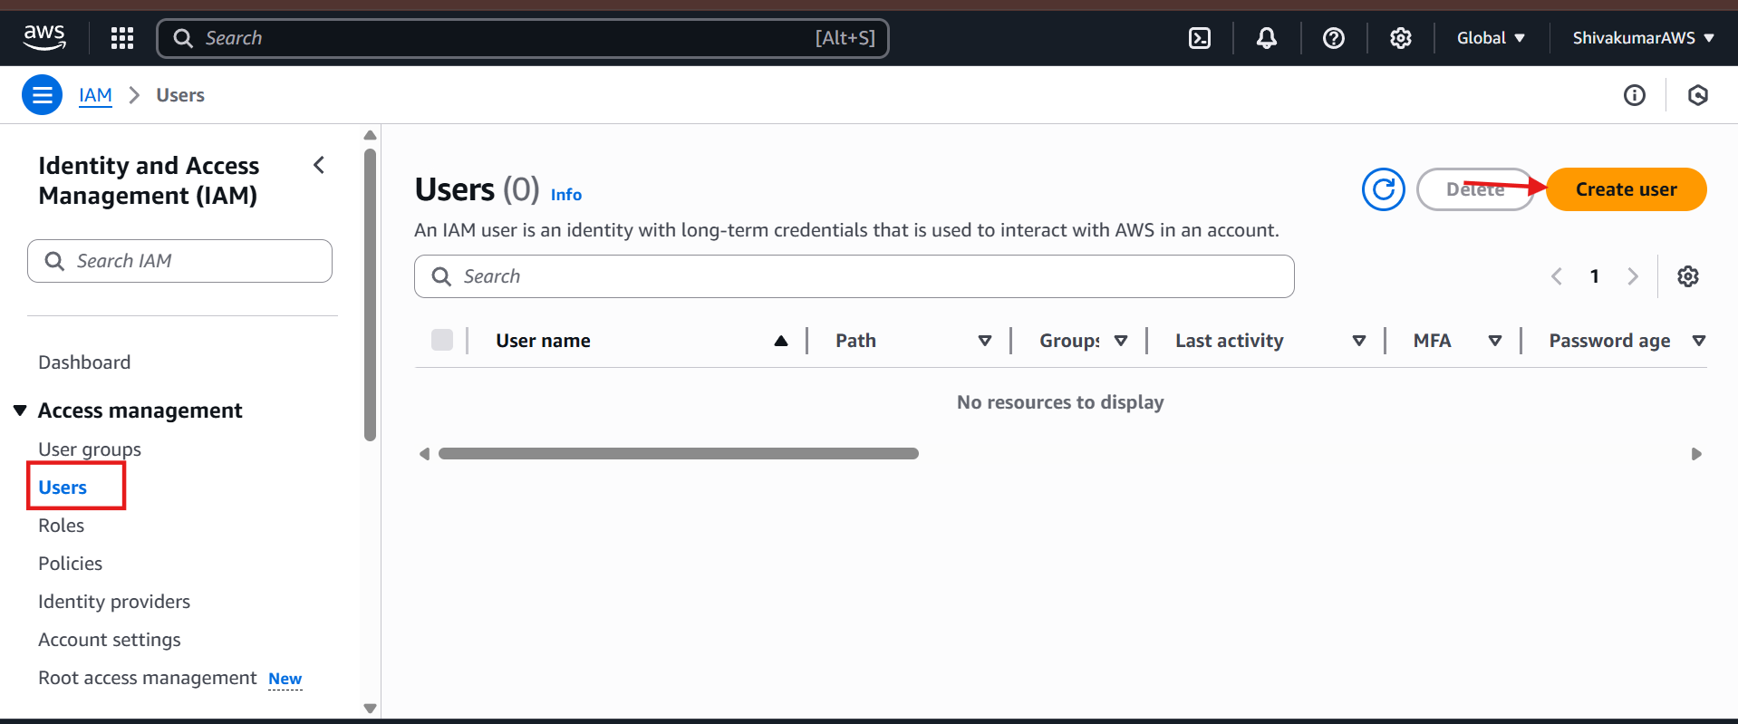

Step 2🡪Giving permissions to user, in this step we can add user to an existing group or we can create new group. Then click on next.

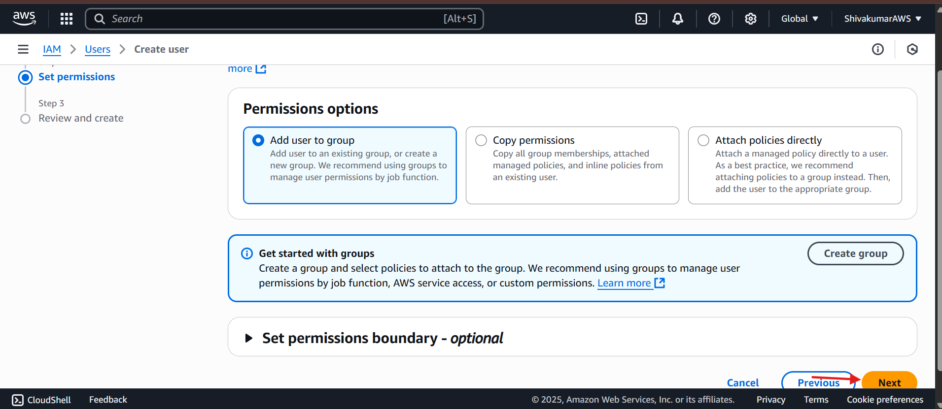

Step 3🡪after clicking create user user will be created

We can delete users by selecting and clicking delete button.

**Creating user groups**

User group is collection of multiple IAM users, it allows us to specify permissions for many users ,it is easier to manage permissions for those users.

Click on user group

Specify user name and click on create user group that will create user group.

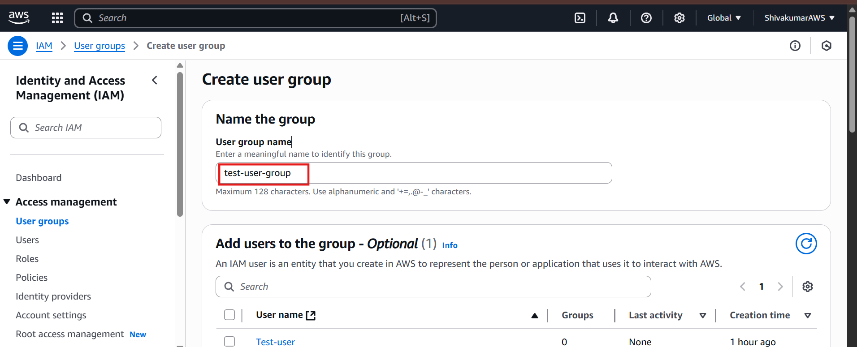

We can add users to user group to manage it will become easier.

For adding users select the user and click on add user.

Added user will be shown in user group.

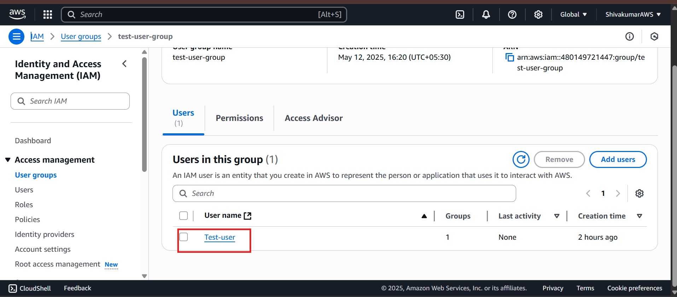

**Creating role**

* An IAM role is an identity within your AWS account that has specific permissions but is not associated with a specific person.
* Roles are intended to be assumable by anyone who needs them, such as users, applications, or services.
* Roles are useful for granting temporary access to AWS resources

In the roles tab click on create role

Step 1🡪 Select the trusted entity

Select the aws service to perform actions,then click on next.



