COURSE CERTIFICATE

This is to certify that

snehal pawar

has successfully completed the course by demonstrating

theoretical and practical understanding of

Introduction to Java



Certificate CC-JIEUNXCH

Issued 03 August, 2024

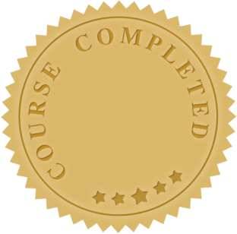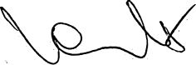

**Yeva Hyusyan**

Chief Executive Officer