EmployeeDetails:

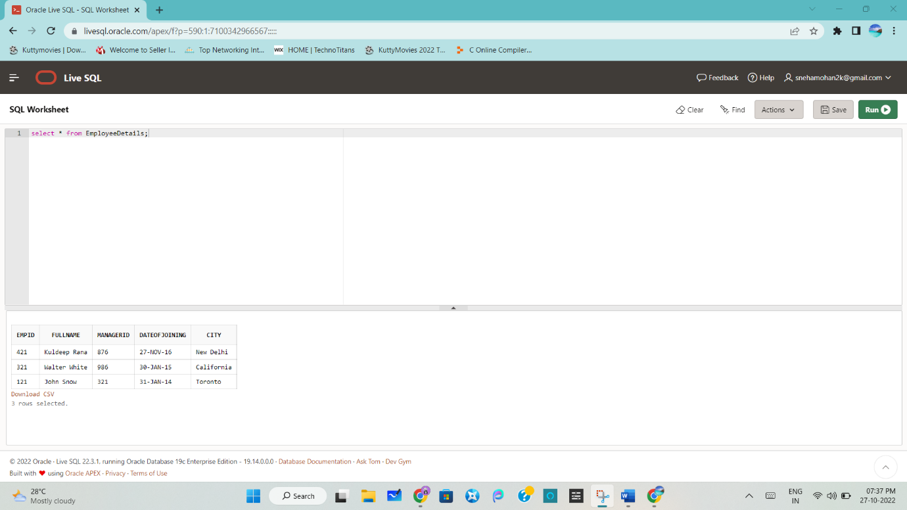

EmployeeSalary:

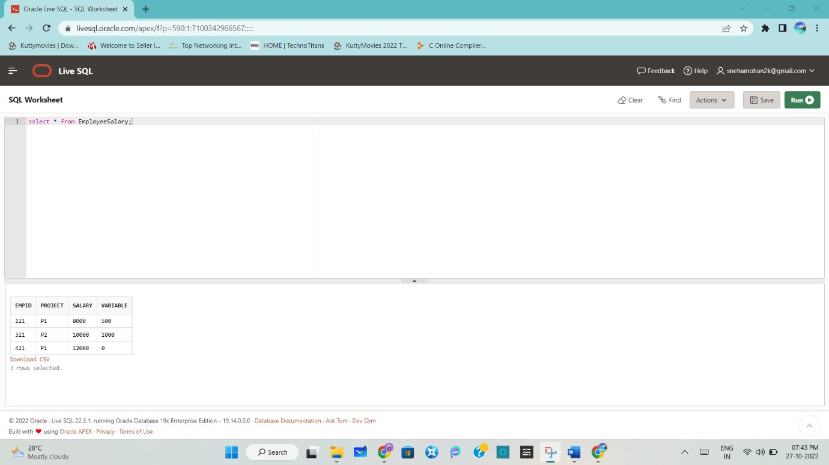

Write an SQL query to fetch the EmpId and FullName of all the employees working under Manager with id – ‘876’.

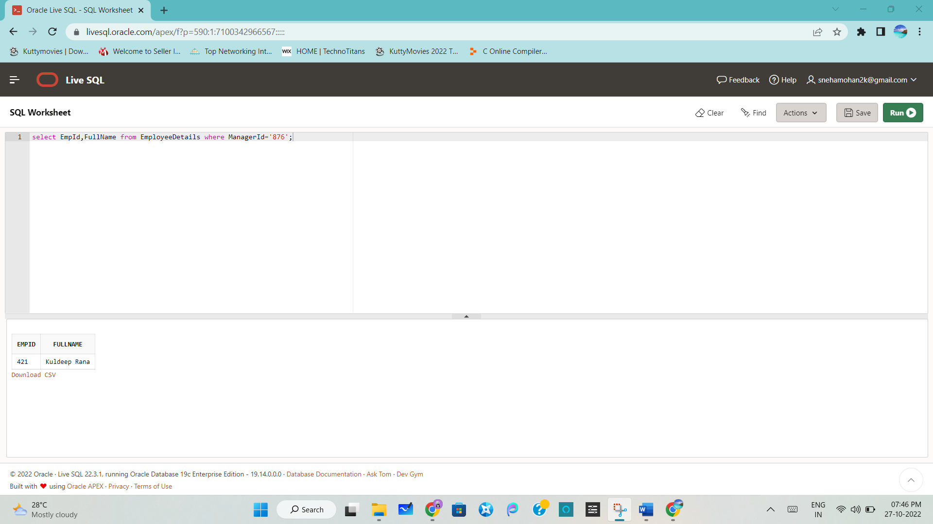

Write an SQL query to fetch the different projects available from the EmployeeSalary table.

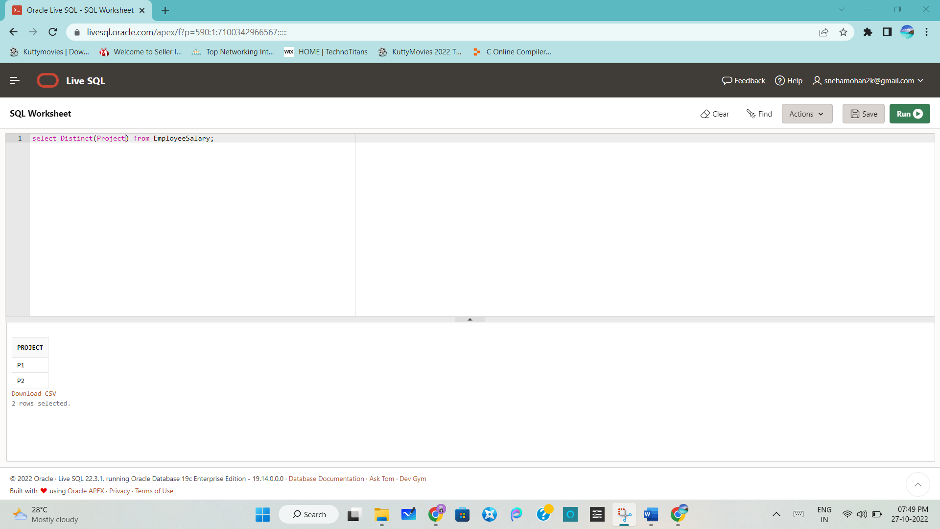

Write an SQL query to fetch the count of employees working in project ‘P1’.

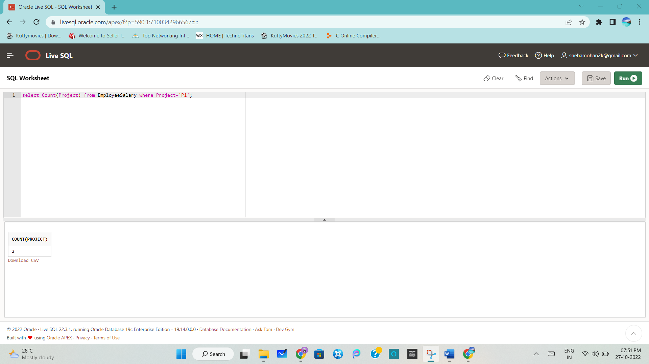

Write an SQL query to find the maximum, minimum, and average salary of the employees.

MAX:

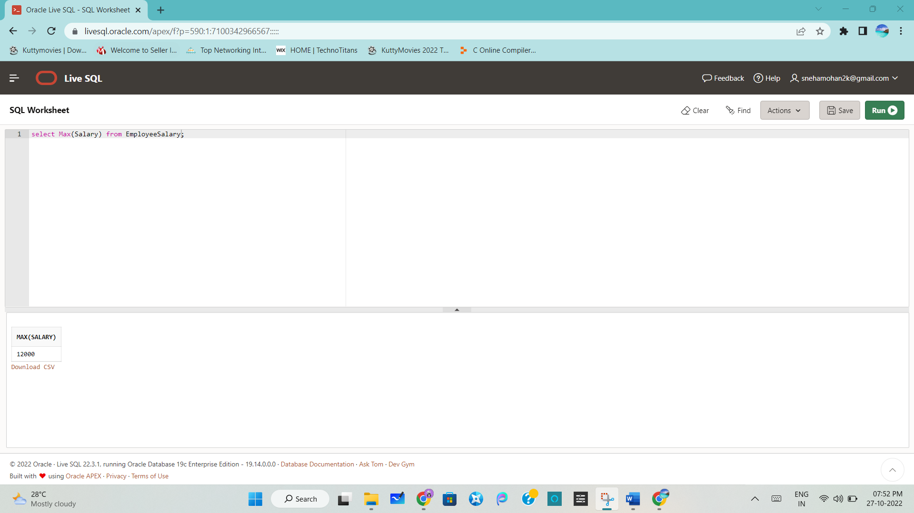

Min:

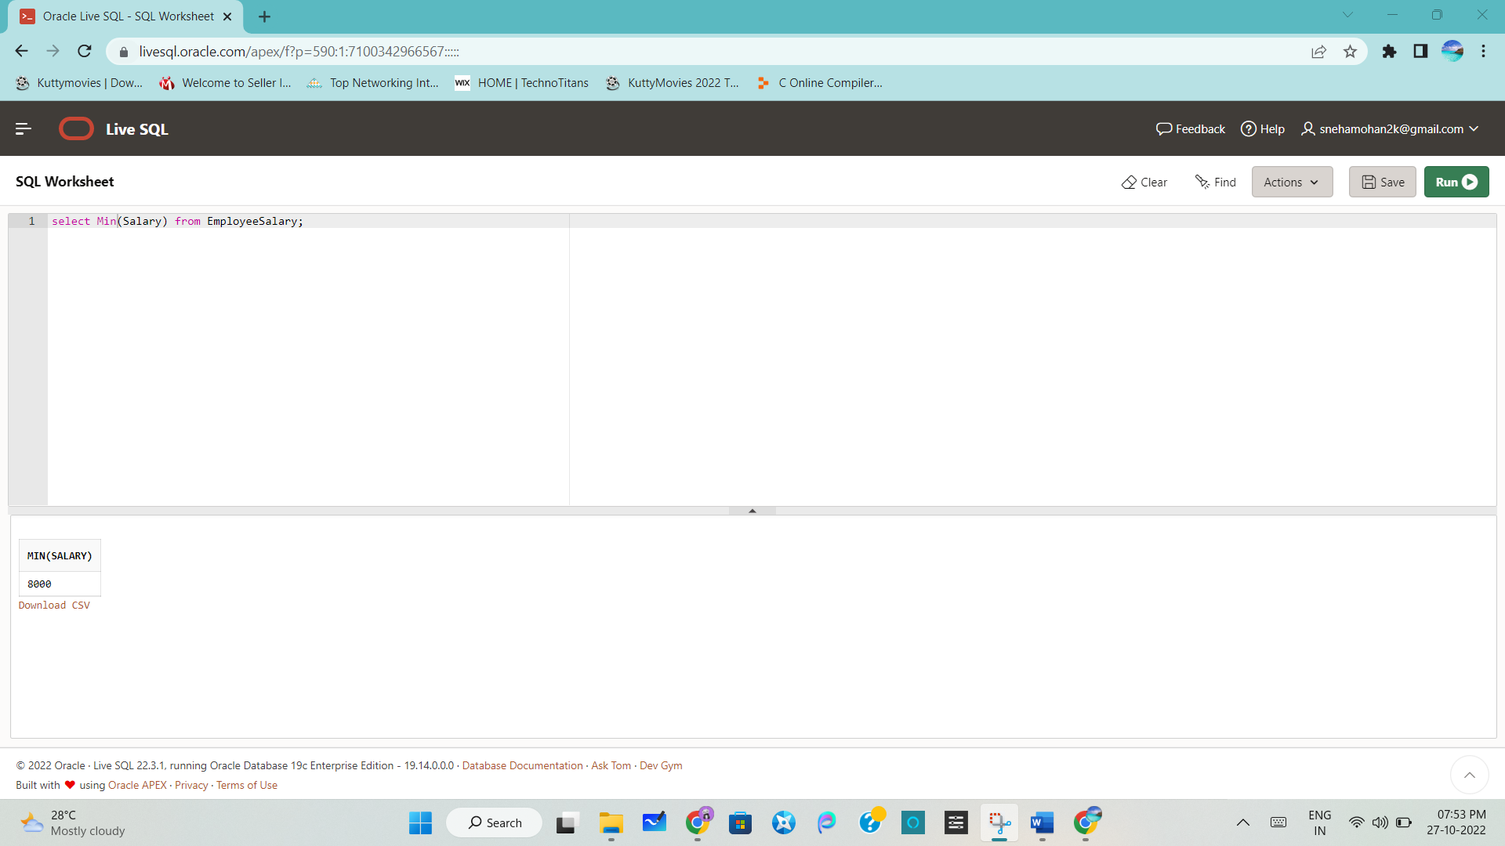

AVG:

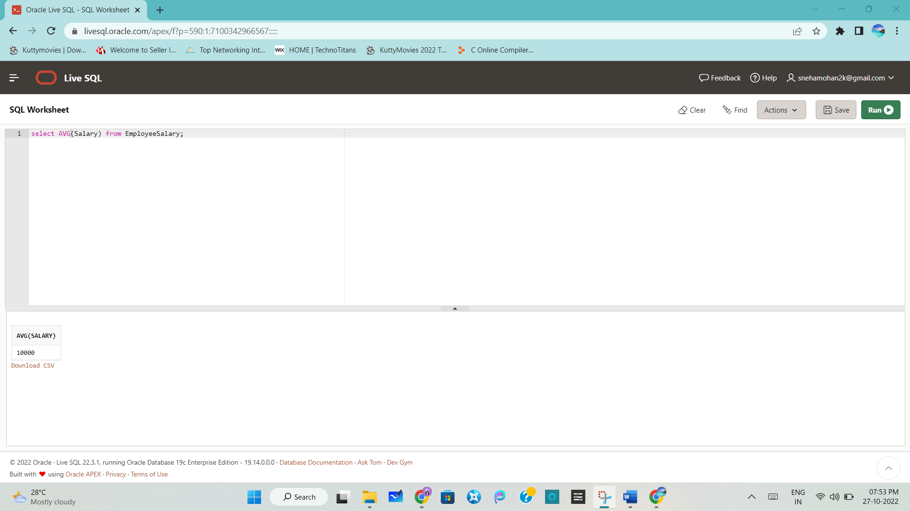

Write an SQL query to find the employee id whose salary lies in the range of 9000 and 15000.

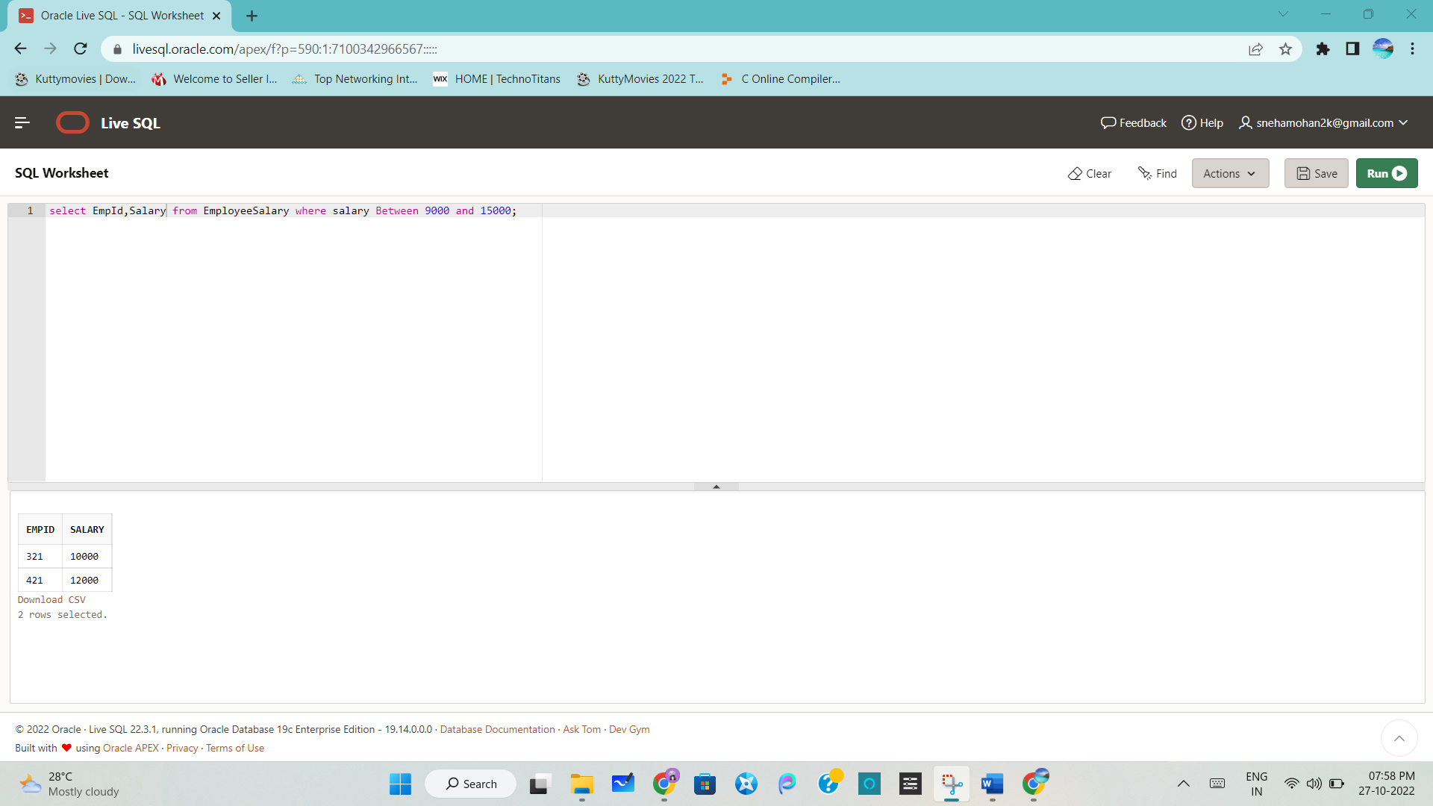

Write an SQL query to fetch those employees who live in Toronto and work under manager with ManagerId – 321.

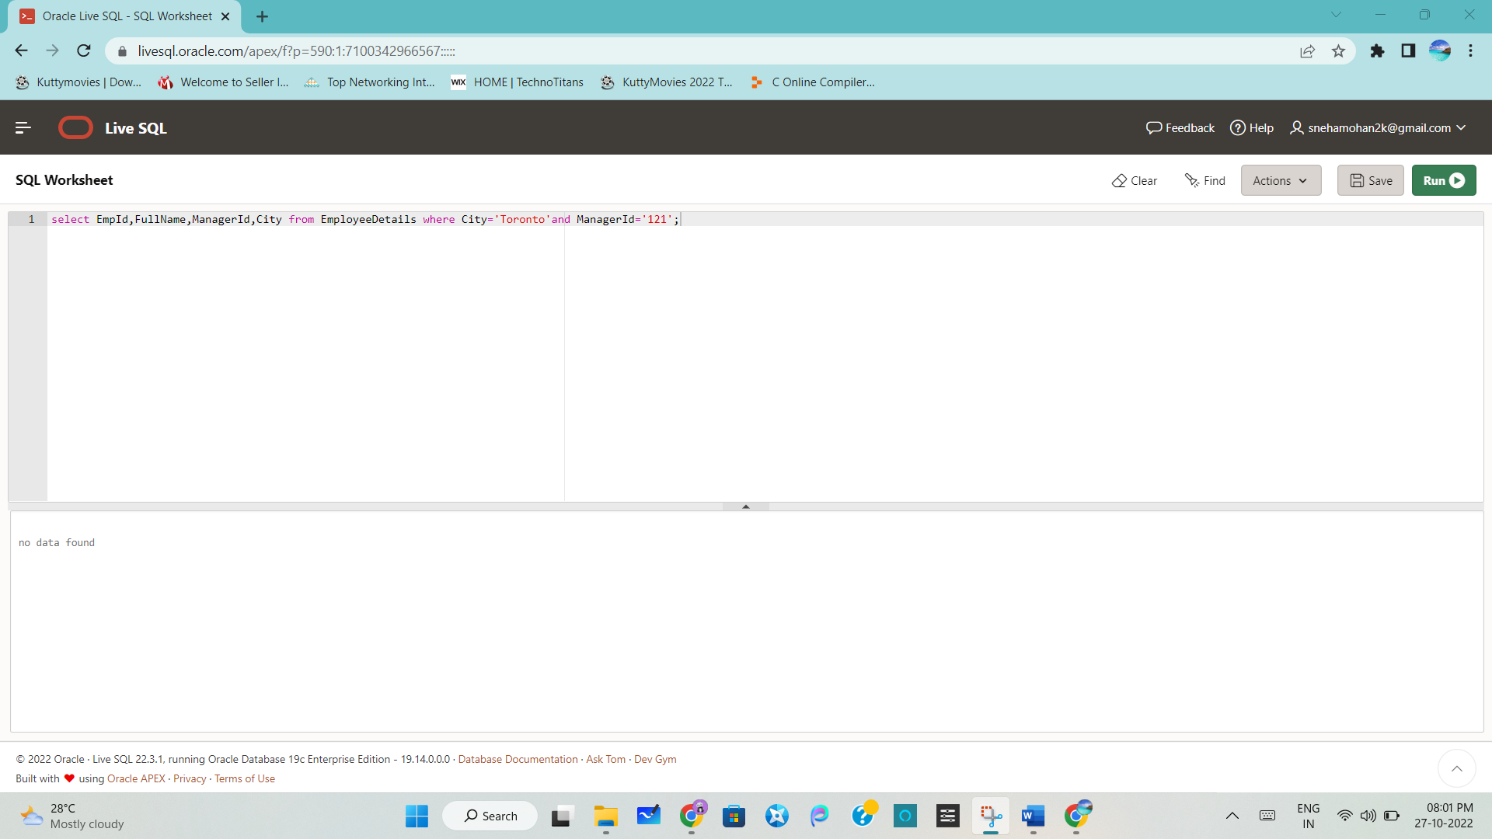

Write an SQL query to display the total salary of each employee adding the Salary with Variable value.

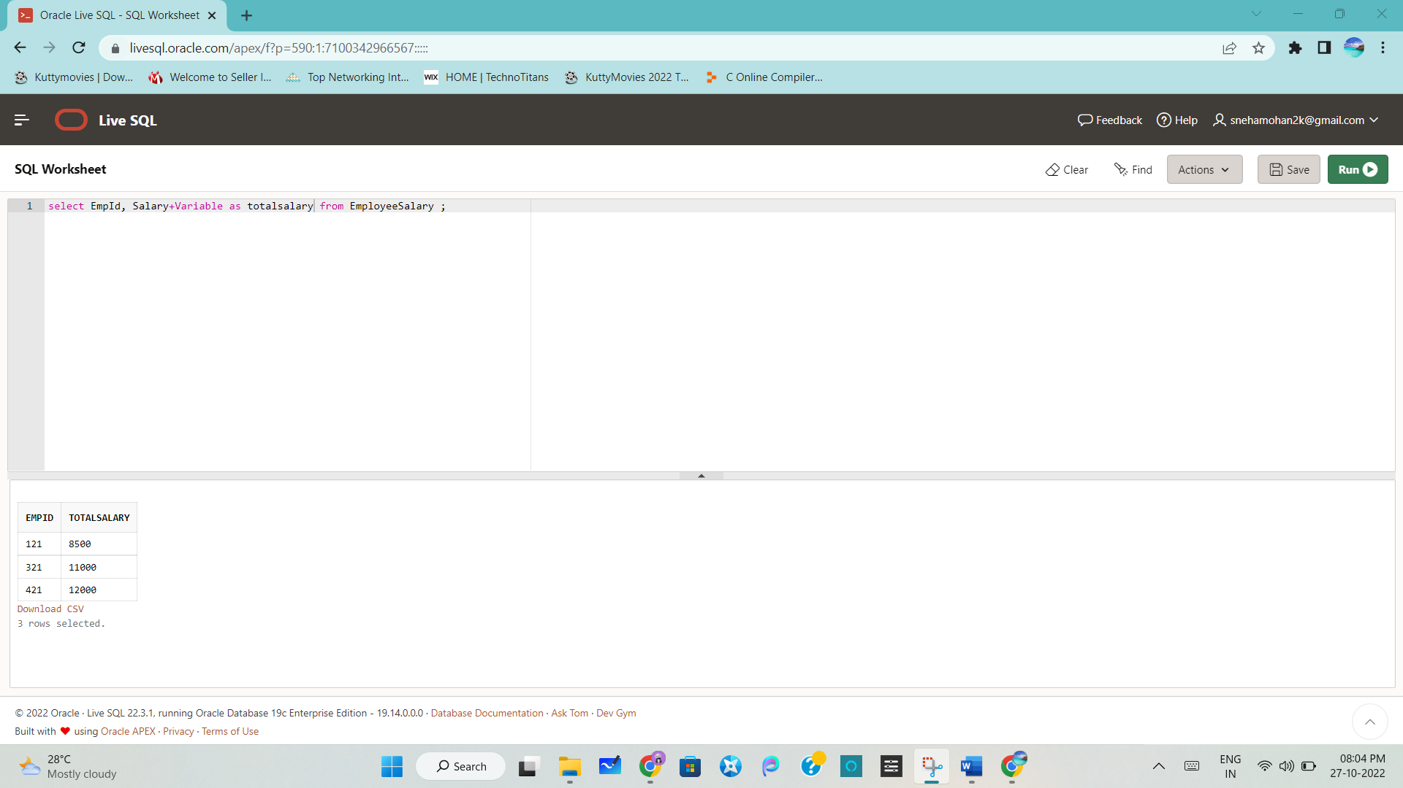

Write an SQL query to fetch the employees whose name begins with any two characters, followed by a text “lt” and ending with any sequence of characters.

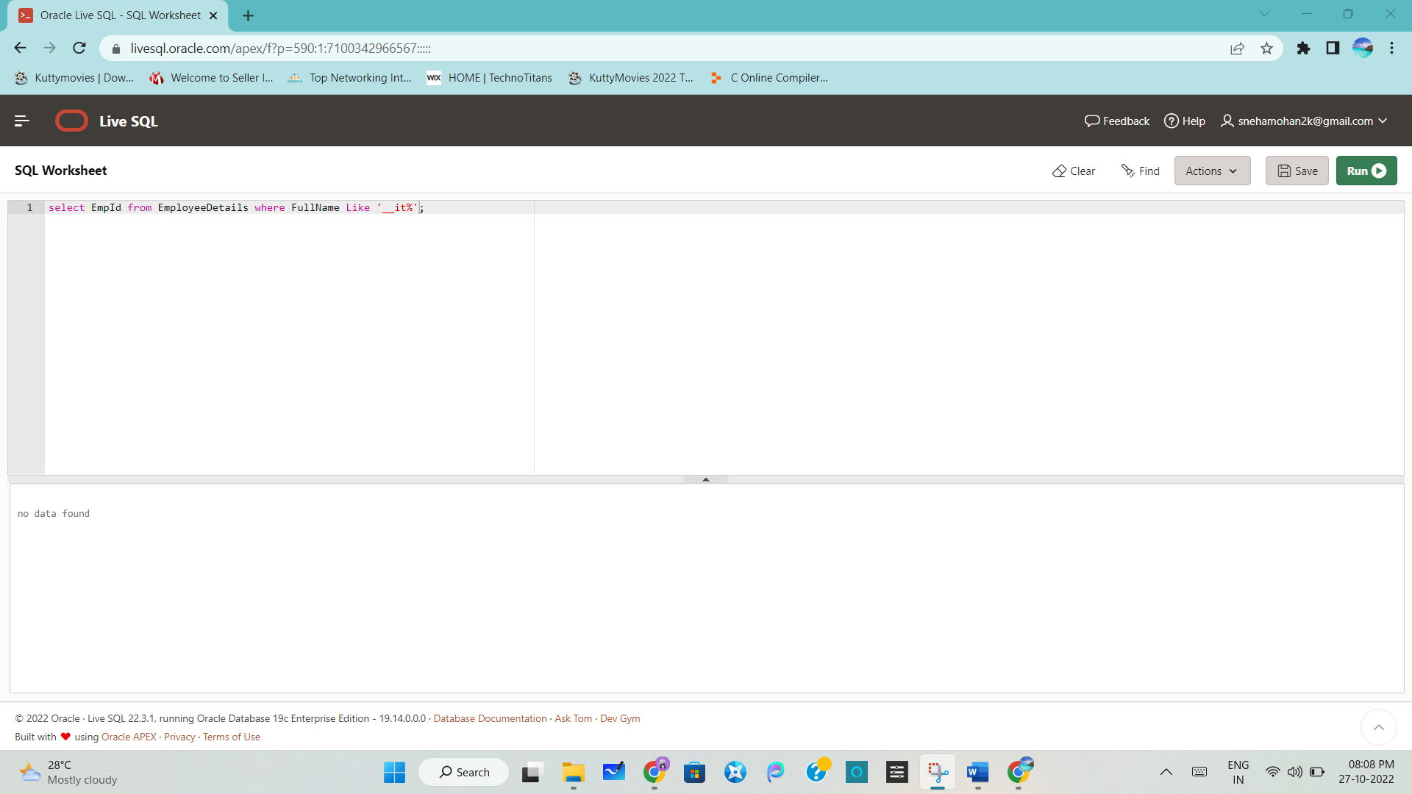

Write an SQL query to fetch all the EmpIds which are present in either of the tables – ‘EmployeeDetails’ and ‘EmployeeSalary’.

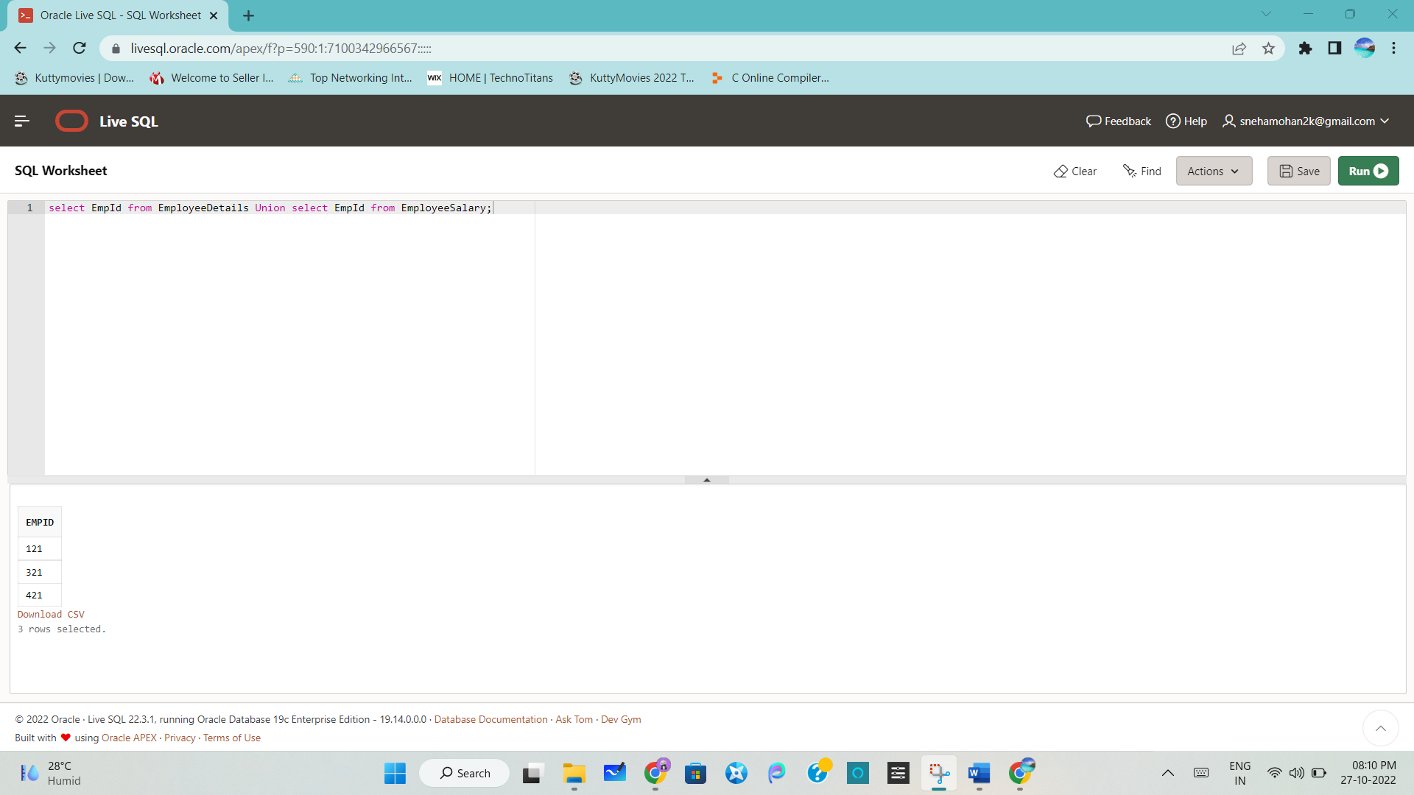

Write an SQL query to fetch common records between two tables

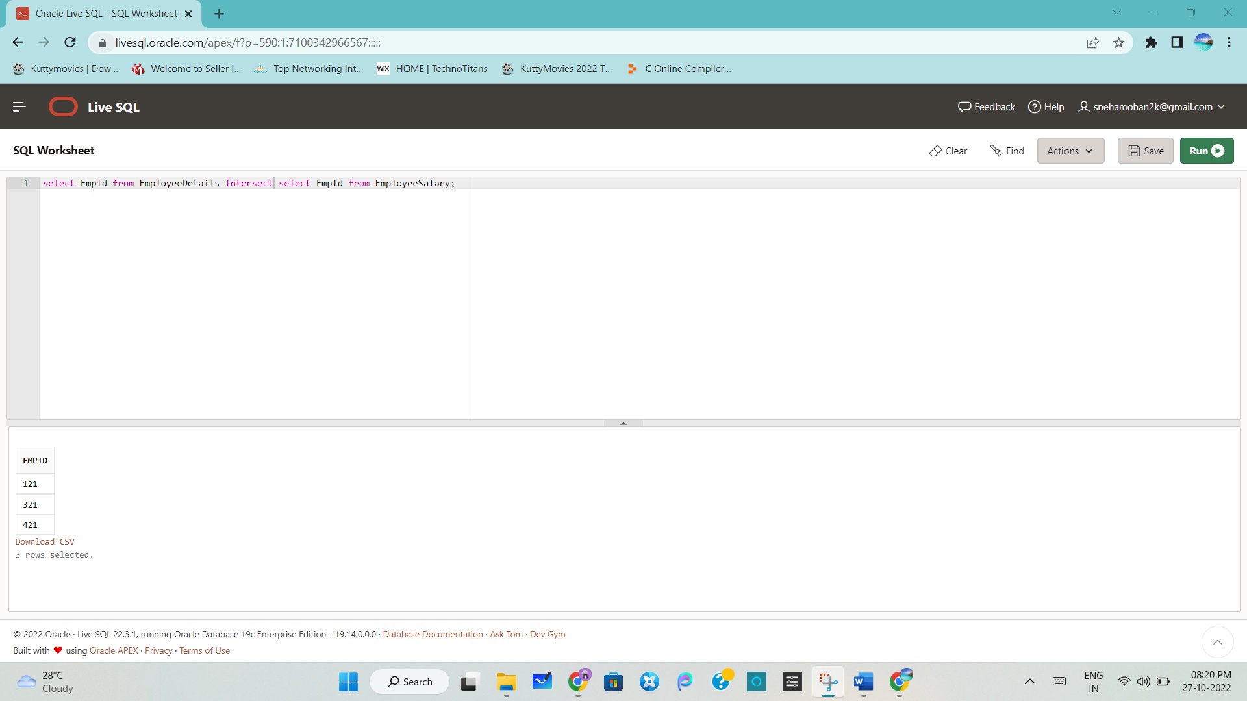

Write an SQL query to fetch project-wise count of employees sorted by project’s count in ascending order.

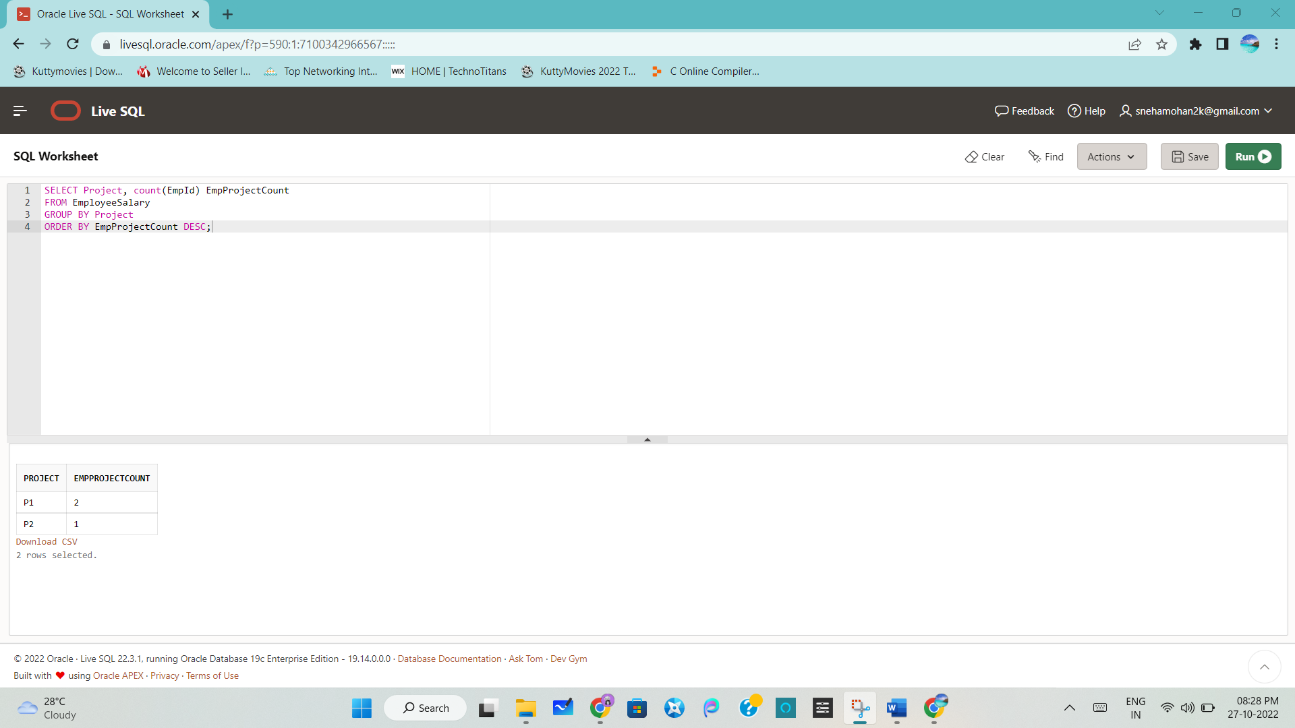

Write a query to fetch employee names and salary records. Display the employee details even if the salary record is not present for the employee.

